Read the descriptions of different super mums in the textbook and complete the following spider webs.

Example

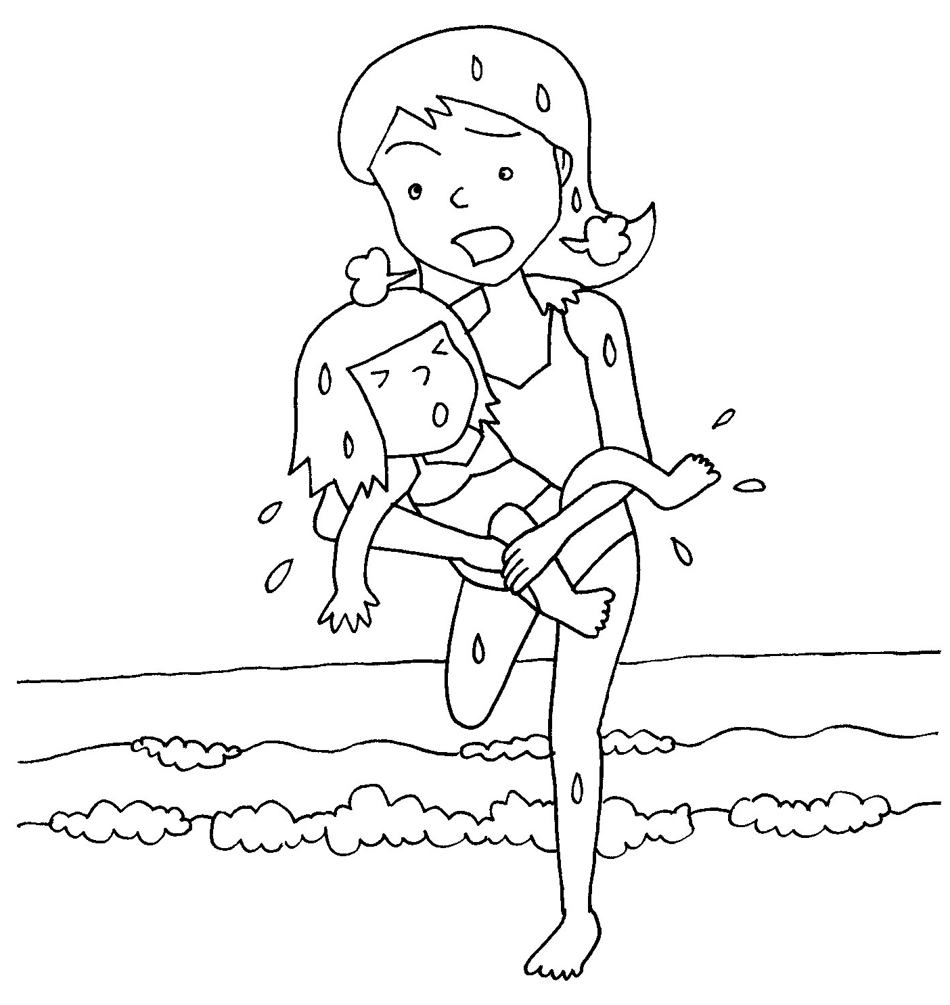
1. Johnson’s Super Mum
brave

isn’t frightened of the sea
rescued a girl from the sea
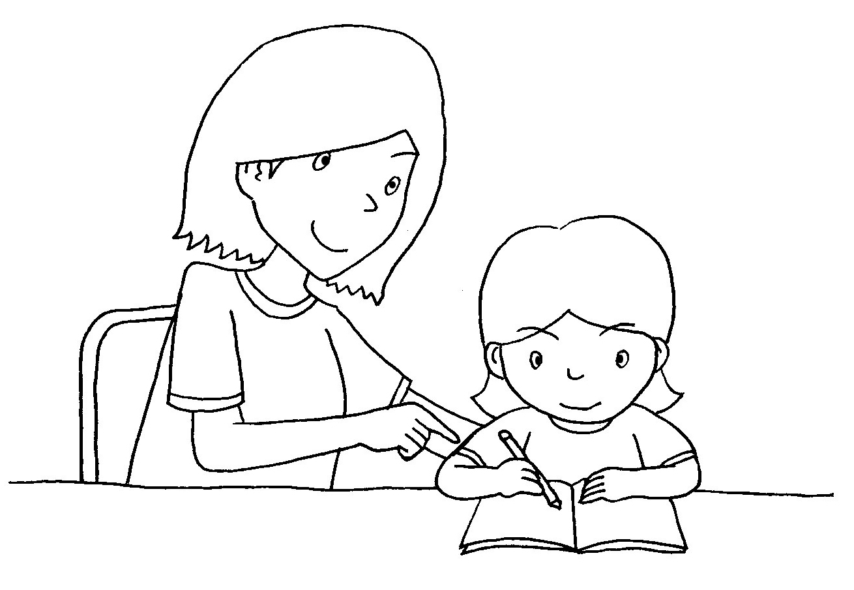
2. Susan’s Super Mum
smart

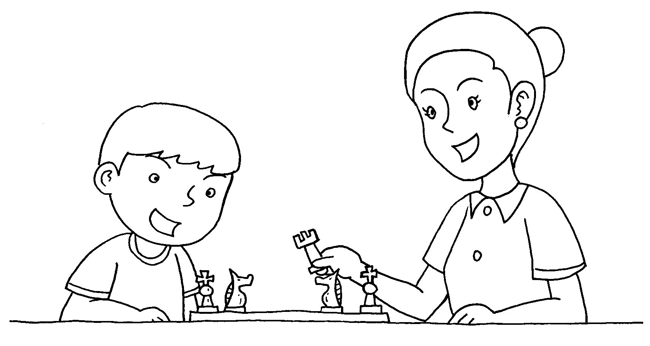

3. Tom’s Super Mum

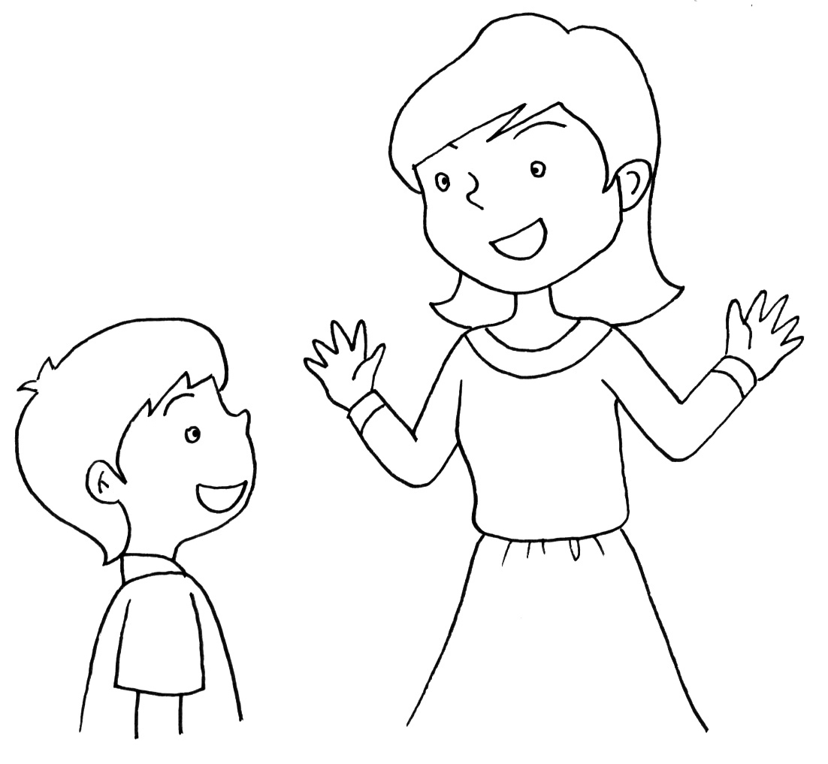
4. Sam’s Super Mum


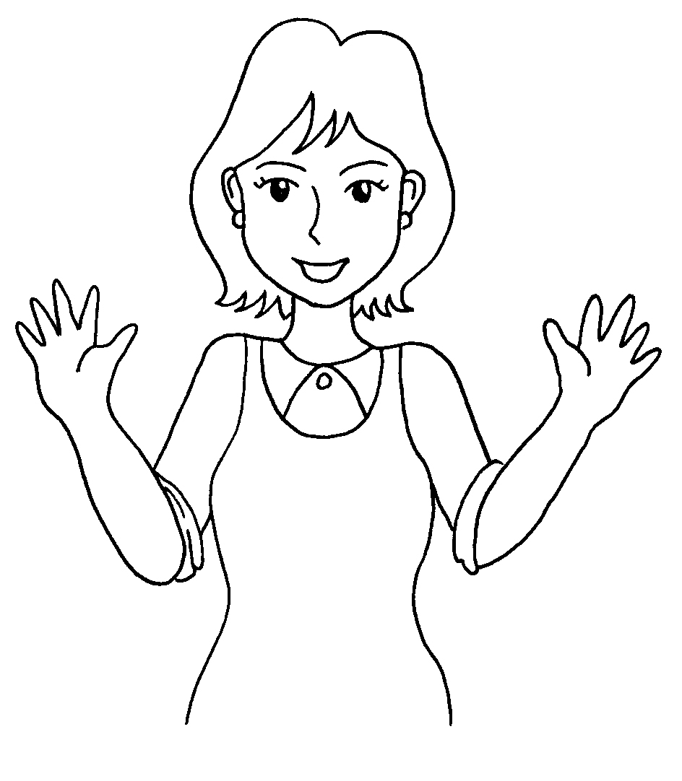
5. Ricky’s Super Mum
Ha…ha…

(Answer Keys)
2. Susan’s Super Mum
smart
good at maths
patient
can do sums faster than others

3. Tom’s Super Mum
did not give up easily
spent many hours
teaching Tom chess
4. Sam’s Super Mum
good-tempered
never lose temper
(Answer Keys)
5. Ricky’s Super Mum
Ha…ha…
humorous
tell funny jokes

