School cases on implementing OLE / SLP

School cases of Other Learning Experiences for Whole Person Development

Case One (School A)
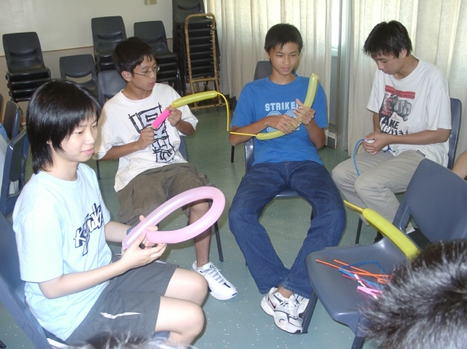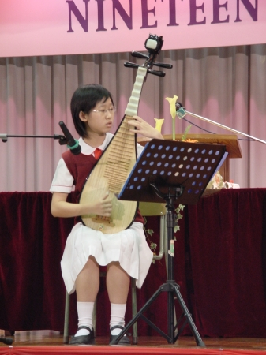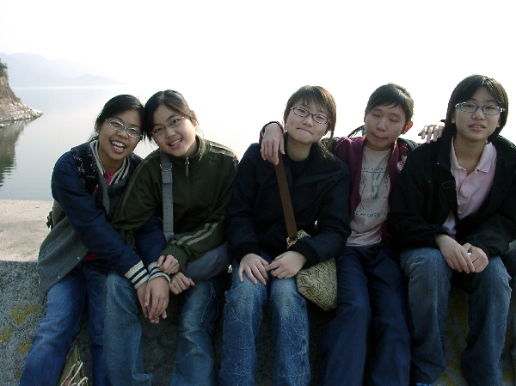
Building on existing strengths

The school is a subsidized co-educational secondary school. The mission of the school is to provide a quality education in a Christian context and a healthy environment where students can develop their potentials, excel intellectually, physically, socially and spiritually, and prepare themselves for the challenges in life.

The school has a very strong culture of self-evaluation for continual improvement. The self-evaluation practice is not only applied to management, it is also practiced in learning and teaching, and nearly every aspect of school life. Teachers are encouraged to engage in self-evaluation and self-reflection through teacher portfolio compilation. Students are also required to prepare annual reflective portfolios as part of the formal assessment. An excellent school culture was built up and there was a strong sense of belonging to the school among teachers and students.

Since 2001, the school has already used Student Portfolio as an incentive to motivate students to involve in those activities that could help students for life-long learning and whole person development.

OLE
Entry Point:
Using Student Portfolio as a catalyst to motivate students to participate in OLE

What is the existing practice?
MCE
Class teacher periods
Religious Studies
AE
Elective Visual Arts
ECA
Subjects in junior
Special Activity Days

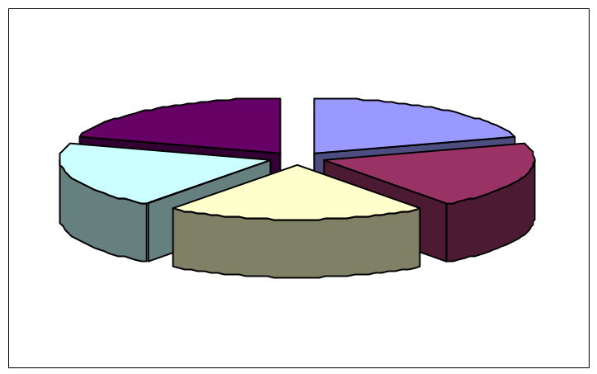

Student Portfolio

Student Portfolio

PE
PE lessons
Sports Days (2 days/year)
ECA / School Teams
CRE
Career guidance programmes
CS
Compulsory to every student

- The school curriculum with Christian faith as the core value is broad and well balanced.
- To provide appropriate life-wide learning opportunities to students, a clear and purposeful policy on participation in extra-curricular activities (ECA) is set. (Annex 1)
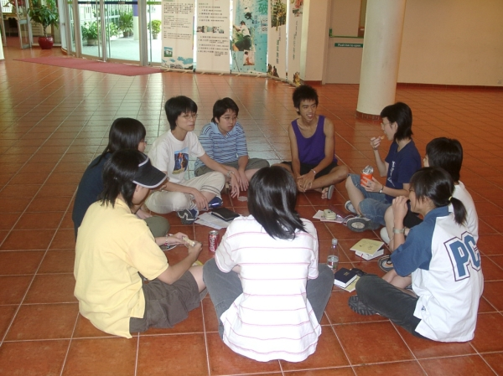
- The student portfolio and the student learning attitude assessment scheme have been introduced to facilitate self-learning through self-evaluation and reflection since 2001.
- There are clearly defined goals to develop leadership skills and a healthy attitude towards life among students.
- The policies and goals of the student supporting teams, led by the vice-principal, were evaluated and appropriately revised from time to time.
- Two 35-minute class teacher sessions and two 35-minutes religious study sessions (both at junior and senior levels) per cycle serve as MCE and they aim to cultivate positive values and attitudes among students.
- Every student will engage at least one “outside school” Community service in a year as the school motto is promoting service leadership.
- The 4-day “Study week” in November provides a wide range of learning activities to students (Annex 2)

What are the features?

- A hard copy of portfolio with (1) clear requirements, (2) continuous progress, (3) more information, and (4) less technical problem, is offered to every student at the beginning of the term so that students could input the details of participations and reflections on their learning.
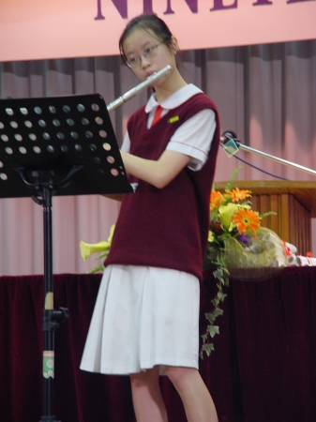
- The portfolio consists of 13 parts. They are
  - the Guidelines / Introduction
  - the school policy on student development
  - the “Personal Development Plan”
  - An overall record
  - Tours and trips
  - Reading Reports
  - Projects / Important assignments
  - ECA
  - Services
  - Other valuable experiences
  - Reflection on School Target Skills
  - Overall self evaluation
  - Others’ remarks
- A list of capabilities and attributes for assessment and development is provided for students’ reference.
- Through interviews with students three times a year when the portfolio is submitted, teachers could give their feedback and make suggestions to the students.
- Students could access to their accounts and make necessary amendments through a school-based electronic recording system.
- Teachers will validate the information before the final outputs of the record.

How does it work?
We have a very strong sense of belonging to the school and treasure the warm and harmonious atmosphere of the school.


- There are evidence to show that students are pleasant and well-behaved, and demonstrate good interpersonal relationship among peers and with teachers.
- Students participated actively in community services.
Students say….
- Some senior form students displayed good leadership skills.
- The students actively involved in intra- and interschool activities. They won many awards in inter-school sports competitions and aesthetic competitions, especially in performing arts. They were also eager to serve, helping in school functions and taking part in various external social service activities.
- The school maintained very good external links with the education sectors and other organisations for co-operation and resources support.

Policy on participation of ECA
Annex 1

- All students, except S.5 and S.7, could enroll in a maximum of 3 activities. For S.5 and S.7 students, they could enroll in a maximum of 2 activities.
- All students should participate in community service for once in a year.
- Compulsory instrumental class for all S.1 students.
- Students’ ambassadors in S.2 and S.3
- S.4 and S.6 will participate in 7 student leadership groups (學生領袖組別), including
- head perfects,
  - chairman of clubs,
  - chairman of houses,
  - Big brother and big sister scheme,
  - counseling team,
  - healthy school project,
  - senior students’ fellowship.
There are over 100 positions to serve in these groups.
- For leadership roles, the school would recruit the students through central recruitment. One single student could not hold two captains’ positions.
- Orientation would be arranged for S.4 and S.6. The purpose is self-understanding and understanding on the personal qualities needed for the 7 student leadership groups. This is to make sure that students would make rational choice on the activities and positions they select.

The 4-day study week
Annex 2

- It’s an individual-based and student-centred activity held in November for all students.
- LWL activities are conducted, such as projects, visits, training, joint leadership training camp and field trips.
- Students could choose their learning activities organized by schools or other out-of-school organizations. They could choose from a variety of categories such as visits the museums or visits to places in HK, cultural activities, training, class picnics (organized by students), etc. All these activities must incorporate the element of “learning”. They then report their learning experiences in their portfolio.
- The school would launch programmes in view of students’ needs, such as improving students’ motivation in learning. Students have the options to select the programmes.
School cases of Other Learning Experiences for Whole Person Development
Case Two (School B)

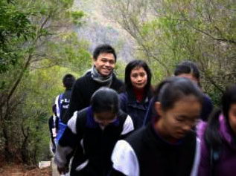 | 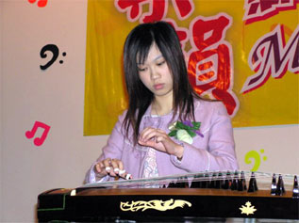 | 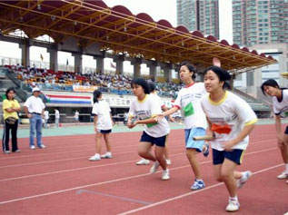
Building on existing strengths

The school is a subsidized co-educational secondary school. The school has a strong foundation in providing a balanced curriculum to address individual student’s learning needs. “Student-centred” is a central focus in the school. The school puts emphasis on both in and out of classroom learning opportunities initiated by teachers and students. Within school, these learning opportunities are usually offered through Extra-curricular Activities (ECA). To incorporate other learning opportunities outside school and those initiated by students, they implement various school policies to recognize and strengthen students’ learning experience. In view of students’ unbalanced participation in ECA activities and community services in the past, the school launched the “Activity Curriculum” in 1997 in order to maintain a balanced curriculum for all students.

Entry Point:
Restructure the Activity Curriculum with focus on Other Learning Experiences (OLE) components.
OLE

What is the existing practice?

MCE
Class teacher periods
Inside and outside school activities freely joined by students (Activity Curriculum)
AE
Integrated cultural & practical subject
ECA

PE
PE lessons
Sports Days
ECA / School Teams
CRE
Subject-based programmes
Career guidance programmes

CS
Compulsory to all students

- Aims and Objectives of the Activity Curriculum
  - To offer a balanced curriculum; and
  - To confirm that ECA is part of whole school curriculum
  - Students could design a curriculum which fits their own needs;
  - Both the quality and quantity of activities attended by students are up to certain standards as set in the curriculum;
  - Students should have a balanced whole person development instead of a biased focus in certain aspects; and
  - Students could participate in inside or outside school activities.
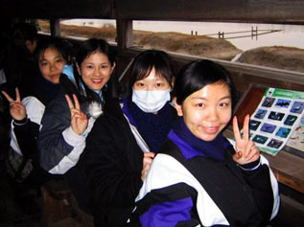
- Domains (Annex)
  - Art
  - Interest
  - Sports
  - Leadership
  - Services
- Students have to complete one to two domains every year.
- Students have to complete one to four domains before graduation at S.5.
- Students have to complete all five domains before graduation at S.7.
- Quantity of activities: not less than 8 hours every year.
- Quality of activities: to be assessed by the school.
- Every year, students are required to propose a personal plan with goals setting, which is to be achieved in the activity curriculum.
- Every year, teachers would review on students’ proposal and give suggestions accordingly so that students could achieve a balanced whole person development.
What are the features?

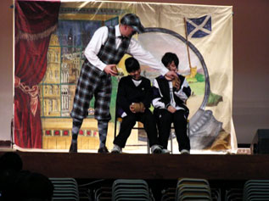
- Students take the initiative to plan their own curriculum. This helps to strengthen their ability in life-long and life-wide learning.
- Students take the initiative to participate in activities according to their interest, including those activities arranged by outside school parties. This flexibility creates a pathway leading to life long learning.
- Teachers’ intervention guarantees a balanced activity curriculum during implementation.
- The school has a manual system to record students’ participation in outside school activities.

Our students have a strong sense of ownership on the activities they choose to fulfill the requirements of the Activity Curriculum.
How does it work?


- The school is in the frontline of the current Curriculum Reform. It has implemented project learning for several years. This strengthens students’ ability in self-learning and generic skills.
Teacher says…
- The school report, goal models of students and student profile properly document and reflect students’ whole person development.
- The school activities are balanced with a good number of varieties for students to participate in.
- The number of students who completed the activity curriculum is increasing every year (from 59.6% in 97/98 to 93.4% in 03/04).

Activity Curriculum
Annex
Domains | Year | Grade | Particulars | Hours
Art | / | S
Art | / | S
Art | / | S
Art | / | S
Art | / | S
Interest | / | S
Interest | / | S
Interest | / | S
Interest | / | S
Interest | / | S
Sports | / | S
Sports | / | S
Sports | / | S
Sports | / | S
Sports | / | S
Leadership | / | S
Leadership | / | S
Leadership | / | S
Leadership | / | S
Leadership | / | S
Services | / | S
Services | / | S
Services | / | S
Services | / | S
Services | / | S

School cases of Other Learning Experiences for Whole Person Development

Case Three (School C)

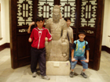
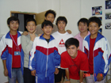



Building on existing strengths

The school mission is to equip the students to become future adult with responsibility, self-confidence and self-appreciation. It aims to provide a loving and caring environment so that the uniqueness of every student could be valued.

Since 2002, the school has organized the “Horizon week” (learning activity days), which is promoting diversified learning for whole person development. The school organises the OLE-related activities as ‘events’ and assigns several days in the school calendar to organise the activities.

OLE
Entry Point:
Using learning activity days to organise OLE components in normal school hours.

What is the existing practice?

MCE
Class teacher periods
Religious Studies
AE
Elective Visual Arts
ECA
Arts Education in junior

Learning Activity Days
(5 – 7 days)

PE
PE lessons
Sports Days
Swimming Gala
ECA / School Teams
CRE
Career guidance programmes

CS
Optional for students

- Five successive days for the “Horizon week” are fixed in the school calendar in every November
- Aims of the “Horizon week”
  - To broaden students’ exposure to the real world
  - To build up healthy life style with positive values and attitudes
  - To empower students’ collaborative skills
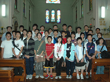
  - To increase students’ alertness to different social cultures
  - To enhance students’ commitment and responsibility to community and nation
  - To help students develop and learn independently
  - To improve the relationship between teachers and students
- The ECA master is responsible to coordinate the activities in the week
- All the teachers are involved in the week and every teacher is assigned to conduct at least one programme
- The activities, which are conducted inside or outside school, include interest groups, uniform groups, community services, martial training, services in remote areas of the Mainland, leadership training, local and outside HKSAR education excursion, visual arts course, musical instrument training, career-related experiences. (Annex)

What are the features?

- During the “Horizon week”, various opportunities for providing essential learning experiences are available for students’ choice
- Students are encouraged to write reflection after every activity programme
- In the student report card, the academic performance and the ECA participation will be displayed
- Some students’ reflections are published in the school newsletter to acknowledge their participation and learning
- Formal evaluation of every programme is conducted after the “Horizon week”
- The school maintained very good external links with other organizations for co-operation and resources support (e.g. Caritas, Warehouse Youth Centre, District Council and etc.).
How does it work?

Teachers are very eager to write comments for their students to recognize students’ performance and progress in learning.
- Positive feedback from students and parents
- Students’ works from the Horizon week are highly recognized by teachers and parents

Annex

多元學習周2004活動名單：

- 樂善勇敢：中一生活營之「生活有序」 (活動編號：A01)
- 科學學習營 (活動編號：A02)
- 領袖訓練營 (活動編號：A03)
- 體育科戶外教育營 (活動編號：A04)
- 培苗行動：中國廣東省乳源縣大布中心小學服務計劃 (活動編號：B01)
- 黃埔軍校少年軍訓營 (活動編號：B02)
- 珠海文化旅遊體驗團 (活動編號：B03)
- 澳門珠海宗教、經濟、文化考察團 (活動編號：B04)
- 越野跑校隊精英培訓班 (活動編號：C01)
- 短片製作 (活動編號：C02)
- 流行樂隊訓練班 (活動編號：C03)
- 影片剪接班 (活動編號：C04)
- 網球訓練班 (活動編號：C05)
- 結他班 (活動編號：C06)
- 口琴初探 (活動編號：C07)
- 中國文字演變 (活動編號：D01)
- 香港社會及歷史探索 (活動編號：D02)
- 書香世代 (活動編號：D03)
- 『力行仁愛、服務社群』：社區服務計劃 (活動編號：E01)
- 工作體驗計劃 (活動編號：E02)

School cases of Other Learning Experiences for Whole Person Development

Case Four (School D)

Building on existing strengths

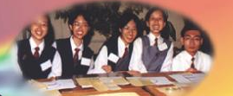

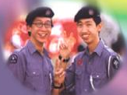
Building good school ethos climate is the heart of the school policy and the school believes that the joint effort of class teachers, guidance & discipline teachers and MCE as well as the Life Education teachers could help a lot in this respect. In this view, the school has developed the school-based Life Education curriculum at junior levels since 2002. Life
Education in and out of classroom learning is reckoned to be a good means to achieve the expected outcomes of MCE since it is relevant to the students’ daily life.

Entry point:
Extend the School-based Life Education Curriculum with OLE components to senior forms
OLE

What is the existing practice?

- School-based Life Education Curriculum at junior levels (S1 to S3)
- The aims and objectives of the Life Education Curriculum
  - To help students get to know about themselves
  - To foster the grow and development of students in a healthy manner
  - To develop attitudes of self-motivated learning and self-discipline among students
  - To build up a simple, honest and pure climate in school
- One 40-minute lesson per cycle. (about 17 hours inside school)
- Small class strategy to facilitate the space for discussion. (Teacher to student ratio is 1 : 20)
- Five teachers are responsible to the students in 15 classes (S1 to S3)
- Work closely with class teachers, discipline and guidance, and MCE teachers

MCE
Class teacher periods
Whole school activities
Life Education (Junior levels)

AE
Visual Arts
ECA
Special Activity Days

CRE
Career guidance programmes
PE
PE lessons
Sports Days
ECA / School Teams

CS
Optional for students

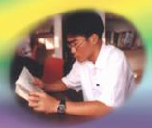
What are the features?

- For the whole person development, the Life Education curriculum could take a balance between formal and informal learning. It encourages students to reach out in an authentic situation and reflect after the experience.
- The curriculum is the core element to promote MCE. It synergies the efforts not only from MCE, but also from reading team, guidance and discipline team as well as ECA and cross-curricular teams.
- Clear learning objectives, precise focus and relevant to the students’ life experiences.
- Good cooperation with reading and project learning programme.
- The themes in each level:
  - S1: Every student take part in at least one sport (一人一運動)
  - S2: Every student is involved in one interest / hobby (一人一情趣)
  - S3: Every student participate in one voluntary work (一人一義工)
- A student record book for promoting self-evaluation is a part of the curriculum. More interaction between teachers and students is encouraged by using the record book..

How does it work?
Our students become more self-disciplined and the school has a good reputation in the district.

- Students’ positive behaviors have been strengthened

- Students felt more empowered to do the peer evaluation in the process. A good turnout on students’ abilities in reflection is observed. Positive attitudes towards learning among students could also be fostered
Students are more willing to think an issue from different perspectives.
Teachers say…..
- There is evidence that students are more equipped with self-management skills. They are polite, kind, friendly, cooperative, and obedient to teachers’ instructions.

School cases of Other Learning Experiences for Whole Person Development

Case five (School E)

Building on existing strengths

- The school has a strong and clear mission on promoting Healthy and was awarded a Gold Medal in HK Healthy School Award Scheme.
- The school offers a number of ECA activities to develop students’ multiple intelligences. There are 39 clubs in the school in 2004/05, including 11 academic clubs, 7 sports clubs, 7 service clubs, 6 interest clubs and 8 art clubs. Students are encouraged to join the clubs according to their interests and abilities.
- There are four houses in the school. Students could participate in the activities arranged by their houses.
- Subject-based extension activities are arranged regularly.
- Both the formal and informal curricula are equally important in school. They supplement each other during implementation.
- The school has a mature recording system to record students’ learning experience. All S1 students are required to report their results and activities attended in the past. All students would record their in-school and out-of-school activities using “student record cards”.
- At junior level, the school has implemented a number of MCE activities during lesson time, including the class teacher periods and parents’ day.
- Drama and music lessons are compulsory for all S2 and S3 students.
- All S1 students must join the “One Sports in Life” scheme (一生一體藝). For S2 and S3, it’s an elective subject.
- In collaboration with NGOs, the school offers community services opportunities for students.
- Students are encouraged to participate in out-of-school activities to fulfill their personal interests.
Entry point:
Using Active Learning Handbook as a tool to promote Quality Reflection in OLE
OLE

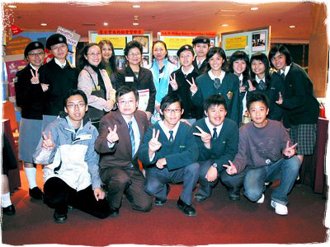
What are the features?

- An “Active Learning Handbook” (主動學習手冊) has been published for each student since 2003. Students are encouraged to make use of the handbook to document their learning experiences. This incorporates students’ reflection and teachers’ comments. The design of the handbook is constantly reviewed yearly to respond to change of the world trend and students’ needs..
- Aims and objectives of setting the “Active Learning Handbook”
    - Students are able to set short-term and long-term goals for their development
    - Students are well equipped by self-confidence, problem solving skills in order to maintain healthy life style
    - Students are able to obtain the ownership in learning and become active learners in a long run
    - Students are able to evaluate and reflect their learning by themselves
- The school highly value students’ learning experience in informal curriculum.
- The school actively provides learning opportunities to address students’ needs and to develop their potentials.
How does it work?

- The school has built up a reflective culture through the use of active learning handbook..
- Students are encouraged to be active learners through the use of active learning handbook..
- Students develop a habit in life-long and life-wide learning.
- Linkage of formal and informal curricula becomes strong.
School cases of Other Learning Experiences for Whole Person Development

Case Six (School F)
Entry point:
Using School-based life-education programme to achieve whole person development
OLE

Building on existing strengths

- The school has a strong belief in whole person development and provides students with a variety of ECA.
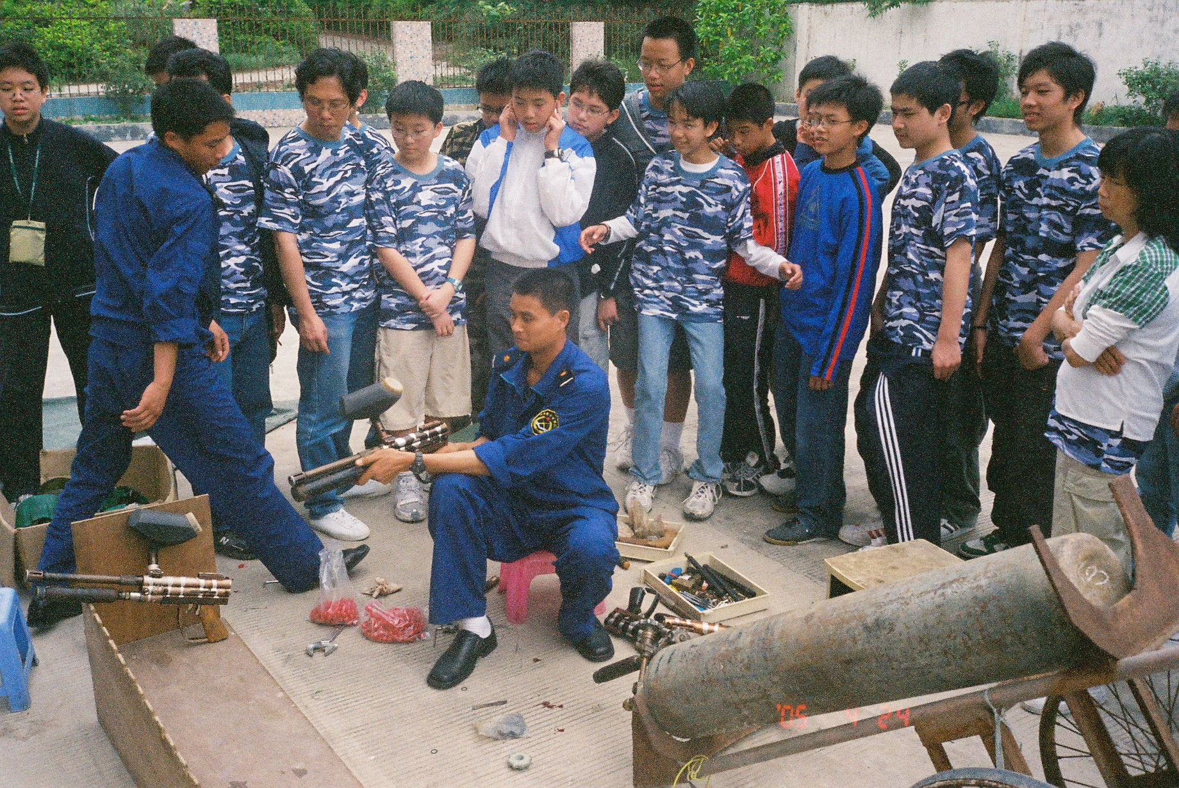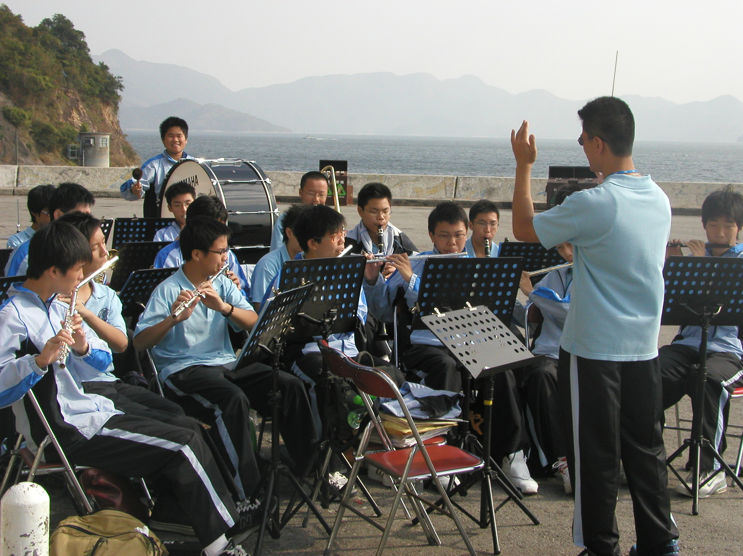

- School-based life education programme has been implemented in junior secondary (S1 to S3) for several years.
- The teachers in-charge of the programme work closely with career & guidance team
What are the features?

- The objectives of the school-based life education programme:
  - To help students get to know about themselves
  - To provide larger exposure in career opportunities
  - To enable students’ capabilities to make choice
- One 40-minute lesson per cycle and it has strong CRE elements through the structured life education programme.
- Under the theme of “一人有一個夢想 / Everyone owns his dream”, reading programme in the first term and project learning approach in the second term are adopted at S2 level. The name of the project is “我的路由我創造 / I create my own pave”.
- Provide rich variety of reading materials for students to reflect
- Provide visits to various workplace / institute visits and career talks to S1 – S3 students
How does it work?

- Through systematic reading programme, students could explore different sharing regarding to CRE from different writers / business experts.
- Students take turns to share in class what they reflect after reading.
- Five students in a group accomplish a project assigned by the teacher. In the process, students are requested to search for CRE information and reflect on how the information could match their individual characters.
- At the end of the process, students are requested to interview with an alumnus who may be an expert in a certain field of work.
- Self-evaluation, peer evaluation and teacher evaluation strategies are adopted under a well informed rubrics.
- Work closely with outside non-government organizations.

