Determining the enthalpy change of a reaction with the use of Arduino
(Teacher Notes)
Sample Result :
1. Data Collected by Arduino System with temperature sensor (sampling rate = 1 sec)

Time of addition of Zinc powder = 173 second
Mass of Zinc powder = 4.02 g

2. Initial Temperature T₁ = 20.19ºC
Highest Temperature T₂ = 69.06ºC
Temperature difference (ΔT ) = 20.19-69.06 = -48.87 ºC

3. ΔH = m c ΔT
= 50.0 × 1.0 × 4.18 × (-48.87)
= -10213.83 J
Zn(s) + CuSO₄(aq) ZnSO₄(aq) + Cu(s)
Number of mole of copper (II) sulphate = 1.0 × 50.0×10⁻³ = 0.0500 mol
Number of mole of zinc = 6.05/65.3 = 0.0926 mol
Mole ratio of CuSO₄ : Zn = 1:1
Therefore, CuSO₄ is a limiting reactant

ΔH per mole of CuSO₄
= -10213.83/0.0500 = -204277 J mol⁻¹
= -204.28 kJ mol⁻¹

Answers for the questions:
(Teachers may choose the questions appropriate for their students to work out.)
- - Heat loss to the surroundings
- Specific Heat Capacity of the solution is not the same as that of water
- The total mass of the reaction mixture is not 50g

- The reaction of zinc and copper(II) sulphate solution is exothermic. Therefore the temperature of the mixture increased when the reaction was underway.
After reaching the peak temperature, all copper(II) sulphate solution was reacted and the mixture started to cool down, as it lost its heat to the surrounding environment.

Note :
Stirring should be done through the experiment.

Experimental result comparison with Data Logger System:

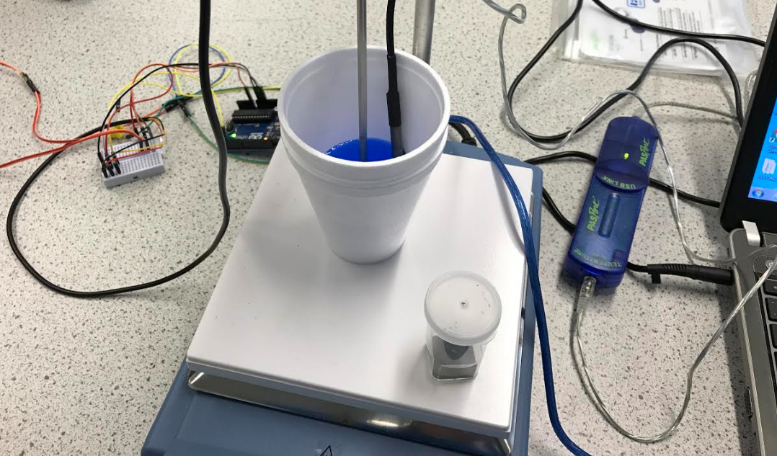
The temperature was recorded simultaneously with
Data logger system with temperature sensor (sampling rate = 1 sec)
Arduino System with temperature sensor (sampling rate = 1 sec)

Data Collected simultaneously by Data Logger with temperature sensor (sampling rate = 1 sec)
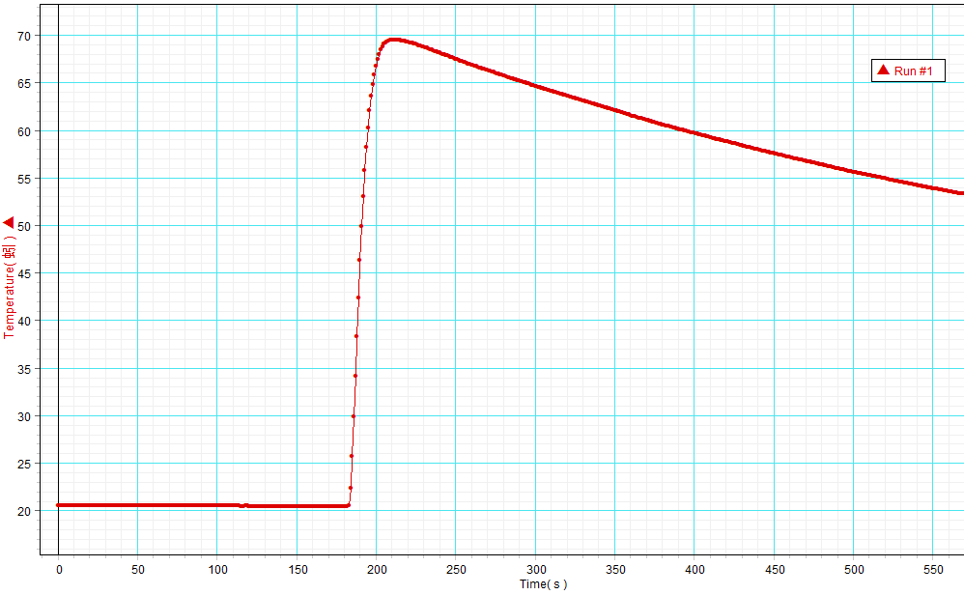

The enthalpy change of the above reaction recorded by Pasco Datalogger system was -212.88 kJ mol⁻¹. The enthalpy change recorded by Arduino System was -204.28 kJ mol⁻¹.

The theoretical value of the enthalpy change of the above reaction was -217 kJ mol⁻¹.

