Microscale Preparation and Testing of Propene

Aim
To prepare propene by dehydrating propan-2-ol using aluminum oxide as catalyst

Curriculum Link
Topic V Fossil fuels and carbon compounds

Apparatus and Equipment
- Glass dropper | x 1
- Spirit burner | x 1
- Delivery tube | x 1
- Water trough | x 1
- Rubber tubing | x 1
- Test tube with rubber stopper | x 3
- Wooden splint | x 1
- Forceps | x 1
- Retort stand and clamp | x 1

Chemicals
- propan-2-ol | 0.5 cm³
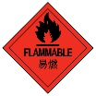  - Mineral wool | Small amount
- Aluminium oxide powder | 1-2 g
- 0.002 M acidified KMnO₄(aq) | 5 cm³
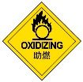  - 0.002 M aqueous bromine solution | 5 cm³

Safety precautions
- Wear safety goggles and disposable protective gloves.
- The solutions used are basic and harmful to skin and eyes. In case of spills, rinse the affected area with plenty of water for about 5 minutes.
- Do not dispose of chemicals by pouring down the drain, use the waste container provided.

Procedure
- Seal the tip of a glass dropper using a strong Bunsen flame. Allow the dropper to cool.
- Add some mineral wool to the sealed dropper, and then about 0.5 cm³ propan-2-ol liquid.
- Add about 1-2 g of aluminium oxide powder into the sealed dropper.
- Fill 3/4 of a water trough with water and then submerge 3 test tubes and 3 stoppers in it.
- Set up the experiment as shown in Figure 1. Use a spirit burner to heat the catalyst (aluminium oxide). Discard the first few cm³ of the gas produced.
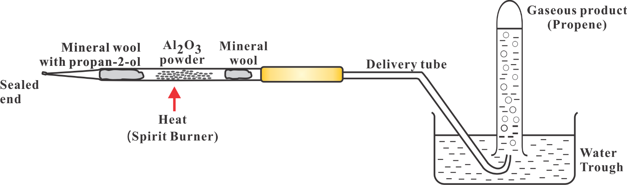
Figure 1
- Collect about 20 cm³ of the gas using a test tube and then seal the tube with a rubber stopper in water.
- Repeat step (6) twice using another two test tubes and stoppers.
- Test the gas in the test tubes with
  - acidified KMnO₄(aq),
  - aqueous bromine solution, and
  - a burning splint.
- Record and explain all the observations with the aid of chemical equations (with state symbols).

Reference:
https://www.youtube.com/watch?v=V66u-TPgKJ8 (Accessed on 9 February 2022)

Acknowledgement:
- Department of Chemistry, The Chinese University of Hong Kong
- Department of Chemistry, SKH Tsang Shiu Tim Secondary School

