Decomposition of Baking Soda

Aim
To determine the decomposition reaction of baking soda by experiment and stoichiometric calculation

Background
Sodium hydrogencarbonate (commonly called baking soda) is extensively used in many food products. Baking soda is used to prepare cakes in order to ensure that cakes “rise” as they bake. As the temperature of the cake mixture reaches approximately 50 ºC, the baking soda decomposes and carbon dioxide is released.

There are three possible chemical reactions that could be occurring during the baking process. All three of these reactions shown below are theoretically possible, yet only one reaction actually occurs.

Possible Decomposition Reactions
sodium hydrogencarbonate (s) → sodium hydroxide (s) + carbon dioxide (g)
sodium hydrogencarbonate (s) → sodium oxide (s) + carbon dioxide (g) + water (g)
sodium hydrogencarbonate (s) → sodium carbonate (s) + carbon dioxide (g) + water (g)

Curriculum Link
Topic III Metals

Safety Precautions
Conduct a risk assessment for this experiment, and summarise the key precautions below.

Materials and apparatus
Baking soda, 2g | Crucible
Electronic balance, 0.01g readability | Crucible tongs
Bunsen burner | Tripod
Pipe-clay triangle | Spatula

Procedure
- Measure the mass of the empty crucible.
- Place the empty crucible on the balance pan and then press the tare/reset button. Weigh accurately about 2.00g of baking soda into the crucible.
- Place the pipe-clay triangle on top of the tripod and place the crucible containing the baking soda on top of the clay triangle.
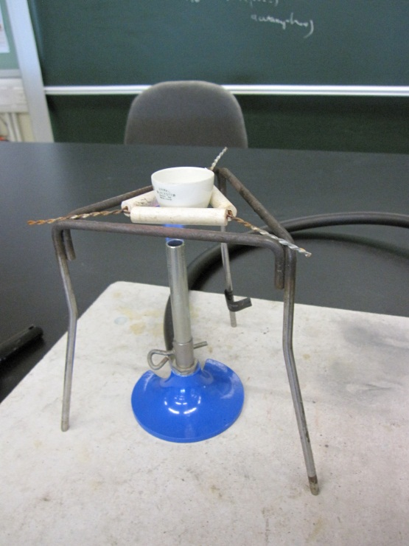
- Heat the crucible and its contents with the Bunsen burner for 5 minutes. Use a spatula to carefully break up any “clumps” that form during heating. Note that clumps need to be broken only once during heating.
- Measure the mass of the crucible and its contents after cooling the crucible.

Data analysis
- Mass of empty crucible = __________________

Mass of crucible and baking soda = __________________

Mass of the baking soda before heating = _____________

Mass of the contents in the crucible after heating = ___________________
- Write the balanced chemical equations for the three possible decomposition reactions of sodium hydrogencarbonate.

sodium hydrogencarbonate (s) → sodium hydroxide (s) + carbon dioxide (g)

sodium hydrogencarbonate (s) → sodium oxide (s) + carbon dioxide (g) + water (g)

sodium hydrogencarbonate (s) → sodium carbonate (s) + carbon dioxide (g) + water (g)

- Calculate the masses of the solid products of the three reactions above. (Relative atomic masses: Na = 23.0, O = 16.0, C = 12.0, H = 1.0)

- Deduce and confirm the decomposition reaction of sodium hydrogencarbonate.

5. Sodium hydrogencarbonate is used as baking powder for making cake. Based on this information and the products of the suggested equations, which reaction(s) is/are not possible? Explain your answer.

