S4-5 Geography
Curriculum Support Materials

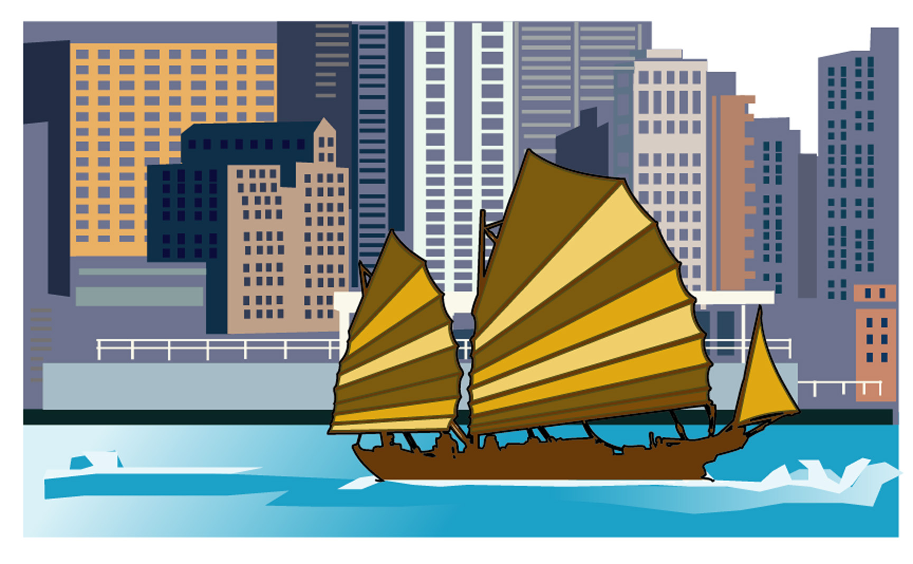

Hong Kong –
Changing towards Sustainable Development

Hong Kong – Changing towards Sustainable Development
☒ Notes for teachers ☒

This worksheet can be used for the teaching and learning of:
- Theme: City; and
- Issue: Sustainable City

The design of this worksheet has two main focuses. Firstly, an exemplar of integrating fieldwork activities into the teaching of geographical concepts is provided. Besides, this worksheet also serves to illustrate how generic skills (collaboration and communication skills) could be developed through various group activities (such as role play, group discussion and group presentation). Details of these focuses are shown in the following table:

Focus | Related part(s) in the worksheet
1. Integration of fieldwork activities into the teaching of geographical concepts | - Part A 1. Fieldwork—Urban encroachment in Tsuen Wan (P.2-11)  [Details: In this part, fieldwork activities about urban encroachment can be found]
2. Development of generic skills (collaboration and communication skills) | - Part A 1. Fieldwork—Urban encroachment in Tsuen Wan (P.2-11)  [Details: In this part, group activities include fieldwork and presentation.]  - Part B 1. Group Discussion Activity—Impact of urban encroachment and urban renewal (Using Tsuen Wan as an example) (P.14-16)  [Details: This is a group discussion activity for the development of communication and collaboration skills.]  - Part B 2. Conflict between environmental conservation and economic development in Hong Kong—Case studies for role play / discussion. (P.16-28)  [Details: In this part, two case studies (‘Tung Chung cable car project’ and ‘The railway project across the Long Valley Wetlands’) can be used for group activities like role play or discussion.

Part A The contents of student worksheets

Contents |  | Page(s)
Part A  Case Study—Urban encroachment and urban renewal in Tsuen Wan | - Fieldwork—Urban encroachment in Tsuen Wan  - Urban Renewal in Tsuen Wan | 1-11  12-13
Part B  Impact of urban development in Hong Kong | - Group Discussion Activity—Impact of urban encroachment and urban renewal (Using Tsuen Wan as an example)  - Conflict between environmental conservation and economic development in Hong Kong  - Case Study (A) Tung Chung cable car project  - Case Study (B) The railway project across the Long Valley Wetlands | 14-16  16-28  17-22  23-28
Part C  Turning Hong Kong into a sustainable city | - Developing Hong Kong into a sustainable city  - Urban planning and the environment  - The role of individual citizens | 29-33  33-35  36

Part B Teaching objectives of this worksheet

Through the activities in this worksheet, students should be able to:

Knowledge/concepts:
- describe the processes and characteristics of urban encroachment and urban renewal in Hong Kong;
- identify the socio-economic and environmental impacts of urban encroachment and urban renewal in Hong Kong;
- understand the conflict between environmental conservation and economic development in Hong Kong;
- describe the characteristics of a sustainable city;
- give suggestions on how to develop Hong Kong into a sustainable city.

Skills:
- develop collaboration and communication skills;
- extract and analyze geographical information from various sources, e.g. newspaper clippings, photos, video clips, maps and websites.
- draw land use maps
- develop a simple town plan based on principles of sustainable development
- make decision according to some principles and analyze the reasons for supporting and objecting a development project;

Values/attitude:
- develop sensitivity to the development of our surrounding environment and the problems arising from it;
- develop a sense of responsibility and willingness to take actions in protecting and improving our urban environment.

Part C Notes for teachers
* When using the following notes, please refer to the relevant part(s) in the student worksheets.

1. Part A, 1 (P.2-11) of the student worksheets (Fieldwork—Urban encroachment in Tsuen Wan)

a) Information about the Sam Tung Uk Museum:
- For information about the opening hours, address, transportation and guided tours of the Sam Tung Uk Museum, teachers may browse the following website:
The Hong Kong Heritage Museum
http://www.heritagemuseum.gov.hk/english/branch_sel_stu_c.htm

- Enquiries:
  - Telephone number: 2411 2001
  - Fax number: 2413 9271

b) Procedure of the fieldwork:

i) Pre-trip Preparation:
Teachers should:
  - decide the number and location of the check points for the fieldwork;
  - divide students into groups (about 4-5 students in one group);
  - conduct a pre-trip to the proposed fieldwork site. In this way, the fieldwork can be planned properly and all potential hazards can be realized and assessed.

ii) Briefing before the fieldwork:
Teachers should:
  - distribute all necessary fieldwork materials (e.g. worksheets) to students:
  - introduce the objectives and details (e.g. background knowledge, skills and equipment) of the fieldwork to students;
  - explain rules of behaviour and clothing about the fieldwork clearly;
  - show some photographs / slides (e.g. the HTML file—‘Changes in Tsuen Wan’) to students to give them some background information about the check points of the fieldwork.
iii) During the fieldwork:
Teachers should:
  - carry out the fieldwork according to the predetermined steps
  - pay attention to the safety of the students.

iv) Follow-up / consolidation after the fieldwork:
Teachers should:
  - organize one to two classroom lesson(s) to help students to analyze fieldwork data;
  - encourage students to discuss their fieldwork data during the lesson;
  - ask students to prepare their group presentations. The presentation could be a verbal report, aided with posters, photographs, diagrams and sketches.

v) Evaluation:
  - Both student evaluation and teacher evaluation should be conducted to collect feedback about the fieldwork.
  - Teachers should check whether the original objectives of the fieldwork have been achieved. Suggest possible areas of improvement for further reference.

c) Other fieldwork location:
In this set of worksheets, Tsuen Wan has been chosen as a case study for fieldwork. However, other fieldwork location may be chosen by teachers in different districts to suit the needs and interests of students of different schools.

2. Part B (P.14-28) of student worksheets (Various group discussion activities)

＜Guidelines for organizing group discussion activities＞

The following guidelines are suggestions for teachers to organize effective group discussion activities in their geography lessons. They are applicable in Part B of student worksheets.

Group discussion in a classroom may include the following stages:
Stage | Points to note
1. Before the discussion | Teacher should:  - divide the class into several small groups to facilitate effective communication between members of groups (e.g. 5 students in a group). Suitable group size is important as a large group size will affect the effectiveness of group discussion;  - arrange the students to sit in certain patterns, e.g. in a circle. This facilitates effective communication (including body language and eye-contact) among group members;  - pay attention to the behavioural problems and disruption, especially during the transition from a whole class to small groups;  - assist each group to select a group leader and a recorder for the discussion. This helps to improve the organization of the discussion activity;  - give students clear instructions about the discussion;  - train students about the skills and attitudes of group discussion;  - provide students with background information about the issue for discussion. This helps them to understand more about the issue before discussion;  - give some guiding questions to each group for discussion. This helps them to concentrate / focus on the important points about the issue.

Stage | Points to note
2. During discussion | Teacher should:  - provide each group some transparencies / paper to write down their key points;  - promote active discussion among group members;  - move around the groups to see if any student need help.
3. During group reporting | A teacher should:  - encourage all students to participate;  - encourage students to ask questions about the issue;  - invite students to respond to the questions raised by other students;
4. After group reporting | Teachers should:  - summarize the points raised by different groups;  - point out the strengths and weaknesses in their reports;  - encourage students to think more about the issues;  - conduct an evaluation session for students to reflect their performance during group discussion

3. Part B2 (P.16-28) of the student worksheets (Conflict between environmental conservation and economic development in Hong Kong)

  - In this part, teacher may choose ONE of the case studies for students to investigate,
OR
  - Teacher may ask half of the class to do case study A and the other half to do case study B.

4. Part B2 Case study (B) (P.23-28) of the student worksheets (The railway project across the Long Valley Wetlands)

The construction of the Sheung Shui-Lok Ma Chau Spur Line of the Kowloon-Canton Railway Corporation (KCRC) was transformed into a controversial issue some years ago. After finishing the related activities in the worksheets, teachers may help their students to know more about the current situation of the proposed Lok Ma Chau Spur Line. The following website may give useful information about this:

Website: http://www.kcrc.com/ Kowloon-Canton Railway Corporation
[In this website, choose ‘New Projects’, ‘East Rail Extensions’ and then  ‘Lok Ma Chau Spur Line’.]

5. Part C2 (P.33-35) of the students worksheets (Urban planning and the environment)

- In this part, students are encouraged to design their own ‘sustainable’ cities freely. If they have problems, teachers may use the following resources to give them more guidelines.
- After students finish designing, teachers may give the following information to the students and ask them to compare their designs with that of the government. Based on the concepts of sustainable development, find out the pros and cons of each of the plans.

Information about the proposed ‘green’ new town
Kwu Tung North
- Planning Department Website: http://www.info.gov.hk/planning/index_e.htm
- 〈環保新城 目標難達〉，《大學線》 2000年2月，頁10-11。

Information about the redevelopment plan of
former Kai Tak Airport
- Apple Daily, 25 May 2000.
- Oriental Daily, 25 May 2000.
- A map of ‘The proposed South East Kowloon Development’ (http://www.hktrader.net/200203/200102/200102s6.htm)
- Press Release - Draft Kai Tak (North) and Kai Tak (South) Outline Zoning Plans approved (http://www.info.gov.hk/gia/general/200207/05/0705245.htm)

Part D References / Teaching resources for this worksheet

A) Books and magazines:
- Johnson, E., (2000). Recording a rich heritage: research on Hong Kong’s “New Territories”. Hong Kong: Leisure and Cultural Services Department.
2. Satterthwaite, D. (Ed.), (1999). The Earthscan Reader in Sustainable Cities. UK and USA: Earthscan Publications Ltd.
- Wong, O.Y., (1996). Environmental Conservation and Planning: Hong Kong and Overseas Encounters. Hong Kong: Woods Age Publishers.
- Yeh, Gar-On, (1996). Planning Hong Kong For The 21st Century. Hong Kong: Centre of Urban Planning and Environmental Management, University of Hong Kong.
- 香港文化博物館編製：《教育活動小冊子—萬花筒 荃灣今昔》(2003)。香港：康樂及文化事務署。
- 許舒博士著：《滄海桑田話荃灣》（1999）。香港：滄海桑田話荃灣出版委員會。
- 勞炯基、蔡穗聲著：《香港城市建設與管理》（1992）。香港：中華書局（香港）有限公司。
- 劉潤和著：《新界簡史》(1999)。香港：三聯書店（香港）有限公司。
- 鄭宇碩著：《變遷中的新界》(1986)。香港：大學出版有限公司。
- 鄭寶鴻著：《新界街道百年》（2002）。香港：三聯書店（香港）有限公司。
- 薛鳳旋著：《香港發展地圖集》（2001）。香港：三聯書店（香港）有限公司。

B) Newspapers:
- Apple Daily (19 February 2000, 25 May 2000, 13 July 2002, 22 July 2002, 27 July 2002)
- Oriental Daily (19 February 2000, 25 May 2000, 27 October 2000, 4 July 2002)

C) Websites:
- Sustainable City (http://www.sustainable-sf.org/)
- Environmental Protection Department (http://www.epd.gov.hk/epd/)
- SUSDEV21 Public Consultation Report (http://www.info.gov.hk/planning/p_study/comp_s/susdev/report/e_index.htm)
- Urban Renewal Authority (http://www.ura.org.hk/)
- Hong Kong Bird Watching Society - Save Long Valley (http://www.hkbws.org.hk/lvalley/intro.html)
- Planning Department (http://www.info.gov.hk/planning/index_e.htm)
- A map of ‘The proposed South East Kowloon Development’ (http://www.hktrader.net/200203/200102/200102s6.htm)
- Press Release - Draft Kai Tak (North) and Kai Tak (South) Outline Zoning Plans approved (http://www.info.gov.hk/gia/general/200207/05/0705245.htm)

