S4 – 5 Geography
Curriculum Support Materials

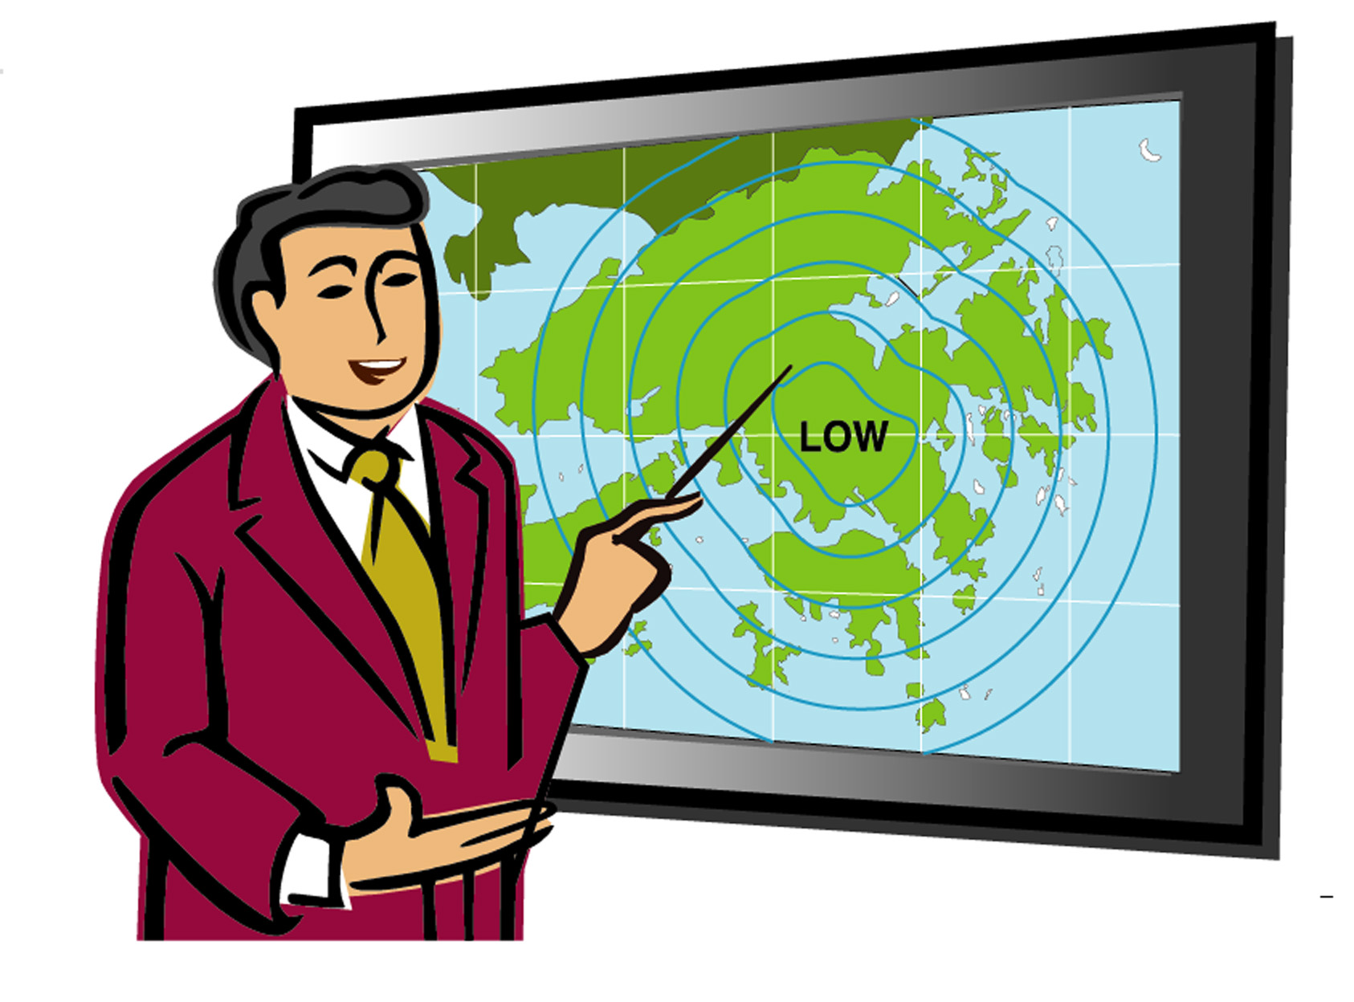

Climatic Anomalies and Climate

Climatic Anomalies and Climate
☒ Notes for teachers ☒

This chapter can be used in the teaching of:

- Theme: Climate; and
- Issue: Climatic anomalies

Part A Contents of students’ worksheet

Contents of students’ worksheets | Page(s)
Part A What is global warming? Which area will be affected? | 1 – 4
Part B How and why are there differences in temperature pattern? | 4 – 9
Part C To what extent do human beings lead to global warming? | 10 – 13
Part D What can be done to alleviate this problem? | 13 – 15

Part B Teaching objectives of this chapter

After studying this chapter, students should be able to:

Knowledge
- Understand the meaning of global warming and its effects to us and the environment;
- Describe the latitudinal difference in temperature between low-latitude region and high-latitude region;
- Relate such latitudinal difference in temperature in relation to the distribution pattern of insolation;
- Explain the causes of global warming in relation to human activities;
- Understand the role played by different parties in causing such problem;
- Suggest solutions to such problem and evaluate their effectiveness.

Skills
- Interpret information from climatic maps, graphs and diagrams;
- Collect information through library search or internet;
- Compare the global distribution pattern of insolation and temperature;
- Write report by analyzing data from graph;
- Develop interviewing skills, presentation skills and communication skills.

Values
- Show concern for global warming and develop a sense that the problem can only be solved by international co-operation;
- Understand the dilemma and conflict of interest among countries in solving this problem.

Part C Explanatory notes

Part | Explanatory notes
A | By conducting a small project on the temperature change in Hong Kong in these 10 – 40 years, students can realize that global warming is happening around them.  The aim of this role play is to let students have the chance to gather information from library or the Internet to find out the effects of global warming. So teachers must give students enough instructions and time to gather information to perform the role play.
B | In Part A, the problem of global warming has been discussed and Hong Kong and China are also affected by such problem. Therefore, by interpreting climatic graphs of Harbin, Qingdao, Hong Kong and Kuala Lumpur and the map of global insolation, students can know the normal temperature pattern of these places and understand why places at different latitudes have different temperature patterns.  (**Teachers can extend this part to teach the other factors that will affect temperature of different areas on the same latitude and the other factors that affect the other climatic characteristics of this place.)
C | By doing the experiment, students can understand the mechanisms behind global warming. In order to enhance the result of the experiment, teacher can place a piece of black paper under the box so that the temperature difference can be greater. The lamp should also be turned on before the lesson so that the result can be seen during the lesson.  Information about the sources and amount of greenhouse gas can be obtained from the following website:  http://yosemite.epa.gov/oar/globalwarming.nsf  http://www.epd.gov.hk  http://www.panda.org  http://www.ieagreen.org.hk  http://www.ghgoline.org
D | The aim of the role play is to let students have a chance to think of the solutions to the problem of global warming from different perspectives. It is hoped that they can experience the difficulties and conflict of interest behind different roles. Values can be developed through discussion.  For details on how to conduct role play, please refer to part D.

Part D Guidelines on conducting role play

In this set of worksheets, there are two role plays – Part A (P.3 - 4) and Part D (P.13 - 15). The aims of these two role plays are as follow:

Role play of Part A, P.3 – 4
- To train students how to gather information from library or internet
- To find out the effects of global warming.

Role play of Part D, P.13 – 15
- To think of the solutions to the problem of global warming from different perspectives.
- To experience the difficulties and conflict of interest behind different roles.

In order to achieve the objectives of these role plays, the following must be borne in mind:

- Preparation:
  - Grouping of students can be voluntary but sometimes teachers can assign specific groupings depending on the abilities of students. Usually a group of four is suitable for discussion.
  - Students must be given enough time to read through the information or gather information beforehand.
  - Teacher may need to assist students when gathering information, such as how to search information from the Internet or library.
  - Avoid preparing everything for them but enough instructions must be given.

- During the discussion:
  - Students must be reminded of the focus of their discussion and the role that they are playing.
  - Teacher should remind the groups to assign one student to be the secretary and one be the presenter.
  - Teacher should walk around to offer help and to make sure they are discussing the matters of the role play.
  - Students must be given the chance to present their ideas.

- After the presentation:
  - Teacher must make conclusion on what they have discussed.
  - Wrong ideas or misconceptions must be corrected.
  - Teacher must also point out the dilemma of every problem and bring out the values of this issue.

Part E References / Teaching Resources for the chapter

Books

  - Briggs, D & Smithson P. (1987) Fundamentals of Physical Geography, Hutchinson Education
b) Garlick J. (ed.) (1996) Atlas of Earthcare, Gaia Books Ltd.
c) Kemp D.D. (1994) Global Environmental Issues, Routledge
d) Warburton P. (1997) Atmospheric Processes and Human Influences, Collins Educational
e) Waugh D. (1998) The New Wider World, Thomas Nelson & Sons Ltd.
2. Websites
Address | Name of Homepage | Details
a)http://www.hko.gov.hk/ contente.htm | Hong Kong  Observatory | Except weather reports and forecast, there are lots of educational resources in this homepage of Hong Kong Observatory. Newspaper articles by Hong Kong Observatory, various topics and instruments about meteorology, and a virtual tour of Hong Kong Observatory’s Exhibition Hall can be found here.
b) http://www.underground.org.hk/ | Weather Underground of Hong Kong | Lots of weather maps, satellite images and links related to weather and climate can be found in this resourceful website. There is also a ‘Weather Discussion Forum’ for people to discuss about current issues of weather.
c) http://www.weatherbase.com | Weatherbase | This website contains weather data of the world, such as temperature and precipitation, for teaching and learning.
d)http://www.planetholiday.com/ asia/malaysia/ malaysia_climate.asp | Climate & Weather Reports for Malaysia | There are climatic graphs and weather reports of some selected Malaysian cities for teaching and learning.
e) http://www.cma.gov.cn | China Meteorological Administration | In this website, information about weather and climate of China and other parts of the world can be found.
f)http://www.epa.gov/ globalwarming | US Environmental Protection Agency | It provides information on the causes and impacts of global warming, the sources of greenhouse gas emission and the actions that can be taken.
g) http://www.panda.org/climate | World Wildlife Fund | It provides information on the effects of global warming and the kind of projects that WWF has done to lessen such problem

