S4-5 Geography
Curriculum Support Materials

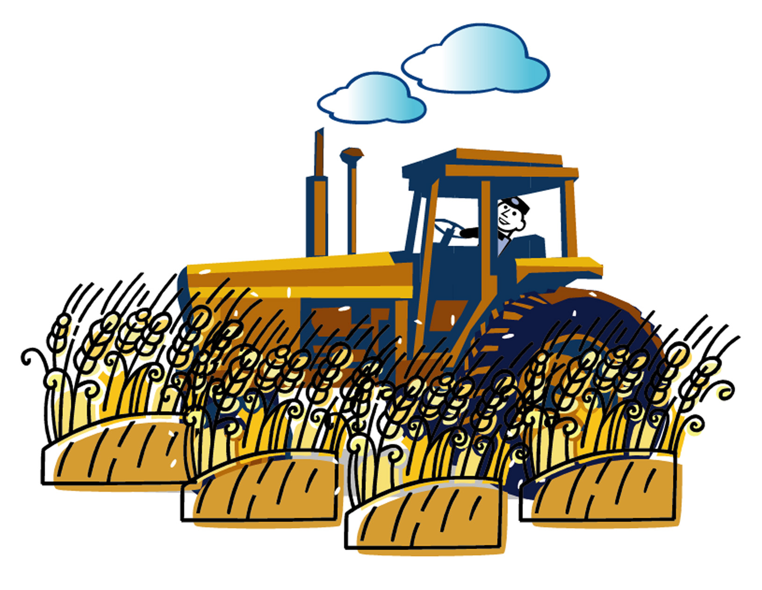

Agriculture and

food supply

Agriculture and food supply
✓ Notes for Teachers ☑

This worksheet package can be used for the teaching and learning of:
- Theme: Agriculture; and
- Issue: Food and Hunger.

The focus of this worksheet package is to integrate the development of geographical values and attitudes in the learning of geographical concepts. To many educators, it is difficult to assess students’ value development. As such, this worksheet package serves as an exemplar of value education in geography. In this package some suggested grading criteria about the assessment of students’ value development are provided for teachers’ reference.

Focus | Related part(s) in the worksheet
1. Learning geographical concepts | P.1-24 of student worksheet  Students can learn about the concepts of agricultural systems and famines systematically.
2. Development of values and attitudes | P.25-26 of student worksheet  This part is about making donation international aid organizations and is aimed at helping students’ values development.

Part A Contents of the Worksheets

Contents | Page(s)
Part A Famine | 1-7
Part B The agricultural systems of Sahel and Southern California | 8-21
Part C Negative impacts of agricultural technology to the environment | 22-24
Part D Donation | 25-26

Part B Learning Objectives

After finishing this worksheet package, students should be able to:

Knowledge/concepts
- analyze the major causes of famines in Sahel;
- relate the problem of famine and food supply in Sahel to the agricultural system and technology level of the region;
- identify the major inputs, processes and outputs of various agricultural systems;
- describe and explain the varying agricultural characteristics in Sahel and Southern California even though their natural environments are very similar;
- understand how to use agricultural technology to overcome some agricultural constraints;
- evaluate the negative impacts of agricultural technology in Sahel and Southern California and suggest measures to alleviate these impacts on the environment;
- know more about the meaning of international aids.

Skills
- extract and analyze geographical information about agriculture and food supply from various sources, e.g. websites, maps and news clippings;
- engage in decision-making process and analyze the reasons and rationale behind various choices.

Values/attitude
- be aware of the advantages, disadvantages and limitation of agricultural technology;
- show concern about difficulties encountered by people in other areas, and take action to help them.

Part C Notes to Teachers

1. Part A, 5a and b (P.4-5) of the student worksheet (Famine: a Natural or Human-induced Disaster? — A case study of Ethiopia)

Teachers may get more information about the characteristics of agriculture in Ethiopia in the following website:

FEWS Information on The Greater Horn of Africa
http://www.fews.org/horn/fewshorn.html

2. Part C (P.22-24) of the student worksheet (Negative Impacts of Agricultural Technology to the environment)
Besides negative impacts of agricultural technology, teachers may ask students to think about the positive impacts of agricultural technology to the environment too. The website below provides information about the positive impacts of irrigation farming in California to the natural environment here. Teachers may provide the information for student discussion.

CFWC Water Fact Book: California Agriculture and Its Use of Water
http://www.cfwc.com/factbook.html

*P.32 to 33 of the book are about the positive impacts of irrigation farming in California to its natural environment.

3. Part D (P.25-26) of student worksheet (Donation)

This part is about assessing students’ cognitive understanding of values and attitudes. Some suggested grading criteria are shown below for teachers’ reference.

Level | Suggested grading criteria
High | - In a complex situation, a student shows compassion / principled action in his / her answers.  - In his / her answers, a student shows his / her consideration about different cultural values and knowledge of the world.  - A student can show consideration on both sides of a situation / an argument in his / her answers.
Medium | - In a simple or familiar situation, a student shows compassion in his / her answers.  - A student chooses to follow the rules or do the ‘right things’ in his / her answers.  - In his / her answers, a student only focuses on one side of an issue / argument.  - In a complex situation, a student only gives very literal response.
Low | - In his / her answers, a student sees no dilemma about an issue / argument.  - In a simple situation, a student only gives very literal response.

4. Extended activities after finishing the worksheet

After studying the agricultural systems of Sahel and Southern California, teachers may ask their students to apply what they have learnt to the case of Hong Kong. Students may be asked to do the following tasks:

  - Draw a diagram to show the inputs, processes and outputs of a major agricultural system of Hong Kong (e.g. market gardening);
  - Identify the constraints on farming in Hong Kong;
  - Conduct a visit to a local farm to find out more about the use of agricultural technology in Hong Kong

The following websites may provide useful information about farming in Hong Kong for teachers’ reference:
- Kadoorie Farm and Botanic Garden
http://www.kfbg.org.hk
- Agriculture, Fisheries and Conservation Department
http://www.afcd.gov.hk/index_e.htm

Part D Reference

1. Books
- California Farm Water Coalition, The Water Fact Book—California Agriculture and Its Use of Water, retrieved from the World Wide Web Site: http://www.cfwc.com/factbook.html.
- Leisinger, K.M., Schmitt, K. and the International Service for National Agricultural Research (ISNAR) (ed.), Survival in the Sahel—An ecological and developmental challenge, retrieved from the World Wide Web Site: http://www.isnar.cgiar.org/publications/books/sahel/english/intro.htm.
- MacDonald, D. and Archer, M., (1993). Aspects of Applied Geography—Rural land degradation. Britain: Hodder & Stoughton.
2. Websites

(a) Websites about famine in the world
- African Studies
http://www.usg.edu/galileo/internet/area/africa.html
- BASIS Publications—Greater Horn of Africa http://www.wisc.edu/ltc/baspubhrn.html
- Famine Early Warning System Network
http://www.fews.net
- FEWS Information on The Greater Horn of Africa http://www.fews.org/horn/fewshorn.html
- International Famine Centre Homepage
http://www.ucc.ie/famine/
- Oxfam Hong Kong Cyber School http://www.oxfam.org.hk/chinese/cyberschool/c-topics01.htm

(b) Websites about famine in Ethiopia
- Deforestation is fuelling environmental deterioration and famine in Ethiopia http://www.etff.org/dec1205deforstation.htm
- Ethiopia: Famine, War, and environmental Destruction http://www.sidamaconcern.com/articles/ethiopia_famine_war.htm
- Uprooting the root causes of famine in Ethiopia http://dekialula.com/articles/dr_g_araia5.html
- War aggravating famine in Ethiopia-DAWN-International; 27 April, 2000 http://www.dawn.com/2000/04/27/int12.htm

(c) Websites about irrigation farming in California
- California Farm Water Coalition
http://www.cfwc.com/
- Fresno Valves & Castings, Inc.
http://www.fresnovalves.com/index.html
- Irrigation Training and Research Centre
http://www.itrc.org/index.html

(d) Website about Salinization and farming
- Salinization
http://oregonstate.edu/instruct/bi301/saliniz.htm

(e) Website about farming in Hong Kong
- Kadoorie Farm and Botanic Garden
http://www.kfbg.org.hk
- Agriculture, Fisheries and Conservation Department http://www.afcd.gov.hk/index_e.htm

