Worksheets - Plate tectonics, natural hazards and Taiwan:

Name: _____________________ ( ) Class: _________

This chapter can be used for the learning of:
1. Theme: Landform and Endogenetic Processes; and
2. Issue: Natural Hazards

Scenario:
At about 1:30am of 21 September 1999, you were chatting online with your cousin, Leo, who lived in Tai-chung, Taiwan. Suddenly, your communication was terminated and you couldn’t even give him a phone call since the telephone network in Taiwan was out of order. Break-in news on TV (The video clip – ‘The disaster in Taiwan’) said that there was a disaster in Taiwan. You were so worried about their situation under this disaster. For this reason, you read some newspaper articles later.

Part A The natural hazard in Taiwan (21 September 1999)

1. Look at the video clip – ‘The disaster in Taiwan’. What happened in Taiwan on 21 September 1999?

2. a) With the help of the following photos and information which you found from XX Daily of 22 September 1999, list the catastrophic effects of the natural hazard in Taiwan (21 September 1999).

XX Daily 22 September 1999

Strongest in this decade
It was calculated that the energy released from this disaster is equal to the explosion of 38 nuclear bombs…

Newspaper cutting 1

Chips industry was severely hit
It was predicted that the economic loss caused by this disaster was up to 23.8 billion Hong Kong Dollars. The information technology industry, especially the chips production plants, suffered from huge loss due to destruction of machineries and failure of electricity supply. Since Taiwan’s production on IC chips accounts for 50 percent of the world’s total, the price of chips is expected to rise sharply…

Newspaper cutting 2

Casualty Report in Brief
Highest numbers of causalities were concentrated in Taichung City and the counties of Nantou and Taichung, where each area had more than a hundred people died and more than a thousand injured. In contrast, Hsinchu City and the counties of Chiayi and Hsinchu had the lowest numbers of causalities—less than ten people injured…

Newspaper cutting 3

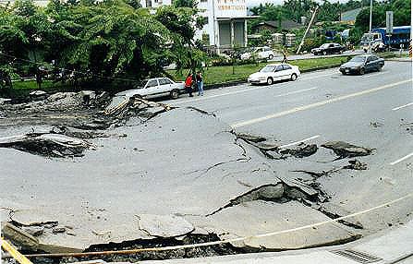 Photo 1

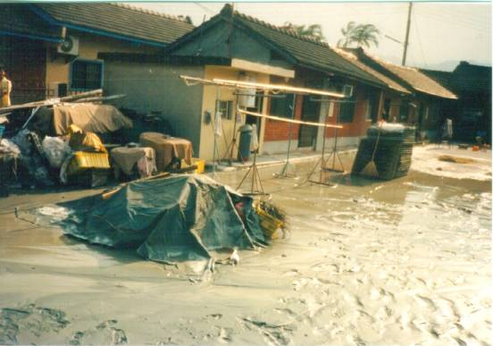 Photo 2

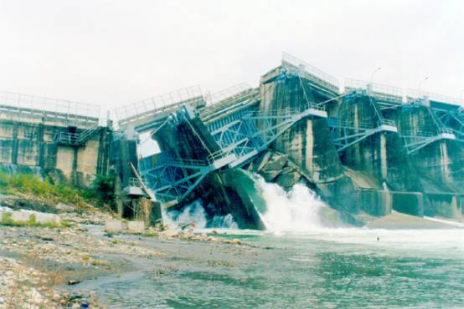 Photo 3

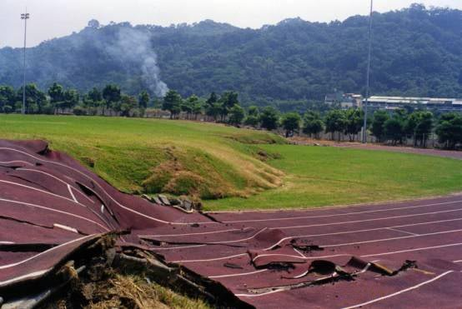 Photo 4
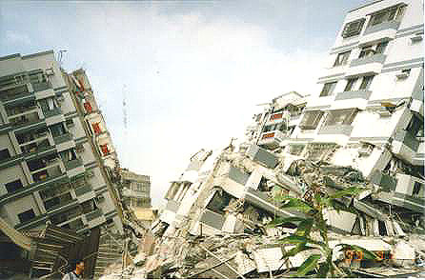 Photo 5

(Source of the photos:
經濟部中央地質調查所全球資訊網 [921地震地質調查報告—照片3.2-04, 3.9-22及6.1-03] [現場照片集Photos1及Photos2]
Date of retrieval: 7 December 2002
http://www.moeacgs.gov.tw/geomain.asp)

b) Besides those shown in the newspaper cuttings and photos above, describe some other effects of the disaster in the spaces below.

Part B Plate tectonics and the resultant landform features of plate movements

Scenario:
On 22 September 1999, you had two geography lessons and ‘Plate tectonics’ was the topic for learning. The exercises below were what you did during the lessons.

1. The jigsaw puzzle on P.23 is a plate tectonics map. Cut out the pieces (plates), re-arrange and paste them on Map 1 below.

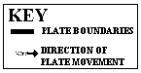 Map 1 Plate tectonics of the world.

2. On Map 1, shade the three different types of plate boundaries around Pacific Ocean with the following colours:

Destructive plate boundary | Red
Constructive plate boundary | Blue
Conservative plate boundary | Green

3. Around the Pacific Ocean, there are three types of plate boundaries. Give ONE example for each.

Type of plate boundary | Example
1. Destructive
2. Constructive
3. Conservative

4. Plate tectonics, folding and fold mountains:
a) Visit the following website about the Himalayas. Then answer questions 4b) to d) below.
- http://library.thinkquest.org/10131/javascriptmenu_final.html | Destination: Himalayas – Where Earth Meets Sky

- Shade the location of the Himalayas on Map 1.

c) In the following table, fill in the names of the two moving plates which cause the formation of the Himalayas. Then, circle the type of plate for each.

Name of the plate | Type of the plate  (Circle the correct answer)
1. | continental / oceanic
2. | continental / oceanic

d) With the help of the information in the website above, describe and explain the formation of the Himalayas.

e) Visit the following websites about the Andes and answer questions 4f) to i) below.
- http://www.ecuador-travel.net/tour.climbing.gallery.htm | Andes mountain picture gallery
- http://www.peakware.com/encyclopedia/ranges/andes.htm | Peakware – Andes Mountain Range

f) Shade the location of the Andes on Map 1.

g) According to the photos in the websites, describe the appearance of the Andes.

h) Circle the correct answer:
i) Is the appearance of the Andes similar to the Himalayas? (Yes / No)
ii) Both the Andes and the Himalayas belong to the same type of fold mountain. They are (young / old) fold mountains.

i) Although they belong to the same type of fold mountain, there are some differences in their formation. Complete the table and outline the differences in the spaces below.

Names of the moving plates which cause the formation of the Andes | Type of the plate  (Circle the correct answer)
1. | continental / oceanic
2. | continental / oceanic

- Plate tectonics, vulcanicity and volcanoes:
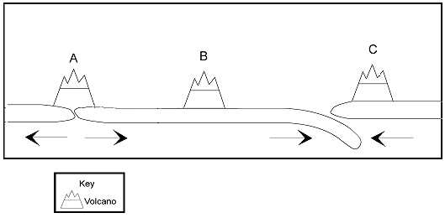
Figure 1 Volcanoes at different locations.
a) Give an example of A, B and C in Asia-Pacific Region respectively.
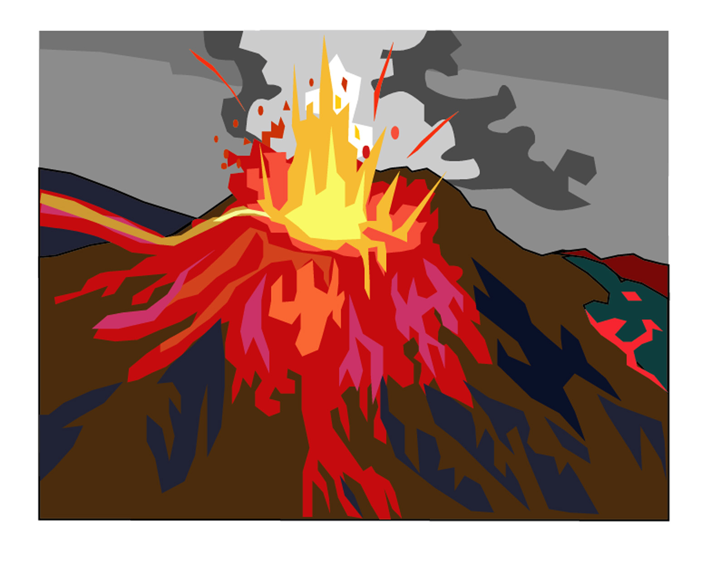
Volcano | Example
A
B
C

b) Fill in the blanks:
______ and ______ are volcanoes formed along plate boundaries. However, ______ is a volcano formed at the interior / center of a plate. It is called a ________________ volcano. Hawaii is an example of this.

c) Describe and explain the formation of volcanoes A and C respectively.

d) Many volcanoes of the world are composite cones. Draw an annotated diagram to show the characteristics of this type of volcano.

Caption: __________________________________________________
Part C Taiwan, plate tectonics and natural hazards

Scenario:
After the lessons, you went to ask your geography teacher about the relationships of plate tectonics and Taiwan. Your teacher discussed the following with you.

1. Find the location of Taiwan and plot it on Map 1.

2. According to the information of Map 1, fill in the blanks below.
Taiwan is located near the ________________ plate boundary between _______________ plate (Plate A) and ________________ plate (Plate B).

3. Assume Plate A collides with Plate B., what will happen then? Which plate will subduct beneath the other? With the help of Table 1, finish drawing the annotated diagrams (b to c) below to show this process of plate movement and its resultant landform features (volcano, sea trench and fold mountain). Besides, circle the correct answer in diagram b and give explanation for diagram c.

Types of crust | Average density (kg/cubic meter)
1. Oceanic crust | 2.9
2. Continental crust | 2.7
Table 1

- Plate A and Plate B are moving towards each other:

Plate A Plate B

b) Plate A is a/an (continental/oceanic) plate and Plate B is a/an (continental/oceanic) plate. Therefore, (Plate A/Plate B) will subduct beneath the other.

c)

Caption: ___________________________________________________________

4. Examples of resultant landform features of plate convergence near Taiwan:
Refer to Map 2 and answer the following questions.
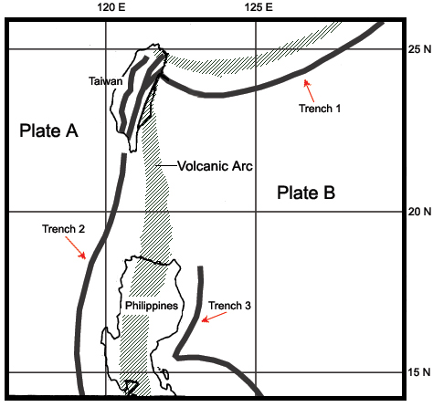
Map 2 Plate tectonics of Taiwan.

a) With the help of your atlas / textbook, name trenches 1, 2 and 3 (Map 2).
Trench 1
Trench 2
Trench 3
- Which of the following volcano(s) is/are located along the volcanic arc of Map 2? Use your atlas and put  or  in each of the boxes below.

White Island

Mt. St. Helens

Kuei-Shan-Tao
Mt. Pinatubo

Tatun Volcano

- In terms of locations, describe and explain the relationships between plate boundaries, trenches and volcanic arcs in Map 2.

5. Natural hazards in Taiwan:
* With what you have learnt about plate tectonics above, list the natural hazards that you think you may find in Taiwan.

6. Summary:
* Now, write a short summary to conclude why Taiwan is a tectonically active area and why there is a disaster in Taiwan on 21 September 1999 in about 50 words.

Part D The selection of a new house

Scenario:

On 23 September 1999, as the telephone network in Taiwan was re-connected, you could contact your cousin. He told you that his house was badly damaged after the disaster. So, your aunt wanted to buy a new house. As she knew you were a geography student, she asked you to choose the location of the new house for her. The only requirement is to choose an area which is relatively safe from tectonic activities and catastrophic natural hazards.

With reference to your aunt’s requirement for the new house, you tried to study the following information in the library.

1. Faulting and earthquakes in Taiwan

a) Plot the locations of the major catastrophic earthquakes of Taiwan (Table 2) on Map 3 below. Follow the symbols in the key. ‘921 Chi-Chi Earthquake’ has been plotted on the map as an example.
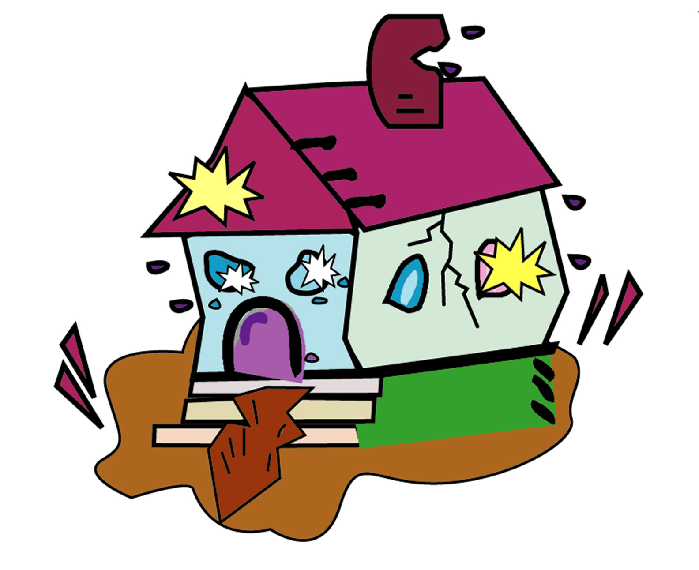
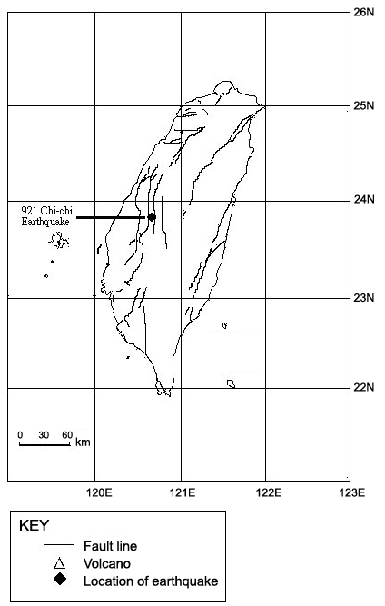

Map 3 The distribution of active faults, earthquakes and volcanoes in Taiwan.

Name of the earthquake | Date | Location of the epicenter |  | Magnitude
Name of the earthquake | Date | (N) | (E) | Magnitude
1. Touliu Earthquake (斗六地震) | 6-11-1904 | 23.58 | 120.25 | 6.1
2. Meishan Earthquake (梅山地震) | 17-3-1906 | 23.55 | 120.45 | 7.1
3. A series of earthquakes at Nantou (南投地震系列) | 28-8-1916 | 24.00 | 121.03 | 6.8
3. A series of earthquakes at Nantou (南投地震系列) | 15-11-1916 | 24.10 | 120.88 | 6.2
3. A series of earthquakes at Nantou (南投地震系列) | 5-1-1917 | 24.00 | 120.98 | 6.2
3. A series of earthquakes at Nantou (南投地震系列) | 7-1-1917 | 23.95 | 120.98 | 5.5
4. Hsinchu-Taichung Earthquake (新竹─台中地震) | 21-4-1935 | 24.35 | 120.82 | 7.1
5. Jung-pu Earthquake (中埔地震) | 17-12-1941 | 23.40 | 120.48 | 7.1
6. Hsinhua Earthquake (新化地震) | 5-12-1946 | 23.07 | 120.33 | 6.1
7. A series of earthquakes at the valley between the Coastal Range and the Central Range  (花東縱谷地震系列) | 22-10-1951 | 23.88 | 121.73 | 7.3
 | 22-10-1951 | 24.08 | 121.73 | 7.1
 | 22-10-1951 | 23.83 | 121.95 | 7.1
 | 25-11-1951 | 23.10 | 121.23 | 6.1
 | 25-11-1951 | 23.28 | 121.35 | 7.3
8. Hengchun Earthquake (恆春地震) | 15-8-1959 | 21.70 | 121.30 | 7.1
9. Bai-he Earthquake (白河地震) | 18-1-1964 | 23.20 | 120.60 | 6.3
10.Hualien Earthquake (花蓮地震) | 15-11-1986 | 23.99 | 121.83 | 6.8

Table 2 Major catastrophic earthquakes of Taiwan.

b) According to the information on Map 3, describe the relationship between the distribution of active faults and major earthquake hazards in Taiwan.

2. Volcanoes of Taiwan

a) Plot the locations of some major volcanoes of Taiwan (Table 3) on Map 3 above. Follow the symbols in the key.
Volcanoes of Taiwan | Location
1. Tatun Volcano | 25.17N, 121.52E
2. Kuei-Shan-Tao | 24.85N, 121.92E
3. Peng-Chia-Hsu | 25.63N, 122.07E
4. Lu Tao | 22.40N, 121.30E
5. Lan Hsu | 22.04N, 121.33E
6. Pescadores (Penghu Lieh Tao) | 23.30N, 119.30E
7. Unnamed submarine volcano | 25.42N, 122.33E
8. Unnamed submarine volcano | 24.00N, 121.83E
9. Unnamed submarine volcano | 21.83N, 121.18E
Table 3 Volcanoes of Taiwan

b) According to Map 3, briefly describe the spatial distribution of the volcanoes.

3. Mountain building in Taiwan

Besides earthquakes, faulting and vulcanicity, there are folding activities along destructive plate boundaries. Map 4 and newspaper cutting 4 were what you found about folding / mountain building in Taiwan.
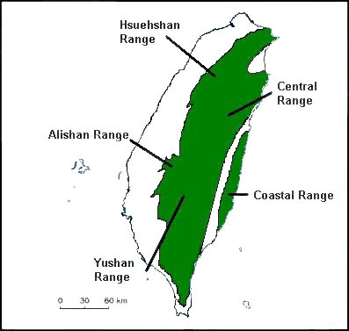

Map 4 The distribution of major mountain ranges in Taiwan.

How did the mountain ranges in Taiwan form?
About 50 million years ago, the sediments from the rivers of the Asian continent began to deposit on the continental shelf of the Pacific Ocean. After a long period of time, sedimentary layers were formed here. Later, under the compression of the moving plates, such sedimentary layers were folded up. Mountain ranges at the central and northeastern parts of Taiwan, such as Central, Yushan and Alishan Ranges, were then formed above the sea. Lastly, the formation of the Coastal Range at the east coast of Taiwan was related to the movement of the Philippine Plate towards Taiwan. In this way, a series of volcanic islands on the Philippine Plate were pushed into Taiwan to form the Coastal Range. Nowadays, these mountain ranges are still rising!

Newspaper cutting 4

4. Decision-making – The best house for your cousin’s family

Scenario:
After studying the information about the spatial distribution of various tectonic activities and natural hazards in Taiwan (1 to 3 above), you received a fax (Map 5) from your aunt. It shows several desirable and possible locations for your aunt’s new house (Refer to points A, B and C of Map 5). Other locations are neglected because of the constraints of capital or relief. Can you help her to choose the best location?

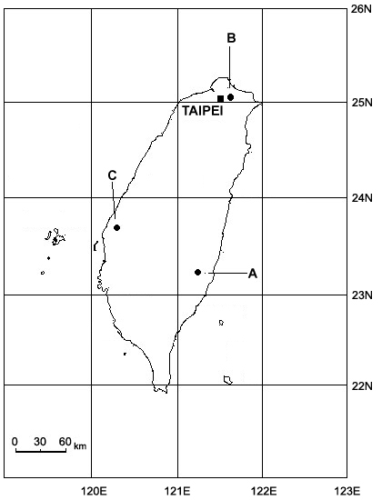



Map 5 A fax showing the possible locations of your aunt’s new house.

With reference to all the information in Part D, which location (A, B or C on Map 5) is the best for your aunt to build her new house? Why?

(Hint: You may copy Map 5 on a piece of tracing paper/transparency and overlay it on Map 3.)

Part E Why do people still live in hazard-prone areas?

Scenario:
Like your aunt in Taiwan, most people try to avoid living in hazard-prone areas. However, you know that many densely populated areas in the world, e.g. San Francisco, Los Angeles and Tokyo, are hazard-prone areas. The resources about Japan below help you to explore why many people still live in hazard-prone areas.

- a) Visit the website – ‘Statistical Handbook of JAPAN 2001’ (by Statistics Bureau & Statistics Center, Ministry of Public Management, Home Affairs, Posts and Telecommunications).
http://www.stat.go.jp/english/data/handbook/c02cont.htm
Look at the part about population density of different prefectures in Japan.

b) Which two are the most densely populated prefectures in Japan?

c) Refer to Map 6 and Table 4, what kinds of natural hazards can be found in these two prefectures?

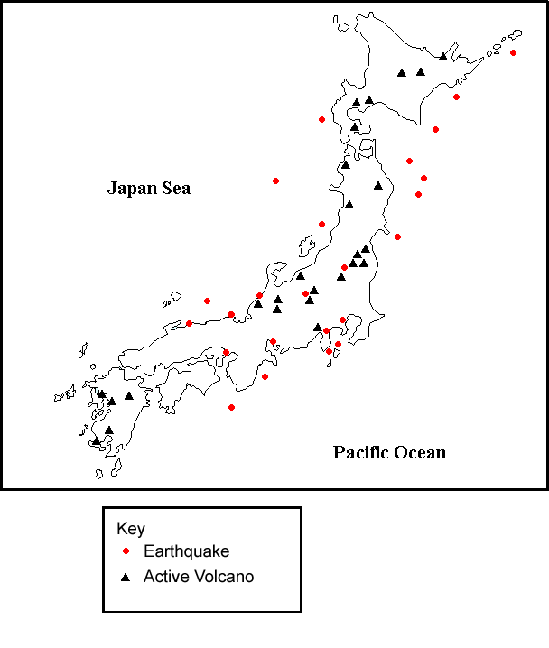

Map 6 The distribution of some major active volcanoes and earthquakes in Japan.

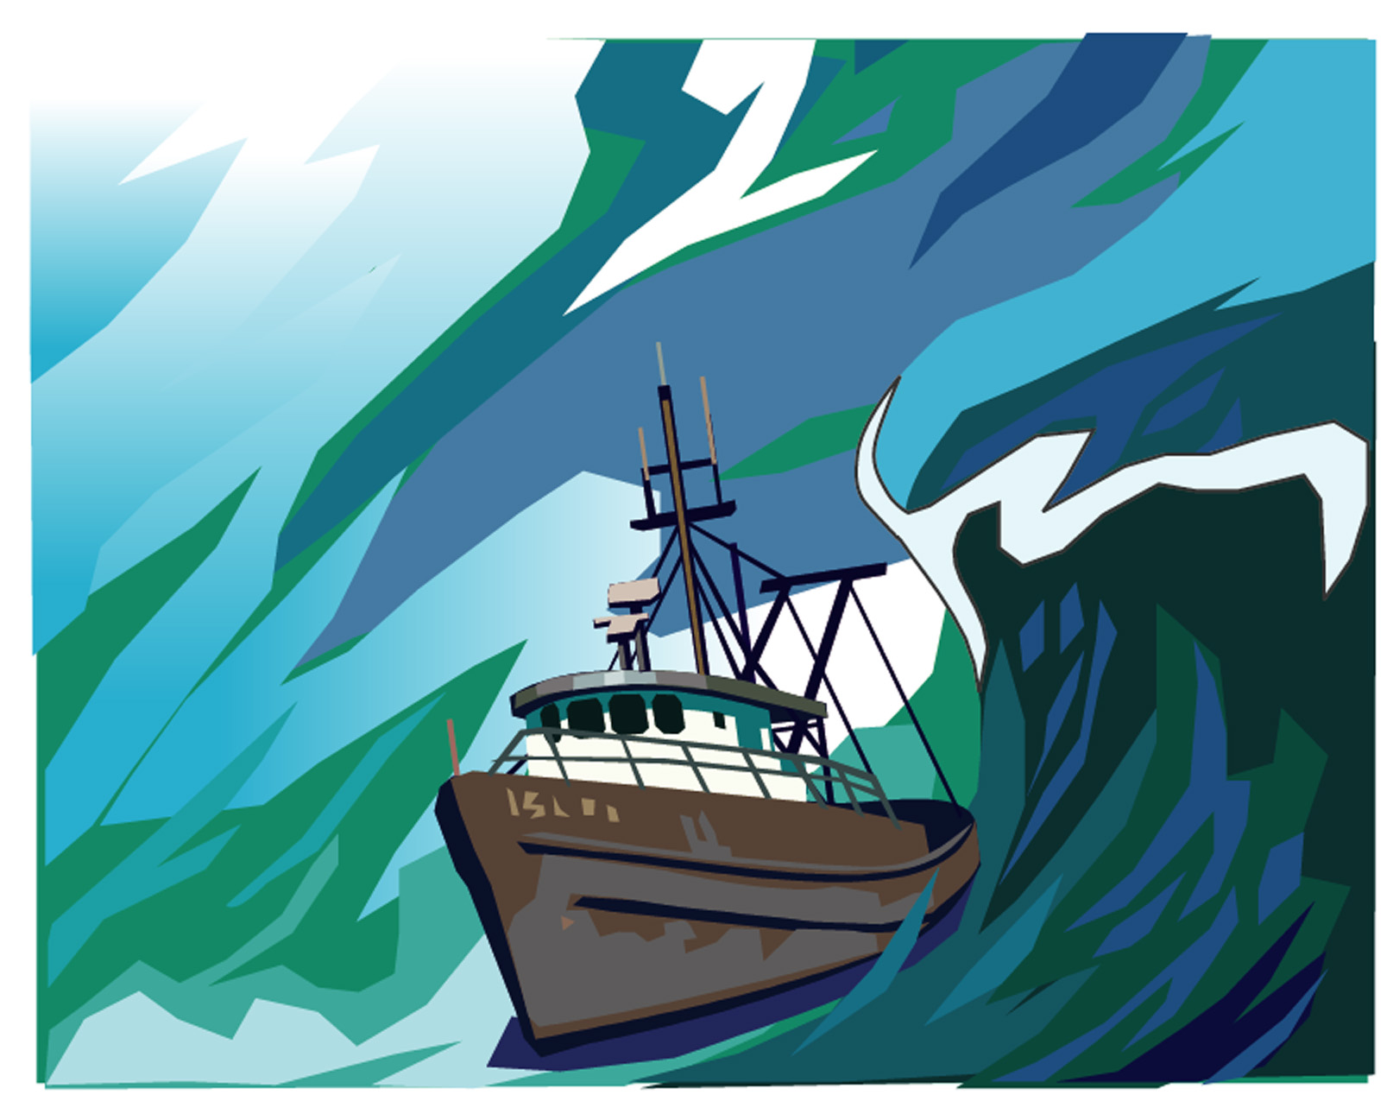

Year | Location
1700 | Sanriku Coast, Japan
1896 | Sanriku Coast, Japan
1933 | Sanriku Coast, Japan
1983 | Hokkaido, Japan
1994 | Shikotan, Japan

Table 4 Some major tsunami disasters in Japan.

- What are the locational advantages of these prefectures? Choose ONE of these prefectures, find information and list points about them in the table below.
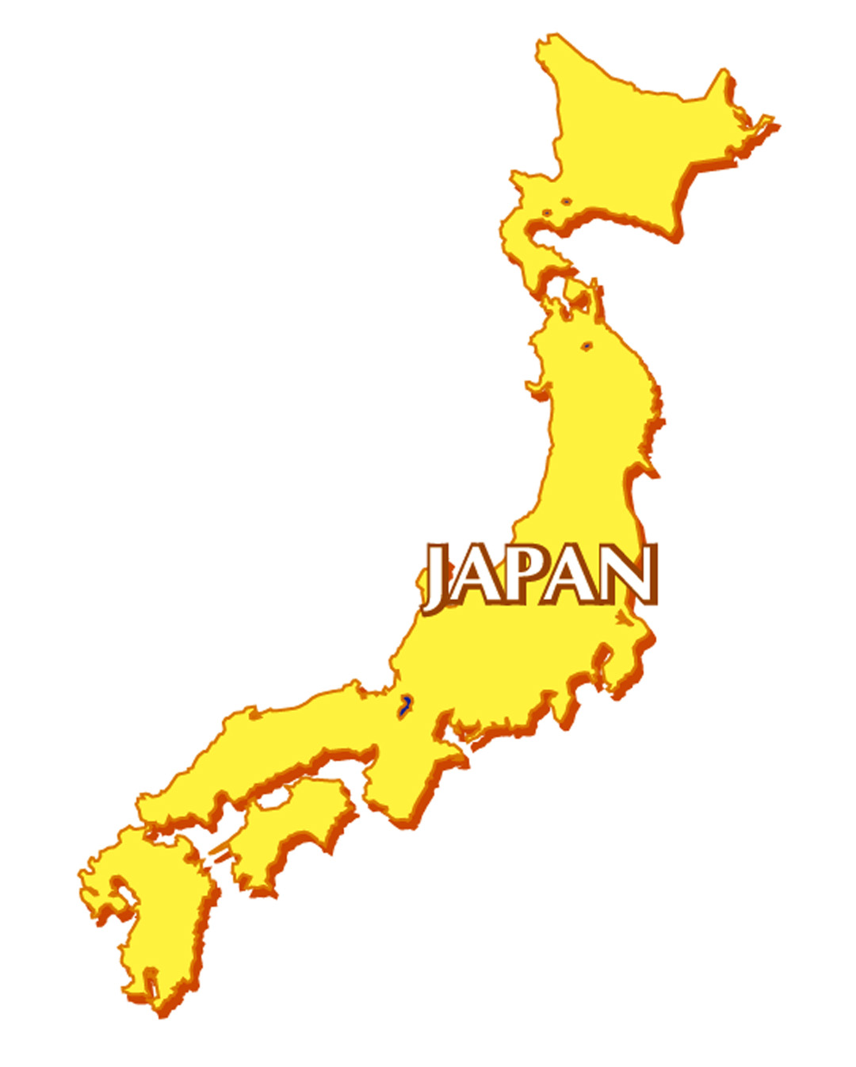

The prefecture you choose: _________________________________________

Locational advantages | Details
1. Weather and climate
2. Location, relief and supply of land
3. Natural resources (e.g. minerals), water supply
4. History of development (e.g.settlement, primary, secondary and tertiary industries)
5. Tourist attractions
6. Others

Suggested sources of information:
- A school atlas
- Internet (e.g. A website – ‘Japan Resources’ http://pubpages.unh.edu/~drysdale/Japan_Resources.html)
- Books and magazines in the library

e) According to all the information in Part E, explain why the Japanese still live in the hazard-prone area you choose.

f) For those people living in hazard-prone areas, suggest some measures to minimize their losses when there are natural hazards.

