Worksheets - Rivers and their associated water problems

Name: ______________________ ( ) Class: __________

This set of worksheets can be used for the learning of:
- Theme: Landform and Exogenetic Processes; and
- Issue: The Trouble of Water.

Scenario:
You and your parents will have a 10-day trip to the Three Gorges of Chang Jiang (長江三峽) and Shanghai in the coming summer holiday (late August). Before that, you are responsible to plan for the trip. Therefore, you want to collect some information and guidebooks about traveling in Shanghai and the Three Gorges.

Part A Preparation for the trip:

Itinerary — A 10-day trip to Shanghai and Chang Jiang

Day 1 Hong Kong → Shanghai (to visit your uncle’s family there)
Days 2-6 Shanghai
Days 7-9 Chang Jiang Cruise (Wuhan→Chongqing)
Day 10 Chongqing → Hong Kong

- You and your parents will visit some of the following places. Follow the instructions and finish the activities below.

a) Map 1 shows some major rivers in China. Identify Chang Jiang and label ‘Hong Kong’, ‘Shanghai’, ‘Hukou(湖口)’, ‘Wuhan’, ‘Yichang (宜昌)’and ‘Chongqing’ on the map.
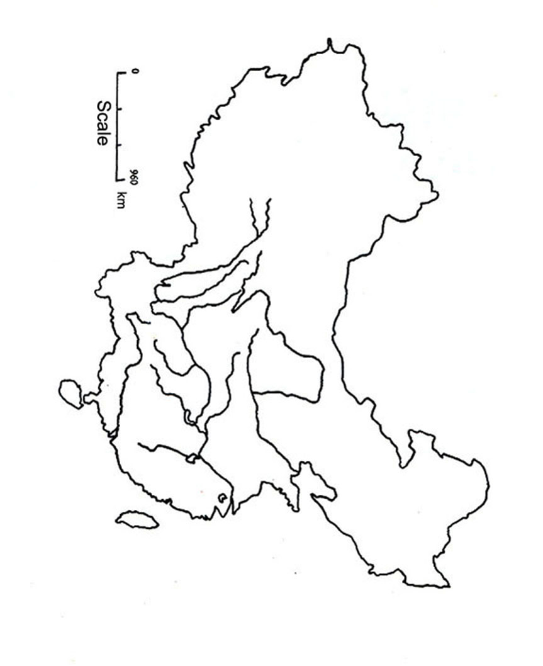
Map 1 A map showing the major rivers in China.

b) On Map 1,
  - colour Huanghe with yellow,
  - according to the following table, colour the upper, middle and lower courses of Chang Jiang with different colours.

Part of Chang Jiang | Colour
Upper course (source of Chang Jiang → Yichang) | Red
Middle course (Yichang→Hukou) | Blue
Lower course (Hukou→mouth of Chang Jiang) | Green

c) On Map 1, plot the following of Chang Jiang:
- Dongting Hu (洞庭湖);
- Poyang Hu (鄱陽湖); and
- Three Gorges Dam.

d) If the speed of a Boeing 747 aircraft is about 900 km/hour, how long do you need to travel from Hong Kong to Shanghai by a Boeing 747 aircraft?

(Hint: Draw a straight line between Hong Kong and Shanghai. Find the distance between the two cities and then finish d) above.)

e) As you will visit Shanghai and Chongqing, you want to know the climatic characteristics of these two cities so that you can prepare suitable clothes for your trip.

i) From the information of the website below (or from your textbook), briefly outline the climatic characteristics of the 2 cities in summer.

Website:
World Travel Guide – China - Climate
http://www.travel-guide.com/data/chn/chn500.asp

ii) Are there any differences in climatic characteristics (e.g. temperature and rainfall amount) between the 2 cities? Why?

iii) What types of clothes will you prepare for the trip in summer then? Explain your choice.

Part B Flooding at Chang Jiang:

Scenario:

Before your trip, you watch from TV news and know that there is flooding at Chang Jiang at that time. Know more about this water problem. See whether the problem will affect your trip or not.

1. Flooding at Chang Jiang in 1998

a) See the images about flooding at Chang Jiang in 1998.
* Images about flooding at Chang Jiang in 1998:

Visit the following website and see the images of flooding at Chang Jiang (3/5/1998, 10/8/1998 and 2/10/1998):
Environmental Monitoring of the Country
http://www1.gsi.go.jp/ch3www/EODAS/EODAS_e.html

b) According to the images, which part(s) of Chang Jiang is/are seriously affected by flooding?

c) Refer to the report below and your knowledge about the characteristics of different parts of a river, describe and explain the physical factors leading to the flooding in 1998.
* A report about the weather conditions and the flooding at Chang Jiang in 1998:
In 1998, there was abnormally heavy rainfall along Chang Jiang. There were continuous heavy downpours and these affected a large area of Chang Jiang. The average precipitation amount of Chang Jiang between 10 June 1998 to 24 August 1998 was about 580 mm.

d) Look at the pictures and the additional information below. The pictures show the types of human impacts at different parts of Chang Jiang.

  * Deforestation in the upper course of Chang Jiang.  e.g. In 1957, about 22% of the drainage area of Chang Jiang was covered with forest. However, the forest area reduced to only 10% in 1986. |   * Reclaim parts of the lakes along Chang Jiang for farming.  e.g. The area of Poyang Hu decreased from 5160km² in 1954 to 3859 km² in 1997 for this reason.
  * Urbanization along Chang Jiang. |   * Industrialization along Chang Jiang.
(Source of data about forest coverage of Chang Jiang and the area of Poyang Hu:
吳祖強、方如康著：《水，危機與困惑》(1999)。上海：上海科學技術出版社。)

Additional information can be found in the following website:
Dongting-Hu (Lake Dongting)
(http://www.ilec.or.jp/database/asi/asi-11.html)

e) What are the relationships of these human activities and the occurrence of flooding along Chang Jiang in 1998?

2. Discuss with your friends (Suggestion: 4-5 students in a group) the effects of flooding to the people living close to Chang Jiang. List them in the table below.

Negative effects | Positive effects

3. a) If the above mentioned flooding is found mainly between Chongqing and Yichang of Chang Jiang, will it affect your trip?
(* Hint: You may need to check your itinerary on P.1 of this set of worksheets.)

b) Explain your answer in 3a) above.

4. Chang Jiang—The Three Gorges Dam Project

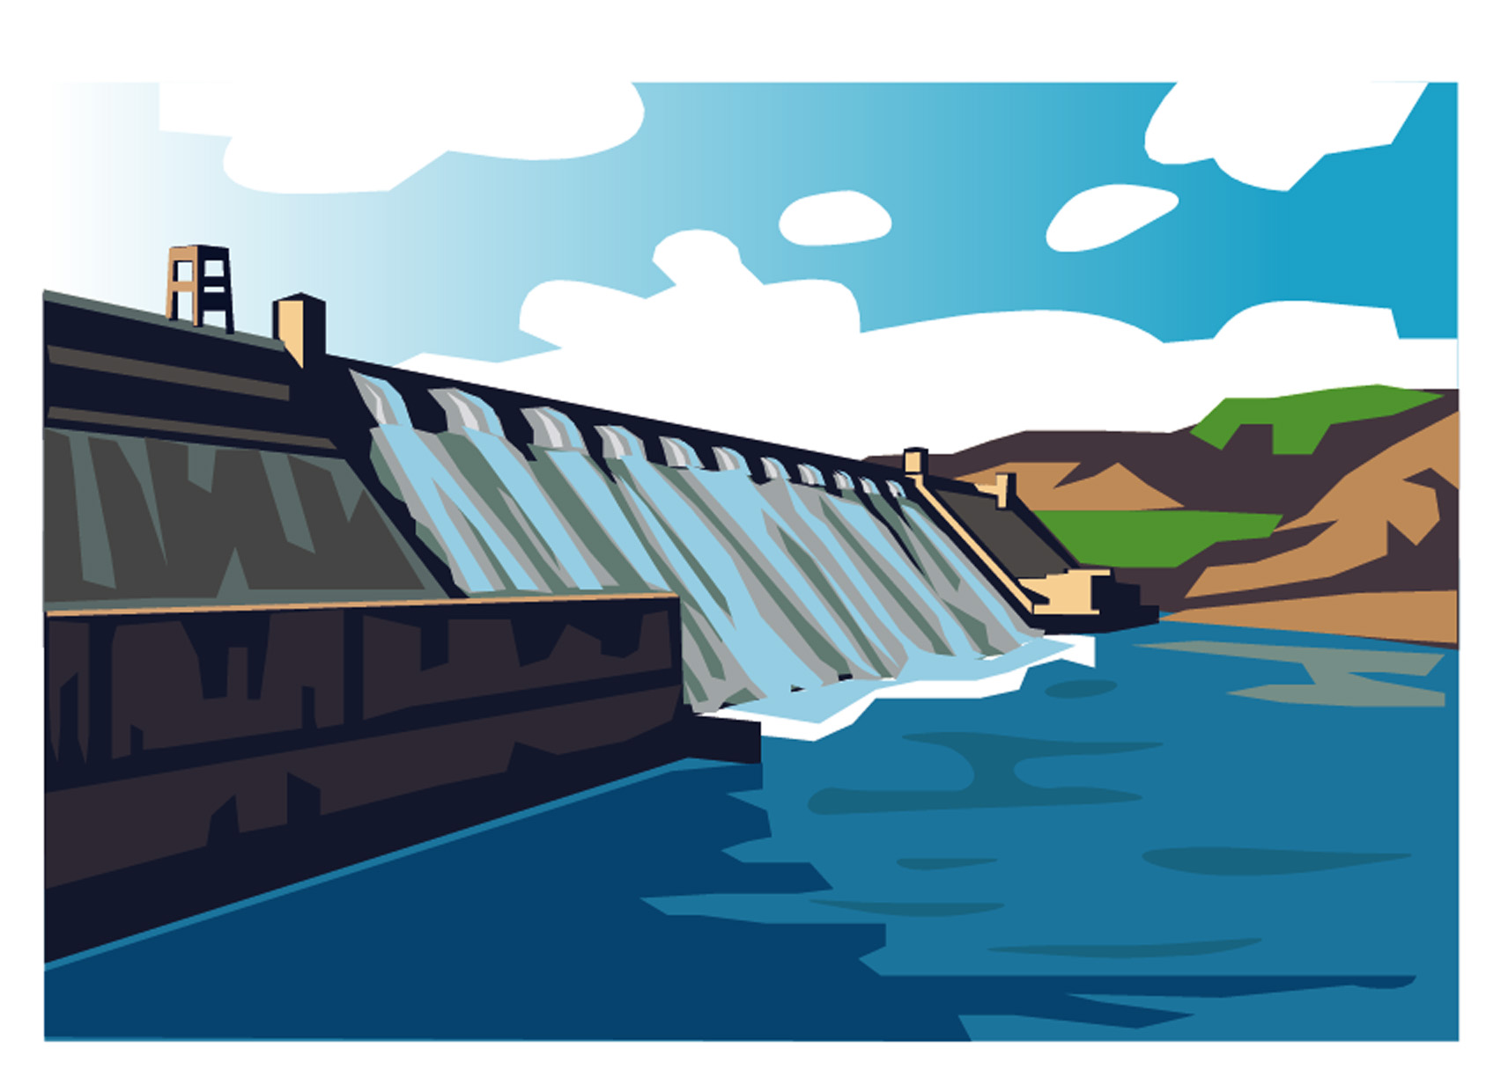
Name of the project: | The Three Gorges Dam Project
Location: | Sandouping, Yichang, Hubei Province
Height and width of the dam: | 185 m high and 1983 m broad
Construction periods: | - 1993-1997  - 1998-2003  - 2004-2009
Functions: | 1. To control floods  2. To generate power  3. To improve navigation
Materials being used: | Cement, steel and timber
Water level: | Water level of Chang Jiang will rise in two stages to 175 m in 2009.
Table 1 Vital information about the Three Gorges Dam Project
In order to solve the water problem at Chang Jiang, the Chinese government decided to carry out the Three Gorges Dam Project here. Table 1 provides some background information about this Project.

Activity—Debate

Motion “The Three Gorges Dam Project is a time-bomb to China”


(* The following websites may help you.)

Useful websites about the Three Gorges Dam Project:

- Centre for Global Environmental Education—Rivers of Life (Three Gorges Dam Project)
(http://www.cgee.hamline.edu/rivers/Resources/river_profiles/journey/dam.html)
- China Online—Three Gorges Dam Project
(http://www/chinaonline.com/refer/ministry_profiles/threegorgesdam.asp)
- ESC 110—The Three Gorges Dam Project
(http://www.soilslab.cfr.washington.edu/esc110/2002Winter/projects/006/index.html)
- The Three Gorges Dam Project
(http://www.sjsu.edu/faculty/watkins/3gorges.htm)
- The Three Gorges Dam Project—Constructing the largest dam in the world
(http://www.imperialtours.net/3gorges_dam.htm)
- Travel China Guide.com—Three Gorge Dam
(http://www.travelchinaguide.com/picture/yangtze/three_gorges_dam/index.htm)

a) After the debate, summarize the advantages and disadvantages of the Three Gorges Dam Project and complete the table below.
Advantages of the Project | Disadvantages of the Project
b) Do you support the construction of the Three Gorges Dam? Why?


c) Besides the building of the Three Gorges Dam, suggest some other measures to cope with the water problem at Chang Jiang.

Part C The trip to Chang Jiang and Shanghai:

Scenario:
For the water problem mentioned in Part B above, your family decided to delay the trip. During the Christmas holiday of the same year, you and your family visited Shanghai and Chang Jiang. You saw many attractive fluvial landforms along Chang Jiang. Identify these landform features and think about their formation processes.

1. Refer to Figure 1 below and answer the following questions.
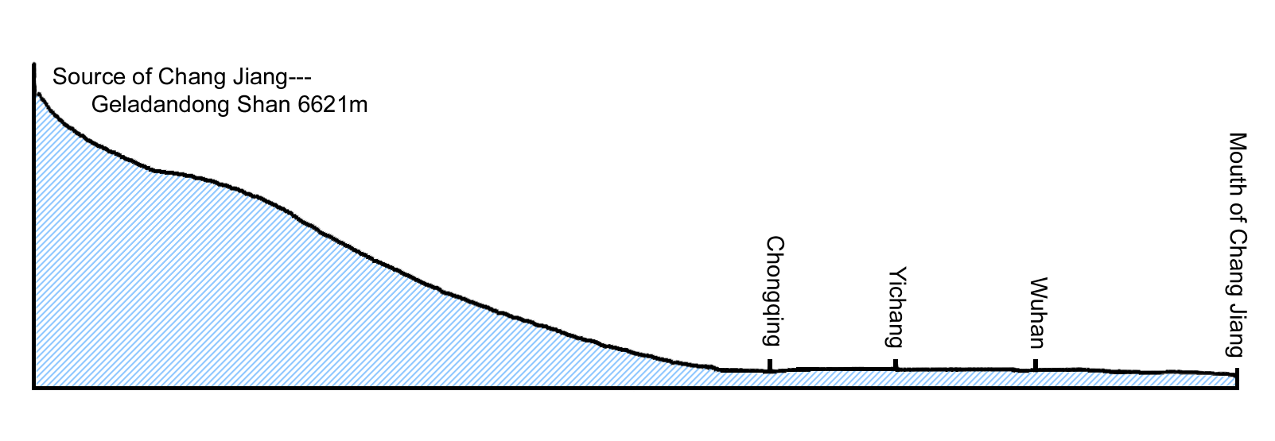
Figure 1 A long profile of the main course of Chang Jiang.

a) When you visited Shanghai and Chang Jiang, you saw the following fluvial landform features:
i) Three Gorges of Chang Jiang;
ii) Chang Jiang delta; and
iii) Chang Jiang Pingyuan (長江平原).
Mark their locations on Figure 1.
(* Hint: A school atlas may help you to finish this task.)

- i) According to their locations at Chang Jiang, classify the fluvial landform features ai to iii above into upper, middle and lower courses. Write your answers in the table below.
Three Gorges of Chang Jiang | Chang Jiang river delta | Chang Jiang Pingyuan
course | course | course

ii) Explain their locations with reference to the dominant fluvial processes at different parts of a river.
c) i) Visit the website below and see the appearance of the Three Gorges of Chang Jiang.
The Yangtze River Database; VIMS; Qingdao (http://www.vims.edu/~jpliu/east/changj.htm)

ii) Describe and explain the formation processes of this type of fluvial landform (ci above).

d) i) Visit the website below and see the appearance of Chang Jiang delta.
Chang Jiang River Delta, China (http://daac.gsfc.nasa.gov/DAAC_DOCS/geomorphology/GEO_5/GEO_PLATE_D-5.HTML

ii) Which type of delta that Chang Jiang delta belongs to?

iii) With annotated diagrams, describe and explain the formation of the Chang Jiang delta.
Diagrams:

iv) Besides the type of delta in dii) above, name the other two types of delta in the world and give one example for each.

e) Besides those fluvial landforms mentioned above, list 2 other landform features that may be found at the upper and lower courses of any one river respectively.

Part D The water problem at Huanghe:

Scenario:
After your trip to Shanghai and Chang Jiang, you are interested to know more about rivers in China. One day, you watched a TV program about Huanghe and noticed that another water problem could be found here.
1. Refer to the graphs (Graphs 1-3) below and answer the following questions.

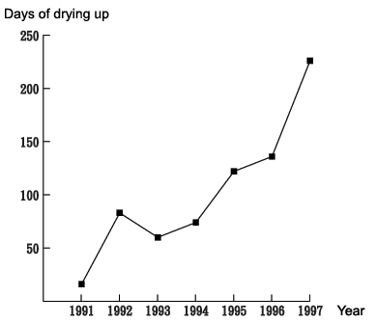
Graph 1 Days of drying up at Huanghe in the 1990s.

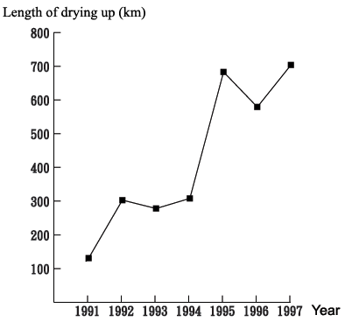
Graph 2 Length of drying up at Huanghe in the 1990s.

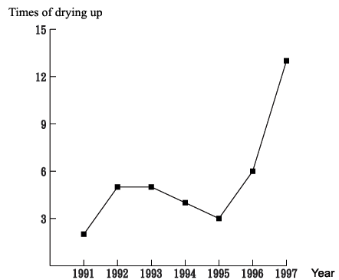
Graph 3 Times of drying up at Huanghe in the 1990s.

a) What type of water problem is found at Huanghe?

b) With the information in the graphs above, describe the water problem (1a above) at Huanghe in the 1990s.

c) What are the effects of this water problem to the households, farmers and factory owners along Huanghe?

2. a) Look at the cartoons on P.18. Discuss with your classmates and explain why Huanghe dried up frequently in the 1990s.

b) Besides those in 2a) above, suggest other reasons to explain the drying up along Huanghe in the 1990s.

Cartoons about the reasons of drying up along Huanghe in the 1990s


Households along Huanghe
‘We need a lot of water from Huanghe for domestic uses.’


A meteorologist in China
‘The precipitation amount along the drainage area of Huanghe is decreasing. 13.6%, 9.7% and 3.2% less rainfall were recorded in recent years for the upper, middle and lower courses of Huanghe respectively.’


An officer in China (Family planning)
‘The rate of natural increase (population) within the drainage area of Huanghe is very high. The rate was about 2.2% between 1953-1990.’


A worker in a factory near Huanghe
‘All the factories near Huanghe need a lot of water from it.’

Farmers with farmlands near Huanghe
‘With rapid population growth, we need more food. More farmlands near Huanghe can be found. We need a lot of water from Huanghe for irrigation.’
3. Huanghe—Diverting water from the South to the North

In order to solve the water problem at Huanghe (Part D), a number of solutions have been proposed. One of these is ‘South-North Water Transfer Project.（南水北調工程）’.

Visit the following websites and answer the questions below.

1. 黃河規劃設計—南水北調西線工程
http://www.yrcc-design.com.cn/ProItem/earitem/xxgc/xxgc-bottom.htm
2. Brief introduction of the planning for South-to-North Water Transfers
http://www.mwr.gov.cn/english/project_introduction/nsbd/index.htm

Name of the project: | South-North Water Transfer Project (South-to-North Water Transfers)
Number of routes: | 3 (They are the Western route, the Central route and the Eastern route. They divert / transfer water from the upper, middle and lower courses of Chang Jiang respectively)
Main function: | Diverting water from the damp south of China (Chang Jiang) to its arid north (Huanghe and some cities in the north, e.g. Beijing and Tianjin) in order to solve the water problems in both regions.
Construction time/period: | About 50 years (from 2002 to about 2050)
Construction cost: | About 500 billion yuan / HK$470 billion

Table 2 Information about the South-North Water Transfer Project in China.

a) According to Table 2 and the information in the website above, briefly describe the Project in about 100 words.

b) The positive and negative effects of the Project:
From the website, find out the positive and negative effects of the Project.
Positive effects | Negative effects
c) Do you support this Project? Why?

