Worksheets – Information Technology Industry in USA

Name: _________________ ( ) Class: ______

This chapter can be used in the learning of:  Theme: Industry | 

Imagine you are the manager of a computer firm in the United Kingdom and the director of your company wanted to expand their business to SE Asia. He is considering setting up the headquarters of the SE Asia branch in Hong Kong. The director has seen an advertisement from the Internet about the leasing of offices in the Science Park of Hong Kong. He asked you to investigate whether this is a good place to set up the headquarters.

Where is the Science Park?

Look at the map on P.2 showing the Science Park in Hong Kong.

  - What are the grid squares where the Science Park is located?

  - Calculate the approximate area of the Science Park.

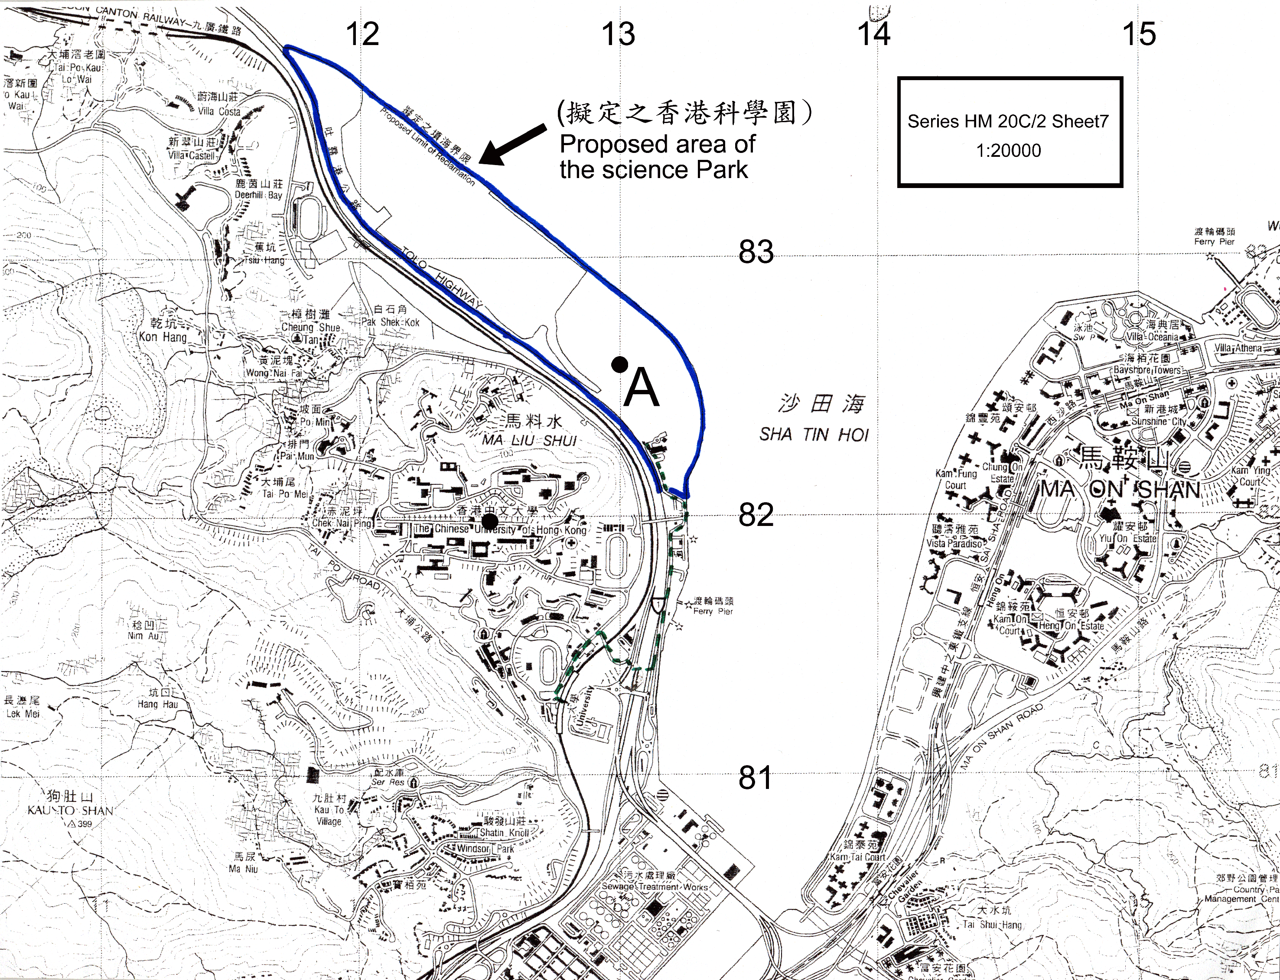
  - Describe the relief of the Science Park.

  - Find out the whole circle bearing of the Chinese University of Hong Kong from Point A in the Science Park.

  - Measure the walking distance from the railway station at the University to the Science Park (the dotted line on the map).

  - Based on map evidences, state the kinds of transport that link the other area with the Science Park.

  - Look at the types of settlement around the Chinese University of Hong Kong:

    - What type of settlement do most of them belong to? Name some of this type of settlement.

    - Why does this type of settlement locate there?

After investigating into the location and site of the Science Park, your colleagues reminded you that you can use some successful examples as reference for your choice. On the Internet, you come across web pages of some companies in the Silicon Valley of the USA .

- A successful example – Hewlett Packard

Browse the following website and answer the following questions:
http://www.hp.com/hpinfo/abouthp/histnfacts/timeline/index.htm

By looking at “hp-timeline – 1930s” find out:

    - Who are the founders of the HP Company?

    - What kinds of products do they produce?

    - Where do they set up their first factory?

    - Why do they set up their factory there?

- Is the Silicon Valley a good place for investment?

After knowing that the birthplace of Hewlett Packard is the Silicon Valley, you continue to investigate into the advantages of setting up information technology (IT) industry in the Silicon Valley.

  - Where is the Silicon Valley?

On Figure 2, mark the boundary of the state ”California”. In addition, plot San Francisco on the map.

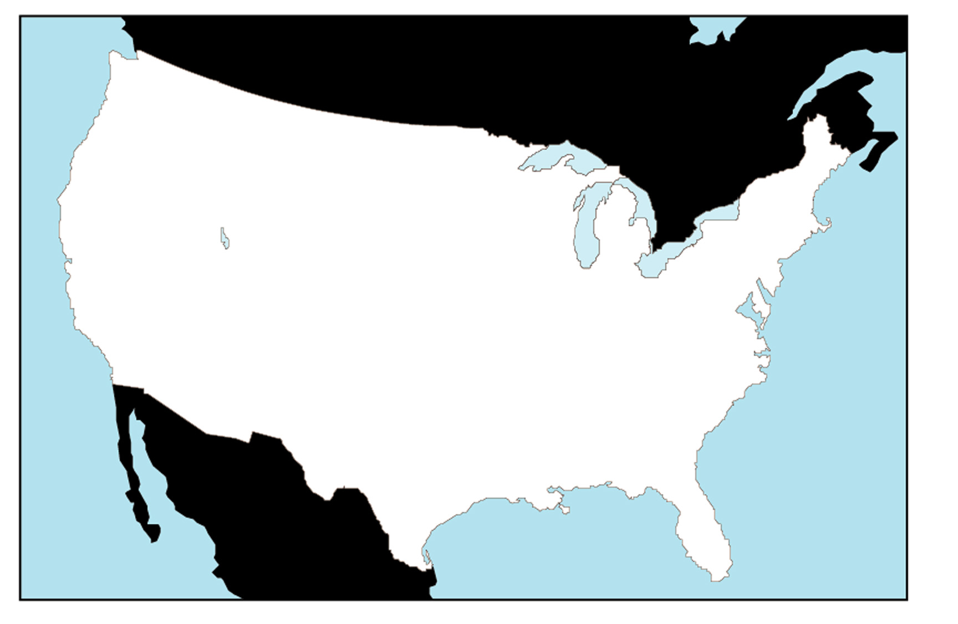
Figure 2: Map of USA Scale 1:40 000 000


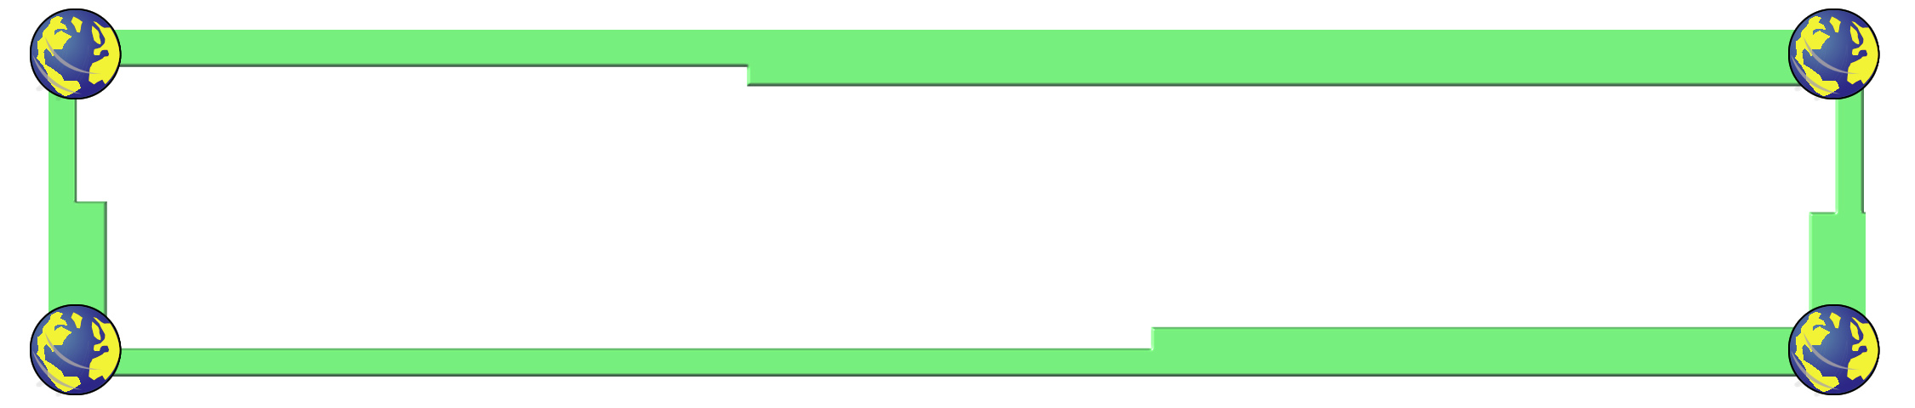
“Silicon Valley” is a 32-kilometre long strip of land just south of San Francisco. It is near to Stanford University. It is contained by the San Francisco Bay in the east and the Santa Cruz Mountains in the west.

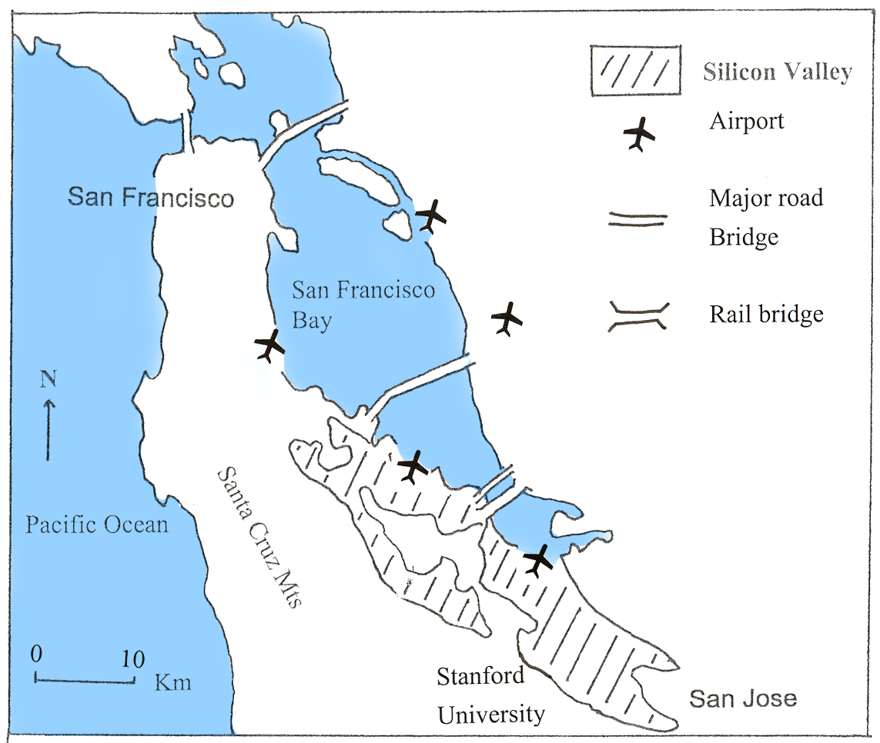

Figure 3: The location of the Silicon Valley

  - Why are there so many IT industries in the Silicon Valley?


Fact sheet 1 – History of development of the Silicon Valley

In the early years, this is a place where fruit orchids predominated and only some small electronic firms are found. In the 1950’s, Stanford University faced financial problem and decided to lease part of the land to high-tech companies for 99 years. The Stanford Industrial Park was founded and it was decided that leases be limited to high technology companies that might be beneficial to Stanford. In 1951 Varian Associates signed a lease and then followed by Eastman Kodak, General Electric, Intel and Apple computer etc.

Nowadays, about 2000 electronics and information technology companies are clustered in the area. They are mainly the innovative industry including computers, semiconductors, lasers, fiber optics, robotics, medical instrumentation, magnetic recording, and educational and consumer electronics.

Fact sheet 2 – Employment change in California

 | 1972 | 1991 (estimate)
High technology | 247 200 | 687 000
Computers | 52 400 | 156 000
Communications equipment | 90 600 | 185 000
Electronic components | 52 000 | 206 000
Aerospace | 184 000 | 248 000
Instruments | 52 200 | 140 000

Fact sheet 3 – Report by Peter Hall on “The Geography of High-technology industry” in the Silicon Valley, USA

A research was done by Peter Hall of the University of Hong Kong to investigate into the factors that affect the location of high-tech industry in the Silicon Valley, USA. He has proposed 12 hypotheses which tried to analyze the importance of these 12 locational factors to high-tech industry. He found out that the most important factors appeared to be business-related and transportation -communication oriented facilities. These include the presence of major universities, larger proportion of defence spending and the presence of major airports with good national and international passengers and air cargo activities. Factors such as low unionization rate, good climate, low unemployment rate and much educational options seem to be less important.

Look at the map of the Silicon Valley on P.6 and the fact sheets on P. 7 - 8.

- What are the characteristics of the industries in this area?

- What are the locational advantages of the Silicon Valley that favours the development of IT industry?

  - Changing mode of production

Fact sheet 4 – An interview with the director of Intel Company
(A US semiconductor components company)

Question (Q): When did your company first set up?
Answer (A): 1968

Q: What kinds of products do you produce?
A: We produce many components of computer including desktop, notebook, server and workstation, etc.

Q: How much money will Intel spend on plant and equipment, and research and development?
A: In 2002, Intel plans to spend US$4.7 billion on plant and equipment and US$4.0 billion on research and development.

Q: What is the current number of employees?
A: We employ more than 80,000 people in more than 45 nations.

Q: Where are your factories located?
A: Well, our headquarter is in the Silicon Valley, California where most of the product innovation is done. We need our experts to innovate new products.

Q: So are there any factories outside USA?
A: Yes, of course. Those factories that require labour-intensive processing and assembly operations are located outside USA where the labour cost is cheaper. They are located in Shanghai, China; San Jose, Costa Rica; Kulim and Penang, Malaysia; and Cavite, Philippines.

Q: Besides labour, what are the other factors considered when your company determines where to build future factories?
A: We also considered the land’s physical characteristics, local utility infrastructure, transportation capability, technical workforce, construction and supplier capabilities, permitting and investment conditions.

Fact sheet 5: Changing mode of production of hard disk drives by US companies
PeriodMode of productionReason1980 – 1985Produce new products in USA and some basic parts are produced in SingaporeThe firms can make use of the cheap labour in Singapore since the production of basic parts did not require high technology.1986 – 1992Innovate and ramp* new product in USA, transfer to Singapore for mass production then send to Thailand and Malaysia for assembly.Since Singapore has already get the managerial and technical experience, they are able to produce the products. Proximity among Singapore, Malaysia and Thailand minimized coordination and transportation cost. They are also nearer to the market in Asia which saves time to spread the new products to the market.1993 - presentUS firms continue to innovate new product. Then they are transferred to Singapore, Thailand and Malaysia for ramping and production.There are more specialized workers, engineers and managers in these Southeast Asian countries. There are better infrastructure such as electronically linked freight forwarders and warehousing.

*Note: At the beginning of production of each new product, ramping is needed to ensure production can go smooth. The technological level required is quite high.

Figure 4: Distribution of production of hard disk drives by US firms

Refer to fact sheet 4-5 on P.9 – 10 and Figure 4 on P.11, answer the following questions:

- Where are the headquarters of IT industries mentioned above?

- Why are they located there?

- In which areas are the processing and assembly of components of IT industry taking place?

- Why are they located there?

D. Is the Science Park a good place for investment?

After investigating into the case in the Silicon Valley, you have to decide whether your company will invest in Hong Kong.

Look at the map of the Science Park on P.2 and visit the website below. Then answer the following questions.
http://www.techcentre.org

- What types of industries are found in the Science Park? Give one example for each type.

- Making use of the map on P.2, the answers to the questions on P.1 and 3 as well as the above website, describe the following locational factors of this site.

Locational factors | Descriptions
- Land

- Raw materials

- Power

- Labour

- Transport facilities

- Market

- Living environment

- Research and development facilities
- Institutional factors



- In groups of four, based on the information above, decide whether you will set up your SE Asia branch headquarters in Hong Kong. In addition, you have to decide whether you will set up the processing and assembly plant too. After making the decision, write a report to the director of the headquarter of your company in UK telling him your decision and the reasons behind.


E. What are the impacts of the development of IT industry ?

Evaluate the advantages and disadvantages of the development of IT industry to Hong Kong (where headquarters of IT industries are set up) and China (where processing and assembly plants are set up) by studying the information provided by the newspaper cutting below.


Newspaper cutting 1
High-tech industry can boost up our economy

…An official in the Industry and Trade Department claimed that the development of high-tech industry is the major aim of government in the development of industry in the next few decades. As an international city, a well-educated work force, a stable government and good communication with the outside world paved a good way to develop high-tech industry. It’s hoped that it will bring up the economy and provide job opportunities to the people of Hong Kong……

Newspaper cutting 2
More professionals are coming – is it a good thing?

……The government announced the release of immigrants from China by launching the “Admission of Mainland Professionals Scheme”. The scheme is only open to professionals in information technology and financial services sectors. According to the Director of Immigration, Mr. Lai Tung Kwok, the objective of the Scheme is to attract qualified Mainland professionals to work in Hong Kong. This helps to meet local manpower needs and enhance Hong Kong’s competitiveness in the global market. These Mainland professionals must be those who are not readily available locally. Therefore, they will not pose a stress on the local labour market…….

Newspaper cutting 3
Unemployment rate has reached a high level Government need to do something

……According to recent statistics, the unemployment rate has increased from 2.2% in 1997 to 6.2% in 2001. Economists stated that the high unemployment rate is mainly due to industrial relocation and economic recession. Many factories have relocated to South China due to the low labour cost. As a result, many unskilled and semi-skilled local labour become unemployed. Since they are those elder in age and low in education, it is difficult for them to find another job, even though the government is developing high-tech industry lately……

Newspaper cutting 4
More factories and firms will be set up
as China enters the WTO

……Since China implemented their Open Door Policy, more factories have been set up in the Special Economic Zone. Some transnational corporations, such as the Intel Corporation of USA, have also set up their branches and factories in China. As China enters the World Trade Organization (WTO), there will be more trading opportunities. More job opportunities will be provided. However, some critics have warned that local industries would face severe competition……

 | Advantages | Disadvantages
Hong Kong

China

