Worksheets – Climatic anomalies and Climate

Name: _________________ ( ) Class: ______

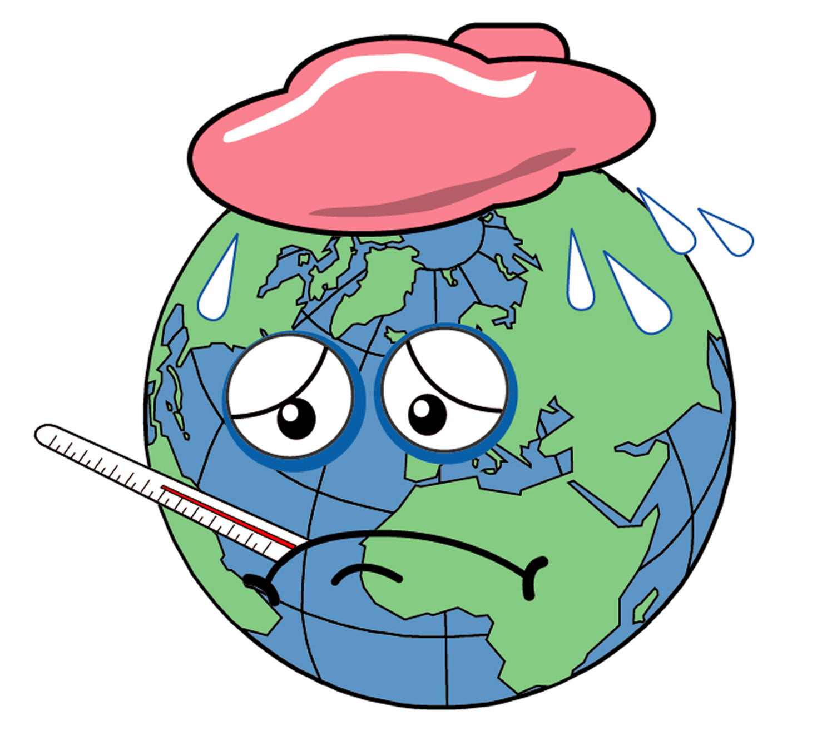
This chapter can be used in the learning of:
- Theme: Climate; and
- Issue: Climatic anomalies

Part A What is global warming? Which area will be affected?

- Increase in temperature – is it a coincidence?

    - Recall one day when the temperature is very high. What do you feel?

    - What activities can you suggest to reduce such heat?

    - In groups of two, try to conduct a small project by:
i) interviewing people of different ages by asking them this question:
“Do you think Hong Kong is hotter than 10 / 20 / 30 / 40 years before?”
ii) analyzing the data by the construction of pie chart and present your results in front of class

Does it happen in Hong Kong only?

Refer to the following extract from a report done by the Royal Observatory of Hong Kong in 1988.
Only in September in the city of Shanghai in China, air-conditioned cinemas had been doing brisk business, with summer temperatures hovering above 35ºC on most days and even topping 38 ºC on most occasions. Eighteen Chinese provinces including the grain belt in the middle and upper reaches of Yangtze River were experiencing prolonged heat and a long serious summer drought….
Scientific measurement shows that temperature worldwide is rising. Data from the Goddard Institute of Space Studies of the U.S. National Aeronautics and Space Administration show an average increase of around 0.25 ºC in the 60 years between 1880 and 1940, a decrease of 0.2 ºC between 1940 and 1970, and another rise of 0.3 ºC in 1970 to 1980.
Source: Elaine Hui Koo (1988) “Climate Change – Secular trends in urban temperature” Royal Observatory Hong Kong

Year | Temperature departure from long-term mean (ºC)
1880 | - 0.16
1900 | 0
1920 | - 0.11
1940 | + 0.06
1960 | + 0.11
1980 | + 0.22
2000 | + 0.39
Table 1 Global temperature change from 1880 to 2000

d) Draw a graph to present the above data.

- From the above information, describe what changes in global temperature have been taken place?

- What is the name given to such phenomenon?

- In groups of four, describe the possible effects of global warming from the following perspectives.

Role play
You are an environmentalist who cares about the vegetation growth of the world. What are the effects of global warming to the vegetation and ecosystem?



You are a farmer in China and your level of technology is not very high. What are the effects of global warming to your harvest?


You are a citizen living in Amsterdam, Netherlands. The altitude of your city is much below sea level and has suffered serious flooding in the past. The government has reclaimed much land and the risk of flooding has been reduced. But now, what are the effects of global warming to your city?

(Hints: You can deduce the effects by
- looking at Figure 1 which shows the predicted events if the earth’s surface temperature increased by an average of 1ºC.
    - browsing the following website: http://yosemite.epa.gov/oar/globalwarming.nsf/content/index.htm
    - finding information from books in the library. )
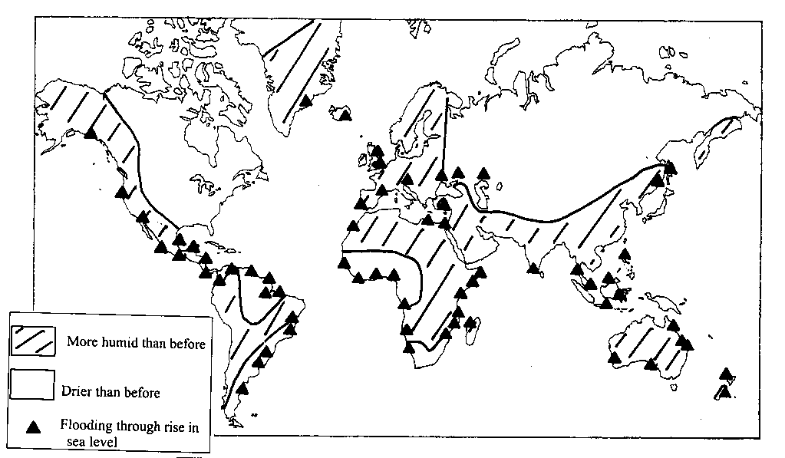
Figure 1 Predicted events if the earth’s surface temperature increased by an average of 1ºC

Part B How and why are there differences in temperature pattern?

- What are the general climatic conditions of Hong Kong, Qingdao, Harbin and Kuala Lumpur?

John knew a friend in China (Wai Wah) by playing ICQ. Wai Wah is living in Harbin, Heilongjiang Province. He is planning to have a trip to Kuala Lumpur in Malaysia in August. He’ll first go to Qingdao, Shandong Province to visit his aunt and he wants to by-pass Hong Kong to visit John. He e-mailed to John to ask him what kind of clothes he should bring. Imagine you are John, by completing the following worksheets, can you make some suggestions for him?

Figures 2 - 5 show the climatic graph of Harbin, Qingdao, Hong Kong and Kuala Lumpur respectively.

- Compare their climatic characteristics by completing the following table:

 | Harbin,  Heilongjiang | Qingdao, Shandong | Hong Kong | Kuala Lumpur, Malaysia
Highest monthly temperature (ºC)
Lowest monthly temperature (ºC)
Average temperature (ºC)
Total rainfall (mm)

- Can you make some suggestions for Wai Wah for the type of clothes he need to bring to Qingdao, Hong Kong and Kuala Lumpur?

2. Why do their climatic conditions different?

Refer to the diagram showing the global distribution of mean annual solar radiation.

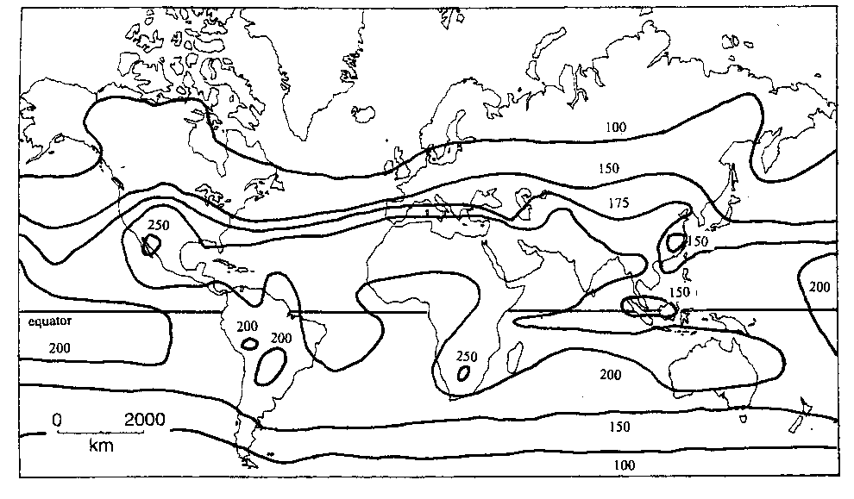
Figure 6 The average annual solar radiation on a horizontal surface at the ground. The units are W m⁻²

- From your atlas, find out the latitudes of Kuala Lumpur, Hong Kong, Qingdao and Harbin.

City | Latitude
Kuala Lumpur
Hong Kong
Qingdao
Harbin

- Plot the location of Kuala Lumpur, Hong Kong, Qingdao and Harbin on Figure 6 and find out the amount of solar radiation received in these cities.

Kuala Lumpur
Hong Kong
Qingdao
Harbin
- Describe how temperature and the amount of solar radiation are different with latitudes.

- Explain this temperature pattern in terms of the difference in the amount of insolation.

Part C To what extent do human beings lead to global warming?

1. Global warming – a natural phenomenon or a man-induced problem?

Experiment:
Apparatus: a lamp, two thermometers, a transparent box (made up of acrylic)



Figure 7 The setting of apparatus

a) Procedure: Put one thermometer inside a box and the other outside. Switch on the lamp for 30 minutes and record the temperature of the two thermometers.

Temperature inside the box | Temperature outside the box

b) Can you explain why this happen?

A similar case can be experienced when you get into a car parked in an open car park in the afternoon.

In natural environment, the matters that make up the box are called greenhouse gases. Look at Figure 8 which shows the major contributors to global warming.

Figure 8 The composition of greenhouse gas

- By browsing information from websites, find out the sources of greenhouse gas.

(Hints: You can search such information from websites of environmental agencies or use the search engine of www.yahoo.com, www.google.com or www.altavista.com by typing “greenhouse gases”.)

Natural sources | Human sources

- Which source is more important in recent years?

2. Who should be responsible?

Imagine you are the official in the United Nations Environment Programme. You are preparing a meeting concerning the world’s effort to combat global warming. Write a short report using the following information and guidelines so that you can present them during the meeting.

Figure 9 Carbon dioxide emission from fossil fuel combustion, 1988

(For more information, refer to http://yosemite.epa.gov/oar/globalwarming.nsf)

In your report, you should include the following:
- The pattern of carbon dioxide emission by various countries
- The countries that have the greatest and the least emission
- Explanation on why they emit such amount
- Whom do you think should bear a greater responsibility for such emission?

Part D What can be done to alleviate this problem?

1. A summit to combat global warming
According to a recent research on global warming, there will be an increase in temperature of 1.5 – 1.6ºC from the year 1990 – 2100. In addition, the length of winter in Northern Hemisphere will also be shortened by 18 days when compared with 150 years ago.


Therefore, the United Nations Environment Programme called for a summit to discuss on how to solve this problem. In order to provide enough information for your discussion, the officials of department concerned have sent you the report of their work for your information (refer to Information sheet on P.15).

Role play
Divide yourselves into groups of four and perform the following roles.

Officials of United Nations:
You are going to lead the meeting and you can use the information
of the last worksheet as a beginning. Try to let every party to
have some time to speak. Jot down some possible solutions for this problem.


President of USA:
Suggest possible solutions but you have to consider the interest
of your people. Any promises may lead to a great discontent
of industrialists of your countries, loss of votes and great economic
depression.


Chairman of the People’s Republic of China:
Suggest possible solutions but you have to consider that your country
is now developing and you need to minimize the cost as much as
possible.

Leader of less developed countries:
Suggest possible solutions. As you think you are not the greatest
contributor, you can make as much suggestions as you can.
Representative of an environmental consultative bodies in Britain:
Suggest solutions by pinpointing the main contributors of global
warming.

After the discussion:

- What are the possible solutions and evaluate their effectiveness.

Possible solutions | Effectiveness

- What are the problems of carrying out these solutions?

Information Sheet
Report given by the US Environmental Protection Agency:
In the year 2001, the US government has pursued a broad range of strategies to reduce net emission of greenhouse gases. The government promotes the development of cleaner and more efficient technologies for electricity generation and transmission by doing research with different industrial enterprise. The “Energy Star” program has been launched to promote energy efficiency in US homes and commercial buildings. Renewable energy has also been developed, such as solar energy, geothermal energy and biopower. The government also promotes development of fuel-efficient motor vehicles and trucks and implement partnership programs with industry to reduce emissions of carbon dioxide and other greenhouse gases. Afforestation is also done to maintain the number of trees in the area.

Report given by the China Meteorological Administration:
The first meeting on the topic “climatic change in China” was held in Beijing on the 5th of April, 2002. Speakers were invited to analyze the conditions of global climatic change. Chief Secretary Jiang stated that the government would support any activities or policies concerning this issue. He will also try to increase the technological level of the country to help to solve this problem. Internationally, the Chinese government should try every mean to protect the benefits of the country.

Report given by Economic and Social department of less developed countries:
We’re sorry to inform you that we haven’t got time to discuss the issue on “global warming” since we have lots of economic and social problems to solve. So no information about this area can be provided.

A recent research done on the projected consequences of global warming in the British Isles:
As water level may rise, nuclear power stations will be threatened. Britain’s largest lagoon – Chesil Beach will be lost and much rare plants and birds will die. Thousands of hectares of farmland in East Anglia will be lost. Besides, there is the growth of pest. Malaria becomes common as mosquitoes breed in warmer climate. Insects migrate to colder uplands posing a threat to artic species of animals and plants. As ice in some area of Scotland may melt, skiing industry in Scottish Highland would go out of business.

