S4 – 5 Geography
Curriculum Support Materials

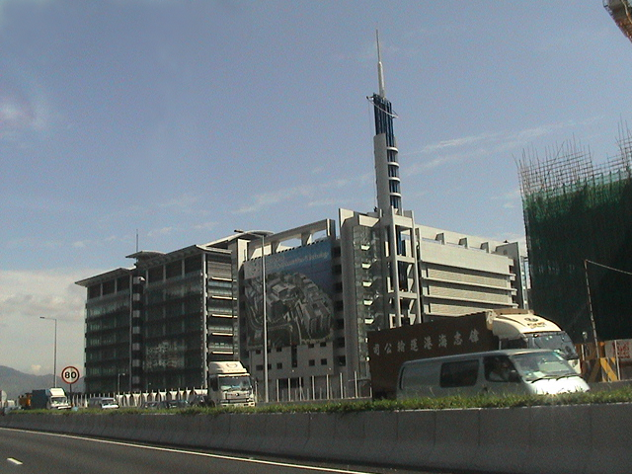

Information Technology Industry in USA

Information Technology Industry in USA
☒ Notes for teachers ☒

This chapter can be used in the teaching of:

- Theme: Industry

Part A Contents of students’ worksheet

Part | Contents | Page
A | Where is the Science Park? | 1 – 3
B | A successful example – Hewlett Packard | 4
C | Is Silicon Valley a good place for investment? | 5 – 12
D | Is the Science Park a good place for investment? | 12 – 14
E | What are the impacts of the development of IT industry? | 15 – 17

Part B Learning objectives

After completing this chapter, students should be able to:

Knowledge
- Understand the factors affecting the location of information technology (IT) industry.
- Understand the special characteristics of IT industry – multi-point and transnational production.
- Investigate into the possibility of Hong Kong to develop IT industry.
- Understand the impact of the development of IT industry.

Skills
- Master simple map-reading skills such as, reading map symbols, calculation of distance and area, using grid square and whole-circle bearing.
- Interpret information from map.
- Generalize and extract information from readings and newspaper cutting.
- Collect information from websites in the Internet.
- Make decision by analyzing information from different sources.
- Learn the skills of writing report.

Values
- Understand the problems caused by the development of IT industry.

Part C Foci of this set of worksheets

The main foci of this set of worksheets are to:
- incorporate map reading skills and map interpretation into the learning of the theme
  - This can be seen in Section A, C and D.
  - The objectives of these exercises are not only on the training of skills, knowledge can be acquired from the information gathered in these exercises. It helps to illustrate how map reading skills can be incorporated into the learning of concept and knowledge.
  - Section A aims at training students’ map reading skills. The information extracted from this exercise can be used for further analysis to deduce the locational factors of the Science Park.
  - In Section C, students have to find out the location of cities and state by referring to their atlas. In addition, they have to interpret the information from the map of the Silicon Valley to deduce the locational advantages of this place.
  - In Section D, the information extracted from Section A can be used to find out the locational factors of the Science Park. Students also need to make use of these information to make their own decision.

- extract information from different sources
- This can be seen in Section C and E.
- The teaching of facts are quite boring to students. But in order to help students to learn these materials, teachers can consider to let the students read them by themselves. The objective of the exercises in Section C and E is that students have to read all the materials in order to answer the questions or finish the assigned task. Therefore, teachers need not teach these boring facts and students have to make use of their reading skills, generalization and analytical power to read through them. This can promote self-learning in students.
- In order to help students to read, teachers should take note of the following points:.
    - Students must know clearly the focus of their reading.
    - Enough time must be given.
    - They can underline the important or relevant facts during reading.
    - They can jot down some key words or subtitle beside the passage as a reminder of what they have read.
    - They have to choose which bit of information is relevant for the question or task.

Part D Notes on teaching

Connections between different parts

The different parts of this worksheet are connected by a scenario: assume the student is the manager of a computer firm and have to decide whether he/she should set up the SE Asia branch in Hong Kong. He / she would consider the case of the Silicon Valley as a reference.

Part | Notes to teachers
A | Using the Science Park of Hong Kong as example, IT industry becomes closer to students’ daily life. This acts as an introduction and motivation for the whole unit. Map reading skills are trained by looking at the location of the Science Park.
B | By looking at Hewlett Packard as example, students can relate IT industry with the Silicon Valley in USA. This can act as an introduction to the investigation of the Silicon Valley and can arouse the interest of students since they come across this brand name frequently.
C | By providing information about the Silicon Valley, students can generalize the locational factors of these IT industries. By studying different fact sheets and graph, the mode of production of IT industry can be identified. Students can also identified the different location factors of headquarters and production and assembly plants.
D | By browsing the website and interpreting the answers of the questions in Section A and the information from the map, students are able to point out the locational advantages of the Science Park. They should be able to apply what was learnt in Section C to decide whether the Science Park is a suitable place for the development of IT industry.
E | By looking at the case of Hong Kong and China, students can deduce the effects of the development of IT industry on the economy of these two places.

Detailed explanation

Section A
In addition to the training of map skills, the seven questions of this section also help students identify some major locational factors for IT industry. A summary of the learning outcomes of these questions are listed in the table below.

Question(s) | Notes to teachers  Students should be able to master:
1 | Map skills: Grid reference
2 – 3 | Map skills: Calculation of area  Locational factor: Flat land
4 | Map skills: Calculation of distance and use of whole-circle bearing  Locational factor: Research and development (proximity to tertiary institute)
5 - 6 | Map skills: Conventional signs and calculation of distance  Locational factor: Accessibility (transport network)
7 | Map skill: Map interpretation  Locational factors: Good living environment; proximity to quality labour supply (middle and high-income residential areas)

Section B

Question(s) | Notes to teachers
1 – 2 | The two questions are just for interest. Since HP is a common brand name, this may arouse students’ interest.
3 – 4 | These two questions can bring the students’ focus on the fact that HP’s first factory is in the Silicon Valley and such location is purely because of “chance”. This introduces a new locational factor – “chance” factor to the students.

Section C

Question(s) | Notes to teachers
1 | This question helps to train students using atlas.
2a | By reading fact sheets 1 and 2, students should be able to identify the location of IT industry.
2b | From fact sheet 3 and the map of the Silicon Valley, students should be able to identify know that the Silicon Valley is close to the Stanford University and airports which make it favourable for the growth of IT industry.
3a – 3b | From the information given, students should be able to find out that the headquarters of IT industry are still in USA because of the presence of experts and the huge amount of investment in research and development.
3c – 3d | Students should be able to find out that at the beginning, the production and assembly factories are located outside USA, e.g. in SE Asia where the labour cost is low. With time, more specialized workers are trained and the infrastructure improves a lot. So these attract more IT factories to set up in these countries.

Section D

Question | Notes to teachers
1a | By browsing the website of the Science Park, students should be able to name some IT industries in the Science Park.
1b | From the answers in Section A, the map of the Science Park on p.2 and the website, students should be able to deduce that the availability of research and development facilities from the universities (due to its nearness to the Chinese University of Hong Kong), the support from government by the provision of funding and technical support, the good transport facilities, availability of land and the presence of good living environment for the professionals are the main advantages of the Science Park.
2 | Skills of decision-making are tested here. Students should be able to make use of the information in Q1b to decide whether Hong Kong is a good place to set up the SE Asia branch.

Section E

Part | Notes to teachers
Advantages to Hong Kong | By reading newspaper cutting 1, students should be able to know that IT industry can help the development of Hong Kong economy and provide employment opportunities.
Disadvantages to Hong Kong | By reading newspaper cuttings 2 and 3, students should be able to know that there may be more unemployment since people of low education and elder in age are not suitable for working in IT industry. They can also see the dilemma of the “Admission of Mainland Professionals Scheme”.
Advantages to China | By reading newspaper cuttings 3 and 4, students should be able to understand that there may be more job opportunities as more industries have moved to China. There can be better economic development.
Disadvantages to China | By reading newspaper cutting 4, students should be aware of the fact that local industries in China may face great competition from large international corporations. Workers working in local industries may face the problem of unemployment.

Part E References
- Books

  - Bunce, V. (1992) Exploring Geography 3: the Global Community. Essex: Longman Publication.

  - Hall, P. (1984) The Geography of High-technology Industry – For presentation to the research Seminar. Hong Kong: Centre of Urban Studies and Urban planning, University of Hong Kong.

  - Harrington, J.W. and Warf, B. (1995) Industrial location – principles, practice & policy. London: Routledge.

  - Kenney M. (2000) Understanding Silicon Valley. USA: Stanford University Press.

  - McKendrick D.G., Doner R.F. & Haggard S. (2000) From Silicon Valley to Singapore. USA: Stanford University Press.

  - Raw M. (2000) Manufacturing industry: The impact of change (Second Edition). London: Collins Educational.

- Websites

Address | Name of Homepage | Details
- http://www.netvalley.com  /lef5tint.htm | Internet Valley | The history of the Silicon Valley, USA and IT industry are provided here. Teachers can find useful information about IT companies and academic institutions in the Silicon Valley
- http://www.siliconvalley  -usa.com | The Silicon Valley Gateway | This website contains information about educational institutions, high-tech companies and history of the Silicon Valley, USA.
- http://www.intel.com | Intel Company | This website provides information about the company that teachers can be used as example for IT industry.
- http://www.hp.com | Hewlett Packard | This website provides information about the company that teachers can be used as example for IT industry. Teachers can also use this to trace back the history of the Silicon Valley.
- http://www.techcentre.org | Hong Kong Science & Technology Parks | This website provides information about the company and this can be used as an illustration of IT industry in Hong Kong.
- http://www.info.gov.hk/  censtatd./eng/hkstat/hkinf/  labour/labor2.htm | Census & Statistics Department HKSAR | This website provides information about the unemployment rate in Hong Kong.

