LT 2.1.1


The Super Alarm Clock S.C.A.M.P.E.R. activity:
Read aloud the following instructions to pupils: | S.C.A.M.P.E.R. Techniques
Let’s imagine we are inventors. We are trying to make a Super Alarm Clock. Close your eyes and we are ready to start. Remember not to speak out when I ask you something. Nod your head to say “yes” or shake your head to say “no”.  … Are your eyes closed?  … Good. Pretend that there is a box with a lot of clocks right here on the table.  … Do you see them?  … How many clocks are there in the box? Make a guess.  Clocks are usually round, but they don’t have to be. Now let’s make some clocks that are not round or flat.  … Make one that looks like a tube.  #… Make one that looks like a diamond.  … Make one that is as small as a rubber.  #… Make it as small as anything you can think of.  … Make it as big as a house.  #… Make it as big as anything you can think of.  Good. Now think of the sound it makes.  #… Try to think of a sound that is really special for you.  Now think of all the good things that you could put on the clock to make it more useful besides telling the time…  #… Think of some strange and special things you could put on the clock.  #… Try to think of something that no one else would think of.  … Can you think of something special?  #… What can your clock do now besides telling the time?  … Can it sing?  … Can it walk?  … Where else can you use it?  … Now, decorate your clock. What colours do you put on it?  #…What do you put on the face of the clock?  … How many hands does it have?  … Take away the hands.  #… Put other things to replace the hands.  … Would you like to rearrange the numbers on the face of the clock as well?  … Take away the numbers.  #… Put other things to replace the numbers.  … Look at the clock you’ve made. Is it good?  … Oh! It’s time to get up. Can it wake you up?  #… How?  … Fine. Now open your eyes.  … pause for 3 seconds #... pause for 10 seconds | M – Modify  M – Minify  M – Magnify  C – Combine  P – Put to other uses  A – Adapt  E – Eliminate  S – Substitute  R – Rearrange  E – Eliminate  S – Substitute
LT 2.1.2

The S.C.A.M.P.E.R. techniques used in the Super Alarm Clock activity:
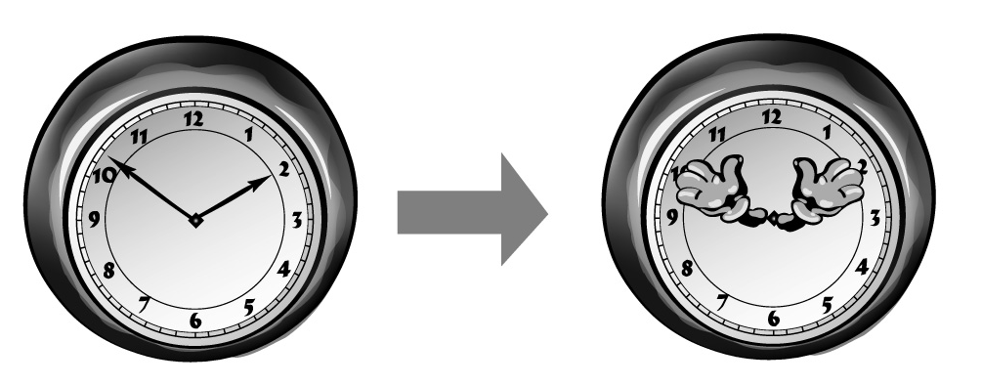 | S | Substitute
 | S | Replace/Change the parts
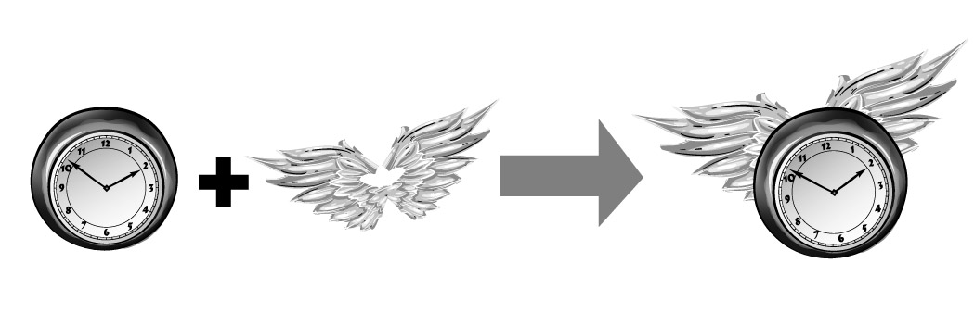 | C | Combine
 | C | Add/Put more things together
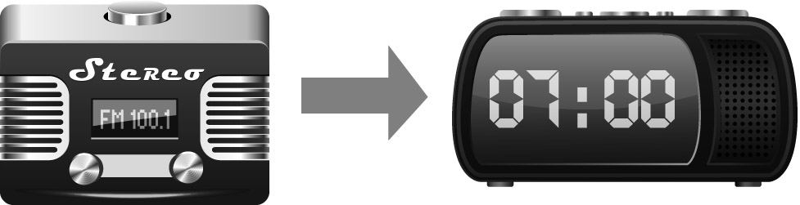  radio radio alarm clock | A | Adapt
 | A | Meet other needs
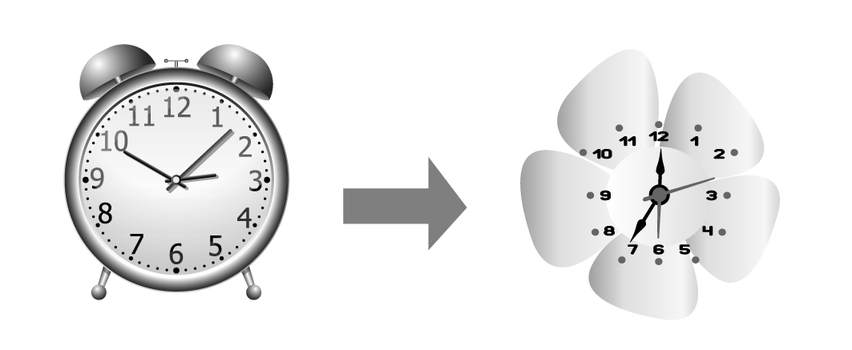 | M | Modify
 | M | Change the look
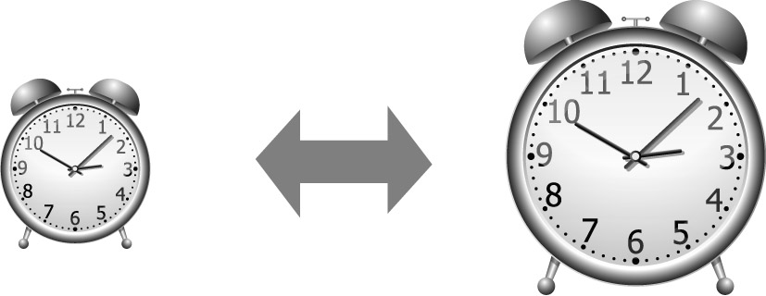 | M | Minify/Magnify
 | M | Change the size
LT 2.1.2

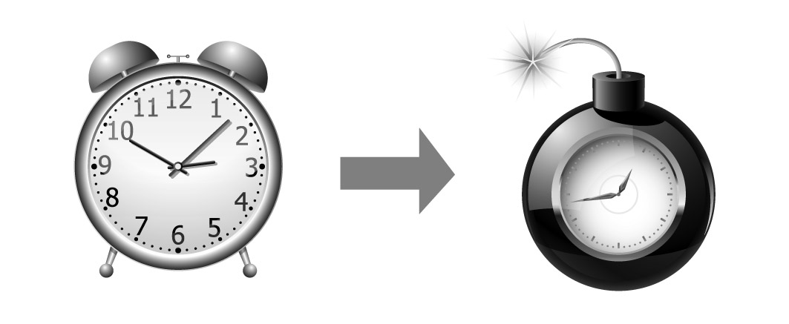 | P | Put to other uses
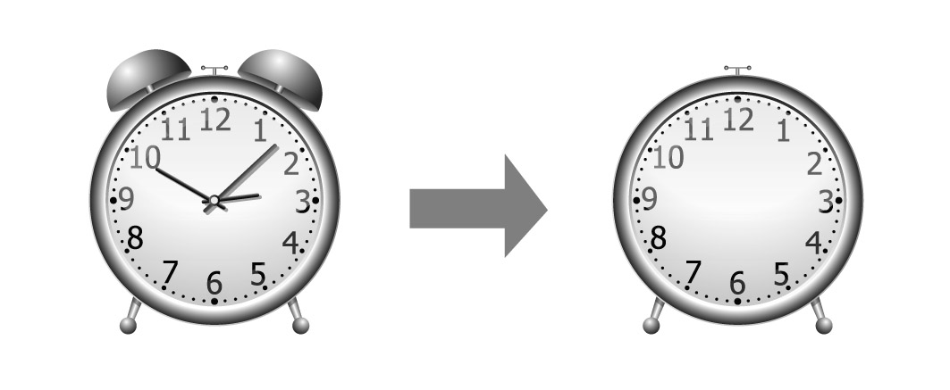 | E | Eliminate
 | E | Delete/Take away some parts
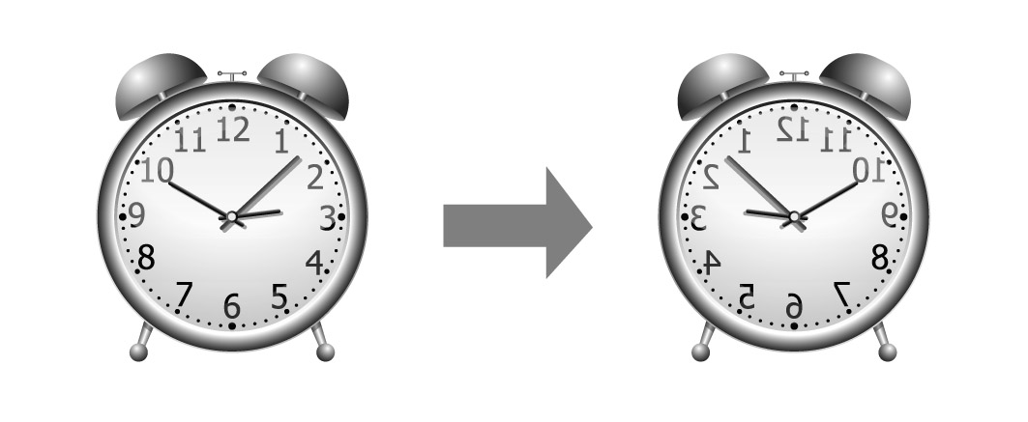 | R | Reverse
 | R | Turn it around
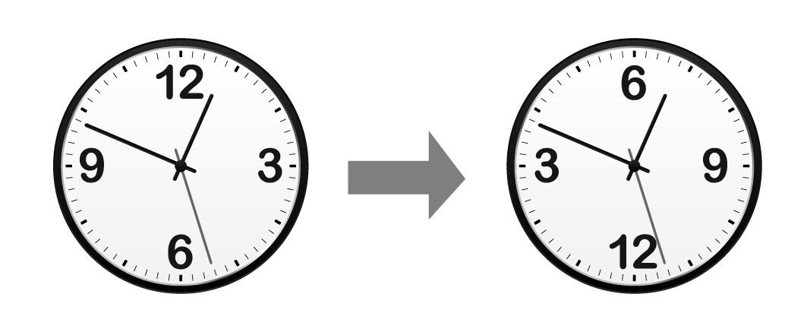 | R | Rearrange
 | R | Change the order

LT 2.1.3
Super Alarm Clock

Draw your Super Alarm Clock and write about its size, shape, look, sound or functions.
I want to get up on time, so I’m going to set
my Super Alarm Clock every night.

Description:
_____________________________________
_____________________________________
_____________________________________
_____________________________________
_____________________________________
_____________________________________
_____________________________________

Super Alarm Clock

Put a tick in the box which shows the method you have used in your invention. You may tick more than one box.
 | Substitute –  Change the parts |  | Combine –  Put things together |  | Adapt –  Meet other needs |  | Modify –  Change the look
 | Minify/Magnify –  Change the size |  | Put to other uses |  | Eliminate –  Take away some parts |  | Reverse/Rearrange –  Change the order

LT 2.1.3
(Answer Keys)
(Accept any reasonable answers)
Super Alarm Clock

Draw your Super Alarm Clock and write about its size, shape, look, sound or functions.
Teachers’ Notes
Teachers should guide pupils to identify what S.C.A.M.P.E.R. techniques they have used in their design.
I want to get up on time, so I’m going to set
my Super Alarm Clock every night.

Description:
The Super Alarm Clock is blue and purple because these are my favourite colours. It is as big as my head and it looks like a pair of headphones. It is made of metal but it is comfortable to wear because it is covered by cotton wool pad. It tells the time. It plays my favourite song to wake me up. It can also vibrate when I choose not to hear
any sounds.

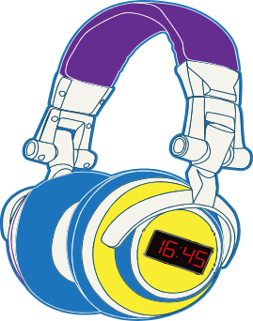

Super Alarm Clock
Magnify - Change the size:
An ordinary alarm clock is usually smaller than one’s head.

Modify - Change the look:
An ordinary alarm clock does not look like a pair of headphones.

Put to other uses: Ordinary headphones do not tell the time.
Eliminate - Take away some parts:
Ordinary headphones are connected to a music player.

Combine - Put things together:
This Super Alarm Clock carries the functions of headphones (to play music), an alarm clock (to tell time and wake people up) and a mobile phone (to vibrate).

Put a tick in the box which shows the method you have used in your invention. You may tick more than one box.
 | Substitute –  Change the parts | ✓ | Combine –  Put things together |  | Adapt –  Meet other needs | ✓ | Modify –  Change the look
✓ | Minify/Magnify –  Change the size | ✓ | Put to other uses | ✓ | Eliminate –  Take away some parts |  | Reverse/Rearrange –  Change the order
LT 2.1.4
A New Invention

Write another thing that you want to do in the new school year. Draw the new invention that can help you achieve that goal. Think of a name for your invention and describe it.
I want to ______________________________,
so ___________________________________
_____________________________________

Description:
_____________________________________
_____________________________________
_____________________________________
_____________________________________
_____________________________________

_________________________

______________________

Put a tick in the box which shows the method you have used in your invention. You may tick more than one box.
 | Substitute –  Change the parts |  | Combine –  Put things together |  | Adapt –  Meet other needs |  | Modify –  Change the look
 | Minify/Magnify –  Change the size |  | Put to other uses |  | Eliminate –  Take away some parts |  | Reverse/Rearrange –  Change the order

LT 2.1.4
(Answer Keys)
(Accept any reasonable answers)
A New Invention

Write another thing that you want to do in the new school year. Draw the new invention that can help you achieve the goal. Think of a name for your invention and describe it.
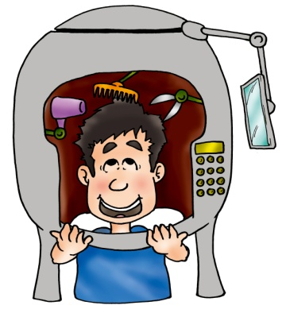
I want to have a tidy hairstyle without spending too
much time, so I am going to use the Helpful Helmet
every morning.

Description:
It is grey and it looks like a helmet. It is much bigger
than my head but it is not heavy. It can do different
things. It can dry and comb my hair. There is a sensor.
If my hair is too long, the scissors inside will cut it.
There is a mirror hanging down from the top of the
helmet for me to see my own hairstyle.

Helpful Helmet
Magnify - Change the size:
An ordinary helmet usually fits the head.
Teachers’ Notes
Teachers should guide pupils to identify what S.C.A.M.P.E.R. techniques they have used in their design.
Combine - Put things together:
The Helpful Helmet puts together a hair-dryer, a comb, a pair of scissors, a sensor and a mirror.
Put to other uses: Ordinary helmets are for safety but the Helpful Helmet is for keeping the hair tidy.

Put a tick in the box which shows the method you have used in your invention. You may tick more than one box.
 | Substitute –  Change the parts | ✓ | Combine –  Put things together |  | Adapt –  Meet other needs |  | Modify –  Change the look
✓ | Minify/Magnify –  Change the size | ✓ | Put to other uses |  | Eliminate –  Take away some parts |  | Reverse/Rearrange –  Change the order
LT 2.1.5

Useful phrases:

It looks like _____________________

There is/are _____________________

It is as __________ as _____________

It can __________________________

