LT 2.5.1

Structure of a Myth

Setting
When?
Where?

Characters
Who?

Solutions
What happened in the end?

Explanation
What beliefs does the story explain?

Events
What happened first?
What happened next?

Problems
What were the problems?


LT 2.5.2

An Intelligent Guess

Before reading about the race, guess the final positions of the animals. Then read to find out if your guesses are right. Give creative reasons to explain why some animals are faster/slower than usual.

What I predict before reading  the myth | Give a star “⬄” to the animal that ran faster than you expected and a cross “X” to the one slower than what you expected. | What I found out after reading the myth
Positions of animals: |  | Positions of animals: | Guess why. Be creative!
1st : |  | 1st : Rat
2nd : |  | 2nd :
3rd : |  | 3rd :
4th : |  | 4th :
5th : |  | 5th :
6th : |  | 6th :
7th : |  | 7th :
8th : |  | 8th :
9th : |  | 9th :
10th : |  | 10th :
11th : |  | 11th :
12th : |  | 12th :
13th :

LT 2.5.2
(Answer Keys)

An Intelligent Guess

Before reading about the race, guess the final positions of the animals. Then read to find out if your guesses are right. Give creative reasons to explain why some animals are faster/slower than usual.

What I predict before reading  the myth | Give a star “⬄” to the animal that ran faster than you expected and a cross “X” to the one slower than what you expected. | What I found out after reading the myth
Positions of animals: |  | Positions of animals: | Guess why. Be creative!
1st : |  | 1st : Rat
2nd : |  | 2nd : Ox
3rd : |  | 3rd : Tiger
4th : |  | 4th : Rabbit
5th : |  | 5th : Dragon
6th : |  | 6th : Snake
7th : |  | 7th : Horse
8th : |  | 8th : Ram
9th : |  | 9th : Monkey
10th : |  | 10th : Rooster
11th : |  | 11th : Dog
12th : |  | 12th : Pig
13th : |  | Cat is out of the game

LT 2.5.3
Interviewing Different Runners to Find out More about the Race

Part 1
Draw or write the names of all animals on the running tracks to help you see their final positions. It will also help you do the interview in Part 3.

 |  |  |  |  |  |  |  |  |  | 12
11

 | 10
 |  | 9
 |  |  |  |  |  |  |  |  | 8
 |  |  |  |  |  |  |  | 7
 |  |  | 6
 |  |  |  | 5
 |  |  |  | 5 |  |  | 4
 |  |  |  |  | 3
 |  |  |  |  |  | 2

1st
FINISHING LINE
LT 2.5.3
(Answer Keys)

Interviewing Different Runners to Find out More about the Race

Part 1
Draw or write the names of all animals on the running tracks to help you see their final positions. It will also help you do the interview in Part 3.

12

Pig
11

Dog
10
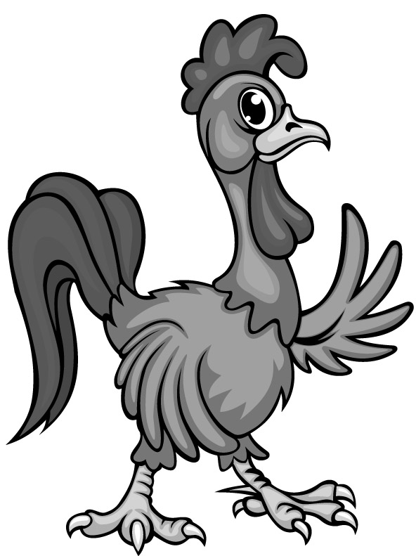
Rooster
 |  | 9    Monkey |  |  |  |  |  |  | 8  Ram
 |  |  | 6    Snake |  |  |  |  | 7    Horse
 |  |  |  | 5    Dragon |  |  | 4    Rabbit
 |  |  |  |  | 3    Tiger | 2  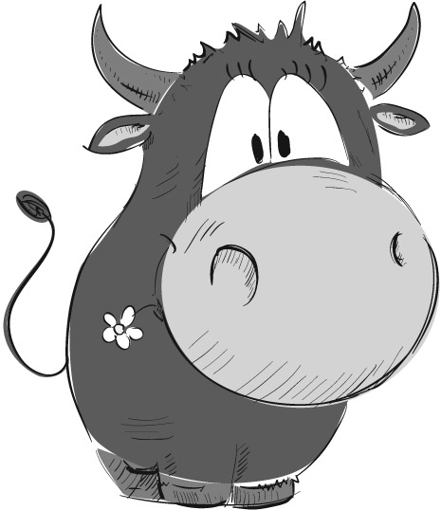  Ox
Rat
FINISHING LINE
LT 2.5.3
Part 2
Buddha found the results strange. Take on the role of one animal you like.
- Recall what happened in the race and fill in the role card.
- Use it to help you answer other animals’ questions in the interview in Part 3.

e.g. I ran faster than usual in the race. I have been running marathons for a year! I have also changed my diet. The organic carrots from Farmer Lee make me stronger and more powerful.

Example:
My Role Card
*

(*Circle the animal role you would like to take)
Think about what happened during the race. Other animal runners are going to interview you.
My performance
- Result of the race: 4th position

- I was *faster/slower than usual because I have been running marathons for a year. I have also changed my diet. The organic carrots from Farmer Lee make me stronger and more powerful.

- I *cheated/ did not cheat in the race.

My Role Card
*
(*Circle the animal role you would like to take)
Think about what happened during the race. Other animal runners are going to interview you.
My performance
- Result of the race: _____ position

- I was *faster/slower than usual because ____________________________________________
_____________________________________________________________________________

- I *cheated/did not cheat in the race.

LT 2.5.3
Part 3
Which animals showed unusual performance in the race? Interview two of them to find out their reasons. Do you believe them? You may refer to Part 1 to look at their positions in the race.

Note Card

I interviewed _______________ and _______________ to find out why their performance
was unusual in the race.

- ____________________ did very *well/badly  because _______________________________  ______________________________________  - I *believe/don’t believe ____________________  because _______________________________  ______________________________________  ______________________________________  ______________________________________  (*Circle the right words) | - ____________________ did very *well/badly  because _______________________________  ______________________________________  - I *believe/don’t believe _____________________  because _______________________________  ______________________________________  ______________________________________  ______________________________________  (*Circle the right words)
◻ None of the animals was trying to cheat. They __________________________________________________________
◻ Both ______________ and ______________ were trying to cheat. They __________________________________________________________
◻ Only ______________ was trying to cheat. He ____________________________________
__________________________________________________________
(☑Tick the right box to describe the result of the interview)

LT 2.5.4
Getting Ready to Tell the Truth about the Race

You will write about the race in the format of a journal entry (LT 2.5.6). Buddha will be your audience. Use the questions below to help you organise what happened during the race. Refer to the information on the Note Card to help you as well (LT 2.5.3).
 | Topic: The Truth about the Race
Role | Did you run faster/slower than usual? | What made you run unusually fast/slow? | Did others run faster/slower than usual? Why? | Find out/Guess how some animals cheated in the race.
Animal  __________  Position:  _______  Did you cheat? Why/Why not?  (How did you cheat?) |  |  |  |   (What did you see, smell and hear?)

LT 2.5.4
(Example)
Getting Ready to Tell the Truth about the Race

You will write about the race in the format of a journal entry (LT 2.5.6). Buddha will be your audience. Use the questions below to help you organise what happened during the race. Refer to the information on the Note Card to help you as well (LT 2.5.3).
 | Topic: The Truth about the Race
Role | Did you run faster/slower than usual? | What made you run unusually fast/slow? | Did others run faster/slower than usual? Why? | Find out/Guess how some animals cheated in the race.
Rabbit  Position:  4th  Did you cheat? Why/Why not?  (How did you cheat?)  No, I didn’t cheat! Games should be fair. I don’t want to upset Buddha and others. | I was faster than usual. | - I have been running marathons for a year!  - I have also changed my diet. The organic carrots from Farmer Lee make me stronger and more powerful. | Two animals were unusually slow!  - Horse forgot to use blinkers for his eyes. He was so busy looking everywhere that he missed the finishing line.  - Poor Dragon had a cold. His runny nose meant he couldn’t breathe out fire. He sneezed a lot and became slow. | (What did you see, smell and hear?)  - I heard that Ox cheated others. He started running before Buddha blew the whistle!  - I saw Rat cheating Ox. He jumped onto Ox’s head at the beginning but slid off to cross the finishing line in the end.

LT 2.5.5
Finding Solutions to the Problem of the Unfair Race

If Buddha cannot arrange a new race for all animals to join, how can the problem of the unfair race be solved? In your group, brainstorm other solutions to the problem of the unfair race.
What solutions do we need?

Problem with Rat
Should Rat be punished? Why/Why not?

Problem with the zodiac cycle
Should Buddha use the results of the race to decide on the order of the zodiac animals? Why/Why not?

Problem with Cat
Should Cat be given a place in the cycle? Why/Why not?

Brainstorming solutions:
Some examples:
- Take Rat’s name off the zodiac cycle because he cheated.
- Give poor Cat a place in the cycle because…
- Hold the same race again to decide on the order of the animals because…
- Hold a lucky draw to come up with a new order of the animals for the cycle because…
- Other suggestions…

Solutions:
Problem with Rat

Problem with Cat

Problem with the zodiac cycle

LT 2.5.6
Telling the Truth about the Unfair Race

In the format of a journal entry, tell the truth about the unfair race you saw in your animal role. Let Buddha be your audience. Suggest how the problems of the unfair race can be solved.
What do we have in the Beginning, Middle and Ending of a journal entry? Fill in the boxes. You can refer to the organiser (LT 2.5.4) for details about the race.

  My Journal | 21st January XXXX  Setting:  When did you have the race?  Characters:  Who ran the race?  Importance of the race to the animals:  Why did so many animals join the race?  Wednesday
Buddha let us run a special race in the field. I ran with __________________
_________________________________________________________________.
The winners would __________________________________________________.
The champion would start the cycle.
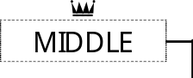
At the beginning of the race, ____________________________________ _______________________________________________________________________________________________. I was faster/slower than usual. I know why! ___________________________________________________________
Sequence of events:
Did you run faster/ slower than usual? Why?

Did others run faster/ slower than usual? Why?

________________________________________________________________
_______________________________________________________________.
Half way down the race, I was even faster/slower than _______________
and ______________. They ran faster/slower than usual today. _____________
________________________________________________________________
________________________________________________________________

LT 2.5.6

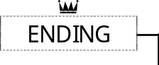
In the end, Rat was the champion, but he cheated. Rat ______________
_______________________________________________________________ ______________________________________________. The game was unfair!
Feelings/Views/ Solutions:
What was the result of the race? How did you feel?

Did you see anyone cheat? How and why did he/they cheat?

What solutions do you suggest?
I think __________________________________________________________
________________________________________________________________ ________________________________________________________________ ________________________________________________________________ ________________________________________________________________.
I hope my suggestions will be accepted!

(Animal’s name)
Signature

