LT 2.6.1
Suggested comprehension questions (with answers)
- What kind of job did Mr Wolf do that day? (Delivering letters as the Storyland Postman)

- Did Mr Wolf blow down Little Pigs’ houses on purpose? (No)

- What did he get for all his kindness? (A sizzled tail and a nasty story)

- What did he call himself? (The Big SAD Wolf)

- Was Mr Wolf bad? (No)

- How would you describe him? Why do you think so? (Kind/Helpful/Responsible; because he helped the Jolly Postman to deliver the letters/ because he tried to blow out the fire outside Little Pig Two’s house/ because he was doing all he could to deliver cards to Little Pig Three)
LT 2.6.2

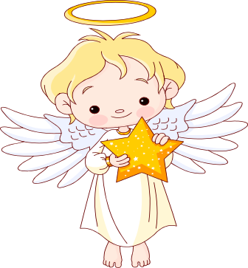
Storyland Baddies Tell the Truth (1)

Do storybooks say unkind things about you?
Don’t miss the chance to tell us your true story!

Take on the role of one Storyland baddie. Try to think from his/her point of view and explain his/her wrongdoing(s).
Example:
Story | Baddie | Wrongdoings | Your experience/  suggestions | New reasons behind the wrongdoings
The Three Little Pigs | Mr Wolf | I puffed Little Pig Two’s house of sticks down. | When would you huff and puff or blow at things?  - catch a cold  - blow out candles  - blow onto food/ drinks to cool it down | - I caught a bad cold. I sneezed outside his house and blew it down.  - I saw a fire outside his house. I huffed and puffed very hard and the house was blown down.
The Three Little Pigs | Mr Wolf | I climbed down the chimney of Little Pig Three’s house. | Why would you climb down a chimney?  - deliver presents like Santa does | - There wasn’t a letter box in his house and no one would let me in, so I climbed down the chimney to give Little Pig Three his cards.
LT 2.6.2
Now, work in groups. Try to put yourself in one of the baddies’ shoes and think of the truth behind his/her wrongdoing(s).
Story | Baddie | Wrongdoing(s)
Goldilocks and the Three Bears | Goldilocks | I broke Baby Bear’s chair.
Goldilocks and the Three Bears | Goldilocks | I went into Mr Bear’s house without permission.
Cinderella | The ugly sisters | We asked Cinderella to do all the housework.
Cinderella | The stepmother | I did not let Cinderella go to the ball.

Story | Baddie | Wrongdoings | Your experience/ suggestions | New reasons behind the wrongdoings

LT 2.6.3
Storyland Baddies Tell the Truth (2)

Take on the role of a Storyland baddie. Others have misunderstood you and think that you are bad. Write a letter to the editor of “Storyland News” or another character in the story to explain why you did something wrong and tell him/her that you are not bad at all. Use your ideas in LT 2.6.2 or come up with some other new ideas.

Think about the four elements of a piece of writing:

Role | A Storyland baddie –  ______________________ in the story of ______________________
Audience | Choose one:  The editor of “Storyland News” OR  Another character in the story (Name the character: ______________________)
Format | A letter
Topic | I am not bad. (Explain what you did in the story and why you did it)

LT 2.6.3
Plan your writing.
Greeting:
Who are you writing to?
How do you greet him/her?

I _________________________________.
___________________________________
___________________________________.
People have misunderstood me and think that I ______________________________.
I feel ______________________________.

Introduction:
What did you do wrong?
When/Where did it happen?
What do people think about you?
How do you feel?

List different reasons to explain your bad behaviour:
______________________________________________________________
______________________________________________________________
_______________________________
_______________________________
Choose one reason which you think is interesting and special. Use it to write the letter.
I choose reason ________.
More details about this reason:
__________________________________
__________________________________

Body:
Why did you do the wrong thing?

Ending:
What do you want him/her to do?
I hope you can _______________________
___________________________________.
Closing:
How would you end a letter?
LT 2.6.3
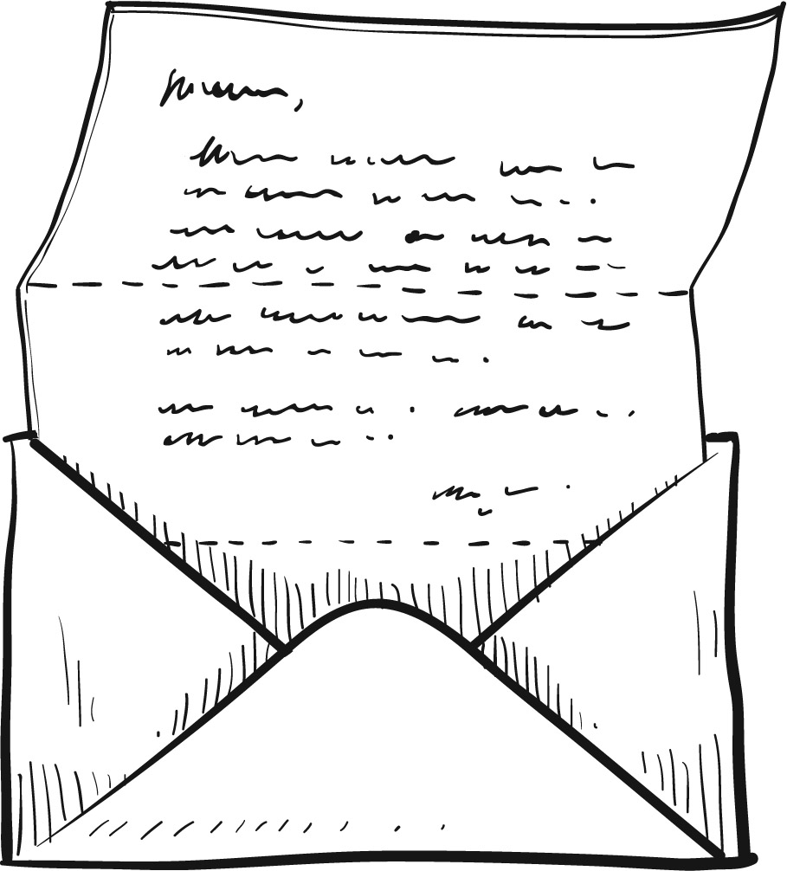


Write your letter in the space below.

Dear _____________________________,
______________________________________________________________________________________________________________________________________________________________________________________________________________________________________________________________________________________________________________________________________________________________________________________________________________________________________________________________________________________________________________________________________________________________________________________________________________________________________________________________________________________________________________________________________________________________________________________________________________________________________________________________________________________________________________________________________________________________________________________________________________________________________________________________________________________________________________________________________________________
__________________________________________________________________________
_________________________________,
_________________________________
LT 2.6.4
A New Fairy Tale

Look at this powerful “Creative Story Machine”. It can give you ideas for a special and interesting story!
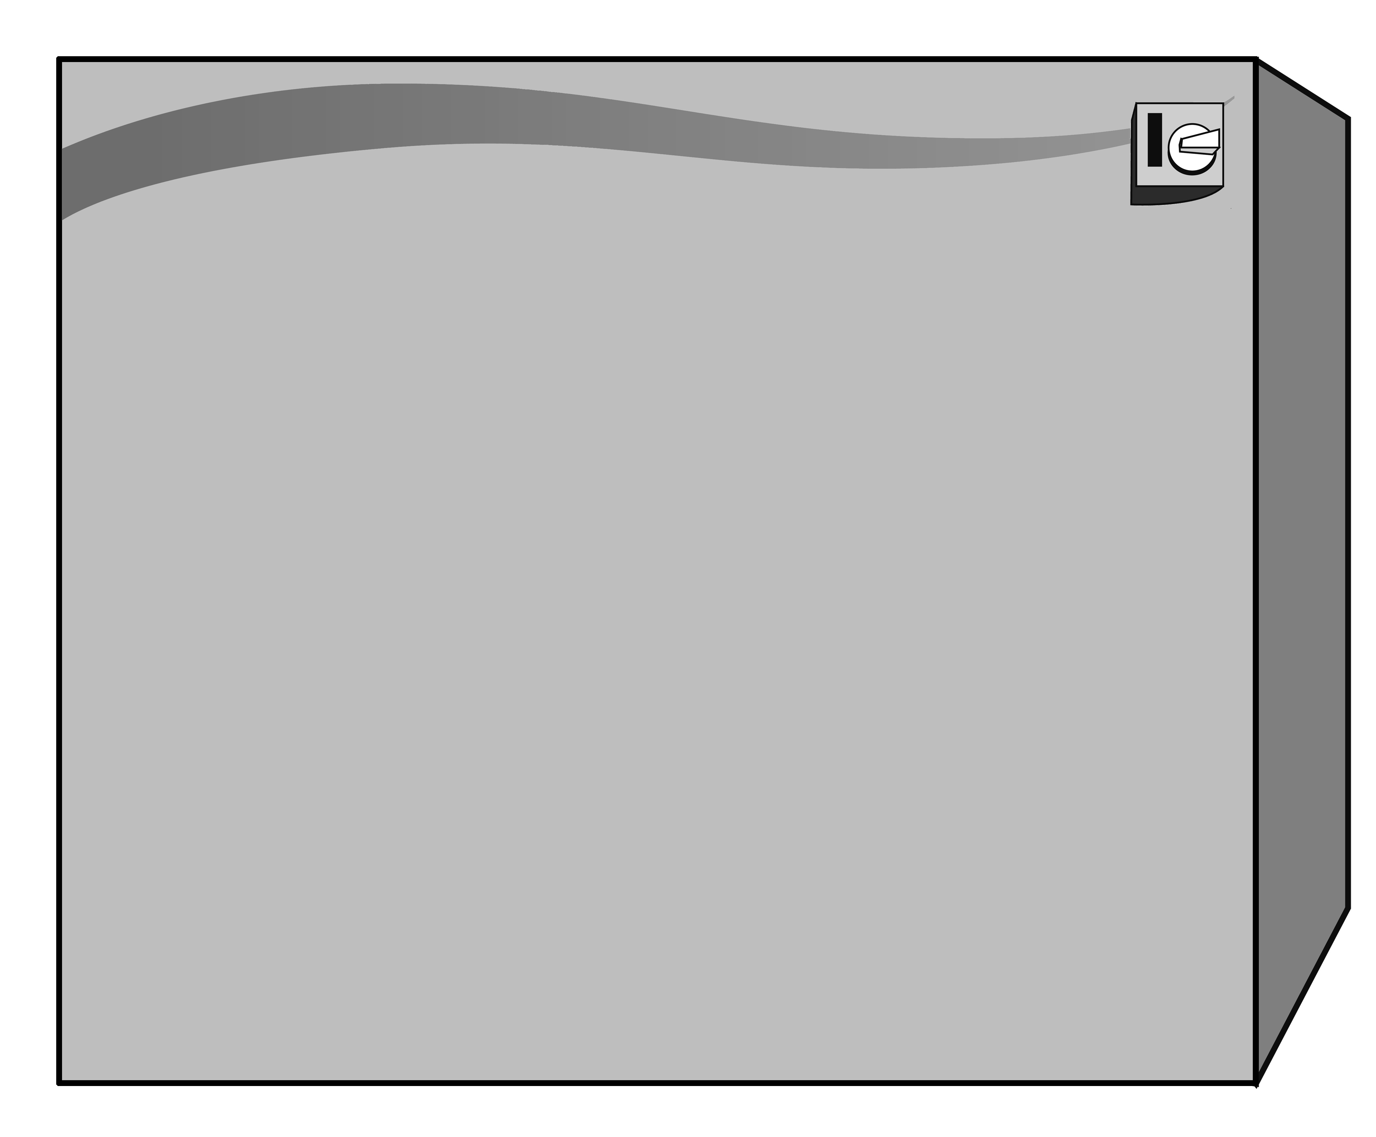
Use a 4-digit number to get one item from each of the four columns of the machine. Then combine the items to make an unusual story.

Creative Story Machine
 | Character 1 | Character 2 | Where | What
1 | Mother Bear | Mr Wolf | palace | beanstalk
2 | Father Bear | Red Riding Hood | bears’ house | glass shoes
3 | Baby Bear | ogre | forest | magic wand
4 | stepmother | Jack | ogre’s house | porridge
5 | stepsister(s) | Cinderella | brick house | gold coins
6 | Snow White | fairy godmother | stick house | pumpkin
7 | witch | prince | straw house | goose which laid golden eggs
8 | Little Pig One | Goldilocks | garden | poisonous apple
9 | Little Pig Two | Beast | Jack’s house | chimney
0 | Little Pig Three | Aladdin | cave | flying carpet

See what I have got:
3151 — Baby Bear - Mr Wolf - the brick house - beanstalk
Here is my story:
Naughty Baby Bear took a sword and chased old Mr Wolf. Mr Wolf saw a giant beanstalk and hid behind it. Baby Bear saw him and Mr Wolf tried to run away. He saw a brick house and went in through the chimney. Poor Mr Wolf did not know the house was Baby Bear’s. When he climbed down the chimney, Baby Bear was sitting on the sofa, waiting for him.
LT 2.6.4

Are you ready for some really funny stories?
Now try playing with any interesting combinations and plan your story!
 | Combination
A 4-digit number | Character 1 | Character 2 | Where | What
Plan your story:

Story Title: _________________________________________________
___ _______________
Characters

Setting

Now, it’s time for you to write your own story using an interesting combination from the

Events/Problems

Ending/Solution

LT 2.6.4
______________________________________________________________________________________________________________________________________________________________________________________________________________________________________________________________________________________________________________________________________________________________________________________________________________________________________________________________________________

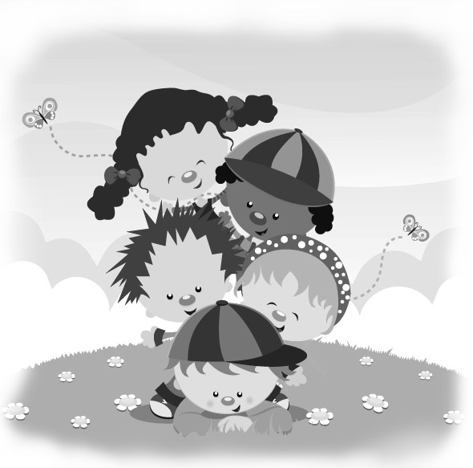
Write your story in the space below.
Tell us your great story!

Title: _________________________________________________________
________________________________________________________________
________________________________________________________________
________________________________________________________________
________________________________________________________________
________________________________________________________________
________________________________________________________________
________________________________________________________________
________________________________________________________________
________________________________________________________________
________________________________________________________________
________________________________________________________________
________________________________________________________________
________________________________________________________________
________________________________________________________________
________________________________________________________________
________________________________________________________________
________________________________________________________________
________________________________________________________________
________________________________________________________________
________________________________________________________________
________________________________________________________________
________________________________________________________________
________________________________________________________________

LT 2.6.4
________________________________________________________________
________________________________________________________________
________________________________________________________________
________________________________________________________________
________________________________________________________________
________________________________________________________________
________________________________________________________________
________________________________________________________________
________________________________________________________________
________________________________________________________________
________________________________________________________________
________________________________________________________________
________________________________________________________________
________________________________________________________________
________________________________________________________________
________________________________________________________________
________________________________________________________________
________________________________________________________________
________________________________________________________________
________________________________________________________________
________________________________________________________________
________________________________________________________________
________________________________________________________________
________________________________________________________________
________________________________________________________________
________________________________________________________________

Self Assessment
Put a ‘✓’ in the box to show how well you did.
I can… | Excellent | Good | OK | Not so good
tell where and when the story happened
describe the main characters in the story
think of interesting and unusual events
provide an ending
write in paragraphs
use the correct tense
use the correct spelling
use adjectives to describe the characters

