LT 2.6

Part A: Video watching

Miss Leung is teaching you how to make a gift box. What stationery and materials does she need to make it?

Tick ☑ the things Miss Leung needs to make a gift box.

1.  □ a ribbon | 2.  □ an old shoe box | 3.  □ glue
4.  □ glitter | 5.  □ a pair of scissors | 6.  □ sticky tape
7.  □ cardboard | 8.  □ wrapping paper | 9.  □ crayons
    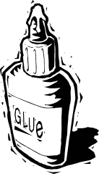  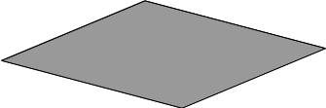    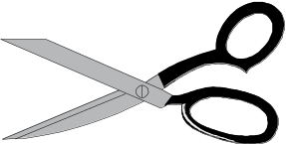    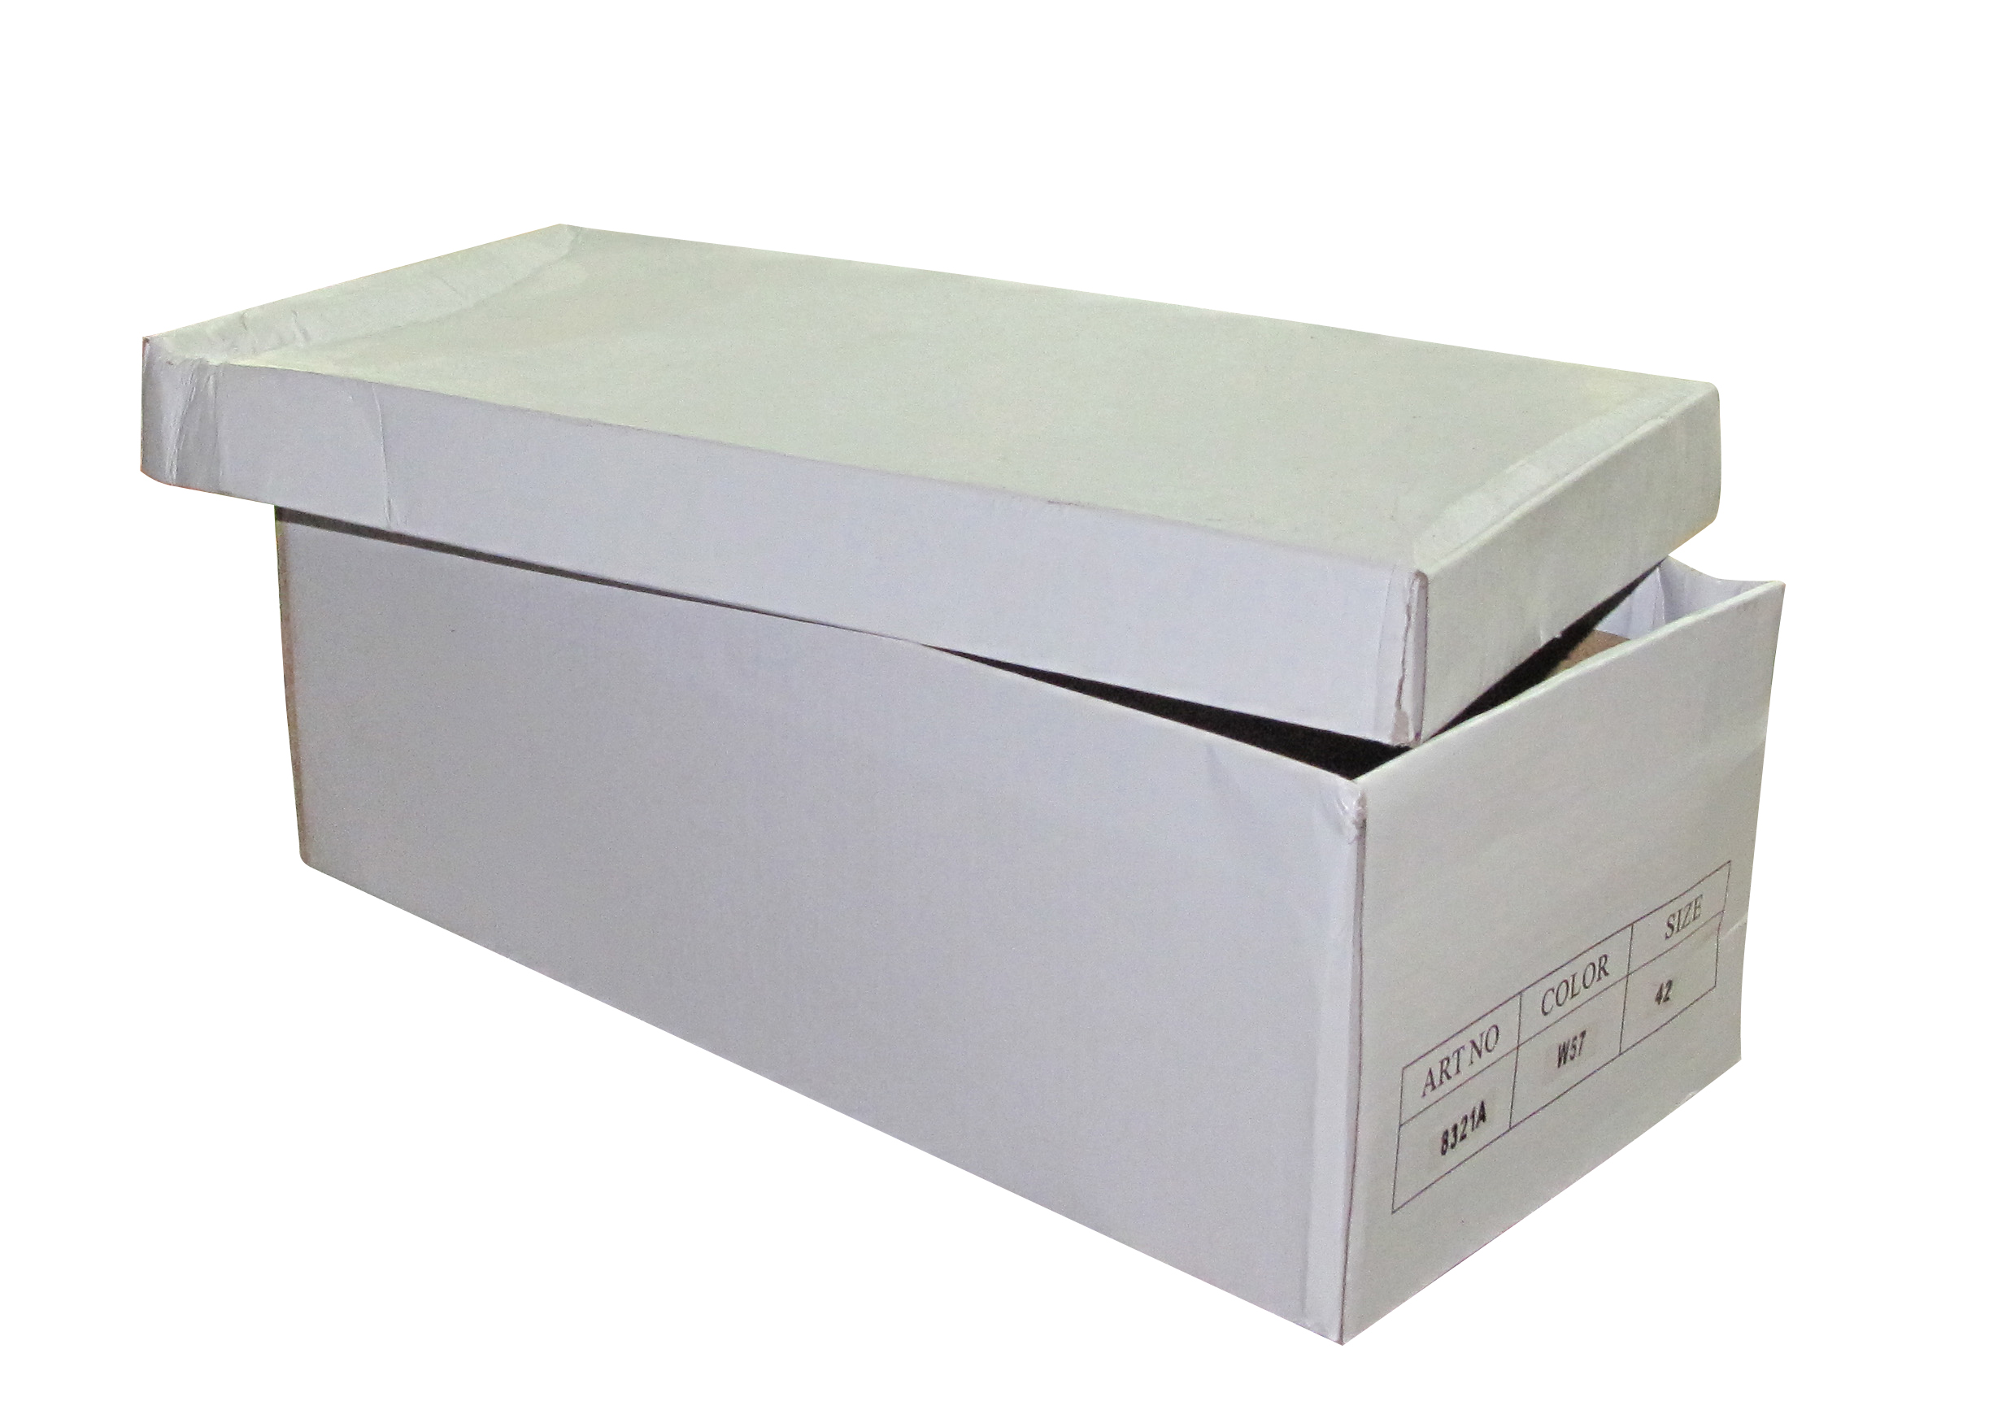  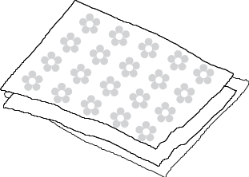    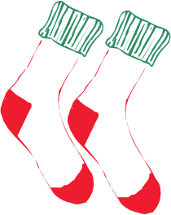    10.  □ magazines and newspapers | 11.  □ paintbrushes | 12.  □ old socks

LT 2.6

Part B: Listening

Listen to what Miss Leung says and complete the steps of making a gift box.

wrapping paper

magazines newspapers

sticky tape

glue remove cut
decorate wrap

* You can use the words more than once.

- the cover from the old shoe box.
- the shoe box and the cover with
and .
- out some pictures of your favourite singer, actor, animal or food from or newspapers.
- the pictures onto the shoe box and the shoe box cover.

LT 2.6
(Answer Keys)

Part A: Video watching

Miss Leung is teaching you how to make a gift box. What stationery and materials does she need to make it?

Tick ☑ the things Miss Leung needs to make a gift box.

1.  □ a ribbon | 2.  ☑ an old shoe box | 3.  ☑ glue
4.  □ glitter | 5.  ☑ a pair of scissors | 6.  ☑ sticky tape
7.  □ cardboard | 8.  ☑ wrapping paper | 9.  □ crayons
10.  ☑ magazines and newspapers | 11.  □ paintbrushes | 12.  □ old socks

LT 2.6
(Answer Keys)
Part B: Listening

Listen to what Miss Leung says and complete the steps of making a gift box.

wrapping paper

magazines newspapers

sticky tape

glue remove cut
decorate wrap

* You can use the words more than once.

- Remove the cover from the old shoe box.
- Wrap the shoe box and the cover with wrapping paper
and sticky tape .
- Cut out some pictures of your favourite singer, actor, animal or food from magazines or newspapers.
- Glue the pictures onto the shoe box and the shoe box cover.

