LT 3.11

Your teacher is writing an e-mail to her friend, Lily, who will come to visit Hong Kong.



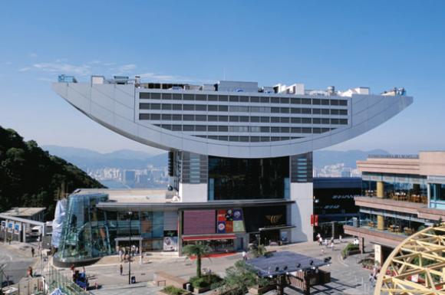
New Message | Reply | Forward | Send | Attach Files

To: Lily
From:
Date: Friday, 18th May, 3:00 p.m.
Subject: The trip in Hong Kong
Dear Lily ,

I have made plans for your trip in Hong Kong. On Day 1, we will have
a tour. , we will go to
. We will go there .
We will .

.

LT 3.11

On Day 2, we will have a .
, we will go to . We will go there
. We will
.

On Day 3, we will have

I hope you will enjoy this trip in Hong Kong.
See you soon!
Lots of love,

* Photo source: Hong Kong Tourism Board

LT 3.11
(Teacher’s Script and Answer Keys)

Script for Dicto-comp

Now, you are going to listen to the e-mail that I have written to Lily. Fill in the missing parts for Day 1 and Day 2. Then design the itinerary for Day 3.

I have made plans for your trip in Hong Kong. On Day 1, we will have a shopping and dining tour. First, we will go to Causeway Bay. We will go there by bus. We will visit the shopping malls. Then, we will have dinner at the floating restaurant in Aberdeen.

On Day 2, we will have a sight-seeing tour. First, we will go to Tsim Sha Tsui. We will go there by minibus. We will watch the light and sound show at night.

Now, suggest a tour for Day 3* and write the itinerary.

* For Day 3, accept any reasonable answers.

