H.K.R.S.S. Tuen Mun Primary School (2008 – 2009)
Worksheet 4 - Animal poem (P4)

Prince Froggie is going to listen to a poem. Which pictures is the speaker talking about? Put a  in the correct boxes.

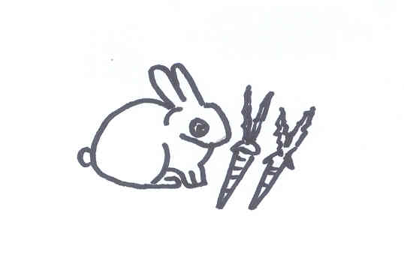  1 | 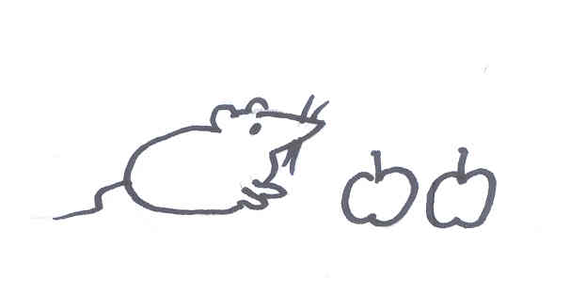  a | b | 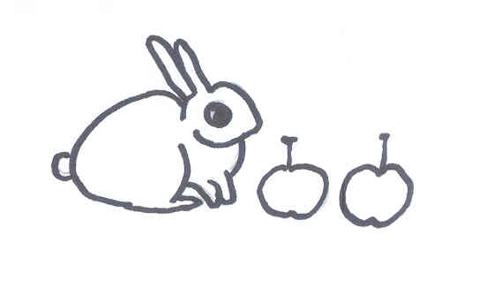  c | 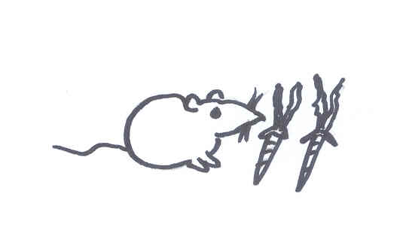  d
 | □ | □ | □ | □

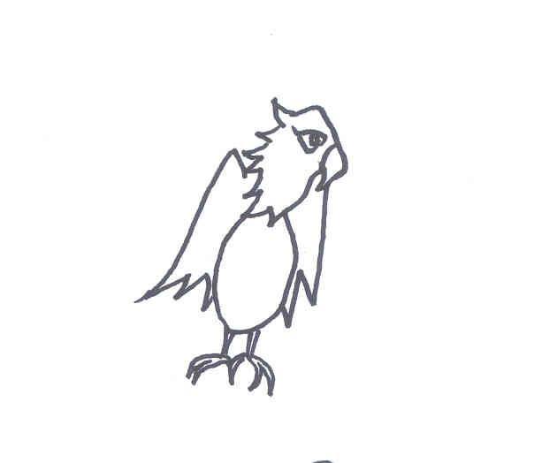  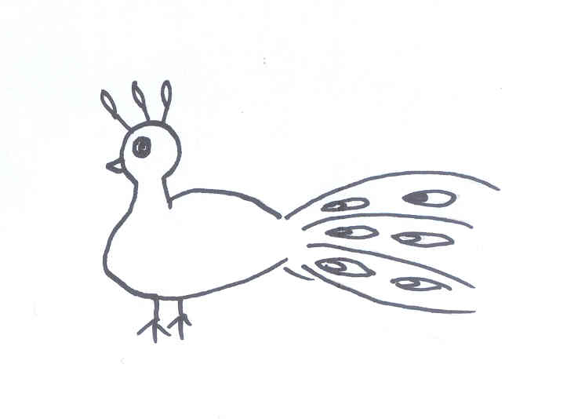  2 | 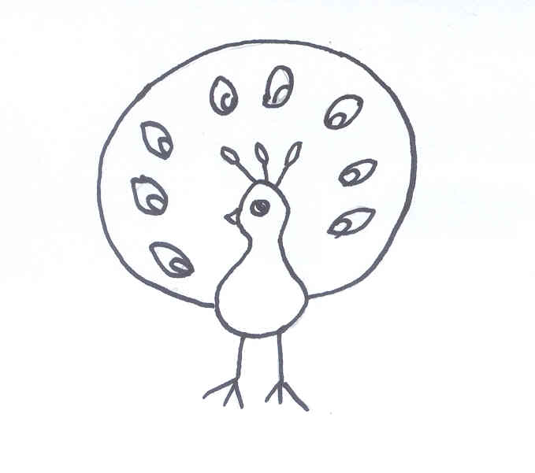  a | b | 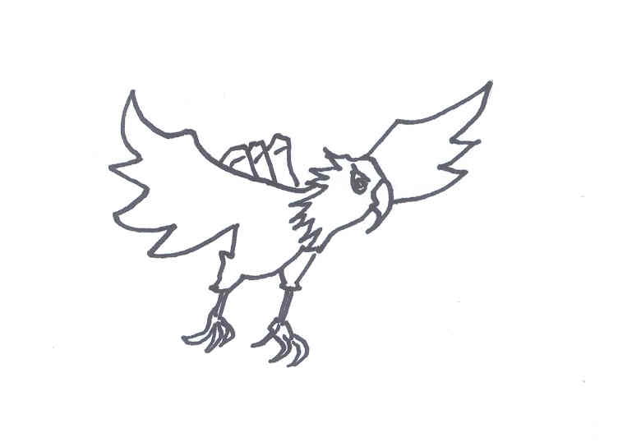  c | d
 | □ | □ | □ | □
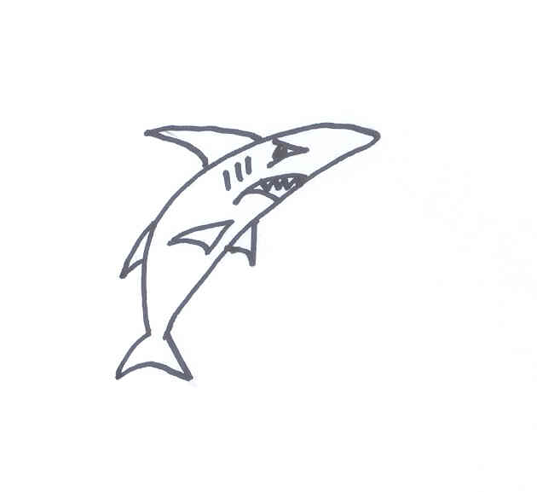
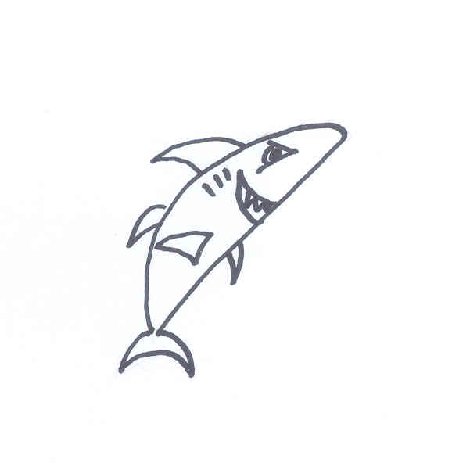
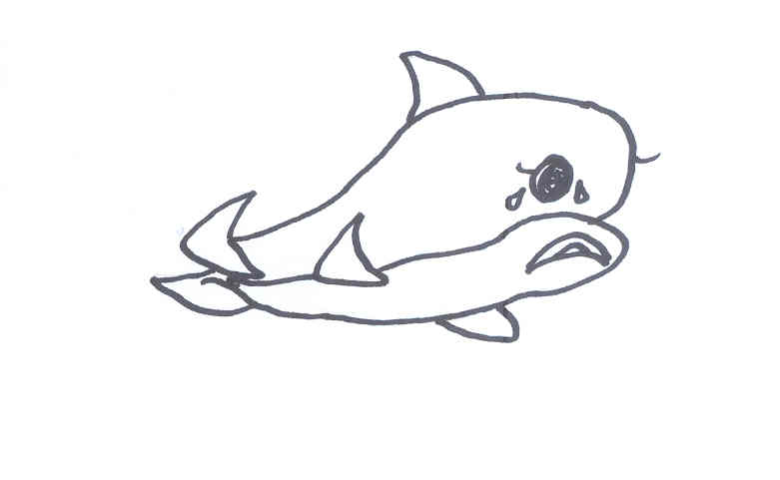  3 | a | b | 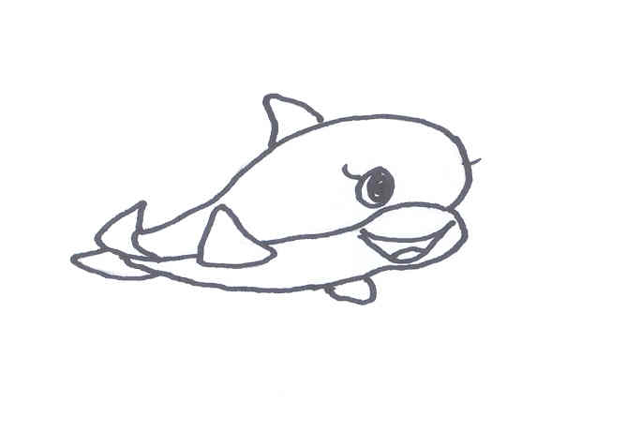  c | d
 | □ | □ | □ | □
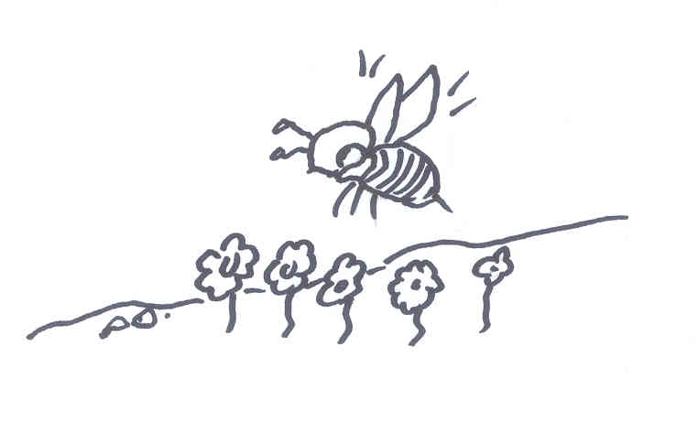
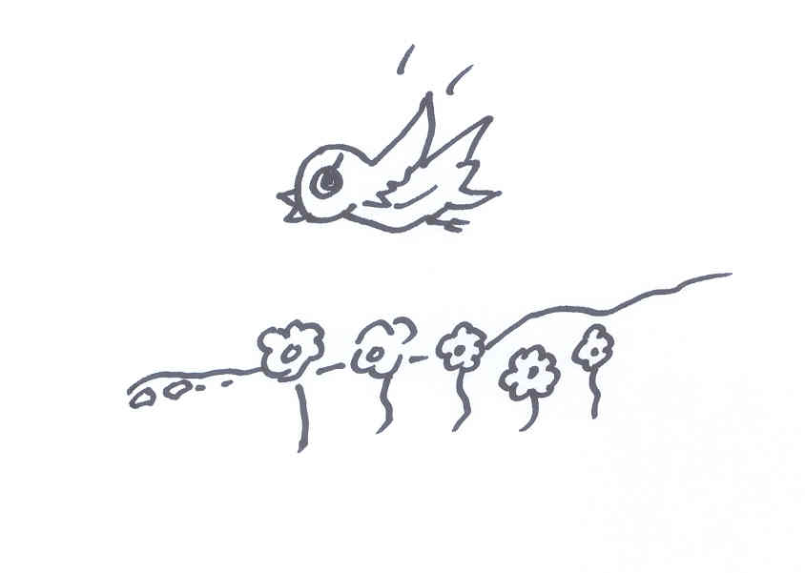  4 | 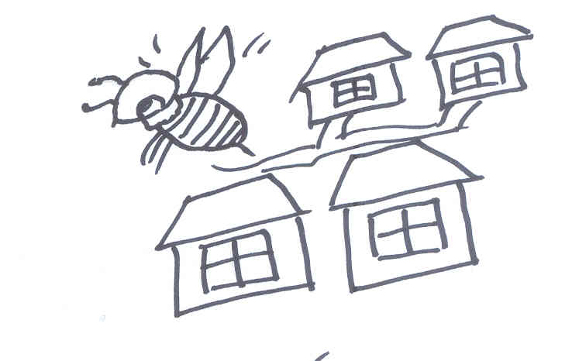  a | 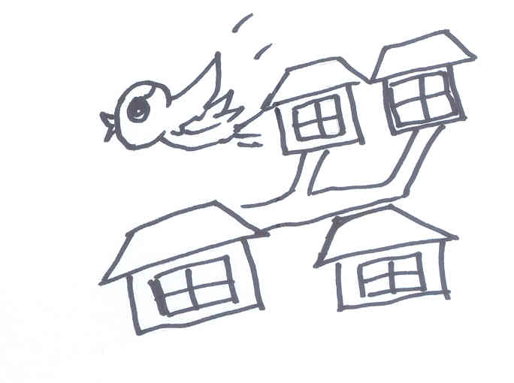  b | c | d
 | □ | □ | □ | □

Transcripts:

Lovely, white rabbit, eating fresh carrots
Big, pretty bird, opening up its tail
Clever, friendly fish, smiling at us all
Little, yellow insect, flying in the park

