3. Selected strategies

Modification:
- Allow free choices of language in writing.
- Minimize the level of language output required for a task
Remediation:
- Adapt a reading passage to a level appropriate to the abilities and interest of the students
- Provide interesting templates for an understanding of the target genre.

3. Sept 07  Unit:  Changes at home | Making book marks  Each student makes a book mark and indicates their expected ‘changes’ in the year in the bookmark using the sentence pattern: ‘I am going to…’ At the start, they choose one target and suggest some actions to achieve them:  This is a difficult task since students have to ‘think’ and make suggestions. They need to use common sense, and world knowledge. Students may write their ideas in English or Chinese. Then their teacher will help them translate the content into English for the Chinese content if necessary. The students are more willing to ‘think’ about their target changes.
  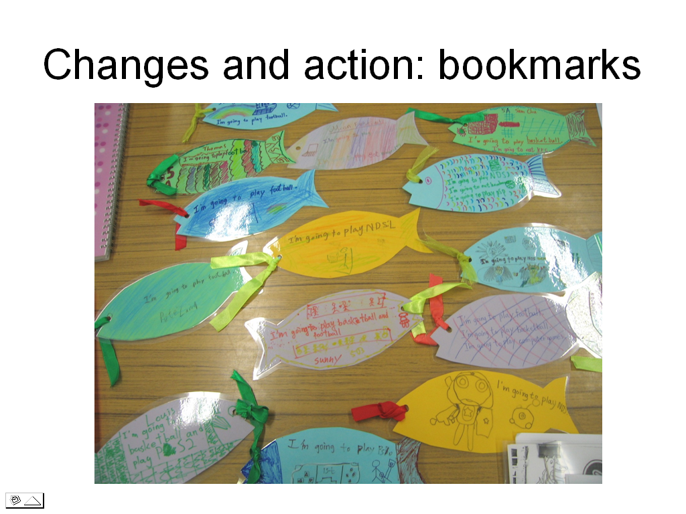
Reading comprehension

The reading passage is dense in text and long in length. The dyslexic students and the less able students in the class could not manage as they were apt to give up when they see the text.

To help the students, the teachers made a copy of the illustrations in a larger size, and these became comic strips.

The teachers then selected six sentences, which largely told the storyline and they matched the illustrations in the passage. The sentences thus became the captions of the comic strips

Instead of struggling with a long and dense text, the students only read comic strips and did matching with pictures and captions.

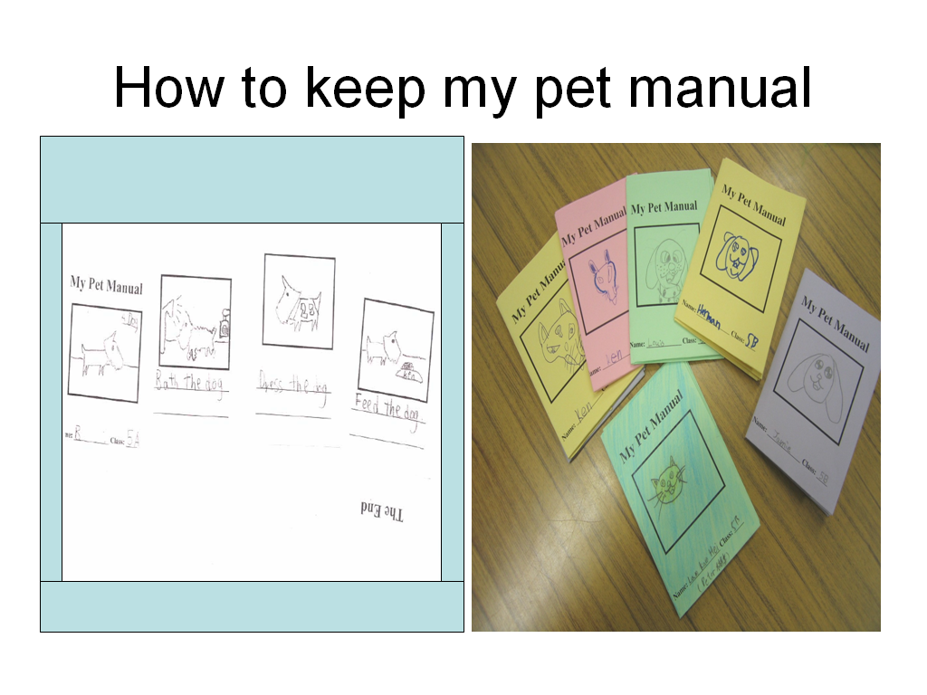 | Each group makes a pet keeping manual.  They fill in the pages with the use of the target sentence pattern and draw some pictures as illustrations  To help students understand the word ‘manual’, the teachers made a mini template of manual for each student.  Students were guided through repeated exercise on the vocabulary before doing the manual writing.  The task was modified to minimize the level of language output to a phrase for each caption only.  Furthermore, the art talent of some students was tapped through drawing and colouring their chosen pet.

