Name: _________________________________ Class: ______ No. ______
Healthy Diet Project
Worksheet 1 - “Jamie’s School Dinners”

- Where do you have your lunch?
____________________________________________________
- What do you usually eat?
_____________________________________________________
- Do you think your lunch is healthy?
_____________________________________________________
- Can you name these fruits and vegetables in Chinese?

A  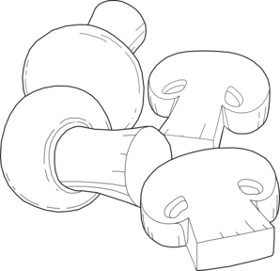 |   B | C  | D 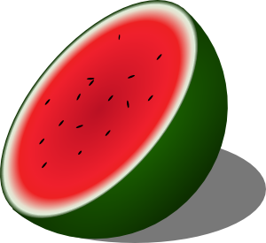 |   E

- Can you match them with their English names?
durian _____
mushrooms _____
leeks _____
watermelon _____
asparagus _____

- Who is Jamie Oliver?
  - A teacher
  - A writer
  - A chef
  - A singer

- What does he want British schoolchildren to do?
  - study harder
  - eat a healthy diet
  - do more sports
  - be quiet and listen to him

- What can Jamie do next to persuade the children to do what he wants? Talk to your partner and write down 2 ideas.

1.____________________________________________________

2.____________________________________________________
Healthy Diet Project
Worksheet 2 – All wrapped up

When you go to buy something in a shop, do you look at the box or packet first? Do you buy things that have attractive packaging? Let’s take a look at some wrappers, packets and boxes to see what information is written there and decide what makes them attractive.

Here is an example of a packet. Look at it carefully and answer the questions below.

Front Back
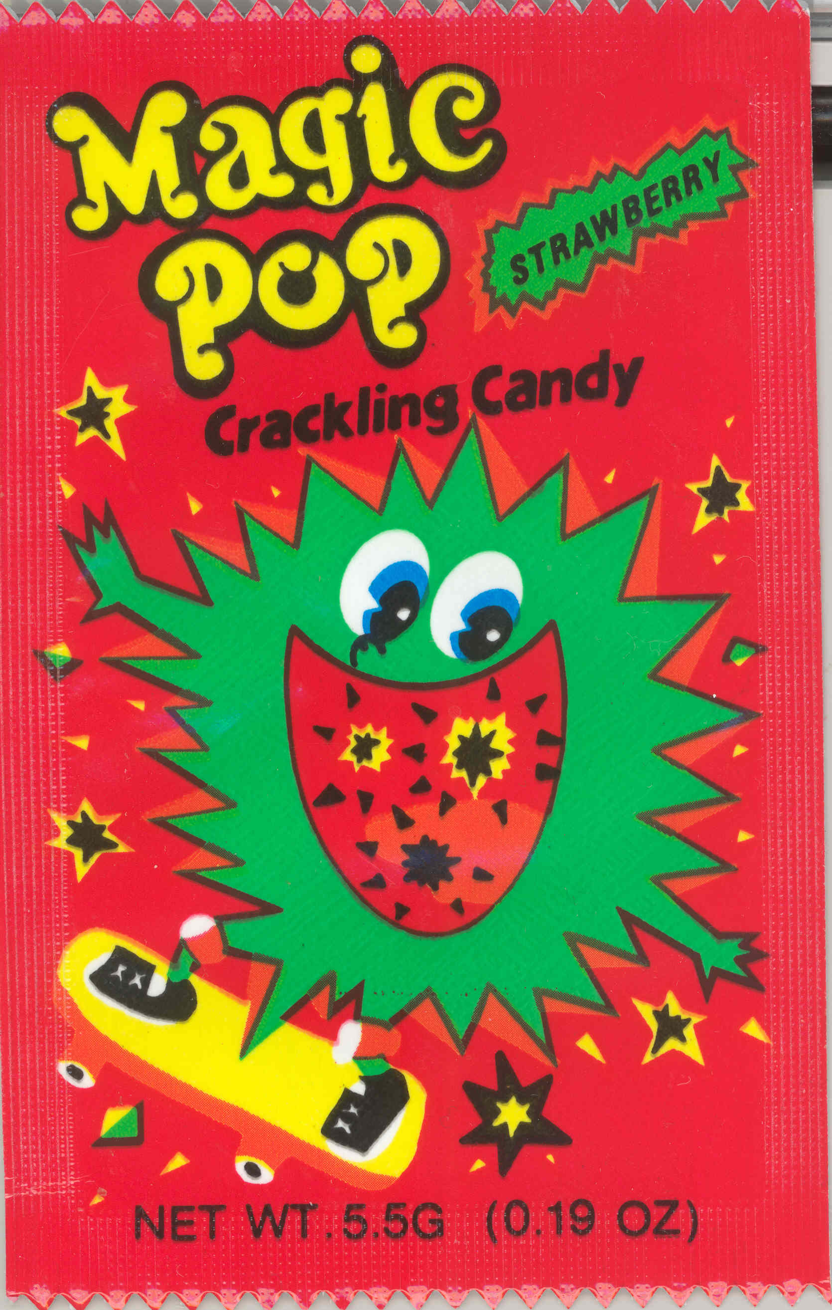
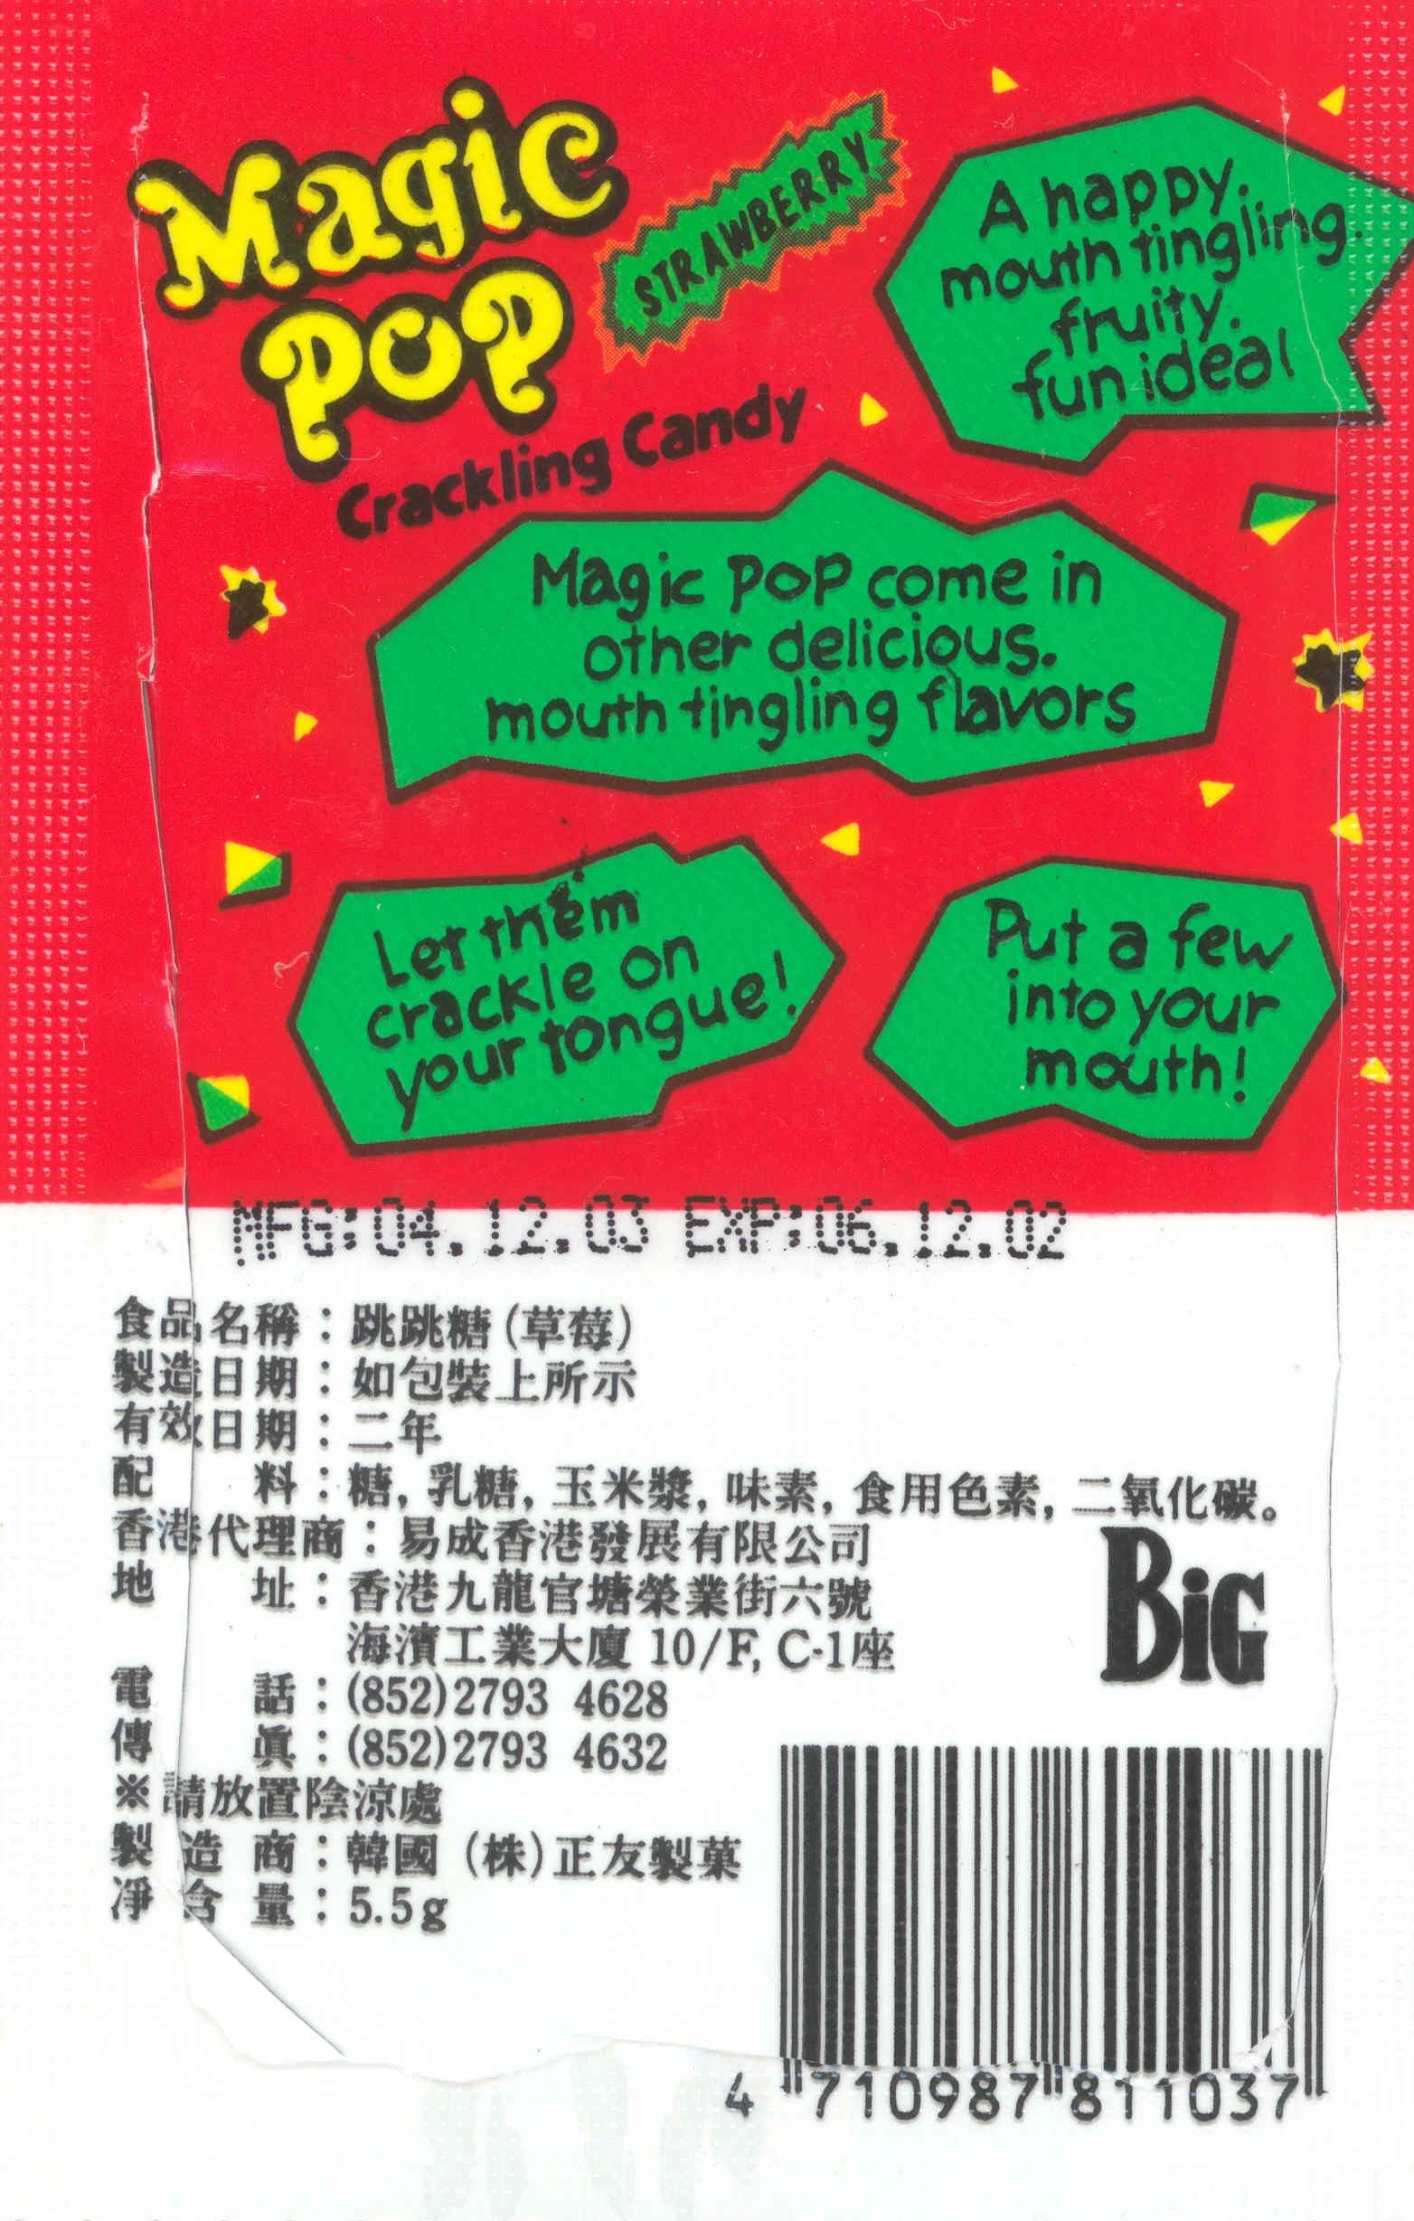

- What is the name of the product? _____________
- What kind of product is it? __________________
- What flavour is it? ________________________
- How much does it weigh?____________________
- Who will buy this product? ________________
- I bought this product in January 2007. Should I eat it? Why (not)?
______________________________________
- What colours are used on the packet?
______________________________________
- What picture can you see on the front?
______________________________________
- Why have these colours and this picture been chosen?
______________________________________
- On the back of the packet, some words are used to describe the product. Write down three of these words.
______________________________________
- Have you ever bought it? Why did you buy it? Did you like it?
______________________________________
- Do you think the packaging is attractive?
______________________________________

Complete this description of the product packaging
This product is called _________________. It is a kind of _________. The packet is mainly _______, with some green and yellow. On the front, I can see ______________________________________. The colours and picture are suitable, because this product is for ________________. On the back of the packet, there are sentences describing the product. Words like _______________________ are used to make the product seem attractive.

You have been asked to collect examples of food packaging. Look at the examples on your desk and complete the table.

 | Product name | Type of product | Who will buy it? | Colour and design | Marks out of 10
1
2
3
4
5

Healthy Product Project
Worksheet 3 – Television advertisements

You have seen a lot of advertisements on television. Your teacher will show you an advertisement for a chocolate bar. Watch it and answer the questions below.

- What is the name of the product? __________________
- What images (pictures) are shown in the advertisement?
________________________________________________________________________________________________________

- Who do you think the advertisement is aimed at (who do they want to attract to buy the product?)
________________________________________________________________________________________________________
- The advertisement has a song. This is called a “jingle”. Here is the jingle with some words missing. Can you fill in the missing words?

This is the day, the waiting is over.
The whole of the crew must now work as a ____________
No turning back, you’re in this ______________

- Here is the slogan of the product. It is a very famous slogan. What do you notice about the last word of each line?

A Mars a day
Helps you work, rest and play

- After the jingle, a voice says:
“There’s all the goodness of milk, glucose, malt and thick, thick chocolate in a Mars”
What message are the advertisers giving us about this chocolate bar?
_________________________________________________________________

- Write down three ideas or feelings which you associate with this advertisement
________________________________________________________________________________________________________

Read this article about advertising strategies. Match the titles to the paragraphs by writing the titles on the lines provided
Star Power Happy Families Make them Laugh

It’s Good for your Health Perfect Children Listen to the Doctor
Titles

Analyzing TV advertisements

1. ____________________________

Children are often used in advertisements for toys and snack foods. They are always good-looking, clever and fashionable. The children watching the advertisements want to be like them.

2. ____________________________

Famous people like David Beckham are often shown in advertisements. The people watching would like to be like the famous person shown.

3. _____________________________

Some adverts show families having a good time together and this is connected with the product in some way. The advertisers give the message that this product will help the family to enjoy time together.

4. _____________________________

Advertisements for beauty products often show a doctor or scientist in a white coat talking about the contents of the product and its good effects. These people are used to give a sense of authority – they should be telling the truth!

5. _____________________________

Something funny in the advertisement makes it interesting and helps people remember it better

6. ______________________________

Nowadays people are concerned about their health, so products are often advertised as healthy, even though they may not be………

Now you are going to watch some more advertisements. Tick off the items on the table for each advertisement.
Name of product | Type of product | Who is it aimed at? | Strategy used (tick) |  |  |  |  |  | Jingle  (tick) | Slogan  (tick)
Name of product | Type of product | Who is it aimed at? | Famous person | Humour (funny) | Scientist | Health | Perfect  children | Happy  familiy | Jingle  (tick) | Slogan  (tick)
Red Bull

Penguin Bar

Kellog’s Special K Cereal

Fresh Cream Cakes

Florida Orange Juice
Mars Bar

Kit Kat

Kellog’s Special K Bar

Healthy Snack Project
Worksheet 4 Jingles and Slogans

A slogan is a short phrase or sentence. It may have the features above, but it doesn’t usually have any music. A jingle is a short song with words and music.

Jingles and slogans should be short and easy to remember, because advertisers want us to remember them and think about their products! They often have the following features:

- Rhyming words: The last word in each line has the same sound (this could also follow a pattern, eg alternate lines)
- Alliteration: Many words start with the same letter
- Repetition: The product’s name or some other words appear again and again

Here are some slogans from the TV advertisements you saw earlier. Underline examples of rhyming words in red, and examples of alliteration in blue.
“Fresh cream cakes,
Naughty, but nice”

“A Mars a day
Helps you work, rest and play”.

Here is an example of a jingle. Underline examples of alliteration and rhyme and circle examples of repetition.

P-p-pick up a Penguin,
A lovely big Penguin,
When you p-p-p-pick up a Penguin
There’s so much more to enjoy!

It’s bigger, so delicious,
Chocolate filling through and through,
When you feel a little p-peckish,
What’s bigger and best for you?

A p-p-p-Penguin,
So pick up a Penguin,
When you feel a little p-peckish,
P-p-p-pick up a Penguin

Find three words used to describe the Penguin bar
____________________________________________________________

What do you think “peckish” means?
____________________________________________________________

Healthy Snack Evaluation Form

What do you think of your classmates’ healthy snack product? Give them marks and write a comment below>

Group ____. Product Name: ______________________________________

Item | Poor Excellent
Product name, description and reasons for choosing | The name is very ordinary and does not tell us anything about the product. It is not clear what kind of customers will buy it. The group does not give a clear explanation of the reason for choosing this product. | 1 2 3 4 5 | The name is interesting or unusual and tells something about the product. The group has thought about what kind of customers will buy it.  They explain clearly why they have chosen the product and the name.
Design of packaging | The packaging is not attractive and gives no information about the product. It is not suitable for the age group of the customers (eg children, adults, teenagers) | 1 2 3 4 5 | The packaging is attractive and carefully done. The design is suitable for the age group of the customers. The packaging gives information about the product.
Slogan | The slogan is very brief and grammatically incorrect. There is no attempt at rhyme, rhythm, alliteration, or making the words interesting. | 1 2 3 4 5 | The slogan is well thought-out and makes the product seem interesting. Alliteration, rhyme, repetition, word play etc. have been used with a clear purpose.
Presentation | The group members are not ready to present the advertisement. They do not know what they are expected to do. They have not planned the presentation well. They do not speak clearly or loudly enough. They do not look at the audience. | 1 2 3 4 5 | The group members are ready and know what to do. Each person is well-prepared. The group members present confidently. They speak clearly and loudly. They look at the audience.
Teamwork | The group does not work well together to deliver the presentation. Some people do a lot more than others. | 1 2 3 4 5 | The group works well together and every member of the group has something to do.

Comments:

