|  |  |
| --- | --- |
| **Physical Education (HKDSE)** | |
|  | **Part IX: Sport and Recreational Management** |
|  | |
| **Physical Education Section**  **Curriculum Development Institute**  **Education Bureau**  **The Government of the Hong Kong Special Administrative Region**  **2022** | |

**(last updated in Sep 2022)**

|  |  |
| --- | --- |
| **Contents** | **Page** |
| Learning objectives | 2 |
| Glossary | 3 |
| Essential concepts and theories |  |
| 1. Concepts of sport and recreation management | 5 |
| 1. Programme organisation | 8 |
| 1. Legal issues regarding PE, sport and recreation | 12 |
| Examples of enquiry activities | 14 |
| References for teachers | 16 |
| References for students | 17 |
| Related websites | 18 |

**Learning Objectives**

This part introduces the basic concepts of sport management and programme organisation. It aims at equipping students with the knowledge which is useful for organising different physical activities in schools and communities. The knowledge acquired in previous parts, particularly Part VIII: “Social aspects of PE, sport and recreation”, provides students with important considerations for organisation and management measures.

**Expected learning outcomes: Students will be able to**

1. explain how the process of sport and recreation management works and the role of managers in it;
2. display the skills required for organising physical activities; and
3. explain the legal issues regarding the organisation of physical activities.

| **Glossary** | | |
| --- | --- | --- |
|  | **Term** | **Description** |
|  | Asset  資產 | Any tangible or intangible object that is of value to its possessor. |
|  | Audit  審計 | A formal examination of an organisation’s or individual's accounts or financial situation. An audit may also include examination of compliance with applicable terms, laws and regulations. |
|  | Authority  權威 | It is the right of a particular post to make decisions, give commands, control others, etc. |
|  | Break even  收支平衡 | A term which describes a point at which revenues equal expenditures. |
|  | Budget  財政預算 | A proposal that outlines anticipated revenues and expenditures. |
|  | Contingency plan  應急計劃 | A planned allotment of time, resources and actions for unforeseeable factors affecting a project. |
|  | Effectiveness  成效 | The extent to which the intended result is achieved. |
|  | Efficiency  效率 | The ratio of the work done to the effort paid. |
|  | Inventory  倉存清單 | A detailed list of all the items in stock. |
|  | Liability  責任 | In a legal sense, it refers to a situation of being responsible for paying compensation for any damage incurred to individuals or organisations. |
|  | Management  管理 | Directing and controlling a group of people or entities for the purpose of accomplishing a goal. Management operates through various functions, including planning, organising, leading / motivating and controlling. |
|  | Management structure  管理架構 | It refers to the way of devolving responsibilities, delivering commands, managing affiliation among staff, etc. |
|  | Manager  管理人員 | A person responsible for management tasks. |
|  | Negligence  疏忽 | Failure to take proper care over incidences or accidents. |
|  | Nuisance  妨擾 | A legal term referring to any use of land which interferes with the use and enjoyment of neighbouring lands. A nuisance may refer to any damaging behaviours to other party. |
|  | Revenue  收入 | The income generated from business activities, usually from the sale of goods, services to customers and the sales of asset rights. |
|  | Shortage  短缺 | A state or situation in which something needed is insufficient |
|  | Tort  民事侵權行為 | A dispute relates to a contract. The law of tort is concerned with damage causing personal injury and damage to property resulting from negligence. |
|  | Vandalism  蓄意破壞 | Action involving deliberate destruction or damage to public or private property. |

**Essential Concepts and Theories**

1. **Concepts on sport and recreation management**
   1. **The management process**

Management is a process in which people and organisations achieve the target results. It includes a number of steps. A manager needs to

* **Plan**
  + Determine the task requirements
  + Conduct SWOT analysis (S and W refer to the internal strengths and weaknesses of the organisation respectively; O and T refer to the external opportunities and threats that the organisation will encounter respectively)
  + Set working objectives
  + Decide working strategies and action plans
* **Organise**
  + Develop efficient management structures
  + Assign appropriate duties to staff
* **Lead**
  + Set good examples for others
  + Foster colleagues’ morale
  + Give support to colleagues
* **Control** 
  + Evaluate and ensure smooth working procedure
  + Assess whether the job targets are achieved and evaluate the effectiveness of work
  1. **Facilities and equipment**

To manage facilities and equipment effectively, the management personnel should take the following measures:

* Have a clear concept of the objectives that determine the appropriate use of the particular facilities. Facilities should be scheduled for use in accordance with an established priority system to avoid conflict or misunderstanding.
* Keep a detailed and updated inventory to ensure the availability of optimal quantity of facilities and equipment for use.
* Repair and maintain facilities and equipment on a regular basis but to minimise interruptions of use.
* Closely adhere to the rules and regulations that govern the purchase of service / equipment and keep all relevant documents for auditing.
* Consider both quality and costs when purchasing service / equipment and compare quotations from different suppliers.
* Ensure that facilities and equipment are properly stored and protected from theft, vandalism, fire, etc.
  1. **Funding**

When preparing budgets, the following principles should be noted:

* Ensure that the budget aligns with the goals and objectives of the strategic plan.
* The budget should be supported with justifications.
* It should be self-explanatory, easy to follow and with detailed information.
* It should be cost-effective. The amount should reflect the significance of the proposed items.
* Collect information such as previous financial reports of the same or similar activities, the facilities and equipment currently available, the views of stakeholders, etc for reference; and make a realistic estimation.
* Apart from the basic expenditures, the following items should be considered:
  + - Expenditure on insurance
    - Contingency for unforeseeable factors
    - Income estimates such as revenues, subsidy, sponsorship, etc.
* Obtain approval for the budget before any expenditure.
* Make adjustments regularly according to the actual expenditure.
  1. **Staffing**

When managing staff, the following should be stressed:

* Train staff regularly to enhance their performance.
* Clearly define duties and responsibilities to minimise duplication and confusion.
* Choose an appropriate span of control (i.e. the number of staff to supervise): a management structure with more levels is called a tall structure (See Fig. 9.1) and a management structure with relatively fewer levels is called a flat structure (See Fig. 9.2). In the tall structure, the top and junior level staff should pass their message through many levels, so many delays and distortion in communication would be easily found. On the other hand, messages can go up and down the flat structure quickly with little distortion. Besides, there are many managers in tall structure, each manager need to manage a few subordinates. However, in the flat structure, there are fewer managers and each manager has to manage many subordinates, so it may overload the senior level staff.
* Exercise appropriate authority over subordinates and earn their respect through making wise decisions, setting good examples, providing encouragement and support.

Fig. 9.1 Example of a tall management structure

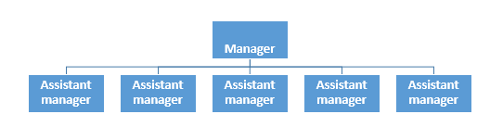

Fig. 9.2 Example of a flat management structure

* 1. **Time factors**

For time management, the following principles should be noted:

* Set priority - To categorise tasks according to their urgency and importance: a) urgent and important, b) not urgent but important, c) urgent but not important, and d) not urgent and not important. Spend time on the most important task first.
* Define the importance of task through goal-setting whether the task relates to the goal or not. In addition, set job details according to the timeframe of the task.
* Develop weekly and daily to-do lists based on the tasks identified in the goal setting process. If a task is not in the to-do list and is unimportant, it should not be dealt with.
* Schedule of the to-do list should not be too tight because over-working will reduce efficiency and may cause burnout.
* Schedule breaks and rests to maintain job efficiency.

1. **Programme organisation**
   1. **Competition system**

Competition system refers to the way of how winners are determined. The purpose of competitions, participating teams / competitors, facilities and equipment, number of officials / umpires / volunteers, duration of competition period will be considered when choosing a competition system. The following are two basic competition systems of round-robin and elimination.

* **Round-robin Competition**

Single round-robin competition involves each team / competitor playing with every other team / competitor once (See Table 9.1), with points awarded for win, draw and lose. The teams are ranked according to the points scored. The competition is called a double round-robin if each team / competitor plays with every other team / competitor twice (See Table 9.2). This method requires more human and material resources, but it brings the following two advantages:

* + Competitors will not be seriously affected by accidental under-performance
  + More opportunities for competitors to interact and learn from each other.

The number of matches of a single round-robin competition can be calculated as follows:

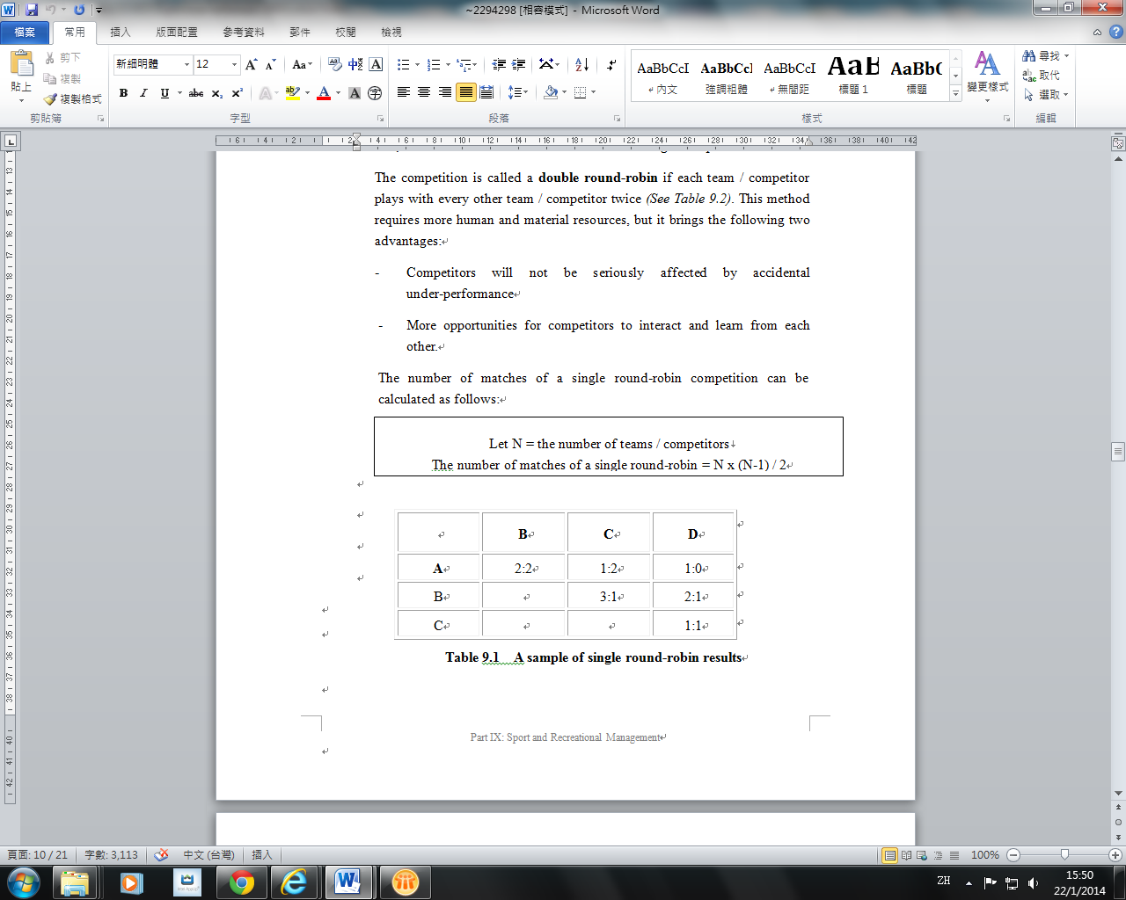

|  |  |  |  |
| --- | --- | --- | --- |
|  | **B** | **C** | **D** |
| **A** | 2:2 | 1:2 | 1:0 |
| **B** | ////////////// | 3:1 | 2:1 |
| **C** | ////////////// | ////////////// | 1:1 |

Table 9.1 A sample of single round-robin results

|  |  |  |  |  |
| --- | --- | --- | --- | --- |
| **First**  **round**  **Second round** | **A** | **B** | **C** | **D** |
| **A** |  | 2:2 | 1:2 | 1:0 |
| **B** | 2:0 |  | 3:1 | 2:1 |
| **C** | 2:0 | 1:4 |  | 1:1 |
| **D** | 1:1 | 1:5 | 0:0 |  |

Table 9.2 A sample of double round-robin layout and results

* **Elimination Competition**

This method is a simple “winner progresses, looser goes home” method *(See Fig. 9.3)*. For example, the number of matches of a single elimination competition with no playoff for third position can be calculated as follows:

|  |
| --- |
| Let N = the number of team / competitors  The number of matches of a single elimination competition = N – 1 |

Compared with the single round-robin system, this system is relatively simple and requires less resource, but will be more exciting. A seeding system may be used to separate the top ranked players at the early stages of competitions to ensure fairness.

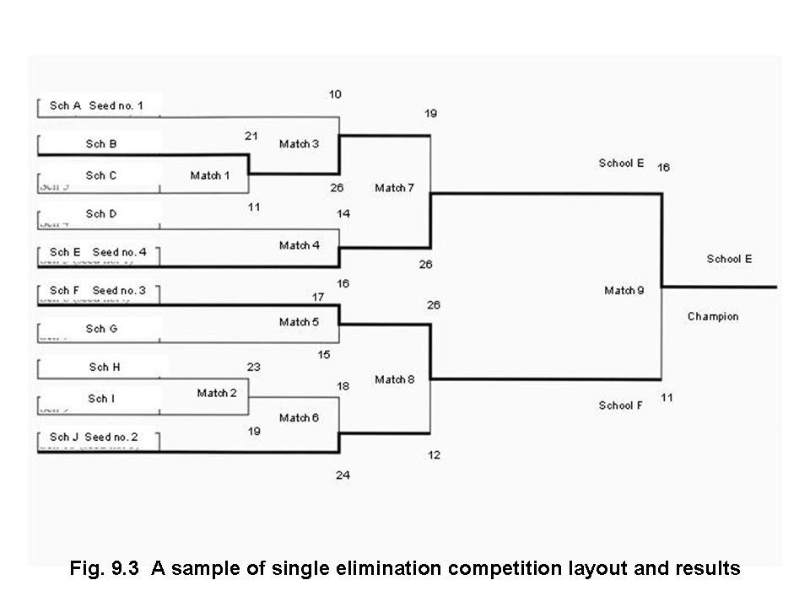

Fig 9.3 A sample of single elimination competition layout and results

**ii) Organisation of physical activities**

When organising physical activities, we should note the following:

* Start preparatory work early.
* Involve experts and stakeholders in the organising committee to brainstorm ideas and to ensure that the event design will match the objectives.
* Develop policies, strategies and budgets in accordance with the preset goals and objectives.
* Set up working groups to look after different work such as technical support, publicity, first aid, etc.
* Observe all relevant guidelines and recruit qualified judges, officials, etc for the events.
* Formulate detailed checklists of work and set deadlines for various tasks.
* Prepare contingency plans to cater for unforeseen events.
* Do publicity work and use marketing strategies to promote the event.

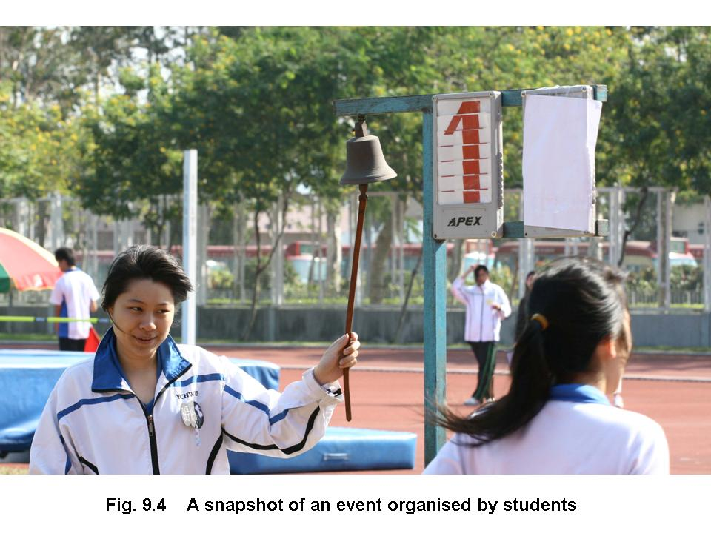Fig 9.4 A snapshot of an event organised by students

1. **Legal issues regarding PE, sport and recreation**

**i) Liability in PE and sports activities**

Liability, in the legal sense, refers to a situation of being responsible for paying compensation for any damage or injuries incurred to individual or organisations. There can be many kinds of unexpected accidents in physical activities. Individuals suffering from accidents may pursue legal actions against the organisers of physical activities according to the law of tort. Therefore, as part of risk management, appropriate insurance should better be bought to cover:

* Public liability - to pay damages in respect of accidental injury to the third party and / or accidental loss of or damage to any property.
* Employees' compensation - to pay compensation for death or injury caused by accidents arising out of and in the course of employment.

At the same time, the organisers can also arrange the “group personal accident insurance” to protect participants. The cost of insurance can be borne by the organisers or the participants. For example, the Hong Kong Schools Sports Federation arranges the “collective personal accident insurance” for registered athletes, team managers, competition officials and helpers. Details of the insurance can be found at the Federation’s webpage at

(http://www.hkssf-hk.org.hk/hk/sec/general-rules/insurance.pdf).

Besides, the Education Bureau arranges the Block Insurance Policy for aided and caput schools. It comprises three types of insurance: (1) the public liability insurance; (2) the employees’ compensation insurance; and (3) the group personal accident insurance. Details of the insurance can be found at the EDB webpage (https://www.edb.gov.hk/en/sch-admin/admin/about-sch/sch-safety.html).

**ii) Negligence in PE and sports activities**

Negligence is not the same as “carelessness”. Someone might be as careful as he / she is capable of, yet it still falls below the level of expectation. When organising physical activities, one must try his / her best to prevent unreasonable risk of harm to participants. When one fails to do so and this failure contributes to the death or injury of another person, the individual can then be declared negligent. For an action to be considered negligent in court, the following four elements must be proved:

* Duty of care owed
* Breach of duty of care
* Actual or proximate causation for damage
* Extent of damages

In general, when organising physical activities, one must ensure the safety of participants through:

* Providing safe facilities and equipment
* Setting appropriate rules; making them clear to the participants; and enforcing the rules
* Assuring that the participants are suitable for the activities, in terms of physical fitness, knowledge and skills
* Providing proper guidance and supervision

It should be noted that, in many cases, even if the participant is careless and it contributes to the accident, the organiser may still be liable. The court would take into consideration the guidelines or recommendations on specific activities produced by professional organisations or government departments (For example, “Safety Precautions in Physical Education for Hong Kong Schools” and “Guidelines on Outdoor Activities” issued by the Education Bureau), or the views of experts and witnesses for the standards of care when judging a “negligence” case. Therefore, it is important for organisers of physical activities to receive proper training and keep abreast of the latest recommendations and guidelines of the relevant authority.

| **Examples of Enquiry Activities** | | |
| --- | --- | --- |
| **Themes** | | **Activities** |
| 1 | Management process | **Information collection:**   * Log on relevant Hong Kong websites and study:   + Management structure of local sports governing bodies   + Organising committees of some of the large scale sporting events   **Topics for project learning:**   * SWOT analysis * Leadership: principles and techniques * Quality control vs quality assurance |
| 2 | Organising activities | **Information collection:**   * Evaluate major school sports events that are mainly organised by students. Collect related proposals, financial reports, work reports, minutes, letters, rules and regulations, enrolment forms, publicity materials, etc.   **Enquiry activities:**   * Analyse the function of each of the above-mentioned documents / materials. * Select and critically evaluate some of them. Based on the information given, discuss how to fine-tune the selected items for improving the organisation work. * Through experience sharing, identify the three biggest difficulties when organising physical activities and suggest solutions. * Design action plans of fund raising for large scale sports functions. |

|  |  |  |
| --- | --- | --- |
| 3 | Competition systems | **Information collection:**   * Use large-scale international sporting events as examples to demonstrate different competition systems.   Enquiry activity:   * Use large-scale international events as examples to compare and criticise round-robin and elimination competition systems. |
| 4 | Legal issues | **Information collection:**   * Browse through relevant websites and collect related court cases of physical activities.   **Topics for project learning:**   * The Block Insurance Policy for aided and caput schools in Hong Kong.   **Enquiry activity:**   * Review the physical activities mainly organised by students. Identify those arrangements and parts that may lead to “negligence” and make recommendations for improvement. |

**References for Teachers**

Appenzeller, H., & Lewis, G. (2000). Successful sport management. Durham, NC: Carolina Academic Press.

Beech, J., & Chadwick, S. (2004). The business of sports management. Harlow: Prentice Hall / Financial Times.

Chelladurai, P. (2001). Managing organizations for sport and physical activity: A systems perspective. Scottsdale, Ariz.: Holcomb Hathaway Publishers.

De Knop, P., Van Hoecke, J., & De Bosscher, V. (2004). Quality management in sports clubs. Sports Management Review, 7, 57-77.

Drowatzky, J.N. (1993). Legal issues in sport and physical education management. Champaign, IL: Stipes Publishing.

Hong Kong Sports Development Board. (2004). Sport, the law & insurance. Hong Kong: Government Printer.

Martens, R. (1995). Youth sport director guide. Champaign, IL: Human Kinetics.

Parkhouse, B.L. (1996). The management of sport: Its foundation and application. St. Louis: Mosby.

Sawyer, T. (2001). Adequate equipment and supervision. Journal of Physical Education, Recreation and Dance, 72(8), 11-12.

Smith, A., & Stewart, B. (1999). Sports management: A guide to professional practice. St Leonards, N.S.W.: Allen & Unwin.

香港教育署輔導視學處體育組 (1999)《香港學校體育科安全措施》，香港：教育署輔導視學處體育組。

教育局 (2000)《教育局通告第1/2000B號—學校水運會、游泳課及訓練的安全措施》，香港：教育局。

教育局 (2000)《教育局通告第4/2000B號—學校陸運會、田徑課及田徑訓練的安全措施》，香港：教育局。

教育局 (2000)《教育局通告第4/2001號—學校遊戲日安全措施》，香港：教育局。

許樹淵 (2004)《運動賽會管理》，台北：師大書苑。

葉憲清 (2005)《學校體育行政》，台北：師大書苑。

鄭志富 (主編) (2004)《體育行政與管理》，台北：師大書苑。

**References for Students**

Crisfield, R., & Sollars, L. (Eds.) (1994). Leadership and delegation: Management styles for work with employees, colleagues and volunteers. Leeds: National Coaching Foundation.

許樹淵 (2004)《運動賽會管理》，台北：師大書苑。

鄭志富 (主編) (2004)《體育行政與管理》，台北：師大書苑。

**Related Websites**

1. Hong Kong e-Legislation  
   https://www.elegislation.gov.hk/
2. Education Bureau (EDB)  
   https://www.edb.gov.hk/en/index.html
   * School Safety and Insurance  
     https://www.edb.gov.hk/en/sch-admin/admin/about-sch/sch-safety.html
   * Safety Precautions in Physical Education for Hong Kong Schools  
     https://www.edb.gov.hk/en/curriculum-development/kla/pe/references_resource/safety-guidelines/index.html
   * Guidelines on Outdoor Activities   
     https://www.edb.gov.hk/attachment/en/sch-admin/admin/about-activities/sch-activities-guidelines/Outdoor_EN.pdf
   * Risk Management and Court Cases (in Chinese only)https://www.edb.gov.hk/attachment/tc/sch-admin/admin/about-sch/sch-safety/21BIP_Risk%20management%20and%20court%20cases.pdf
   * Briefing Sessions on Block Insurance Policy of EDB for 2021/22 School Years (in Chinese only)

https://www.edb.gov.hk/attachment/tc/sch-admin/admin/about-sch/sch-safety/21BIP_Coverage.pdf

1. European Association for Sports Management (EASM)  
   https://www.easm.net/
2. Hong Kong Recreation Management Association (HKRMA)  
   http://www.hkrma.com.hk/
3. Hong Kong Schools Sports Federation (HKSSF)  
   http://www.hkssf.org.hk/
   * System of Competition  
     http://www.hkssf-hk.org.hk/hk/sec/general-rules/system.pdf
4. Hong Kong Schools Dance Association (in Chinese only) (HKSDA)  
   http://www.hksda.org.hk/
5. Hong Kong Sports Institute (HKSI)  
   https://www.hksi.org.hk/en/
   * Coach Education   
     https://www.hksi.org.hk/training-the-athletes/coach-education/
6. Leisure and Cultural Services Department (LCSD)  
   https://www.lcsd.gov.hk/en/index.html
   * General Conditions of Use   
     https://www.lcsd.gov.hk/en/facilities/facilitieslist.html
7. North American Society for Sports Management (NASSM)  
   http://www.nassm.com/
8. Sport Management Association of Australia and New Zealand (SMAANZ)  
   https://smaanz.wordpress.com/