|  |  |
| --- | --- |
| **Physical Education (HKDSE)** | |
|  | **Part III: Movement Analysis** |
|  | |
| **Physical Education Section**  **Curriculum Development Institute**  **Education Bureau**  **The Government of the Hong Kong Special Administrative Region**  **2022**  **(last updated in Sep 2022)** | |

|  |  |
| --- | --- |
| **Contents** | **Page** |
| Learning objectives | 2 |
| Glossary | 3 |
| Essential concepts and theories |  |
| 1. Forces and movement | 5 |
| 1. Types of movements | 12 |
| 1. Steps and guidelines for performance analysis | 15 |
| Examples of enquiry activities | 21 |
| References for teachers | 29 |
| References for students | 31 |
| Related websites | 32 |

**Learning Objectives**

This part covers the basic principles in human movement and is linked to the discipline of physics. It guides students to understand the scientific basis of body movement and to apply this knowledge, together with the acquired psychological skills in Part VII, to enhancing performance or interest in participation in (Part X) PE, sport and recreation. It also helps students understand more about the causes of some common sports injuries (Part VI).

**Expected Learning outcomes: Students will be able to**

1. explain, using practical examples, the contents and meanings behind Newton’s three Laws of Motion;
2. apply the principles of leverage to improve movement performance;
3. when analysing movement performance, identify the different types of movements regarding the musculoskeletal system, and understand the execution of the three movement planes; and
4. explore some basic principles in sports biomechanics by using simple measurements.

| **Glossary** | | |
| --- | --- | --- |
|  | **Term** | **Description** |
|  | Acceleration  加速度 | The rate of velocity of an object. |
|  | Biomechanics  生物力學 / 生物機械學 | Area of study wherein the knowledge and methods of mechanics are applied to the structure and function of the living human system. |
|  | Centre of gravity重心 | The center of gravity (CG) of an object is the point at which weight is evenly dispersed and all sides are in balance. |
|  | Displacement  位移 | The net distance for an object from the change of position. |
|  | Distance  距離 | The total length of the route travelled. |
|  | Force  力 | The “push” or “pull” exerted upon an object or body which may cause either a motion of a stationary body or a speeding up, a slowing down or even a change of direction of a moving body. |
|  | Gravity  重力 | This is the force of attraction between any two masses in the universe; especially for the attraction force exerted by the earth on the objects in its vicinity. |
|  | Inertia  慣性 / 慣量 | The tendency of an object to remain at rest or in motion at the same speed and in the same direction, unless acted upon by a force. |
|  | Lateral rotation  外旋 | Rotation of the axis of a joint away from the midline of the body. |
|  | Magnitude  量值 | Greatness or relative size. |
|  | Medial rotation  內旋 | Rotation towards the midline of the body; opposite of lateral rotation. |
|  | Moment of force / Torque  力矩 / 轉矩 | A measure of the turning effect of a force about an axis. Moment of a force, also known as torque. |
|  | Newton  牛頓 | A Newton is a unit of force. It is defined as the amount of force needed to make an object of one kilogram to accelerate by one meter per second squared (1 N = 1 kg/ms2). |
|  | Scalar  標量 | Physical quantity with magnitude but no direction, such as mass, volume or time. |
|  | Speed  速率 | The distance travelled at a given time. |
|  | Vector  矢量 / 向量 | Physical quantity with both magnitude and direction, such as force, displacement and velocity. |
|  | Velocity  速度 | The rate of change of displacement of an object. |

**Essential Concepts and Theories**

1. **Forces and movement**
   1. **Newton’s Law of Motion**

Please refer to paragraph (v) of this section.

* 1. **Motion**

In mechanics, “motion” refers to a change in position. It is described in terms of velocity, acceleration, displacement and time.

* 1. **Velocity**

It is the rate of change of displacement of an object. Speed is a scalar, with no direction. Velocity is a vector, possessing both magnitude and direction, and can be calculated as follows:

|  |  |  |
| --- | --- | --- |
| **Velocity =** | **Displacement** |  |
| **Time taken** |  |

* 1. **Acceleration**

Acceleration represents the rate of change of velocity during a given time. It is a vector, possessing both magnitude and direction, and can be calculated as follows:

|  |  |  |
| --- | --- | --- |
| **Acceleration =** | **Change in Velocity** |  |
| **Time taken** |  |

OR

|  |  |  |
| --- | --- | --- |
| **Acceleration =** | **Final Velocity - Initial Velocity** |  |
| **Time taken** |  |

* 1. **Force**

Force is the “push” or “pull” exerted upon an object which may cause either a motion of a stationary object or a speeding up / slowing down or a change of direction of a moving object.

|  |
| --- |
| **1st Law: The Law of Inertia**  Every object at rest, or moving in a constant velocity in a straight line, will continue in that state unless it is compelled to change by an external force exerted upon it. |
| Example 1: Before the penalty kick of football player, the ball is at rest; to perform a kick, the football player has to apply a force (kicking) to a football to overcome it’s inertia. This makes the football moves forward.  Example 2: When the sprinter reaches the finishing line, he/she cannot stop immediately due to the influence of forward inertia. |

Force is a vector, possessing both magnitudeand direction. The unit of force is Newton (N). One Newton (N) represents the force required to give a one kilogram mass an acceleration of one meter per second squared.

|  |
| --- |
| **2nd Law: The Law of Acceleration**  The acceleration of an object is proportional to the force causing it and inversely proportional to the mass of the object; the acceleration takes place in the direction in which that force acts. |
| Example 1: In a volleyball match, a more powerful spiking causes a greater acceleration of the ball making it more difficult for the defenders to receive the spike.  Example 2: We can feel the force and acceleration when we ride on a car. When the car started, we feel the push from the back of the seat. This force accelerates our bodies forward. If we ride on a roller coaster, the push will be stronger and the acceleration will be greater. |

In order to generate a greater acceleration, a stronger force must be exerted. If the mass of the object and the acceleration are known, the force required to give that acceleration can be calculated by using the following formula:

|  |
| --- |
| Force = Mass of the object x Acceleration |

|  |
| --- |
| **3rd Law: The Action / Reaction Law**  When an object exerts a force on a second object, there is a force equal in magnitude but opposite in direction exerted by the second object on the first. |
| Example 1: A high jumper exerts a force on the ground when taking-off. The ground reaction force in upward direction is generated acting upon the jumper to propel him / her over the bar.  Example 2: The foot strike and plantarflexion motion of the runners exerts a downward and backward force on the ground, and the ground exerts a force on the runner with an upward and forward reaction force. |

* 1. **Resultant force**

A resultant force is the vector produced when two or more forces act upon a single object. Its magnitude and direction can be calculated by constructing a parallelogram of forces *(See Fig. 3.1)*.

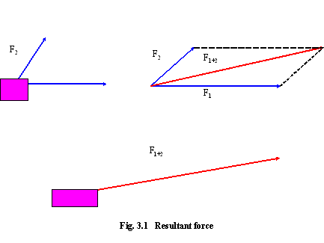

Fig 3.1 Resultant force

* 1. **Centre of gravity**

Gravity is a force that occurs naturally and pulls a object towards the centre of the earth at a rate of 9.81 meters per second squared. Gravitational pull always occurs through the centre of mass of an object. The location of the centre of gravity depends on the arrangement of mass within the object. In humans, this location is changing constantly during movement. When standing with anatomical position, a person's center of gravity is about 53% to 57% of his body height. In high jump, an athlete can move his / her centre of gravity outside his / her body by arching the back, so that the centre of gravity is close to / passes under the bar while he / she passes over it *(See Fig. 3.2)*.

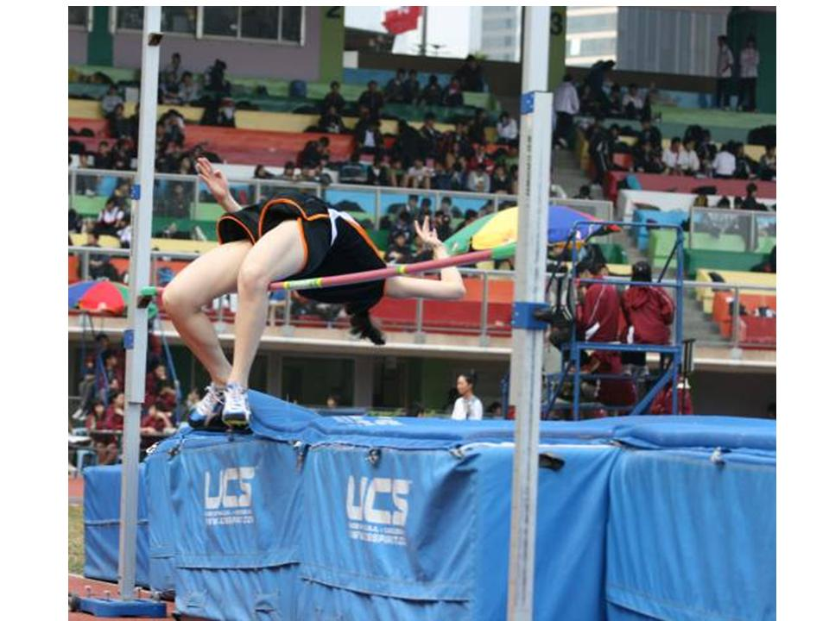

Fig. 3.2 A high jumper performing a Fosbury Flop

* 1. **Lever**

Application of leverage principles enhances the effectiveness and efficiency of movement.There are many examples in our daily life, such as, loosening and tightening of screws with spanners, inserting and removing of nails with hammers or hitting the ball with a baseball bat. There are three types of levers *(See Fig. 3.3)*:

**First Class Lever** -The fulcrum lies between the effort and the load.

**Second Class Lever** - The load lies between the fulcrum and the effort.

**Third Class Lever** - The effort is between the fulcrum and the load.

(F: Fulcrum, E: Effort, L: Load)

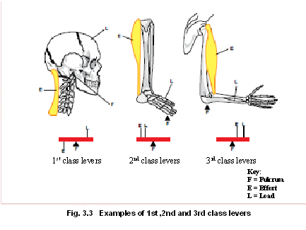

Fig 3.3 Examples of 1st, 2nd and 3rd class levers

If the load remains unchanged, we can lift a heavier object or increase the speed of the object by using leverage principles. The effectiveness is determined by the length of load arm and effort arm.

The levers of the human body are capable of rotational movement only, and this turning effect is known as the “moment of force”, which is directly related to the distance between the point of muscle insertion and the joint. The moment of force is equal to the force applied multiplied by the length of the moment arm.

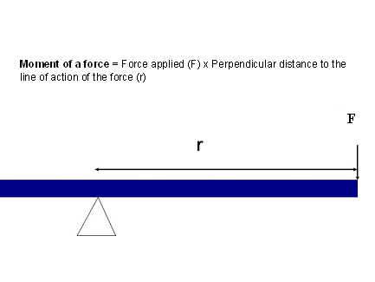

There are a number of examples of applying the leverage principles in PE activities. For instance, the length of a golf club affects the travel distance of the ball hit. If the angular velocity remains the same, a golfer can hit the ball a longer distance by using a longer club. The travel distance of the ball is smaller if a shorter club is used. (The driving force would be different)

* 1. **Angular motion**
* **Angular Displacement -** It is measured in degrees travelled by an object rotating around a central axis. One full rotation is 360 degrees *(See Fig. 3.4).*
* **Angular Velocity -** It is the variation of angular displacement with time of an object, the unit of measurement is degrees per second( ° / s) or radians per second (rad / s).
* **Angular Acceleration -** It is the variation of angular velocity with time, the unit of measurement is degrees per second squared ( ° / s2) or radians per second squared (rad / s2).
* **Moment of Inertia -** It is a measure of a body’s resistance to changes in its rotational rate. This is determined by the distribution of mass around the axis of rotation. The further its mass is away from the axis, the greater its moment of inertia. Where the body’s mass is concentrated about the axis, the lower the moment of inertia. Moment of inertia can be calculated as follows:

|  |
| --- |
| Moment of Inertia = Mass of body part x (distance from axis of rotation)2 |

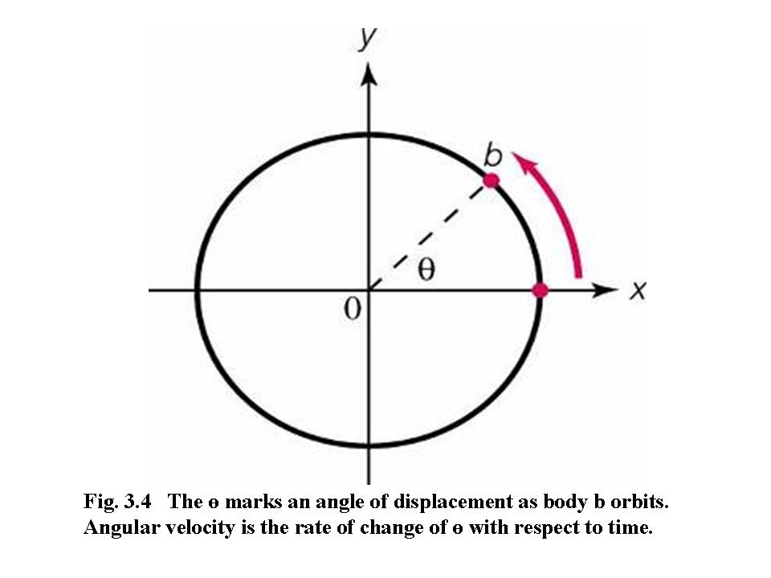

* **Newton’s Laws of Angular Motion**

**The angular form of Newton’s first law -** A rotating body will continue to turn about its axis of rotation with constant angular momentum unless an external force is exerted upon it. For example: After rotating the body during the flying spin, the ice skater will keep the spin going before landing.

**The angular form of Newton’s second law -** The angular acceleration of a body is proportional to the torque causing it and takes place in the direction in which the torque acts. For example: Appling force to the bicycle tire to the direction of rotation based in fig 3.5, larger force applied will induce larger torque, the angular acceleration of the bicycle tire would be greater.

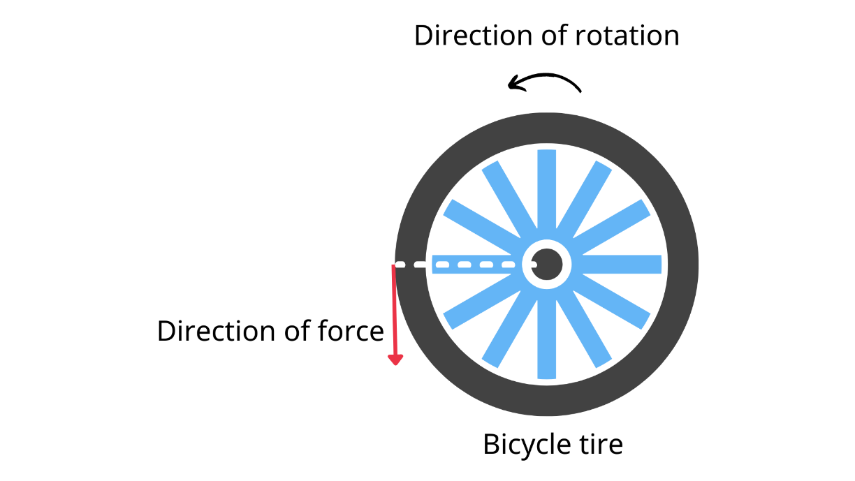

Fig. 3.5 The direction of rotation when applied force to the bicycle tire

**The angular form of Newton’s third law** - For every torque that is exerted by one body on another, there is an equal and opposite torque exerted by the second body on the first. For example: When a gymnast senses she is about to topple off a balance beam. As soon as she feels she is starting to overbalance, she rotates her arms (and perhaps her nonsupporting leg) in the direction in which she is falling in order to maintain the equilibrium. (Fig. 3.6)

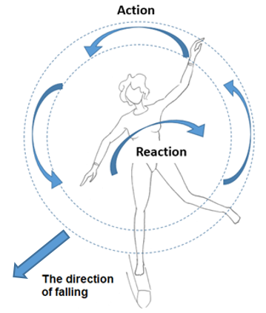

Fig. 3.6 A gymnast senses she is about to topple off a balance beam

1. **Types of movements**
   1. **Anatomical position**

|  |  |
| --- | --- |
| The body standing up straight and facing forward, eyes are looking forward, feet together and pointing forward, arms by the sides of the body and palms facing forward. (Fig. 3.7) | Fig. 3.7 Anatomical position |

* 1. **Flexion / extension**

**Flexion –** It occurs when the angle between the articulating bones is decreased *(See Fig. 3.8)*. An example of this is when the lower arm is raised to touch the shoulder. A muscle that causes flexion is known as a “flexor”. In this instance, the biceps brachii is the flexor.

|  |  |
| --- | --- |
|  |  |

Fig. 3.8 Raising the hand toward the shoulder causes flexion

**Extension –** It occurs when the angle of the articulating bones is increased. An example of this is when someone stands up from a seated position, the angle between the femur and the tibia increases, causing extension of the knee joint. A muscle that causes extension is called an “extensor”. In this case, the quadriceps muscle group is the extensor.

* 1. **Abduction / adduction**

**Abduction –** It refers to the movement of a body part away from the midline of the body. An example of this is when the arms are placed by the sides of the body and thenraised laterally *(See Fig. 3.9a).*

**Adduction –** It refers to the movement of a body part towards the midline of the body. An example of this is when the arms are straight above the head and lowered laterally down to the sides of the body *(See Fig. 3.9b).*

|  |  |
| --- | --- |
| Fig. 3.9a Abduction | Fig. 3.9b Adduction |

* 1. **Pronation / supination**

**Pronation** – The pronation of forearm takes place at the elbow and involves medial rotation between the radius and the humerus. It occurs when the palm of the hand is moved from facing upwards to facing downwards *(See Fig 3.10a)*. For example, pronation is commonly observed in playing forehand attack/ drive in table tennis.

**Supination –** The supination of forearm takes place at the elbow and involves lateral rotation between the radius and the humerus. It occurs when the palm of the hand is turned so that it faces upwards *(See Fig. 3.10b)*. Can you name one drive in table tennis using supination?

|  |
| --- |
| Fig 3.10a Pronation Fig 3.10b Supination |

* 1. **Plane of motion**

There are three body planes *(See Fig. 3.11)*:

* **The Sagittal plane -** It splits the body vertically into left and right sides.
* **The Transverse plane -** It divides the body into superior and inferior sections.
* **The Frontal plane -** It divides the body into anterior (front) and posterior (back) sections.

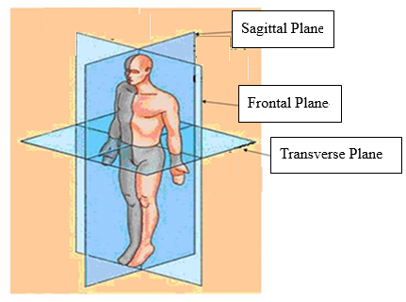

Fig 3.11 Planes of motion

* 1. **Circumduction**

The human body has three basic axes that are perpendicular to the related planes.

**Anteroposterior Axis** - A line, parallel to the ground, runs from the front to the back of the body. The rotation movements in frontal plane are around this axis, for example, abduction, adduction, cartwheel, etc.

**Mediolateral Axis** - A line, parallel to the ground, runs from the medial to the lateral side of the body. The rotation movement in sagittal plane are around this axis, for example flexion, extension, forward roll, front somersault and forward handspring etc.

**Longitudinal Axis** - A line, perpendicular to the ground, runs along the length of a body or segment. The rotation movements in transverse plane are about this axis, for example, pronation, supination, twisting, etc.

Shoulder and hip joints can perform movement across more than one plane and also circumduction.

1. **Steps and guidelines for performance analysis**
   1. **Scientific method**[1]

**Scientific attitude** – Scientific inquiry is searching for the truth which is based on evidence and empirical standards. Also, it encourages innovation and scepticism.

**Scientific thinking** - Scientific knowledge is built on creative thinking. The scientists apply deductive and inductive logic, and suggest the emergence of new scientific theories, which are then tested empirically. Scientific knowledge, while durable, is not eternal.

**Scientific practice** – Scientists use precise research designs and proper instruments to inquire into phenomena or examine theories. They analyse the quantitative and qualitative data carefully and report the findings honestly.

* 1. **Movement and performance analysis**

The movement and performance analysis is one of the topics of biomechanics. We can explore some basic principles in biomechanics by using simple measurements

* **Review the movement**
  + - Sequential description of the movement *(See the part of “key learning points” in Fig. 3.12)*
    - Joints and muscles involved (See Fig. 3.13)
    - Types of muscle contraction (i.e. concentric contraction, eccentric contraction and isometric contraction) (See Figs. 3.14)
    - Range and speed of joint movements (See the part of “different joint angles in throwing javelin” in Table 3.1)

|  |  |  |  |
| --- | --- | --- | --- |
| **World Athletic Championship 1995 – Javelin** | **Different joint angles during the delivery phase**  **in throwing the javelin** | | |
| **Hip joint** | **Elbow joint** | **Shoulder joint** |
| Gold medallist | 59° | 170° | 55° |
| Silver medallist | 59° | 147° | 45° |
| Bronze medallist | 70° | 154° | 59° |

Table 3.1 A comparison of joint angles in javelin throw[2]1

* **Quantify the performance**
  + - Quantify the process as well as the result (See Table 3.2)
    - Use rating scale for a systematic observation (See Fig. 3.13)
    - Use technology to collect precise data such as velocity, angle, tension, etc (See Fig. 3.15, *Table 3.1 and 3.2)*

|  |  |  |  |  |  |  |
| --- | --- | --- | --- | --- | --- | --- |
| **Runner** | **Velocity (km/hr)** | **Stride frequency (times/min)** | **Velocity (km/hr)** | **Stride frequency (times/min)** | **Velocity (km/hr)** | **Stride frequency (times/min)** |
| A | 12 | 171 | 14 | 177 | 16 | 183 |
| B | 12 | 174 | 14 | 178 | 16 | 182 |
| C | 12 | 182 | 14 | 188 | 16 | 194 |
| D | 12 | 176 | 14 | 181 | 16 | 187 |
| E | 12 | 177 | 14 | 180 | 16 | 186 |

Table 3.2 A comparison of the velocity and stride frequency of five distance runners

* **Movement comparison**
  + - Simulation - explore the effect of different ways of executing the skill
    - Imitation - make adjustment with reference to high-level performance (See Table 3.1)

|  |  |  |  |
| --- | --- | --- | --- |
| **World Athletic Championship 1995 – Javelin** | **Different joint angles during the delivery phase**  **in throwing the javelin** | | |
| **Hip joint** | **Elbow joint** | **Shoulder joint** |
| Gold medallist | 59° | 170° | 55° |
| Silver medallist | 59° | 147° | 45° |
| Bronze medallist | 70° | 154° | 59° |

Table 3.1 A comparison of joint angles in javelin throw[3]1

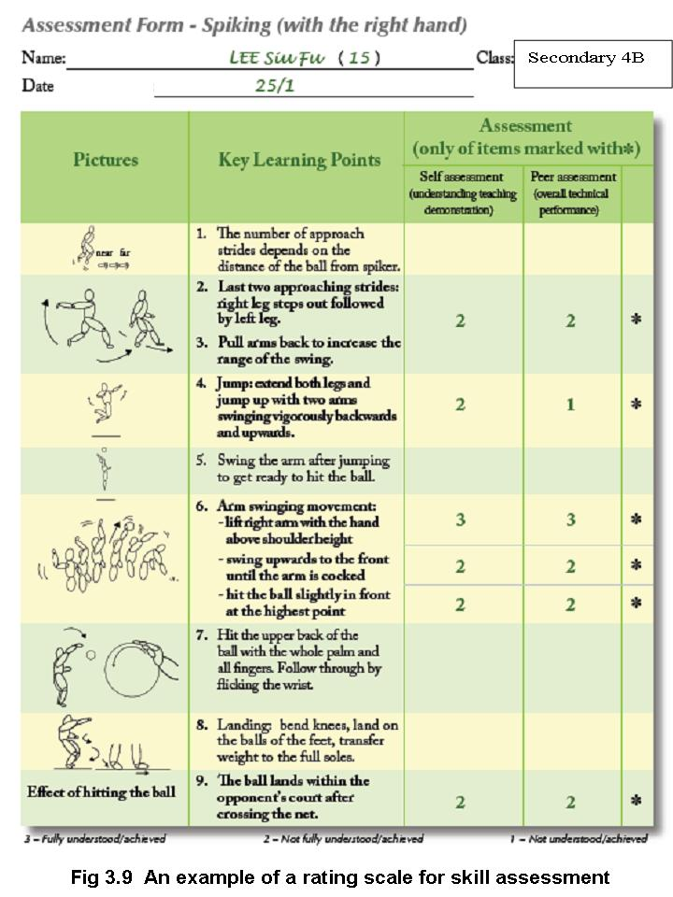

Fig 3.12 An example of a rating scale for skill assessment

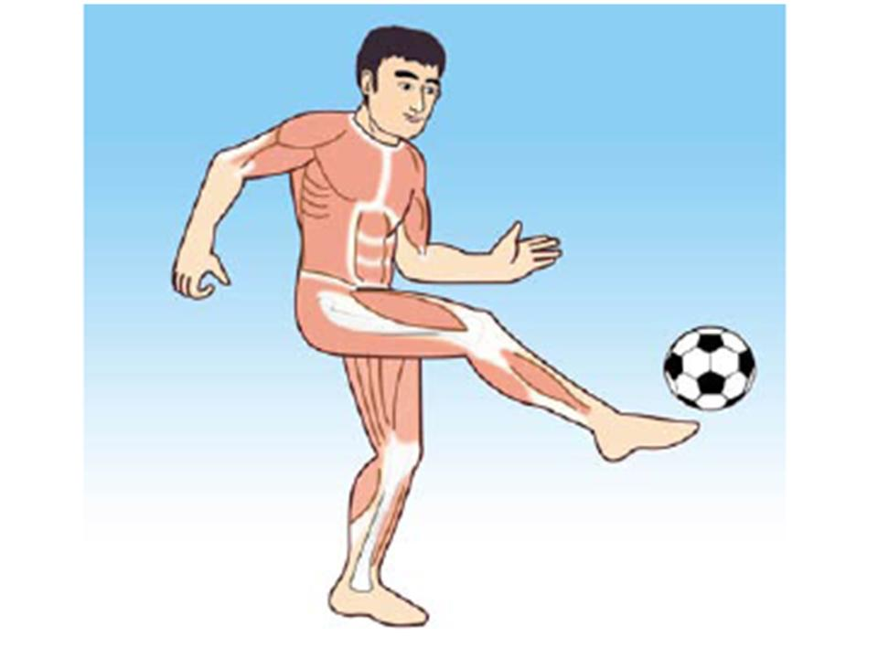

Kicking takes place in a [sagittal plane](http://www.brianmac.co.uk/musrom.htm). It involves the hip, knee and ankle joints and comprises two phases:

**Preparatory Phase**

|  |  |  |
| --- | --- | --- |
| **Joints involved** | **Action** | **Agonist (Major muscles)** |
| Hip | [Extension](http://www.brianmac.co.uk/musrom.htm) | Gluteal muscles (gluteus maximus and gluteus minimus) |
| Knee | [Flexion](http://www.brianmac.co.uk/musrom.htm) | Hamstrings |
| Ankle | [Plantar flexion](http://www.brianmac.co.uk/musrom.htm)* | Gastrocnemius |

**Kicking phase**

|  |  |  |
| --- | --- | --- |
| **Joints involved** | **Action** | **Agonist (Major muscles)** |
| Hip | [Flexion](http://www.brianmac.co.uk/musrom.htm) | Iliopsoas |
| Knee | [Extension](http://www.brianmac.co.uk/musrom.htm) | Quadriceps group of muscles |
| Ankle | [Plantar flexion](http://www.brianmac.co.uk/musrom.htm)* | Triceps Surae (Gastrocnemius and Soleus muscle) |

**Fig 3.13 The joints and agonist muscles involved in kicking**

|  |  |
| --- | --- |
| * **Plantar flexion** describes the extension of the ankle so that the toes points down and away from the leg ; **dorsiflexion** describes the flexion of the ankle so that the toes are brought closer to the shin. |  |

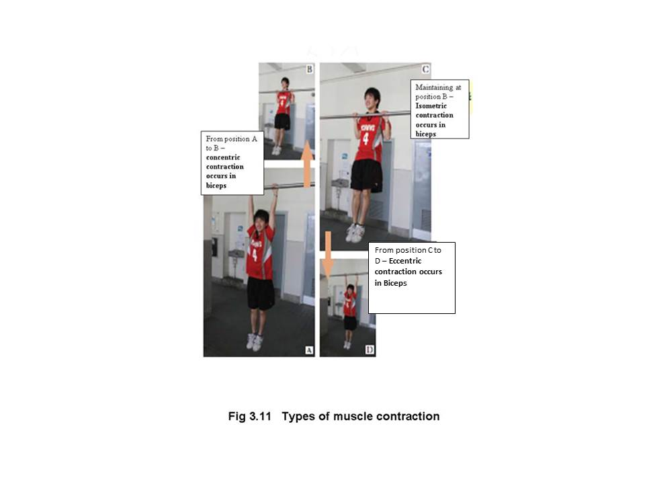

Fig 3.14 Types of muscle contraction

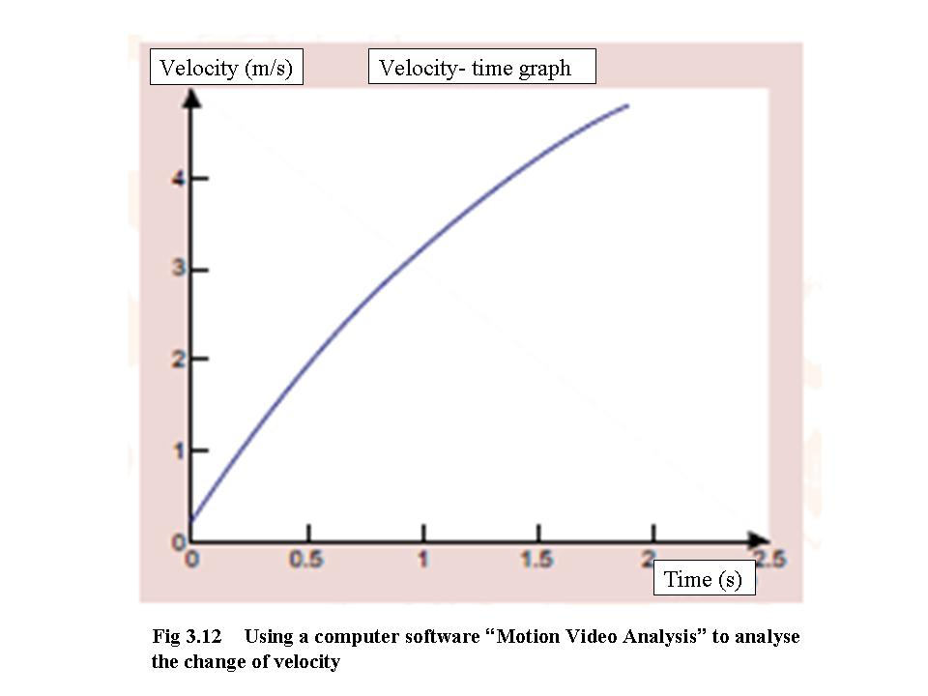

Fig 3.15 Using computer software “Motion Video Analysis” to analysis the change of velocity

**Research Popularity and Trends on the Study of Sports Biomechanics**

With the continuous development of new advanced technology, the research in sports biomechanics continue to progress. Recent hot topics in sports biomechanics can be divided into:

1. Motion analysis;

2. Sports performance enhancement;

3. Motion control related science;

4. Rehabilitation;

5. Sport technology.

The forward-looking issues include special needs for people (aging, elite athletes, strength training); application practice (functional apparel, sports industry) and innovative technology (wearable technology), etc.

| **Examples of Enquiry Activities** | | |
| --- | --- | --- |
| **Theme** | | **Activities** |
| 1. | Forces and Movement | * Newton’s Laws of Motion   *(See additional information (1))*   * Lever (See additional information (2)) |
| 2. | Types of Movements | * Types of motion (See additional information (3)) * Weight Training (See additional information (4)) |
| 3. | Performance Analysis | * Centre of gravity (See additional information (5)) * Vertical jump (See additional information (6)) * Throwing (See additional information (7)) |

**Examples of enquiry activities (Additional information) (1): Newton’s Laws of Motion**

**Objective:** To enable students to see how the theory of each of Newton’s Laws of Motion can be applied to movement analysis.

**Implementation:**

* In a classroom setting, students are divided into 15-20 groups and each group is assigned a specific sport skill for analysis.
* Members use Newton’s Laws of Motion to analyse the assigned skill, and suggest some key points for improving performance.
* The teacher can assist and provide feedback whenever necessary to enhance students’ analytical power.

**The following examples are relevant:**

|  |  |  |
| --- | --- | --- |
| **Sport skill** | **Newton’s law of motion** | **Explanation** |
| Start or finish in sprinting | 1st Law: The Law of Inertia | During the start or finish, the runner needs to overcome inertia. Therefore, he / she can only accelerate / decelerate gradually |
| Acceleration during running | 2nd Law: The Law of Acceleration | If the mass and acceleration of the runner are known, we can find out the force required to produce the acceleration by using the formula F=ma. |
| Take-off in high jump | 3rd Law: The Action / Reaction Law | A high-jumper exerts a force on the ground when taking-off, the ground then exerts an upward force upon the jumper to propel him / her over the bar. |

**Examples of enquiry activities (Additional information) (2): Leverage principles**

**Objective:** To enable students to have a deeper understanding of the concept of leverage principles and to be able to put the theory into practice.

**Implementation:**

* Students are divided into groups of 5. Apparatus includes a baseball bat, 5 small balls (10cm in diameter; not fully inflated), a batting tee (1 meter in height) and a measuring tape.
* The first round of batting – Each student makes 5 consecutive hits with the middle part of the bat (the hitting form and force applied should be kept consistent across the 5 hits); and record the average distance that the ball travels.
* The second round of batting – It is the same as the first round, but the far end of the bat is used to hit the ball.

**Examples of questions to be raised:**

* Which type of lever does “baseball batting” demonstrate? Draw a diagram to show the “effort arm”, “fulcrum” and “load arm” of the movement.
* [Ask individual student] What are the average distances that the ball travelled when it was hit by the middle part and the far end of the bat respectively?
* Collect data of the whole group and compare the results of batting with the middle part and that of batting with the far end of a bat.
* What conclusions can be drawn from this experiment?

**Examples of enquiry activities (Additional information) (3): Types of motion**

**Objective:** To enable students to apply appropriate terms to illustrate the motion types and mechanical principles of sports skills.

**Implementation:**

* Ask students to collect photos of various kinds of sports skills from the internet.
* The students develop presentation materials using the photos collected and discuss the motion types and mechanical principles involved in the skills.
* They present their findings in class.

**Students may refer to the following format to describe the photos:**

|  |  |  |  |
| --- | --- | --- | --- |
| **Event** | **Skill** | **Types of motion** | **Mechanical  principles** |
| Gymnastics | Swing on high bar | Angular motion | Moment of inertia |
|  |  |  |  |
|  |  |  |  |
|  |  |  |  |
|  |  |  |  |

**Examples of enquiry activities (Additional information) (4): Weight training**

**Objective:** To deepen students’ knowledge of muscle movements.

**Implementation:**

* Students are taught the correct techniques for lifting weights.
* They perform the muscle movements by lifting dumbbells with both the upper and lower limbs. Movements include flexion, extension, abduction, adduction, pronation, supination, etc.
* In pairs, students take turns to perform and observe. The observer will provide feedback to help the partner develop the correct techniques.
* The teacher should explain clearly to the students their roles and responsibilities in the learning process.
* The teacher should observe and provide timely feedback and guidance when necessary.
* The teacher should use more open questions to encourage students to think.

**Examples of enquiry activities (Additional information) (5): Centre of gravity**

**Objective:** To help students gain a deeper understanding of centre of gravity and master the skill of charting the changes.

**Implementation:**

* Students watch videos of 100-meter sprint, high jump, triple jump, dismount from a balance beam, “clean and jerk” weightlifting, 110-meter hurdle, etc.
* The teacher demonstrates the technique of using serial pictures (For example, by capturing pictures from a video clip) to show the changes in centre of gravity.

**Examples of enquiry activities (Additional information) (6): Vertical jump**

**Objective:** To help students understand the relationship between biomechanical principles and sports performance.

**Implementation:**

* The teacher explains and demonstrates the proper technique for vertical jump.
* Each student performs 2 vertical jumps, one with an arm swing and the other without (i.e. hands placed on the hips or the thighs throughout the jump).
* Students then evaluate their own performance and use biomechanical principles to explain the differences in outcomes. Results should be recorded.

**Analysis of performance in vertical jump**

**Procedure:**

1. Perform a vertical jump with and without an arm swing. What are the differences in your feelings?

________________________________________________________________

________________________________________________________________

1. Which technique produces a better performance (i.e. jump higher)? Can you explain why?

__________________________________________________________________

1. Perform and evaluate the two jumps again. Try to find out the most efficient vertical jump technique by using the hints in the table:

|  |  |  |  |
| --- | --- | --- | --- |
| **Body parts** | **Key points (position and actions)** | | **Discussion (using biomechanical principles)** |
| **First jump**  **(with arm swing)** | **Second jump (without arm swing)** |
| Arms |  |  |  |
| Hips |  |  |  |
| Knees |  |  |  |
| Ankles |  |  |  |
| Others |  |  |  |

**Examples of enquiry activities (Additional information) (7): Throwing**

**Objective:** To help students understand the relationship between actions and sports performance.

**Implementation:**

* In groups of three, a student throws a bean bag, another student measures the distance and the last one observes the movement of the thrower.
* Students compare and contrast the following five methods of throwing a bean bag:

1. Sitting with back against a wall. Throwing with arm only.
2. Sitting on the ground. Throwing with arm and rotating the shoulders.
3. Standing. Throwing with arm, turning hips and rotating shoulders. The feet must stay in contact with the ground and not twist.
4. Standing. Throwing with arm, turning hips and rotating shoulders. Throwing with one foot forward.
5. Standing. Throwing with arm, turning hips and rotating shoulders. Throwing by taking a run-up and using a side-on position.

* Results should be recorded in the chart below. Ask the students why there are differences between the results.

|  |  |  |  |  |  |
| --- | --- | --- | --- | --- | --- |
|  | **Method 1** | **Method 2** | **Method 3** | **Method 4** | **Method 5** |
| **Distance** |  |  |  |  |  |
| **How the body feels** |  |  |  |  |  |
| **Discussion** |  | | | | |

**References for Teachers**

王明禧 (2012) 《運動解剖學》。台灣：大展出版社出版社。

王樹傑、張憲強、張樹青 (2005)〈帆船運動迎風航行力學分析及航線選擇〉，《體育科學》，25(8)，56-58。

吳劍、李建設 (2006)〈青少年女性穿不同鞋行走時足底壓力分佈研究〉，《體育科學》，26(6)，67-70。

洪得明等 (2014) 《運動生物力學理論與應用》。台中市：華格那企業出版社。

林國全、王敏憲 (2009) 〈排球跳躍發球的運動生物力學機制〉《文化體育學刊》第9輯 51 - 60 頁。

紀仲秋 (2005) 《運動生物力學》，桂林：廣西師範大學出版社。

教育統籌局資優教育組 (2007)《物理奧林匹克力學》，香港：教育統籌局。

陳啓明 (主編) (1995)《運動醫學與科學》(169-186)，香港：中文大學出版社。

陳文和 (2014) 〈划船划槳週期發力時序與船速變化之探討〉《運動教練科學》 第34期，49-60頁。

陳柏潔、黃長福 (2014) 〈以生物力學觀點探討不同跑步著地動作〉《運動表現期刊》第1(2) 期， 68-74頁。

翁梓林 (2018) 〈運動生物力學之研究熱門與前瞻：以2006~2015為例〉《華人運動生物力學期刊》第 15 卷 第 1 期，01-13 頁。

游正忠、陳建勳、黃宏春 (2006) 〈人體的角動量變化對三級跳遠成績影響之分析〉《運動教練科學》第6期3月，41-49頁。

辜瀞儀、孫苑梅、簡偉全、王令儀 (2018) 〈疲勞對耐力跑的下肢生物力學與著地型態之影響〉《華人運動生物力學期刊》 第 15 卷第 2 期，16-24 頁。

劉宗翰、謝長欣、相子元 (2018) 〈以生物力學觀點應用於跑鞋研發設計實例〉《華人運動生物力學期刊》 第 15 卷 第 1 期，23-29 頁。

Bartlett, R. (1999). Sports biomechanics: Reducing injury and improving performance. London: E & FN Spon.

Bartlett, R. (2014). Introduction to Sports Biomechanics: Analysing human movement patterns (3rd ed.). Taylor & Francis.

Batman, P. (1994). Exercise analysis made simple: A step by step approach (4th ed.). Sydney: FIT4U, Fitness and Healthy Lifestyle Publications.

Carr, G. (2004). Sport mechanics for coaches (2nd ed.). Champaign, IL: Human Kinetics.

Gerhardt, J. J. (2002). The practical guide to range of motion assessment. Chicago, IL: American Medical Association.

Hughes, M., & Franks, I.M. (Eds.). (2004). Notational analysis of sport: Systems for better coaching and performance in Sport. (2nd ed.). London: Routledge.

Kreighbaum, E., & Barthels, K.M. (1996). Biomechanics: A qualitative approach for studying human movement (4th ed.). Boston : Allyn and Bacon.

McGinnis, P. M. (2005). Biomechanics of sport and exercise (2nd ed.). Champaign, IL:Human Kinetics.

Neumann, D.A. (2017) Kinesiology of the Musculoskeletal System, (3rd ed) : Mosby/Elsevier.

Royston, A. (2001).Forces and motion**.** Oxford : Heinemann Library

Ryan, S., Marzilli, S., & Martindale, T. (2001). Using digital camera to assess motor learning. Journal of Physical Education, Recreation and Dance. 72(8), 13.

Saladin, K. S. (2018). Anatomy & physiology: the unity of form and function, New York, NY : McGraw-Hill Education.

Watkins, J. (2014). Fundamental Biomechanics of Sport and Exercise. Routledge.

Men's 100m - 2017 IAAF World Championships Biomechanical report. <https://www.worldathletics.org/about-iaaf/documents/research-centre>

Morris et al. (1995). Biomechanical analysis of the men’s javelin throw at the 1995 world championships in athletics. www.athleticscoaching.ca

**References for Students**

紀仲秋 (2005) 《運動生物力學》，桂林：廣西師範大學出版社。

教育統籌局資優教育組 (2007)《物理奧林匹克力學》，香港：教育統籌局。

Batman, P. (1994). Exercise analysis made simple: A step by step approach (4th ed.). Sydney: FIT4U, Fitness and Healthy Lifestyle Publications.

Honeybourne, J., Hill, M., & Moors, H. (2004). Advanced physical education and sport for A-Level (3rd ed.). Cheltenham: Nelson Thornes.

**Related Websites**

1. Australian Sports Commission (ASC)  
   https://www.ausport.gov.au/
2. BrianMAC Sports Coach   
   https://www.brianmac.co.uk/

* Movement Analysis  
  https://www.brianmac.co.uk/moveanal.htm
* Biomechanics  
  https://www.brianmac.co.uk/biomechanics.htm

1. Chinese University of Hong Kong - Motion Video Analysis Software  
   <http://www.hk-phy.org/mvas/>
2. English Institute of Sport (EIS)  
   https://www.eis2win.co.uk

* Performance Analysis  
  https://www.eis2win.co.uk/expertise/performance-analysis/

1. HKPE.NET (Chinese only)  
   http://www.hkpe.net/hkdsepe/

* Biomechanical Aspects of Running (Chinese only)  
  <http://www.tswong.net/hkpe/running/running_biomechanics.htm>

1. International Society of Biomechanics in Sports (ISBS)  
   https://isbs.org/
2. Loughborough University - Sports Biomechanics and Motor Control Research Group   
   <https://www.lboro.ac.uk/microsites/ssehs/biomechanics/>
3. The British Association of Sport and Exercise Sciences (BASES)  
   <https://www.bases.org.uk/>

* Biomechanics

https://www.bases.org.uk/spage-divisions-biomechanics_and_motor_behaviour.html

1. Hong Kong Sports Institute

https://www.hksi.org.hk

1. Morris, et al. (1995). Biomechanical analysis of the men’s javelin throw at the 1995 world championships in athletics. (Source: www.athleticscoaching.ca)
2.
3.