Module 3

Part B : Different Human Faces under AP

Activity 1

Refer to the following video clips and complete the activity below.
RTHK: broadcast on SARS
(http://www.rthk.org.hk/special/sars/)
Programme “Caring for Each Family – Exploring SARS and People <家家有關懷> - 探討疫症背後的人和事
Main Themes of the Video:
- Block E of Amoy Gardens has become a disastrous area. People get frightened hearing the name. Iris, a resident of Block E, has not been infected. But already she had experienced a reality both sweet and sour. She has to deal with the threat brought by SARS. She also faces discrimination by others. Fortunately, before the closure of the building, a friend offered her a place to stay. It gives her a warm feeling in these difficult days.
- Those are not able to “Cure”, can offer their “Care” and concern to others. There are voluntary organizations giving away masks to the elderly and the homeless. There are volunteers staffing the hotlines to offer counseling.
- Professor Joseph SUNG of Department of Medicine of the Chinese University of Hong Kong has been a doctor for more than 20 years. In the decades, he has served many patients. This time, he sees his peers at work being infected one by one. There is a change in his attitude. He is now giving more focus on the needs of his patients than on the disease itself. He wants to convey a message to them: someone is taking care of you. Patients need “Cure”, they also need “Care”. Although the professor has not been infected, for the sake of the safety of his family, he isolates himself from his wife and son. No intimate contact with his family, he nevertheless is receiving support from them in special ways. Taking good care of oneself is a form of caring for one’s family.
- SIU Yuet-kwan is the first batch of front-line medical staff infected by SARS. During her isolation, she realized that her colleagues were also fighting hard against the disease. A photo from her colleague became a most effective support for her.
- TSE Yin-kwan went to the Prince Wales Hospital to visit her infected elder brother who is threatened by death. This realization brings them much closer than ever before.
- Ah Sun, owner of a dessert shop, shows his support of front-line medical staff by bring them delicious dessert. His action bears out the truth that “Giving is much more blessed than receiving”.

To think about：
Complete the following table:

IrisVolunteersProf. SUNGSIU Yuet-kwanTSE Yin-kwanAh SunWhat have they done in the AP crisis？

What is/are the reason(s) behind?

What price do they have to pay？

What did they gain？

Any new understanding towards life and relationship?

Have you come across similar stories during these days? Share them with your classmates.
________________________________________________________________________________________________________________________________________
________________________________________________________________________________________________________________________

Activity 2
“LIVE SCENES UNDER A.P.”
Refer to the following scenes, then finish the discussion.

Source 1

You know, wearing masks all day long is not only inconvenient, it also makes me feel uncomfortable and my supervisor has said that it would severely affect our company’s image.
Dad, you have contact with so many travelers every day, but you don’t wear masks and wash your hands. You know, this is highly risky at this critical moment!
Mother

Yes! Wearing masks does cause inconvenience. It is very hot and it makes my hair messy. What’s more, I don’t think I would ever be infected.



Father

Son

Source 2

George

You are infected.
Don’t use the micro-oven.

Don’t come near me,.

I am only having a running nose and everyone sees me as a SARS patient.

George



Refer to Source 1.
a. Do you think the reasons they give make sense? Why?
RoleReasons behindSensible / Not SensibleWhy?MotherFatherSon
b. What should they do to improve the communication among themselves?
__________________________________________________________________
__________________________________________________________________
__________________________________________________________________

Refer to Source 2.
a. How would you behave towards George if you were his colleague?
__________________________________________________________________
__________________________________________________________________
__________________________________________________________________
b. What should George do to improve the relationship with his colleagues?
__________________________________________________________________
__________________________________________________________________
__________________________________________________________________

Activity 3
Read the following case studies and fill the table below.

Case 1
1.4.2003

Amoy Gardens residents accept isolation at home

Atypical pneumonia infection continued its steep rise at Amoy Gardens in the past few days. Many residents had fled their homes. The Government issued an isolation order on 31 March which required residents of Block E, Amoy Gardens, to remain in their flats until midnight April 9.

The Wen Family lived in Block E. They fled on 30 March and stayed in a hotel. After hearing of the isolation order, they returned home at noon yesterday.

A member of the Wen family thought that the isolation order was good news. “When the hotel staff found out that we live in Amoy Gardens, they tried to baf us from the hotel. They backed off only after we showed them our health certificates. We feel discriminated against. But we also worry that we might infect others.”

Now that the Government has issued the isolation order, she is relieved. “The virus could be anywhere. Is there any safe place at all? When we return to Amoy Gardens, health workers would be there to take care of us. This is better, isn’t it?”

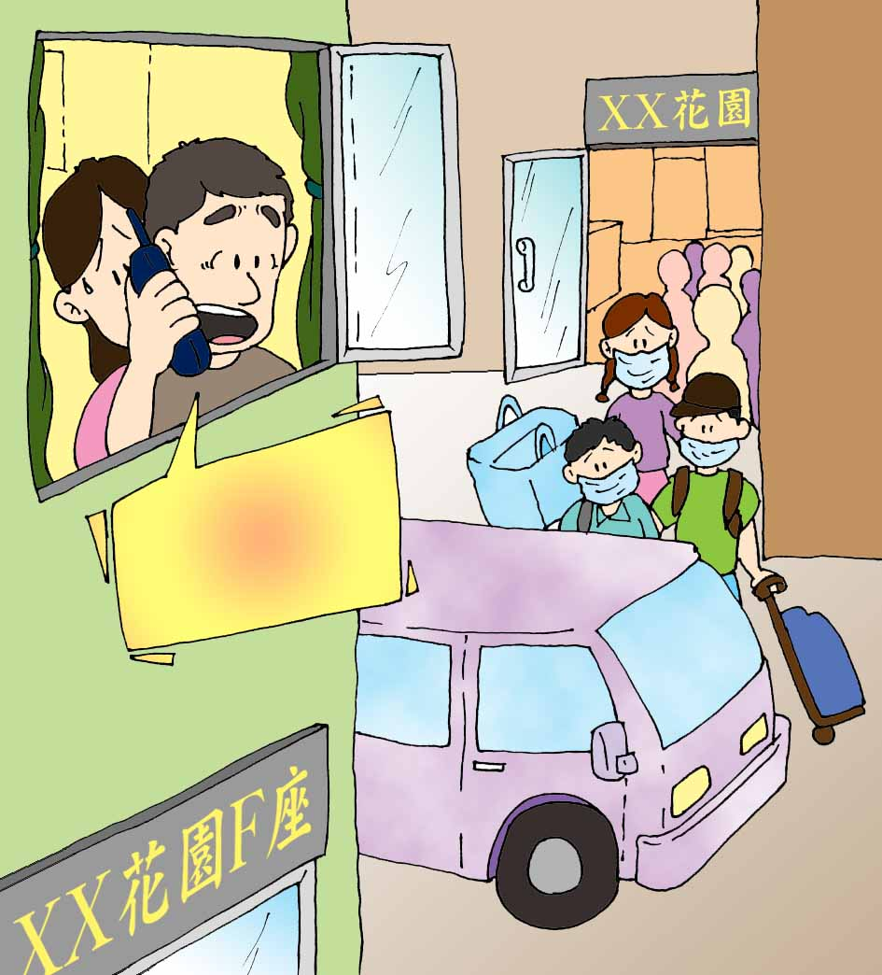
Dad and Mum, we are not coming to your place for dinner for the time being. We are not sure if we are infected, so for the safety’s sake, it is better for us to stay.
……

Case 2
7.4.2003

Suspect victim in 14-hour standoff

After confirming that a man living in Ying Ming Court, Tseung Kwan O, was suffering from Atypical Pneumonia, officers from the Department of Health went to his home to ask him to go to hospital immediately. The man insisted that he was free of the disease and locked himself in his home. Police were called in but to no avail. After more than 14 hours of negotiation, the man gave in and was sent to hospital.

His wife later pointed out that her husband had diabetes. He had been admitted to hospital two weeks before, with fever and coughing. He was discharged after treatment. His wife said, “Doctors said that he was OK. Now they say that he is ill. We don’t know which is which. My husband is worried that he could become infected with Atypical Pneumonia when the second time in hospital. He is free of the disease now.”

The man had refused to be sent to the hospital. He was agitated. He declared in anger that the hospital had been negligent and should be held responsible for the confrontation. He also pointed out that he could be fired by his boss if he had to
be treated in isolation. Thus he refused the order of the health officers.

During the incident, many residents of Ying Ming Court fled their homes to escape infection. When it was over, the police and health officers involved were disinfected.

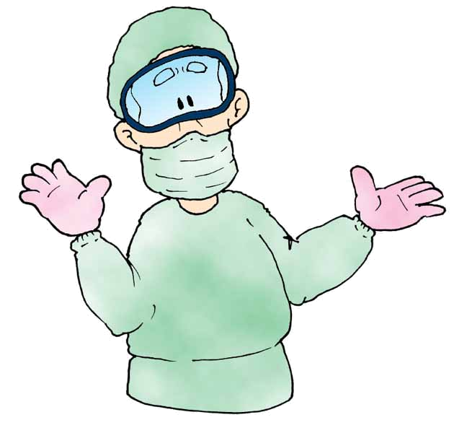

I have no AP! I refuse to go to hospital. It is a most dangerous place…I might be infected there!!

Sir, we suspect that you are infected by AP. Please come with us to the hospital for checking.

Who is more rational？

 | Case 1 | Case 2
Perceived situation of the key individual

Reaction of the key individual

Reaction of others

Action taken by the key individual

Benefits of the key individual’s action

Costs of the key individual’s action

Is the action rational? Why?

What is its impact on others?

Activity 4
Read any one of the following case studies and finish the discussion below.

THE STORY OF A DOCTOR AT THE PRINCE
WALES HOSPITAL

Afraid of being infected, this doctor at the Prince Wales Hospital chooses nevertheless to stay in this dangerous place. His mission is to care for his patients.

The SARS has severely affected his daily life. He is always on the alert. He needs to put on extra clothes at work. He wears masks and gloves for protection. At the end of the day, he cleans up before he drives back home. On arrival, he rushes to the bathroom, pulls off all his clothes, cleans himself again thoroughly. Then and only then does he meet his family.

His daughter in kindergarten has also fallen victim to SARS in some way. The parents of other kids have told their children to stay away from her.

The doctor has suffered severely and much stressed. But he finds encouragement from public support. There are words of comfort posted on hospital walls. These touch him deeply, propelling him to continue to serve the community.

What risks do medical workers face when they take care of AP patients?
____________________________________________________________
____________________________________________________________
____________________________________________________________

What prices do medical workers have to pay in taking care of AP patients?
What do they gain?
____________________________________________________________
____________________________________________________________
____________________________________________________________

Why do medical workers decide to take care of AP patients? Do you think
they are rational?
____________________________________________________________
____________________________________________________________
____________________________________________________________

Suppose a member of your family is thinking seriously of taking care of AP
patients voluntarily. How would you respond?
____________________________________________________________
____________________________________________________________
____________________________________________________________

As a Hong Kong citizen, what can you do to express your sincere support
of the medical workers who are rescuing patients from A.P.?
____________________________________________________________
____________________________________________________________
____________________________________________________________

“Atypical” Medical Staff

- A number of doctors has voluntarily joined the Intensive Care Unit for SARS at the Prince Wales Hospital. They are there to support front-line medical staff in caring for the infected patients. In the daytime, they care for their confined peers who are struggling with SARS. In the nighttime, their masks are always on even at home. They have to keep away from family members in order not to infect them. They dare not talk to them face to face. They intentionally isolate themselves, having dinner by themselves. They do not hug their children. They only look at them in tears. They are under great stress. Yet, everyday, they man the battle line and do not retreat.

- Dr. LEE, a volunteer, said “No one can stand by when dear ones are sick or near death. My colleagues are now in trouble. I am willing to fill in the gap in the front-line. I can do no less.” His words sound so ordinary but so powerful.

- Another of Dr LEE’s colleagues is on the same team. His wife is pregnant. The team takes their meals and rest in a far corner to avoid infecting others. Some move into dormitories in the hospital with only a few basic necessities.

What risks do medical workers face when they take care of AP patients?
____________________________________________________________
____________________________________________________________
____________________________________________________________

What prices do medical workers have to pay in taking care of AP patients?
What do they gain?
____________________________________________________________
____________________________________________________________
____________________________________________________________

Why do medical workers decide to take care of AP patients? Do you think
they are rational?
____________________________________________________________
____________________________________________________________
____________________________________________________________

Suppose a member of your family is thinking seriously of taking care of AP
patients voluntarily. How would you respond?
____________________________________________________________
____________________________________________________________
____________________________________________________________

As a Hong Kong citizen, what can you do to express your sincere support
of the medical workers who are rescuing patients from A.P.?
____________________________________________________________
____________________________________________________________
____________________________________________________________

Read and Write

Your heroic serving spirit, love and care devoted to the patients touch our hearts. Thanks for setting an ideal model for every citizen of Hong Kong, especially for our younger generation. Thanks for showing us what actually a hero is. Take care!!

A group of teachers
Edited from several Letters to Editor
Every Hong Kong people are proud of you who dedicate yourselves to help without reservation. Our admiration for your acts cannot be put into words.

A patient
TO:
OUR MOST RESPECTED MEDICAL WORKERS

I don’t know how to put my admiration and gratitude into words. When I am trembling with fear at home, you are combating the undetectable virus second after second. I had a fever and felt a tickle in my throat yesterday. After I consulted a doctor, I was afraid of going home and pondered upon finding a hotel. … Our diminishing pride of Hong Kong has been salvaged by your courage, professionalism, affection and sense of responsibility. …

A Hong Kong resident

Words of appreciation or gratitude

