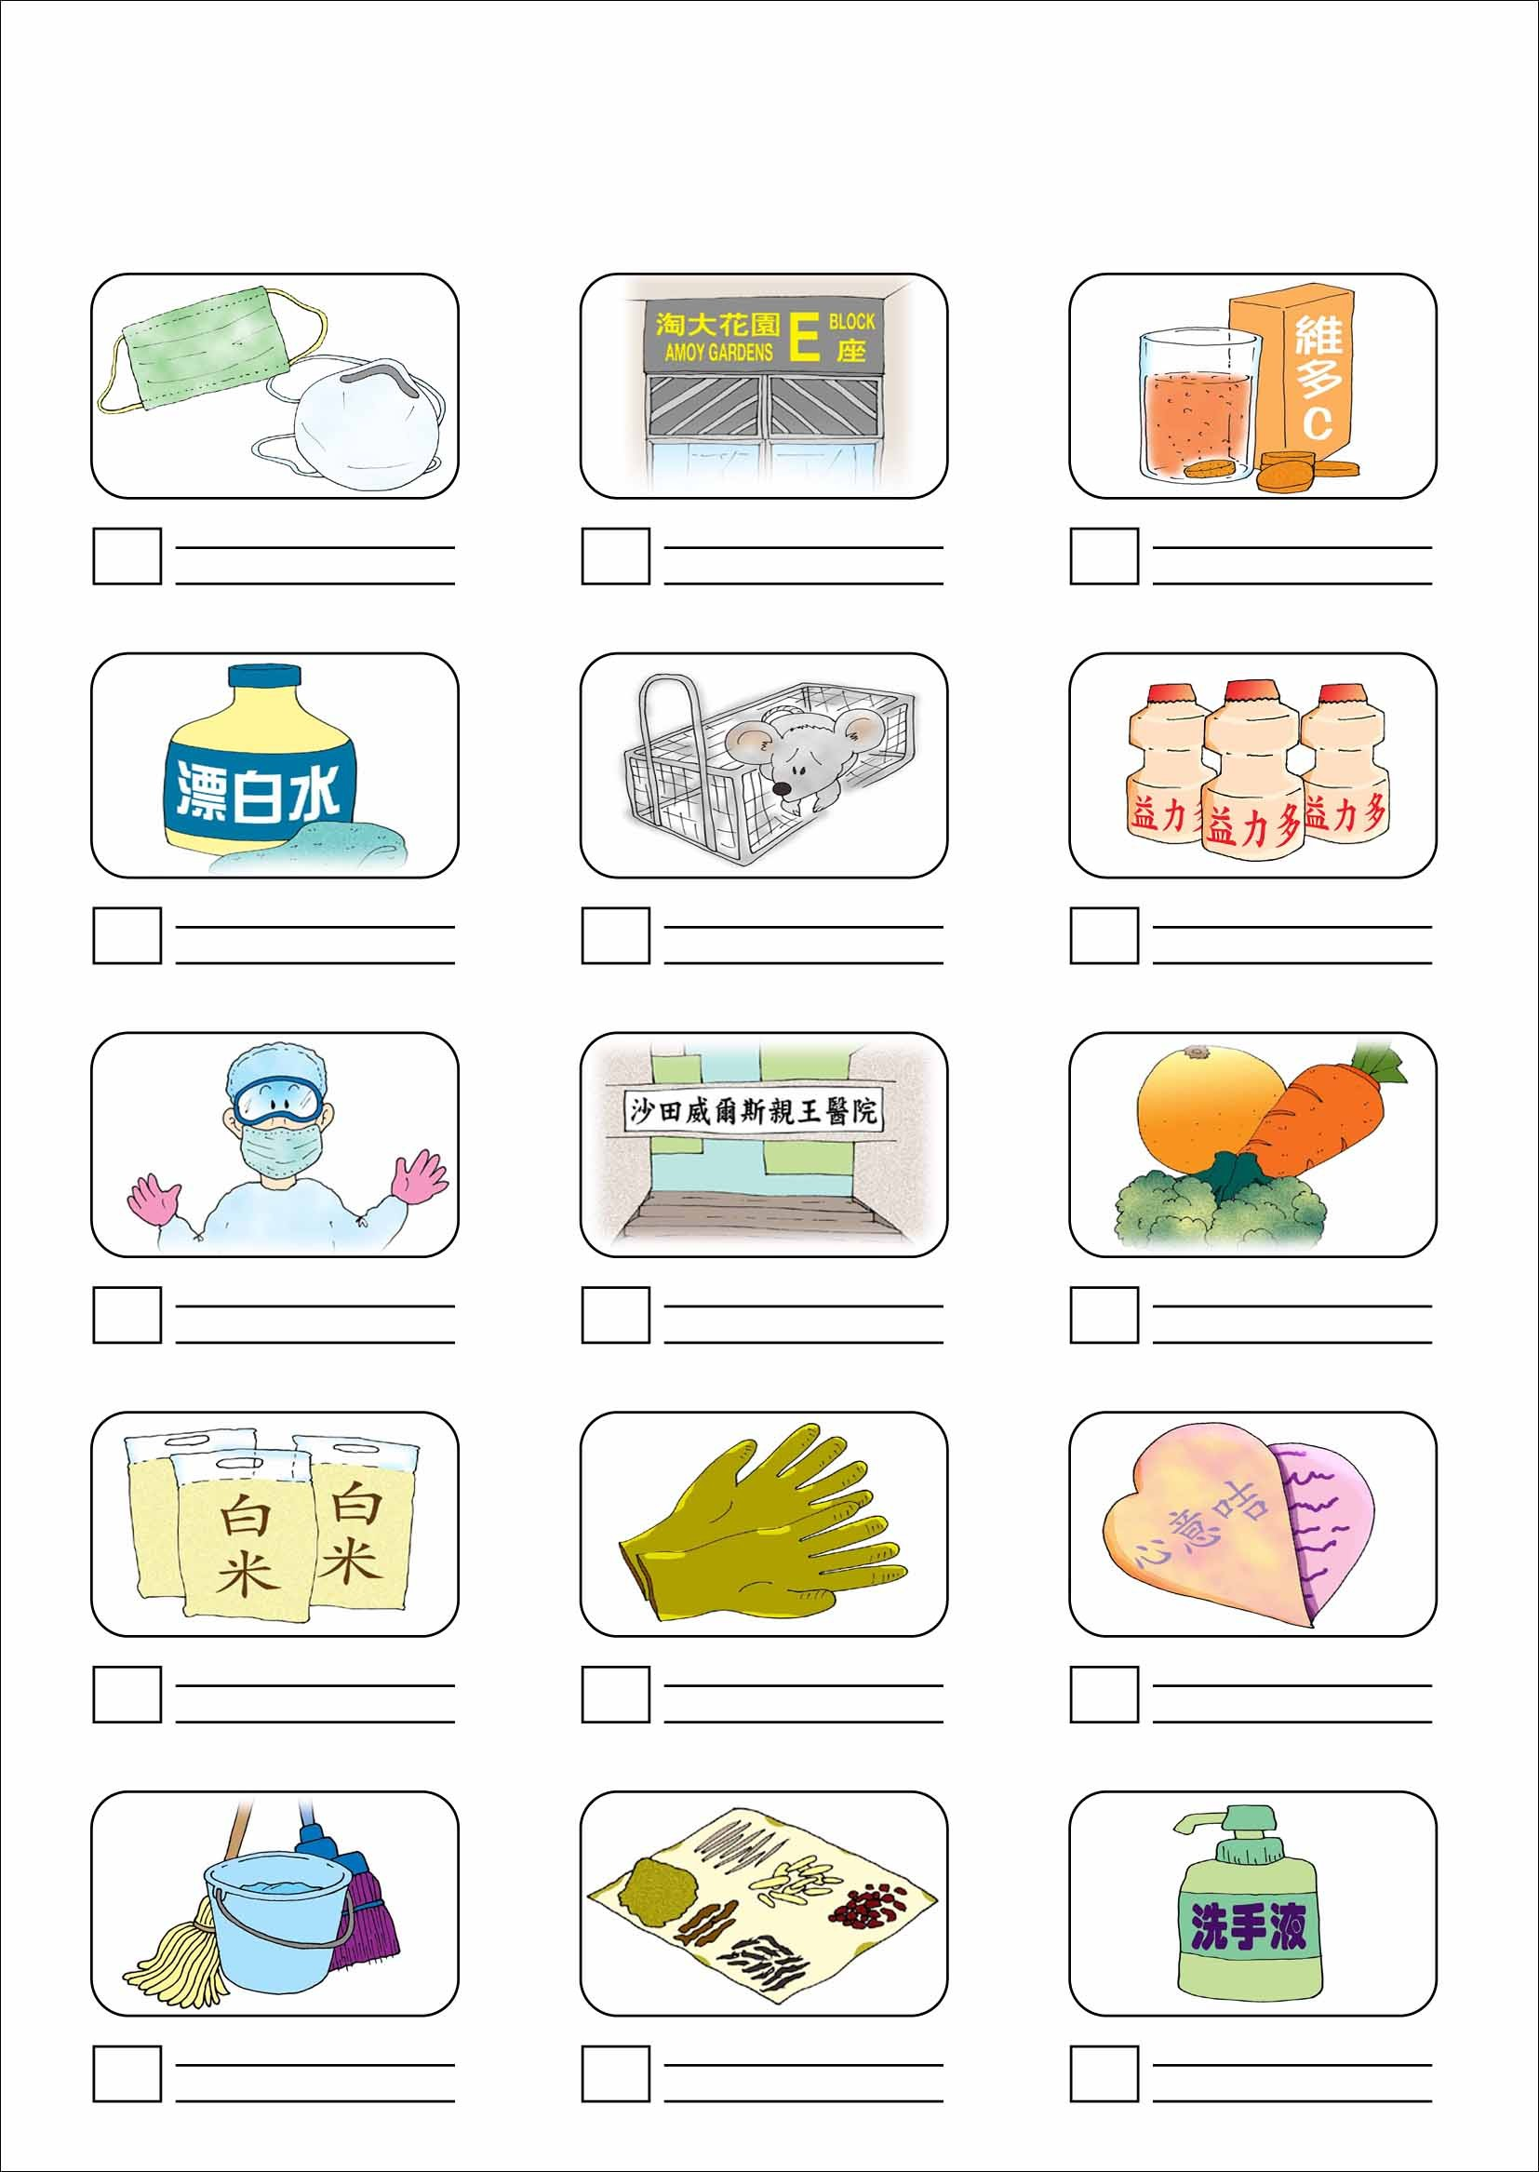
中藥

My Choice for AP Time Capsule
Time Capsule

