Aim
To investigate the effect of the electrolysis of tin(II) chloride solution and sodium chloride solution using microscale apparatus

Background
Electrolysis is a process using an electric current to decompose compounds. An electrolytic cell is required several components including a power supply, anode and cathode, and an electrolyte. In this demonstration, an electrolytic cell is constructed using microscale apparatus. The electrolytic cell is then used to carry out the electrolysis of (i) tin(II) chloride solution and (ii) sodium chloride solution.

Curriculum Link
Topic VI Redox Reactions, Chemical Cells and Electrolysis (Chemistry)

Part I: Electrolysis of tin(II) chloride solution
Electrolysis of
tin(II) chloride solution and sodium chloride solution
Apparatus and Equipment (per group)
- One 9V battery
- One petri dish
- Two connecting wires with crocodile clips at both ends
- Two paper clips
- One filter paper
- One filter funnel
- Two 100 cm³ beaker

Chemicals (per group)
- 30 cm³ of saturated SnCl₂ solution

Procedure
- Transfer about 20 cm³ of saturated tin(II) chloride solution in a petri dish to cover the bottom of the dish.
- Attach two paper clips to opposite sides of a clean petri dish. The long ends of the paper clips should be on the inside of the dish touching the liquid.
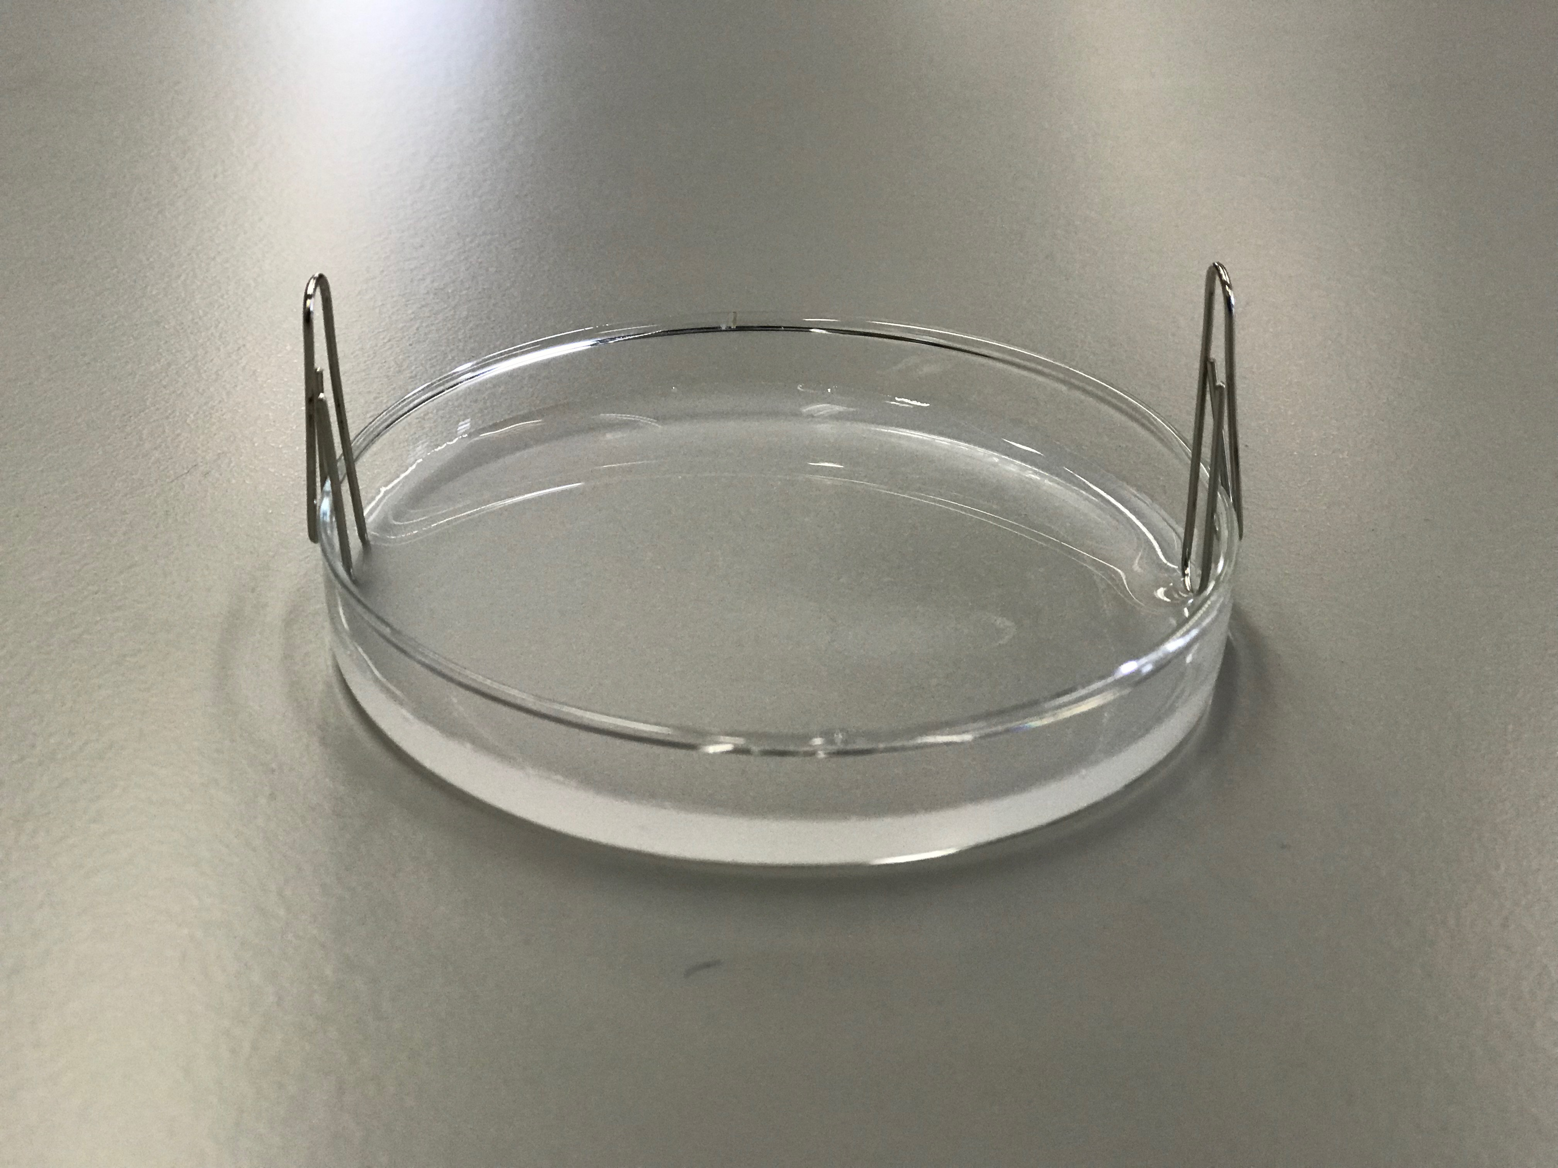
- Attach the two connecting wires to the positive and negative terminal of a 9V battery respectively.
- Attach the two connecting wires to the two paper clips attached on the petri dish.
- Wait for one minute. Observe and record the changes in the petri dish.

Safety precautions
Conduct a risk assessment for this experiment, and summarise the key precautions below.
Questions
- When the paper clips are attached on the petri dish and dipped into the tin(II) chloride solution, the dipped part of the paper clips turns black. Explain this observation.

- Sketch in the space below a labelled diagram to describe the observation(s) in the experiment.
Cathode
Anode

Petri dish

- Describe the physical appearance of the products formed at cathode and anode.

- In the electrolysis of tin(II) chloride solution, insoluble tin(IV) chloride solid and tin metal are formed. Write two half equations to represent the products formed at anode and cathode respectively.

- Write an chemical equation to represent the overall reaction of the electrolysis of tin(II) chloride solution..

Part II: Electrolysis of sodium chloride solution

Apparatus and Equipment (per group)
- One 9V battery / power suppply
- One petri dish
- Two connecting wires with crocodile clips
- Two pencils with both end sharpened / two pencil leads
- Wash bottle

Chemicals (per group)
- Concentrated NaCl solution
- Solution A
- Solution B
- Universal indicator

Procedure
- Add a few drops of concentrated NaCl solution, solution A, solution B and universal indicator in the petri dish as shown in the following diagram.

solution B

conc. NaCl solution

universal indicator
solution A

petri dish

- Attach the two connecting wires to the positive and negative terminal of a 9V battery respectively.
- Attach the two connecting wires to the two pencil leads. Make sure the crocodile clips have good contact with pencil leads.
- Dip another end of the pencil leads in the concentrated sodium chloride solution on the petri dish.
- Observe and record the changes on the solutions in the petri dish.

Safety precautions
Conduct a risk assessment for this experiment, and summarise the key precautions below.
Result

Observation at :
Solution A

Solution B

Universal indicator

Concentrated NaCl solution

Questions

- Solution A and solution B are potassium halides.
With reference to the observation in the experiments, deduce which of the following could solution A and B be, support your answer with appropriate chemical equation(s).

potassium fluoride, potassium chloride, potassium bromide, potassium iodide

- Explain the observation that occurs at the universal indicator during the electrolysis.

- Explain the observation that occurs at the concentrated NaCl solution during the electrolysis with the use of half equations. Hence, write a chemical equation to represent the overall reaction of the electrolysis of concentrated sodium chloride solution.

