Aim
The Reaction of an Acid and an Insoluble Base
To study the change in pH during the reaction of hydrochloric acid and an insoluble base

Curriculum link
Topic IV Acids and Bases

Equipment
- A pH probe
- A datalogger (e.g. PASCO USB link) with a pH sensor interface
- A computer with a datalogging software (e.g. Datastudio)

Apparatus
- One magnetic stirrer unit and stirrer bar
- One stand and clamp
- One 100 cm³ beaker
- One 1,000 cm³ beaker
- One 10 cm³ measuring cylinder (or plastic syringe)
- One plastic dropper

Chemicals (per trial)
- About 60 cm³ of 1 mol dm⁻³ hydrochloric acid [dilute HCl(aq)]
- About 0.01 mole of an insoluble base like 4MgCO₃Mg(OH)₂5H₂O(s) [base B]
- 5 cm³ universal indicator solution
- 500 cm³ deionised water

Procedure
- Add 0.01 mole of base B to 500 cm³ deionised water in a 1,000 cm³ beaker
- Add 5 cm³ universal indicator solution to the mixture, and then a stirrer bar and a pH probe (connected to a datalogger unit)
- Put the beaker with the mixture on a magnetic stirrer unit, and start stirring for about 2 minutes
- Record the pH of the mixture by using appropriate software (use “digit” and “graph” display)
- Add a sample of 10 cm³ dilute HCl(aq) to the mixture, and continue stirring
- Observe careful the variations in pH values and colour changes of the mixture
- Repeat steps 4 and 5 for several times, i.e. up to a total of about 50 cm³ dilute HCl(aq)

Set-up
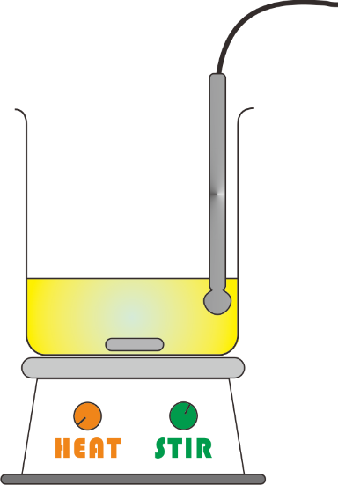
base B in deionised water with universal indicator

batches of 10 cm³ dilute HCl(aq)

magnetic stirrer bar
stirrer bar

pH probe connected to a datalogger

(Note: There is no need to turn on the heater.)

Safety precautions
Conduct a risk assessment for this experiment, and summarise the key precautions below.

Pedagogy
Discuss and summarise the possible ways to use this experiment for learning and teaching of Chemistry.

Questions for Students
- Describe the observations in the reaction mixture before and after the addition of first batch of dilute HCl(aq).
- Interpret the graph showing the variation of pH values upon the addition of first and second batches of dilute HCl(aq), using a molecular perspective.

Reference
- “Upset Tummy? - MOM To The Rescue” by FlinnScientific
URL: http://www.youtube.com/watch?v=VTUSUtT0nQ8

- Dilute HCl on 3MgCO₃Mg(OH)₂3H₂O(s) (an insoluble base like B)
with universal indicator
URL: http://www.youtube.com/watch?v=5pwFyINXzKg

- MSDS of Hydrochloric Acid 物質安全資料表－氫氯酸
http://www.ch.ntu.edu.tw/~genchem99/msds/exp30/hcl.pdf （中文版）
http://cd1.edb.hkedcity.net/cd/science/laboratory/safety/msds_2000_Q.pdf (#043)

- MSDS of Universal Indicator
http://cd1.edb.hkedcity.net/cd/science/laboratory/safety/msds_2000_Q.pdf (#262)

- MSDS of magnesium carbonate
http://cd1.edb.hkedcity.net/cd/science/laboratory/safety/msds_2000_Q.pdf (#380)

