**The construction of a simple Arduino device to detect alcohol in air**

Objective

To construct a simple Arduino device to detect the presence of alcohol in air with Arduino kits including: LEDs, wires, a breadboard and a MQ-3 alcohol sensor.

Task

* To connect LEDs to a breadboard
* To connect an Arduino UNO board to a breadboard
* To connect a MQ-3 alcohol sensor to an Arduino UNO board
* To upload codes to an Arduino UNO board
* To detect the presence of alcohol in air with an Arduino device

## Background

Arduino boards are microcontrollers with versatile functions.

People can build digital devices and many interactive objects with sensors and kits compatible to Arduino board. The sensors will generate a voltage base on some specific stimuli from the environment. The received voltage reading will be processed by Arduino board following the instructions (code uploaded to the board) of users. With linkage of different kits to the board, the devices built can response to environmental stimuli, logging data for investigative studies or other purposes.

In this project, we are going to construct a device to detect the presence of alcohol in air and response by turning on/off LEDs.

## Apparatus and Equipment (per group)

* 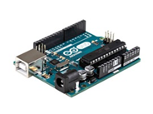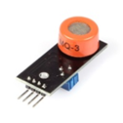Arduino Uno board x 1
* MQ-3 (Alcohol Sensor) x 1
* 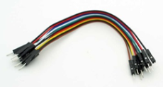Green LED x 1
* 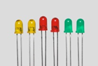Red LED x 1
* Breadboard x 1
* 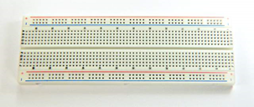Jumper Wire (Male to Male) x 5
* Jumper Wire (Male to Female) x 3
* Computer x 1

Safety precautions

Alcohol is highly flammable, keep away from open flames and sparks when conducting the project.

* Alcohol is irritating to eyes, skins & respiratory tract, avoid eye & skin contact or direct inhalation.
* Inhalation of high concentrations of alcohol can cause headache, dizziness, nausea, and stupor.

Procedure

**Part A: Installation of Software and Arduino board**

1. Download and install the Arduino software (Arduino integrated development environment (IDE))from <https://www.arduino.cc/en/main/software>
2. Connect your Arduino board to computer via the USB port.
3. Execute the Arduino software and go to Tools 🡪 Get Board Info (If you can see the Board Info, the connection is completed; otherwise, select a different port for board connection).

**Part B: Wiring**

B1: LEDs connection on breadboard

1. Place your LEDs* on the breadboard similar to the picture below:

*The longer leg of LED is the anode (+), shorter one is cathode (-)

*DO NOT place the LEDs on the same columns

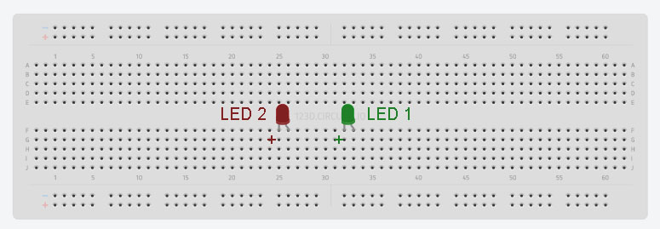

B2: Connecting Arduino board to the breadboard

1. Using a **Green\*** wire to connect Arduino board pin 10 to **LED 1**.
2. Using a **Yellow\*** wire to connect Arduino board pin 11 to **LED 2**.
3. Using a **Black**# wire to connect GND pin from Arduino board to the breadboard.

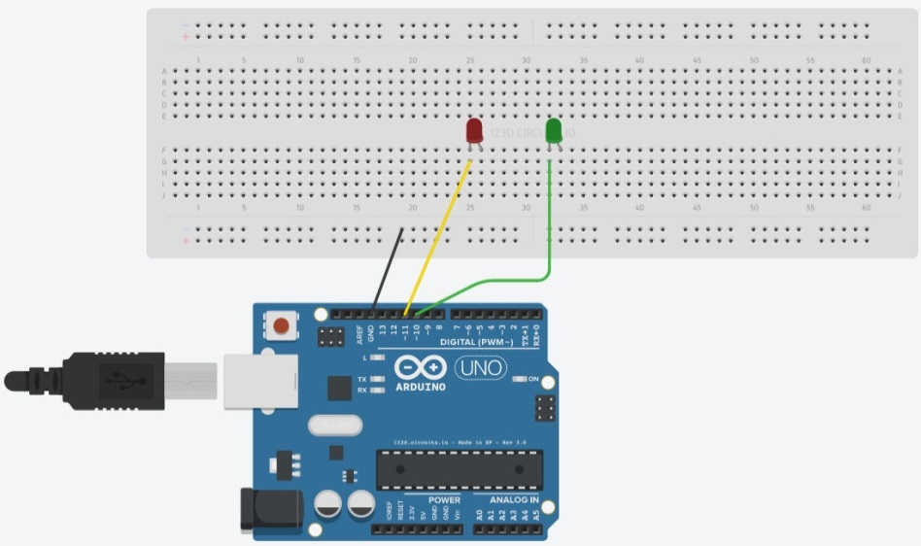

*The colors of wires are for indication only. Wires of the same color represent the same power source (same pinhole).

You can use wires of different colors for the same purpose.

#It is always a good practice to use **red** wire for Anode connection and **black** wire for GND connection.

B3: Wiring on the breadboard

1. 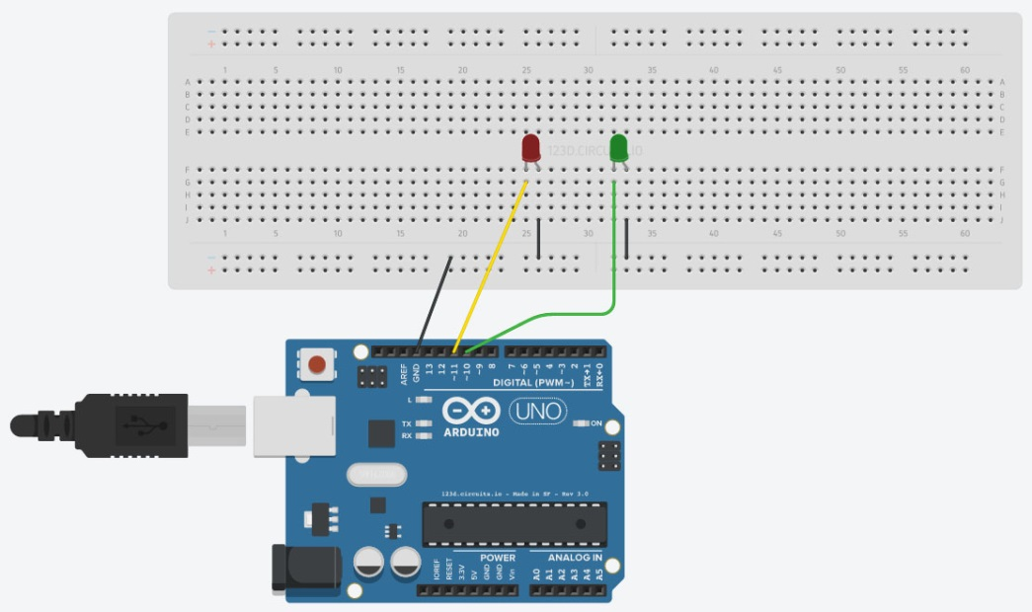Connect **LED 1** to GND^.
2. Connect **LED 2** to GND^.

^Connect the cathode of LEDs to GND to complete the circuit

B4: Connecting MQ-3 alcohol sensor to Arduino board

1. Connect the VCC on Sensor to **5V** on Arduino board with a **Red** wire.
2. Connect the GND on Sensor to **GND** on Arduino board with a **Black** wire.
3. Connect the AOUT on Sensor to **A0** on Arduino board with an **Orange** wire.
4. 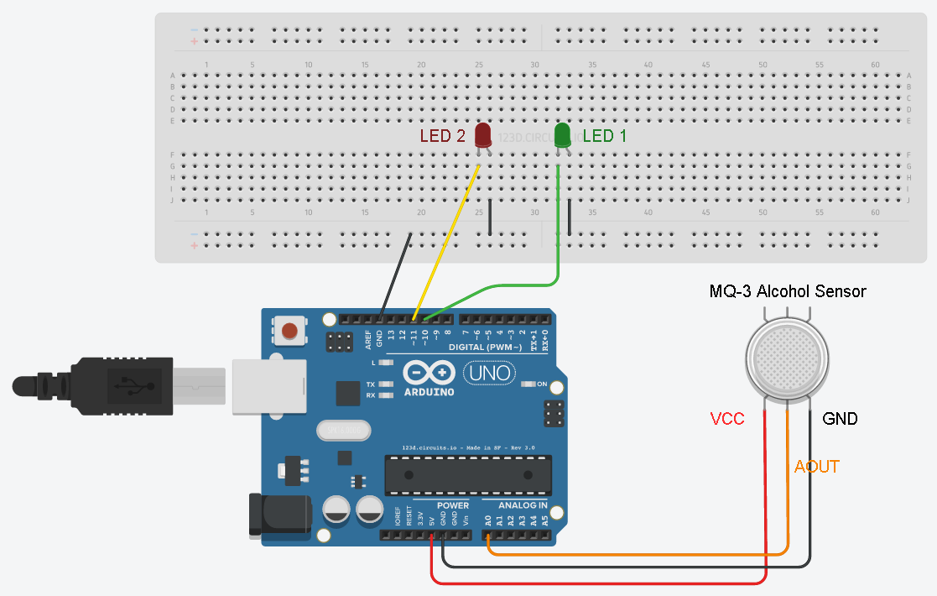Wiring is done!

**Part C: Coding**

1. Download the code from [https://sites.google.com/site/cdichem/](https://sites.google.com/site/cdichem/sharing_20161219) or copy it from last page of this file.
2. In the Arduino IDE window, replace all the code by the code provided.
3. Save the code by pressing the verify button.
4. Upload the code to your Arduino board by pressing the upload button.

Detection

1. When loaded with codes, wait for at least 1 minute before detection.
2. Blow gas towards the detector directly with a distance of about 2 cm.

(DO NOT spray solution into the detector directly)

1. Monitor the LEDs on breadboard. (If alcohol is detected, **LED 2** will turn on to indicate the presence of alcohol. Otherwise, **LED 1** will shine)

Reference

* Arduino IDE

<https://www.arduino.cc/en/Main/Software>

* MQ-3 sensor technical data

<https://www.sparkfun.com/datasheets/Sensors/MQ-3.pdf>

* Code for this project

<https://sites.google.com/site/cdichem>

* AUTODEST CIRCUITS

<https://circuits.io/>

//Declaration of variable: define the name and data type of variable

const int AOUTpin = A0; //The AOUT pin of the MQ-3 alcohol sensor goes into analog pin A0 of the arduino

int sensor_value = 0; //This is the integer that stores the reading from MQ-3 alcohol sensor, we set the initial reading of the sensor as 0

int LED_1 = 10; //This declare an integer to store the pin number for LED 1

int LED_2 = 11; //This declare an integer to store the pin number for LED 2

void setup() {

Serial.begin(9600); //This set the baud rate which is the rate of communication between your computer and the Arduino board

pinMode(LED_1, OUTPUT); //Set the pin as OUTPUT to give out current

pinMode(LED_2, OUTPUT); //Set the pin as OUTPUT to give out current

}

//The codes in void loop(){} keep running after upload.

void loop() {

sensor_value= analogRead(AOUTpin); //To read sensor analog reading from the A0 port

Serial.print("Recorded value: "); //To display message in Serial Monitor

Serial.println(sensor_value); //To display message in Serial Monitor

if(sensor_value < 120){ //An if-else logic to decide when to turn on LED 1 and LED 2

//When the sensor value is lower than 120

digitalWrite(LED_1, HIGH); //HIGH 🡪 Turn on Green LED

digitalWrite(LED_2, LOW); //LOW 🡪 Turn off Red LED

}

else{ //When the sensor value is higher than 120

digitalWrite(LED_1, LOW); //LOW 🡪 Turn off Green LED

digitalWrite(LED_2, HIGH); } //HIGH 🡪 Turn on Red LED

}