The construction of a simple Arduino device to detect alcohol in air
Expected Results
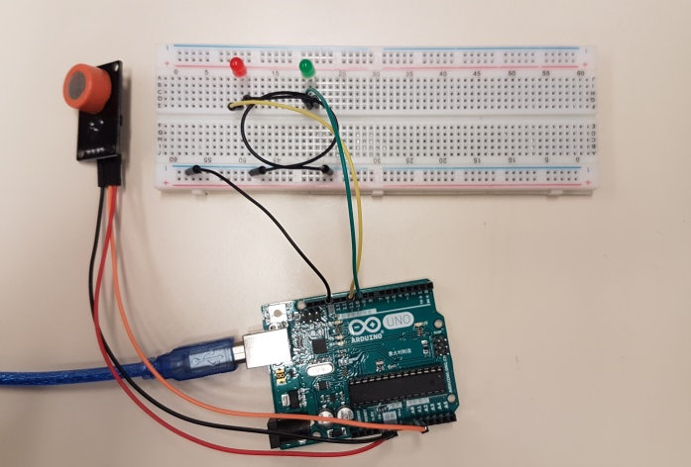
When the device is not connected to your computer OR when your code is not uploaded to the board. No LED will be turned on.

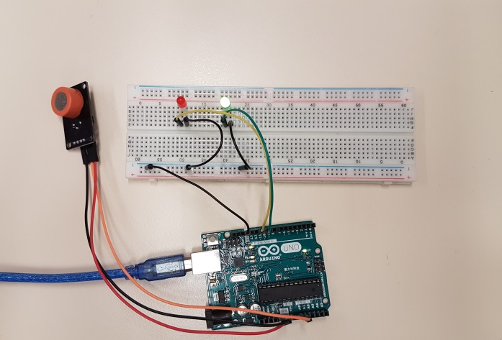
When the device is connected to computer and is loaded with codes provided, under normal circumstances (e.g. alcohol-free environment), Green LED will be turned on.

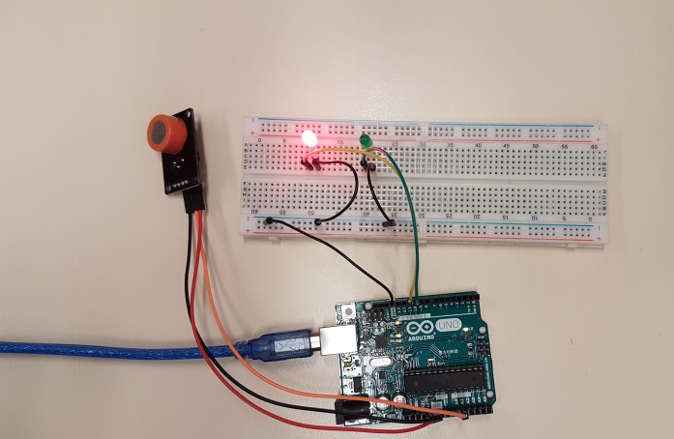
When alcohol is detected, Red LED turns on. It takes some time for the Red LED to go off.

Possible Errors
Error 1: Wrong LED placement
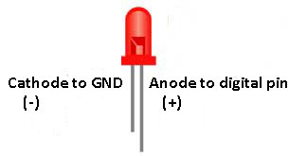
Connecting the Anode of LED to the GND and Cathode to digital pin of Arduino cannot turn on the LEDs. Remove the LED from breadboard and try again.
Error 2: Wrong connection on breadboard
The Anode of the LED is not connected to digital pin of Arduino board. The Red LED can never be turned on as there is no power supply.

Error 3: Missing wire(s)
The wire connecting the GND from Arduino board is missing. The circuit is not completed. The two LEDs cannot be turned on.

Specificity (According to our experience)
- The sensor is not just sensitive to Ethanol (CH₂CH₂OH) but also the member of alcohol including but not limited to:
Methanol (CH₃OH)
Isopropyl alcohol (CH₃CHOHCH₃)
Propanol (CH₃CH₂CH₂OH)
1-Pentanol (C₅H₁₁OH)
- The sensor also gives response to Acetone.

Coding
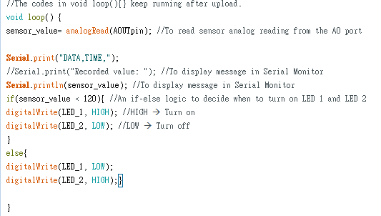
The Green LED is set to turn on when the sensor_value is under 120. As the sensor_value is beyond 120, Red LED will be lighted up. The code is based on the performance of the sensor (See below graph).
In the first minute of connection of senor to Arduino board, the reading drops rapidly to below 120. And in the following 7 minutes, the reading keeps dropping continuously to about 60 in an alcohol-free environment.
In order to make sure that we are not responding to the background noise and use the minimum amount of time to start up the device for alcohol detection, we decided to set the boundary at 120.
It is also advised to start the detection at least 1 minute after the device is loaded with the code.

