**Determining the enthalpy change of a reaction with the use of Arduino**

Objective

The purpose of this experiment is to determine the enthalpy change for the displacement reaction:

Zn(s) + Cu2+ (aq) → Zn2+(aq) + Cu(s)

Principle

Arduino boards are microcontrollers with versatile functions. People can build digital devices and many interactive objects with sensors and kits compatible to Arduino board. The sensors will generate a voltage based on some specific stimuli from the environment. The received voltage reading will be processed by Arduino board following the instructions (code uploaded to the board) of users. With linkage of different kits to the board, the devices built can response to environmental stimuli, logging data for investigative studies or other purposes.

In this experiment, by adding an excess amount of zinc powder to a known amount of copper(II) sulphate solution, and measuring the temperature change by temperature sensor over a period of time into the Arduino board, the enthalpy change of the reaction can be calculated.

Copper (II) sulphate Zinc powder

 

Curriculum link

Topic III Metals

Topic VIII Chemical Reactions and Energy

Chemical and apparatus (per group)

Zinc powder (about 4 g)

1.0 M copper(II) sulphate solution (50 cm3)

Goggles x1 per student

25cm3 pipette x1

Pipette filler x1

Polystyrene cup with lid x1

250 cm3 beaker x1

Weighing bottle x1

Spatula x1

Magnetic Stir bar x1

Magnetic Stirrer x1

Electronic Balance (read to 0.01g) x1

Computer and Arduino

Computer (Windows 7 or above with pre-installed Arduino software IDE[1], PLX DAQ[2] and Microsoft Excel®)

Arduino UNO microcontroller board and USB cable x1

Solderless Breadboard x1

Jumper wire (Male to Male) x10

Resistor (4.7k ohm) x1

Waterproof DS18B20 Temperature Sensor x1

Adhesive Tape x1

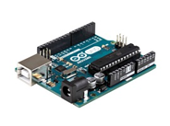Scissor x1

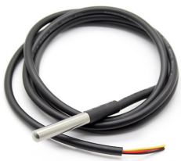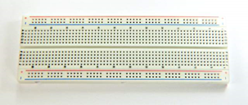

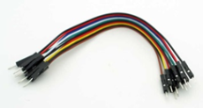

Procedure

Part A: Installation of Software and Arduino board

1. Download and install the Arduino software (Arduino integrated development environment (IDE))from <https://www.arduino.cc/en/main/software>
2. Connect your Arduino board to computer via the USB port.
3. Execute the Arduino software and go to Tools > Get Board Info (If you can see the Board Info, the connection is completed; otherwise, select a different port for board connection).

Part B: Wiring Arduino board

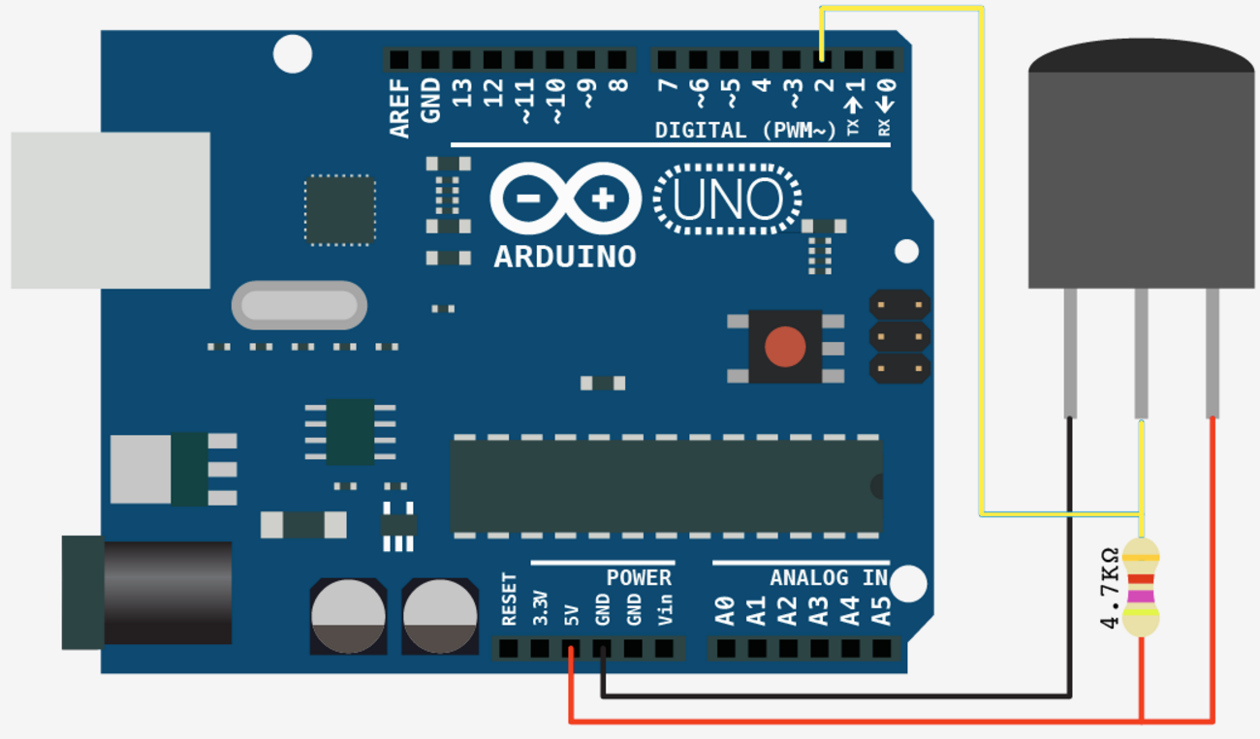 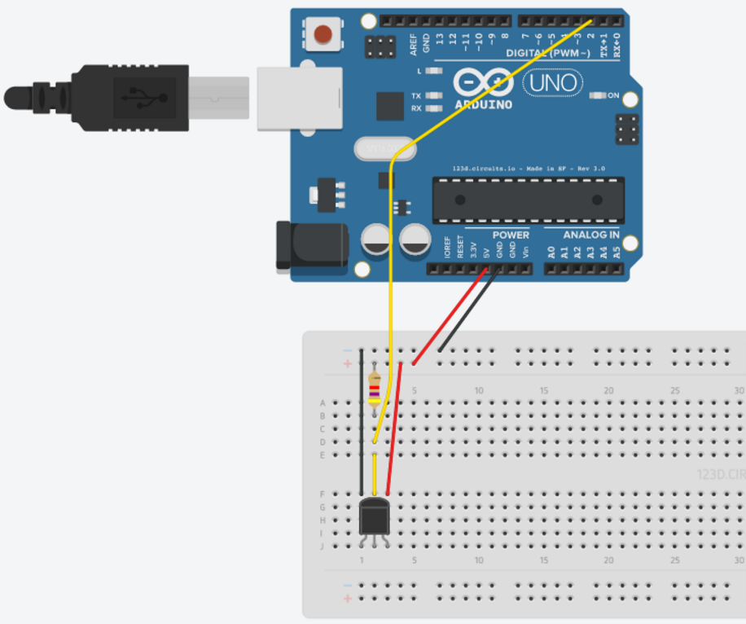

1. Connect RED wire from 5V (5 Volt) port of Arduino board to + (Positive) hole on the breadboard.
2. Connect BLACK wire from GND (Ground) port of Arduino board to - (Negative) hole on the breadboard.
3. Connect one end of a resistor to the + (Positive) hole and connect another end of the resistor to B2 on the breadboard.
4. Connect a yellow wire from port number 2 of Arduino board to D2 on the breadboard.
5. Connect the BLACK, YELLOW and RED wires of the temperature sensor to J1, J2 and J3 on the breadboard respectively.
6. Connect a BLACK wire from - (Negative) hole to F1, a YELLOW wire from E2 hole to F2 and a RED wire from + (Positive) hole to F3 on the breadboard.

Part C: Coding

1. Download the code from https://sites.google.com/site/cdichem/ or copy it from the attached file.

2. In the Arduino IDE window, replace all the code by the code provided.

3. Save the code by pressing the verify button.

4. Upload the code to your Arduino board by pressing the upload

Part D: Thermometric Experiment

1. Pipette 50.0 cm3 of the copper(II) sulphate solution into the polystyrene cup.
2. Weigh about 4.0 g of zinc powder in the weighing bottle – as this is in excess, there is no need to be accurate.
3. Put the thermometer sensor and a magnetic stir bar (adjust position of thermometer to avoid the stir bar from hitting the thermometer during stirring) into the Polystyrene cup. Stir the mixture with a magnetic stirrer, and start recording the temperature in the computer with PLX-DAQ Excel Spreadsheet (Launch Excel with Data Acquisition for Excel - PLX DAQ and press Connect).   
     
    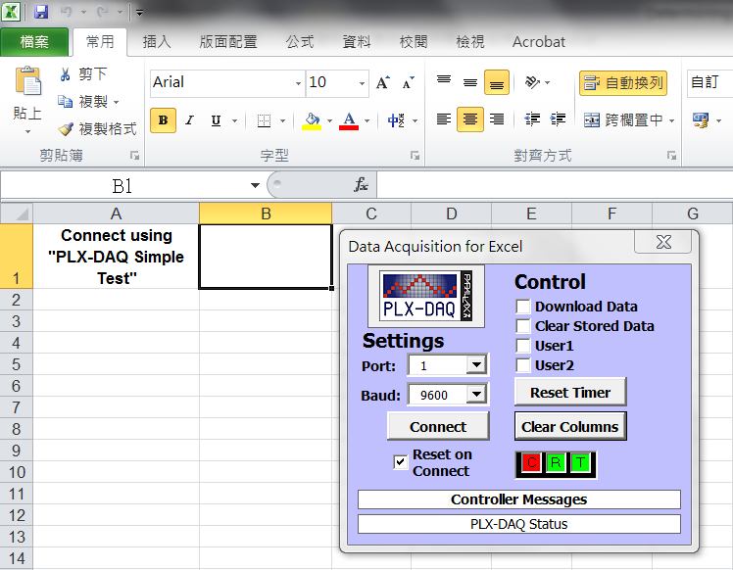
4. After 3 minutes, add all the zinc powder to the Polystyrene cup quickly with continuous stirring.
5. Record the temperature for an additional 6 minutes.

Experimental Result

Time of addition of Zinc powder = second

Mass of Zinc powder = g

Data Analysis

1. Copy the temperature and time data from Data Acquisition for Excel - PLX DAQ spreadsheet. Use Microsoft Excel template to plot the temperature (y-axis) against time (x-axis).

2. Extrapolate the curve back to time for adding zinc powder to estimate the maximum temperature rise. 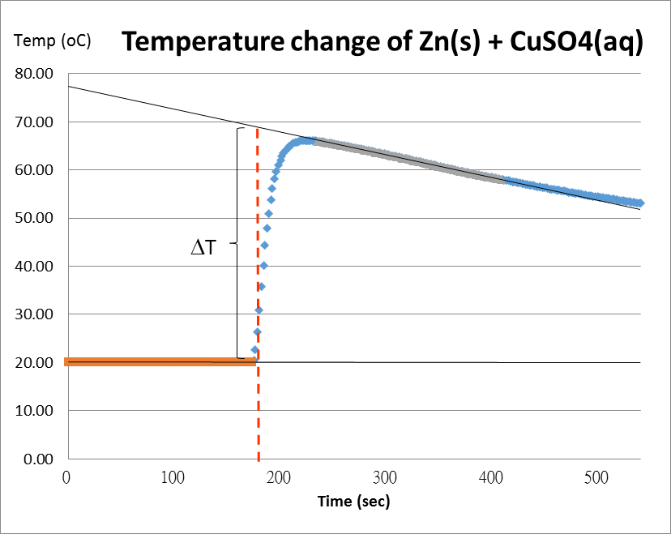

Collect the temperature result from Data Acquisition for Excel - PLX DAQ

Initial Temperature T1 = oC

Highest Temperature T2 = oC

Temperature difference (Δ*T* ) =  oC

3. Calculate the enthalpy change of the reaction per mole of copper(II) sulphate:

ΔH = m *c* Δ*T*

where m = mass of solution (g)

*c* = specific heat capacity of water = 4.18 J g-1 K-1

Δ*T* = temperature change (oC)

Question

1. List some possible reasons for the difference between the experimental enthalpy change and the theoretical one (these should not be the apparatus errors mentioned above). (**what is the theoretical enthalpy change value?)
2. Why did the temperature of the mixture increase for a period of time after adding the zinc and then decrease?

1. 1URL: <http://www.arduino.cc/en/Main/Software>

   2URL: <https://www.parallax.com/downloads/plx-daq>
2.