Limiting and Excess Reactants

Aim
To determine the limiting and excess reactants in a chemical reaction

Background
This experiment uses the simple reaction between vinegar and baking soda to provide observational evidence of limiting and excess reagents. Students will be able to understand that the limiting and excess reagents depend upon the amount of each reactant.

The reaction between vinegar and baking soda:
CH₃COOH(aq) + NaHCO₃(s) → CO₂(g) + H₂O(l) + CH₃COO⁻Na⁺(aq)

After the experiment, students are guided through a series of calculations to confirm their observations, and to determine the amount of each reactant necessary for neither to remain when the reaction reaches completion.

Curriculum Link
Topic III Metals
Topic IV Acids and Bases

Apparatus and Equipment
- One plastic funnel
- Five 100 cm³ conical flasks
- Five 30 cm (12”) or 33 cm (13”) latex rubber balloons
- One 100 cm³ measuring cylinder
- One spatula
- Two 100 cm³ beakers
- Weighing papers
- An electronic balance, 0.01g readability

Chemicals
- 30 g of baking soda / sodium hydrogencarbonate (NaHCO₃)
- 300 cm³ of white vinegar (~5% m/v ethanoic acid)
- Bromothymol blue indicator
- Deionized water

Safety Precautions
- Wear safety goggles

Procedure
- Fill each 100 cm³ conical flask with 50 cm³ of vinegar. Label each flask respectively, 1 g, 3 g, 5 g, 7 g, 9 g.
- Measure about 1.0, 3.0, 5.0, 7.0 and 9.0 g of sodium hydrogencarbonate into separate balloons. This can be done by attaching a balloon to the plastic funnel and then transferring the solid through the funnel into the balloon (Fig. 1).
- Carefully attach each balloon to the designated flask without spilling any sodium hydrogencarbonate into the vinegar. Be sure to squeeze out any air in the balloon before fully attaching. Arrange the flasks in consecutive order (Fig. 2).
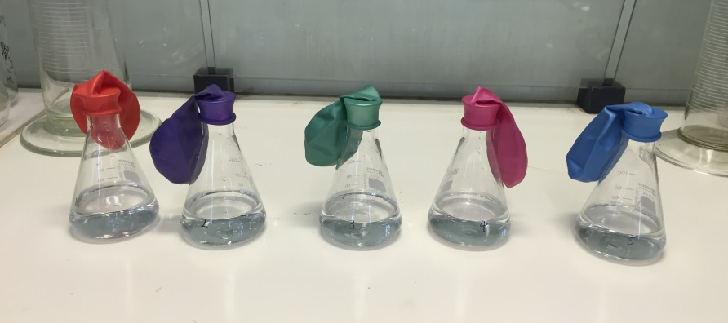
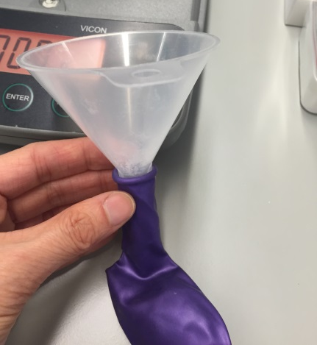

Fig. 2 Left to right: NaHCO₃ (1.0, 3.0, 5.0, 7.0 and 9.0 g) in the balloons with all flasks with 50 cm³ of vinegar
Fig. 1 Use plastic funnel to transfer the solid into the balloon

- Holding onto the balloon where it is attached to the flask, raise the balloon containing 1.0 g sodium hydrogencarbonate so that all of the solid will fall into the vinegar. Allow it to completely react.
- Repeat the above process in order for each flask.
- Compare the volumes of each balloon and examine the bottoms of each flask for excess sodium hydrogencarbonate.
- Fill each 100 cm³ beaker with about 15 cm³ of vinegar and a water solution of sodium hydrogencarbonate respectively. Add bromothymol blue (about 15 drops) in both solutions and observe the color of them.
- Carefully remove the balloons from each flask and add bromothymol blue (about 15 drops) to each flask. Write down the color of the solutions.

Data analysis and questions
1. Please write down the observations for the experiment in the table below.
Mass of NaHCO₃(s) | 1.0 g | 3.0 g | 5.0 g | 7.0 g | 9.0 g
Any excess NaHCO₃(s) left? (Y or N)
Colour of solution after adding bromothymol blue

2. There is 5% mass/volume of ethanoic acid (CH₃COOH) in the white vinegar. Convert the concentration of ethanoic acid in the white vinegar in mol dm⁻³.
(Relative atomic masses: O = 16.0, C = 12.0, H = 1.0)

3. Determine the limiting and excess reactants for each flask using stoichiometric calculations. (Relative atomic masses: Na = 23.0, O = 16.0, C = 12.0, H = 1.0)

(a) 50 cm³ vinegar and 1.0 g NaHCO₃(s)

(b) 50 cm³ vinegar and 3.0 g NaHCO₃(s)

(c) 50 cm³ vinegar and 5.0 g NaHCO₃(s)

(d) 50 cm³ vinegar and 7.0 g NaHCO₃(s)

(e) 50 cm³ vinegar and 9.0 g NaHCO₃(s)

4. Determine the mass of NaHCO₃(s) for reacting with 50 cm³ vinegar so that neither reactant remains at the end of the reaction.

