Electrolysis of tin(II) chloride solution and sodium chloride solution

Aim
To investigate the electrolysis of tin(II) chloride solution and sodium chloride solution using microscale apparatus

Background
Electrolysis is a process using an electric current to decompose compounds. An electrolytic cell is composed of several parts including a power supply, anode and cathode, and an electrolyte. In this experiment, an electrolytic cell is constructed using microscale apparatus. The electrolytic cell is then used to carry out the electrolysis of (i) tin(II) chloride solution and (ii) sodium chloride solution.

Curriculum Link
Topic VII Redox Reactions, Chemical Cells and Electrolysis

Part I: Electrolysis of tin(II) chloride solution

Apparatus and Equipment (per group)
- 9V battery x 1
- Petri dish x 1
- Connecting wires with crocodile clips at both ends x 2
- Paper clips x 2
- Filter paper x 1
- Filter funnel x 1
- 100 cm³ beaker x 2

Chemicals (per group)
- About 30 cm³ of saturated SnCl₂ solution
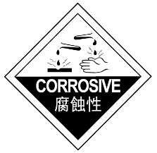
Procedure
- Transfer about 20 cm³ of saturated tin(II) chloride solution in a petri dish to cover the bottom of the dish.
- Attach two paper clips to the opposite sides of a clean petri dish. The long ends of the paper clips should be on the inside of the dish touching the solution.
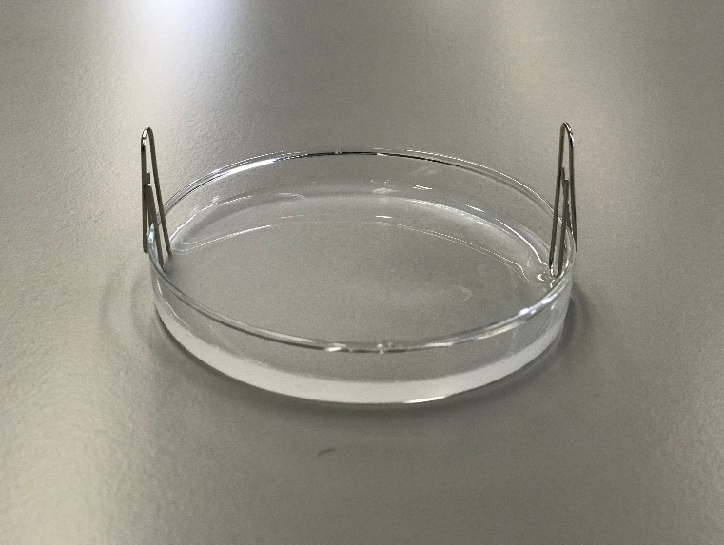
- Attach the two connecting wires to the positive and negative terminal of a 9V battery respectively.
- Attach the two connecting wires separately to the two paper clips attached on the petri dish.
- Wait for one minute. Observe and record the changes in the petri dish.

Safety precautions
Conduct a risk assessment for this experiment, and summarise the key precautions below.
Questions
- When the paper clips are attached on the petri dish and dipped into the tin(II) chloride solution, the dipped part of the paper clips turns black. Explain this observation.

- Sketch in the space below a labelled diagram to describe the observation(s) in the experiment.
Cathode
Anode

Petri dish

- Describe the physical appearance of the products formed separately at cathode and anode.

- Insoluble tin(IV) chloride solid and tin metal are formed in the electrolysis. Write half equations for the changes occurred at anode and cathode respectively.

- Write a chemical equation for the reaction of the electrolysis of tin(II) chloride solution.

Part II: Electrolysis of sodium chloride solution

Apparatus and Equipment (per group)
- 9V battery x 1
- Petri dish x 1
- Connecting wires with crocodile clips x 2
- Pencil leads / pencils with both end sharpened / graphite electrodes x 2
- Wash bottle

Chemicals (per group)
- Concentrated NaCl solution
- Solution A ( 2.0 M KI(aq) )
- Solution B ( 2.0 M KBr(aq) )
- Universal indicator

Procedure
- Add a few drops of concentrated NaCl solution, solution A, solution B and universal indicator in the petri dish as shown in the following diagram.
conc. NaCl solution

solution A
universal indicator

solution B
petri dish

- Attach the two connecting wires to the positive and negative terminal of a 9V battery respectively.
- Attach the two connecting wires to the two pencil leads. Make sure the crocodile clips have good contact with pencil leads.
- Dip another end of the pencil leads in the concentrated sodium chloride solution on the petri dish.
- Observe and record the changes on the solutions in the petri dish.

Safety precautions
Conduct a risk assessment for this experiment, and summarise the key precautions below.
Result

Observation at :
Solution A

Solution B

Universal indicator

Concentrated NaCl solution

Questions

- Solution A and solution B are potassium halides.
With reference to the observation in the experiments, deduce which of the following could solution A and B be. Write chemical equation(s) to support your answer.

potassium fluoride, potassium chloride, potassium bromide, potassium iodide

- Explain the observation that occurs at the universal indicator.

- With the use of half equations, explain the changes that occurs at the concentrated NaCl solution. Hence, write a chemical equation of the electrolysis of concentrated sodium chloride solution.

