Elephant Toothpaste

Aim
To follow the progress of a decomposition reaction.

Background
“Elephant toothpaste” is an experiment to study catalysed decomposition reaction. Detergent solution is added to the hydrogen peroxide solution with the presence of catalyst. The mixture will produce thick foam.

In particular, the decomposition reaction can be followed by measuring the amount of the foam produced in a container at regular time intervals. Hence, students can roughly estimate the change in rate of reaction.

Curriculum Link
Topic IX Rate of Reaction (Chemistry)

Apparatus and Equipment (per group)
- One spatula |  |  | - One filter funnel
- One 10 cm³ measuring cylinder |  |  | - One stopwatch
- One 50 cm³ measuring cylinder |  |  | - Weighing papers
- One 500 cm³ measuring cylinder |  |  | - Digital balance (readability 0.01 g)
- One 250 cm³ beaker
Chemicals (per group)
- 0.5 g of MnO₂ solid (catalyst)
- 30 cm³ of 4.5% H₂O₂ solution
- 3 cm³ dish detergent (soap solution)
- 1-2 cm³ glycerol

Procedure
- Add about 0.5 g of the catalyst to the 500 cm³ measuring cylinder with a filter funnel
- Add 30 cm³ of 4.5% H₂O₂ solution, 3 cm³ of dish detergent and 1-2 cm³ of glycerol to a 250 cm³ beaker.
- Swirl the mixture from step (2) for a while and then add it into the 500 cm³ measuring cylinder as quickly as possible.
- Start the stopwatch immediately and swirl the mixture for a few seconds.
- At regular time intervals (e.g. every 30 seconds), observe and record the volume of the foam produced as indicated by the measuring cylinder reading.

Safety precautions
Conduct a risk assessment for this experiment, and summarise the key precautions below.

Data analysis and questions

Time after the addition of hydrogen peroxide to the catalyst (seconds) | 10 | 40 | 70 | 100 | 130 | 160 | 190 | 220 | 250 | 280 | 310
Volume of foam produced / measuring cylinder reading (cm³)

- Plot a graph of volume of foam produced (cm³) against time (seconds).

- (a) Rising of foam in the measuring cylinder is related to the gas produced during the decomposition of hydrogen peroxide. Estimate the volume of foam produced during:
(i) 10 to 40 seconds (ii) 130 to 160 seconds
(iii) 280 to 310 seconds

- What can you conclude with reference to the above calculation?

Discussion questions

- Write down a balanced equation for the decomposition of hydrogen peroxide. Hence, suggest a chemical test to confirm the identity of the gas given off in the experiment.

- Comment on the following statement concerning to the experiment:
“The decomposition reaction of hydrogen peroxide can be accurately followed by measuring the volume of foam produced in different periods of time during the experiment.”

Assessment
Based on the following information, complete the plots in (a) and (b) to represent the expected experimental results:

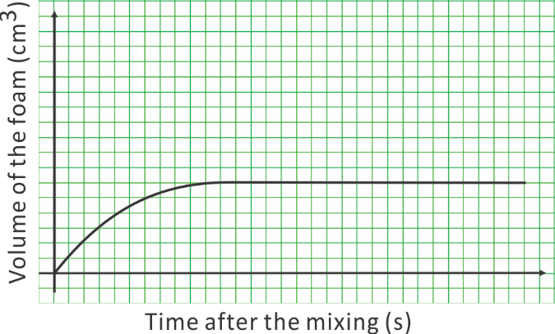
Catalytic decomposition of 30 cm³ of 4.5% H₂O₂
solution at room conditions

(a)  Catalytic decomposition of 30 cm³ of 9% H₂O₂ solution at room conditions | (b)  Catalytic decomposition of 60 cm³ of 4.5% H₂O₂ solution at room conditions

