Enzyme Catalysed Hydrolysis of Urea

Aim
To follow the progress of enzyme-catalysed hydrolysis of urea with a pH meter

Curriculum Link
Topic IX Rate of Reaction

Background
Plants require fertilizers with nitrogen, phosphate and potassium (NPK). Urea, H₂NCONH₂, has a high nitrogen content but it has to be hydrolysed before it can be absorbed by plants. The chemical equation for the hydrolysis of urea is as follows.
H₂NCONH₂(aq) + H₂O(l) → CO₂(aq) + 2NH₃(aq)
Due to the formation of alkaline ammonia in the hydrolysis of urea, there is a gradual increase of pH in the reaction mixture.

Urease is an enzyme present in soya beans and can catalyse the hydrolysis of urea. In the presence of urease, the rate constant of the hydrolysis of urea at 298K will increase from 3×10⁻¹⁰ s⁻¹ to 3×10⁴ s⁻¹, i.e. a ratio of 1 to 10¹⁴.

In this experiment, the progress of the hydrolysis of urea is followed by measuring the pH of the reaction mixture using a pH meter.

Apparatus and Equipment
- Beaker, 100 cm³ | x 2 | Coffee grinder | x 1
- Conical flask, 100 cm³ | x 1 | Electronic balance (x 0.01g) | x 1
- Filter funnel, 150 cm³ | x 1 | pH meter (x 0.01) | x 1
- Glass dropper | x 2 | Magnetic stirrer and magnetic bar | x 1
- Graduated pipette, 2 cm³ | x 1
- Measuring cylinder, 25 cm³ | x 1
- Thick cotton cloth | x 2 pieces
(or cotton wool)

Chemicals
- 0.66 M Urea solution | 20 cm³
- Soya beans | 2 g
- 0.1 M NaOH(aq) | 10 cm³
- 0.1 M HCl(aq) | 10 cm³

Safety precautions
- Wear safety goggles and disposable protective gloves.
- The solutions used are basic and harmful to skin and eyes. In case of spills, rinse the affected area with plenty of water for about 5 minutes.
- Do not dispose of chemicals by pouring down the drain, use the waste container provided.

Procedure
- Grind about 2 g of whole soya beans into powder form with a coffee grinder or a similar device.
- Mix the soya bean powder with about 20 cm³ deionised water in a 100 cm³ conical flask. Swirl the mixture well and allow the mixture to stand for at least 2 hours.
- Filter the mixture using a thick cotton cloth (or cotton wool). The filtrate may still be cloudy. If needed, filter the filtrate obtained again.
- Use a 25 cm³ measuring cylinder to add about 10 cm³ of the filtrate and then 10 cm³ of denionised water into a clean 100 cm³ beaker.
- Adjust the pH of the filtrate to about 6.5 by adding drops of 0.1 M HCl(aq) or 0.1M NaOH(aq) as appropriate.
- Careful submerge the bulb of the pH meter probe into the filtrate, and then add a magnetic bar.
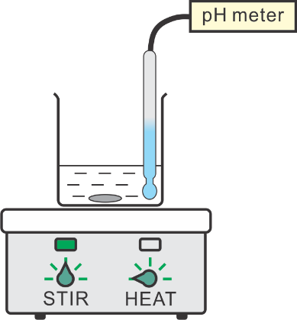
filtrate
- Put the set-up on a magnetic stirrer unit and then turn it on.
- Use a graduate pipette to add 2.0 cm³ of 0.66 M urea solution into the filtrate.
- Without delay, start the timer and record the pH meter reading every 20 seconds for about 5 minutes (or until there is no obvious change in pH meter reading).

Data Analysis and Discussion
- Record the pH meter reading in the following table.
Time / s | 0 | 20 | 40 | 60 | 80 | 100 | 120 | 140 | 160 | 180 | 200
pH
Time / s | 220 | 240 | 260 | 280 | 300
pH

- Plot a suitable graph to show the progress of hydrolysis of urea.

- Describe the variation of pH with time from 0th to 20th seconds.

- Compare the difference in variation of pH with time from 0th to 20th seconds, from 80th to 100th seconds and from 200th to 220th seconds. Explain your answer.

Reference:
https://edu.rsc.org/resources/fertilisers-and-sustainability-16-18-years/4014231.article
(Accessed on 9/2/2022)

Acknowledgement:
- Department of Chemistry, The Chinese University of Hong Kong
- Department of Chemistry, SKH Tsang Shiu Tim Secondary School

