Learning & Teaching Resources
for Science (S1-3) Curriculum (2017)

Unit 13 From atoms to materials

A Microscopic view of Salt Crystals

Student Version

Copyright © 2018 Science Education Section, Curriculum Development Institute, Education Bureau, HKSAR
All rights reserved.
(Developed by Hong Kong Association for Science and Mathematics Education)
Learning Objectives
After the activities, you are should be able to:
- state symbols of simple ions and the formula of some ionic compounds;
- draw ionic structure of sodium chloride crystal; and
- be aware that the physical properties of the materials are stem from the structural characteristics of the substances.

Activity 1: Physical properties of materials
Diagrams below show pictures of ice cube and salt crystal. The salt crystal cubes have a similar appearance as ice cubes.

Ice cube*  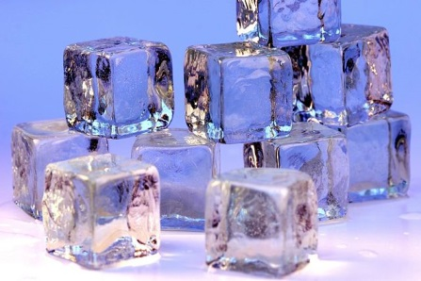 | Salt crystal#  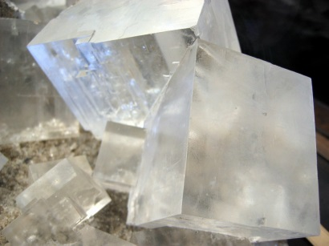

1. Which of the two materials, the ice cube or the salt crystal, do you think is more easily to be broken under pressure? Suggest a way to perform the test.

2. Which of the two materials, the ice cube or the salt crystal, do you think is more easily to be melt under heat? Suggest a way to perform the test.

Reference:
* “Ice cubes” ©Darren Hester (https://commons.wikimedia.org/wiki/File:Ice_cubes_openphoto.jpg).
CC BY-SA 2.5
# “Rock salt crystal” ©włodi from Szczecin, Poland (https://commons.wikimedia.org/wiki/File:Rock_salt_crystal.jpg). CC BY-SA 2.0

Activity 2: Chemical symbol of ionic compounds

Ionic compounds are comprised of both positive ions and negative ions. They are held together by attractive force (the attraction between ions is called “ionic bonding”). The following shows some examples of ion.
Chemical Name | Chemical Symbols | Graphic Symbol
Sodium ion | Na⁺ | 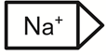
Calcium ion | Ca²⁺ | 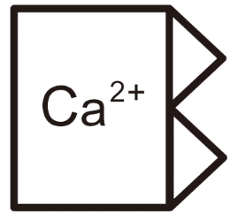
Fluoride ion | F⁻ | 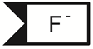
Chloride ion | Cl⁻ | 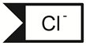
Oxide ion | O²⁻ | 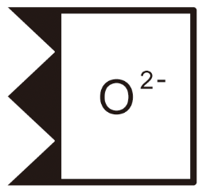

According to the example below, draw graphic symbols and write down the chemical formulae of the followings.
Matter | Ions | Graphic Symbols | Chemical formula
Example: Active ingredient in toothpaste | Sodium ions + Fluoride ions | 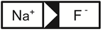
Drying agent | Calcium ions + Oxide ions
Salt crystal | Sodium ions + Chloride ions

Activity 3: Exploring the structure of sodium chloride crystal

Table salt are consisted of sodium chloride (NaCl) crystals. Explore the structure of sodium chloride crystal, and answer the following questions:

- How many Na⁺ ions are adjacently surrounding one Cl⁻ ion?

- How many Cl⁻ ions are adjacently surrounding one Na⁺ ion?

- Use different colours to represent sodium ion and chloride ion respectively, draw the 3D structure of sodium chloride crystal.

Activity 4: Making sodium chloride crystal model

- Discuss among your group, on how to construct a ball-and-stick model of sodium chloride crystal with the following materials:
  - 14 foam balls of bigger size
  - 14 foam balls of smaller size
  - 35 thin sticks

- Construct a model of sodium chloride crystal. Attach a photo of your model in the box below.

3. With reference to the structure of sodium chloride, explain why salt crystals are brittle.

If there is a slight shift of the ion layers, the ions of same charges . The layers will repel each other.

