Learning & Teaching Resources
for Science (S1-3) Curriculum (2017)

Unit 4 Cells, Human Reproduction
and Heredity

Constructing DNA Model

Student Version

Copyright © 2018 Science Education Section, Curriculum Development Institute, Education Bureau, HKSAR
All rights reserved.
(Developed by Hong Kong Association for Science and Mathematics Education)
Learning Objectives
After the activities, you are able to:
- use a microscope to examine prepared slides of plant and animal tissues;
- recognise that the chromosomes found in the nucleus of each cell contain the genetic materials, DNA;
- state that DNA encodes the instructions that determine our different traits;
- state that heredity is the passing of traits from one generation to the next as a result of the transmission of genetic information;
- state that there are only four different kinds of bases, A, T, C and G, on the DNA; and
- state that the double helix structure of DNA is based on the base pairing of A with T and C with G.

Activity 1：Introduction of DNA

1. Using the words below to fill in the blanks in the paragraph and label the diagram.

cells | nucleus | chromosome(s) | DNA

Cells are the basic units of all living things. Inside the nucleus of a cell, there are pairs of chromosomes. Each chromosome contains one long strand of DNA . | 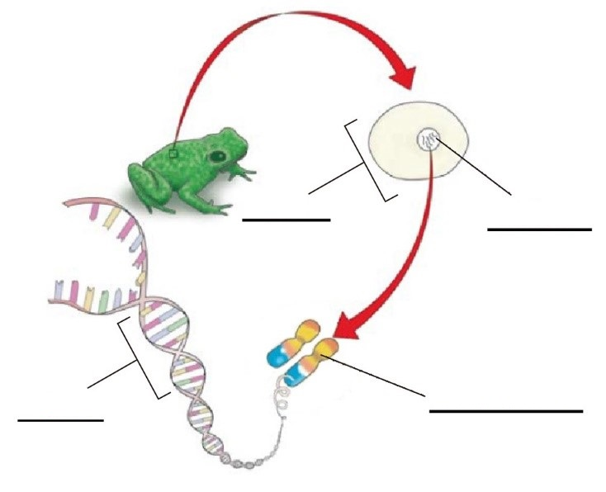

2. What is the function of DNA?

Activity 2：Locating DNA

You are going to observe animal cells and plant cells under microscope, and to find out where DNA is found in the cells.

Materials and Apparatus:
- Microscope 1
- Prepared microscopic slide of animal tissue 1
(e.g. human cheek cells)
- Prepared microscopic slide of plant tissue 1
(e.g. longitudinal section of root tip)

Procedures:
- Put a prepared microscopic slide of animal tissue under the microscope.
- View the animal cells carefully under the microscope.
- Find an undamaged animal cell. Draw it in the space below and label the nucleus.
- Repeat the above steps using the prepared microscopic slide of plant tissue.

Animal cell | Plant cell

Questions:
- The following paragraph is about the procedures of the appropriate use of microscope. Fill in the blanks.

First, use an objective of the lowest magnification to view the cells. Focus the image with coarse adjustment knob and fine
adjustment knob. Find an undamaged cell and move it to the centre of the field of view. Then, use an objective of a higher magnification to magnify the image of the cell, and focus it using the fine adjustment knob.

2. Complete the following table.

Magnification of microscope:
Magnification of the Eyepiece | Magnification of the Objective | Magnification  of the microscope
e.g. 10X | 4X | 40X
10X | 10X
10X |  | 400X
 | 40X | 600X

Activity 3：Features of DNA model

Materials and Apparatus:
- A bag containing DNA models 1

Procedures:
1. Each group will receive a DNA model from the bag.
2. Have a close look at the structure of the DNA model.
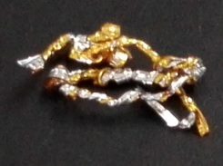

Questions:
1. Which structure of a cell does the bag represent?

2. With reference to the DNA model, state the features of DNA.
(a)
(b)

Activity 4：DNA and heredity

Procedures:
1. Each group was given 8 portrait photos (A to H).
2. Compare the appearance of the people in the photos. From the portrait photos, identify which 2 people are from the same family.

Result:
People in photo and photo are from the same family.

Questions:
1. Why DNA is known as “Book of Life”? Why do the members from the same family often look similar?

DNA carries instructions to determine the traits of living things. For members of the same family, they receive their DNAs from their same parents . Therefore, the members of the same family look similar .

2. In what way does the genetic information pass to the next generation?

The genetic information is determined by the sequence of bases on the DNA.
The four kinds of bases are A , G , T and C . The sequence of these bases in the DNA encodes a set of instructions for determining the traits of living things.

Activity 5：Constructing double helix model of DNA

1. Search information about the ‘double helix structure of DNA’ from the internet. Draw it in the space provided and label the key parts.

- With reference to the information on the internet, construct a DNA model using materials of your own choice.

Assessment criteria of the DNA model

Criteria | Good | Satisfactory | Unsatisfactory
Shape of the model | The model shows a double-helical shape | The model shows a flatted ladder shape  (not twisted) | The model does not show a ladder shape
Base-pairing | The model shows correct base-pairs effectively | The model shows correct base-pairs | The model does not show correct base-pairs
Materials | The choice of materials used is appropriate, creative and environmental friendly | The choice of materials used is either creative or environmental friendly | The choice of materials used is neither creative or environmental friendly
Neatly constructed | The model is well structured and neatly done | The model is either well structured or  neatly done | The model is neither well structured nor  neatly done

