Science (S1-3)

Updated Curriculum (2017)

Unit 4: Cells, Human Reproduction and Heredity

DNA and Heredity

Compiling a “Café Staff Handbook”

(Student’s version)

Ms TSANG Mei Yuet
Ms Siu Chi Ying

Precious Blood Secondary School

Science Education Section, Curriculum Development Institute, Education Bureau

Science (S1-3)
Unit 4: Cells, Human Reproduction and Heredity
Topic: DNA and Heredity
Compiling a “Café Staff Handbook”
【Learning Objectives】
After this learning activity, students should be able to:
- recognise what gene, DNA and chromosome are and understand the relationship between them;
- recognise that DNA encodes the instructions that determine our different traits; and
- recognise that different cell types in an individual possess the same genetic materials

- Concept Revision – Basic structures and functions of animal cells

A photomicrograph of human cheek cells is shown as below:

A
B
C

Human cheek cells stained by methylene blue by Joseph Elsbernd, used under CC BY 2.0

Label structures A, B and C. Write down one function of each structure respectively.

Structure | Name | Function
A
B
C

- Relationship between gene, DNA and chromosome

Activity 1 : Working procedures of different departments and the staff handbook of a Café
Activity 2 : The dress code and daily routine for the staff working in different departments of a
Café
Complete the table below after the activities:

Activity | Represent | Introduction
The paper strip with a working procedure of a department in a Café printed on it | ( ) | - ( ) is a segment of DNA which carries an ( ).
The connected paper strips from whole group/class | ( ) | - DNA is a long-chain chemical. DNA carries many ( ).
The booklet complied from a cover page and pieces of paper with strips of working procedures sticking onto it | ( ) | - A chromosome is ( )  folded together with other chemical substances.  - Each human cell (except sperms and eggs) carries ( ) pairs of chromosomes.
Each student has the same staff handbook but each of them is allowed to read and carry out the instruction on a specific page only | Different types of cell of an individual carry the same genetic materials but each cell can only carry out some specific instructions on the DNA. | - Different types of cell of an individual carry the ( ) genetic materials.  - As each cell can only carry out some specific instructions, different cells hence have different ( ) and ( ) .

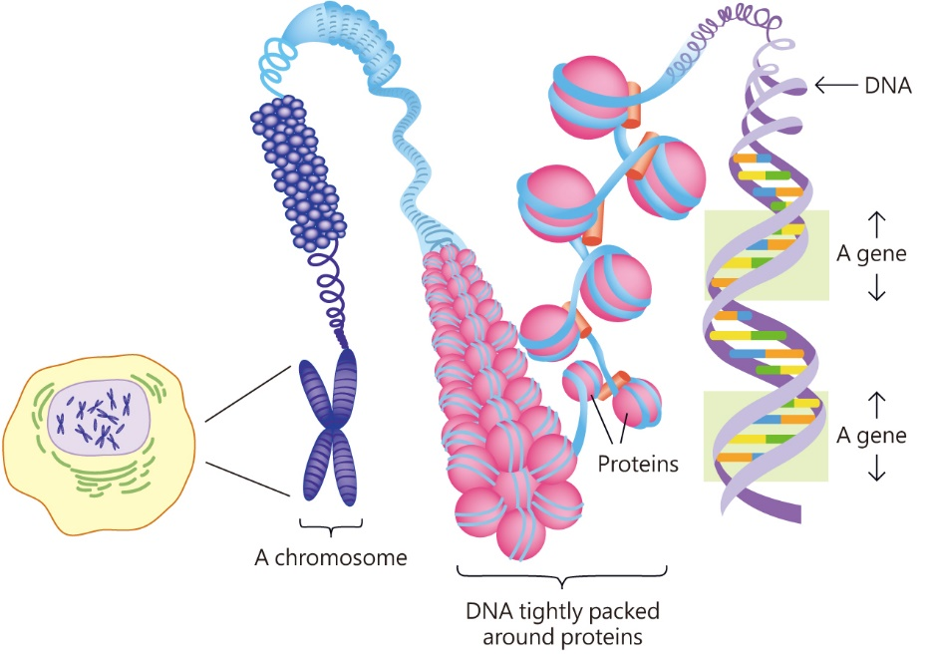

The relationship between DNA and Chromosomes

