Science (S1-3)

Updated Curriculum (2017)

Unit 4: Cells, Human Reproduction and Heredity

Topic: DNA and Heredity

Structure of DNA & Making a DNA model

（Teacher’s Version）

Ms TSANG Mei Yuet
Ms Siu Chi Ying

Precious Blood Secondary School

Science Education Section, Curriculum Development Institute, Education Bureau
Science (S1-3)
Unit 4: Cells, Human Reproduction and Heredity
Topics: DNA and heredity

Estimated lesson time：40 mins

Structure of DNA & Making a DNA model
【Learning Objective】
After the learning activity, students should be able to:
- state that the base of the basic unit of DNA can be A, T, C or G; and
- state that DNA is a double helical structure which is based on the base pairing of A with T and C with G.

A. The structure of DNA

- Aim: To learn about the structure of DNA.

- Materials:
- Worksheet | One per student
- Video “Packing DNA”  (Duration: 1 Min. 46 Sec.) | (https://www.youtube.com/watch?v=xk7jE4MRCR8)
- Video “Structure of DNA”  (Duration: 2 Min.) | Chapter 5 of the ETV programme “DNA and Heredity (Science (Secondary 1-3))”  (https://www.hkedcity.net/etv/resource/7682492029)

- Teaching rundown:

1. | Play the video “Packing DNA” to review the relationship between gene, DNA and chromosome with the students.
2. | Play the video “Structure of DNA” to let the students to learn about the structure of DNA.
3. | Show a photo of DNA model and introduce its double helical structure.
4 | Check about students’ concept of the complementary base pairing of DNA by asking them to fill in blank in the diagram provided in the worksheet.

- Suggested answers:

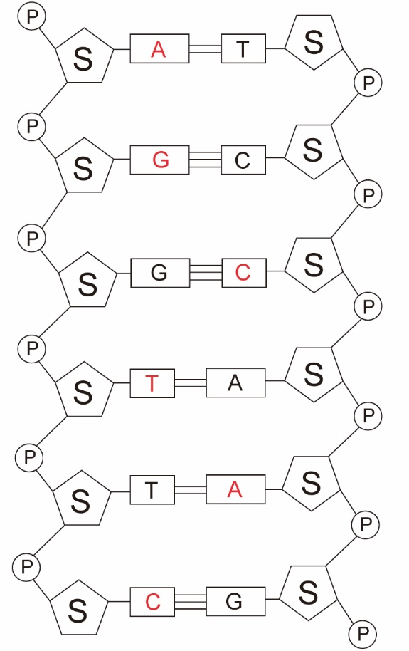

B. Group activity: Making a paper DNA model

- Aim: To learn about the double helical structure of DNA through model making and such structure
is based on the base pairing of A with T and C with G.

- Materials:
Template of ‘paper DNA model’ developed by Mr Yoshida Eiichi  (simplified version) | or | Template of ‘paper DNA model’ developed by Mr Yoshida Eiichi  (complementary base pairing version)
http://x2.gmobb.jp/sfa1/f04sim60.pdf  (Consent has been sought from Mr Yoshida Eiichi, Hong Kong teachers can download the relevant template of ‘paper DNA model’ for non-profit-making learning and teaching activities in schools) |  | http://x2.gmobb.jp/sfa1/f03sep2.pdf  (Consent has been sought from Mr Yoshida Eiichi, Hong Kong teachers can download the relevant template of ‘paper DNA model’ for non-profit-making learning and teaching activities in schools)
- Suggested to have 2 students in a group |  | - Suggested to have 2 students in a group
- Copy the template and give one copy to each group.  - Print with harder paper if you want the model to stand up-right. Otherwise, the paper model has to be hung up only. |  | - Copy the template and give 4 copies to each group.  - As there are 6 pairs of bases on each template, the DNA model made by each group will be composed of 24 pairs of bases.
- Distribute the copies of paper template to students before the lesson and let them to cut out the ‘DNA basic unit’ at home. Ask them to bring the prepared ‘DNA basic unit’ back to school and construct the paper model during the class. |  | - Distribute the copies of paper template to students before the lesson and let them to cut out the ‘DNA basic unit’ at home. Ask them to bring the prepared ‘DNA basic unit’ back to school and construct the paper model during the class.

- Teaching rundown:

1. | Show some pictures of the paper model of DNA to the students.
2. | Play the video about making the paper DNA model to teach the students how to make the model.
3. | Each group construct their own paper DNA model.
4. | Let each group to show their models in the class.
5. | Ask the students to check about the base pairing of the model and to look at the specific double helical structure of DNA.

- Conclusion:
DNA consists of two long chains. It has a double helical structure with complementary base pairings between the two chains.

