Science (S1-3)

Updated Curriculum (2017)

Unit 4: Cells, Human Reproduction and Heredity

Topic: DNA and Heredity

The Code of DNA

(Teacher’s Version)

Ms TSANG Mei Yuet
Ms SIU Chi Ying

Precious Blood Secondary School

Science Education Section, Curriculum Development Institute, Education Bureau

Science (S1-3)
Unit 4: Cells, Human Reproduction and Heredity
Topic: DNA and Heredity

Estimated lesson time：30 minutes
The Code of DNA

【Learning Objectives】
After this learning activity, students should be able to:
- understand that the instructions encoded in DNA depend on the sequence of bases on the DNA; and
- recognise that DNA encodes the instructions that determine our different traits.

Activity A: Decode the Morse code

- Aim : To recognise the common methods of encrypting messages.
To recognise that instructions encoded in DNA depend on the sequence of bases on the DNA.

- Materials :

- Worksheet |  | One per student
- A table for the code of DNA (Appendix 1) |  | One per student
- A circuit board with the following components connected in series (battery, switch, buzzer / light bulb) |  | For teacher’s demonstration
- Video clip ‘TVB news today music’ (Play the first 25 sec) | (https://www.youtube.com/watch?v=8ddEmFkROa8)
- Video clip ‘The Morse code of TVB’s ‘News Today’’  (Duration: 1 min 5sec) | (https://www.youtube.com/watch?v=u493fX2hYgU)

- Teaching rundown :

1. | Divide the class into groups of 4.
2. | Play the video ‘TVB news today music’ to arouse students’ interest.
3. | Play the video ‘The Morse code of TVB’s ‘News Today’ to let the students to know about one of the applications of the Morse Code.
4. | The teacher delivers a message in Morse Code to the students using the buzzer / light bulb. Ask the students to decode the messages into English alphabets with reference to the Morse Code Table below.

A | ‧－ | H | ‧‧‧‧ | O | － － － | U | ‧‧－
B | －‧‧‧ | I | ‧‧ | P | ‧－ －‧ | V | ‧‧‧－
C | －‧－‧ | J | ‧－ － － | Q | － －‧－ | W | ‧─ ─
D | －‧‧ | K | －‧－ | R | ‧－‧ | X | －‧‧－
E | ‧ | L | ‧－‧‧ | S | ‧‧‧ | Y | －‧－ －
F | ‧‧－‧ | M | － － | T | － | Z | － －‧‧
G | ─ ─‧ | N | －‧
 | (The Morse code of each English letter is composed of different numbers and sequence of two symbols, ‘－’ and ‘‧’. To encrypt a message with the Morse code, you need to find the relevant code of the English alphabet according to the Morse Code Table, then close the switch of the circuit to let the buzzer buzz or the light bulb to light up for 1 second for the symbol ‘‧’, and for 3 seconds for the symbol ‘－’).
5. | Discuss with the students to infer the characteristic of the Morse Code and let them to write it down in their worksheets.
6. | The teacher introduces the DNA code and its characteristics.
7. | With reference to the ‘Code of DNA Table’, the students decode the messages given by the teacher into English words.

- Suggested answers for the questions in the worksheet:

- Characteristic of Morse code：
- only 2 symbols
- the symbols can be repeated
- various length

3. Characteristic of DNA coding:

- Every___3___bases make up one unit.
- All bases will only be read ___once___.

4. DNA code:
A | A | A | C | T | G | G | G | A | T | T | C | A | T | T | C | G | C | T | T | C

A | T | T | C | G | C | G | A | A | T | G | T | C | G | C | G | A | A

T | T | A | T | T | A | C | A | T | A | C | C | A | T | A | C | G | T

The message of gene after decoding is:

This is an apple
Activity B: Decode the DNA code
- Aim: Recognise that DNA encodes the instructions that determine our different traits.

- Materials:
- A table for the decoding the DNA (Appendix 1) | One per student
- A face outline diagram (Appendix 2) | One per group (May randomly choose a boy face or a girl face for each group)
- A sheet with some facial characteristics of one of the family members written in ‘DNA code’  (Appendix 3 a-h) | One unique copy for each group
- The DNA code for some facial characteristics  (Appendix 4) | For teacher’s reference
- Video ‘Variations among Humans’
Chapter 1 of ETV programme ‘DNA The Book of Life’ (Duration: 1min 47 sec)
(https://www.hkedcity.net/etv/resource/6092727039)

- Teaching Process:

1. | Divide the class into groups of 4.
2. | Each group will be given a sheet with some facial characteristics of one of the family members written in ‘DNA code’ (Appendix 3). (Teachers may also arrange the content of appendix 3 themselves by making reference with Appendix 4)
3. | With reference to the table for decoding the DNA (Appendix 1), the students have to find out the facial characteristics of the family member of their group and write down the characteristics in the spaces under the relevant DNA codes.
4. | The students then have to draw the characteristics on the face outline diagram provided.
5. | Each group displays their own face outline diagram to show the variations of the facial characteristics.
6. | Play the video ‘Variations among Humans’ for summary.

- Summary:

1. | DNA encodes the instructions that determine our different traits.
2. | The instructions encoded in DNA depend on the sequence of bases on the DNA.
3. | Individual variations in humans are resulted from the variations in DNA base sequence.

- Suggested Answers for the activity:

 |  | Facial characteristics
3a | The first child | Have  blue eyes | Do not have dimples | Have  attached earlobes | Have  a cleft chin
3b | The second child | Have  blue eyes | Have  dimples | Have  attached earlobes | Have  an uncleft chin
3c | The third child | Have  brown eyes | Have  dimples | Have  free earlobes | Have  an uncleft chin
3d | The fourth child | Have  blue eyes | Do not have  dimples | Have  free earlobes | Have  an uncleft chin
3e | The fifth child | Have  brown eyes | Do not have dimples | Have  free earlobes | Have  an uncleft chin
3f | The sixth child | Have  brown eyes | Have  dimples | Have  attached earlobes | Have  a cleft chin
3g | The seventh child | Have  blue eyes | Have  dimples | Have  attached earlobes | Have  a cleft chin
3h | The eighth child | Have  blue eyes | Have  dimples | Have  free earlobes | Have  a cleft chin

Appendix 1

Table for the code of DNA
START | A A A | SPACE | C G C | STOP | A T A
A | G A A | I | T T C | R | A G T
B | C T C | J | T G C | S | A T T
C | C G T | K | C G G | T | C T G
D | C A G | L | C A T | U | G T T
E | A C C | M | T A C | V | G C A
F | A C A | N | T G T | W | A T G
G | G T C | O | G T G | X | T T T
H | G G A | P | T T A | Y | C C C
 |  | Q | T A T | Z | A C A

Appendix 2a

The ( ) child

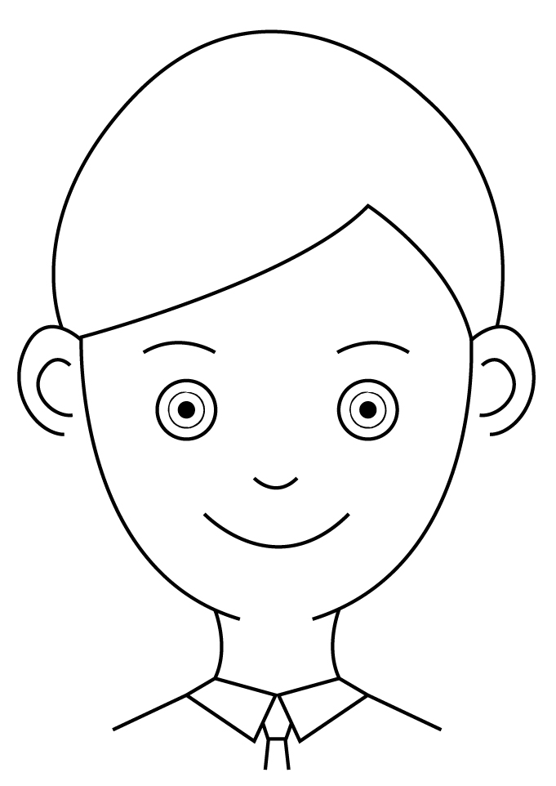

Appendix 2b

The ( ) child

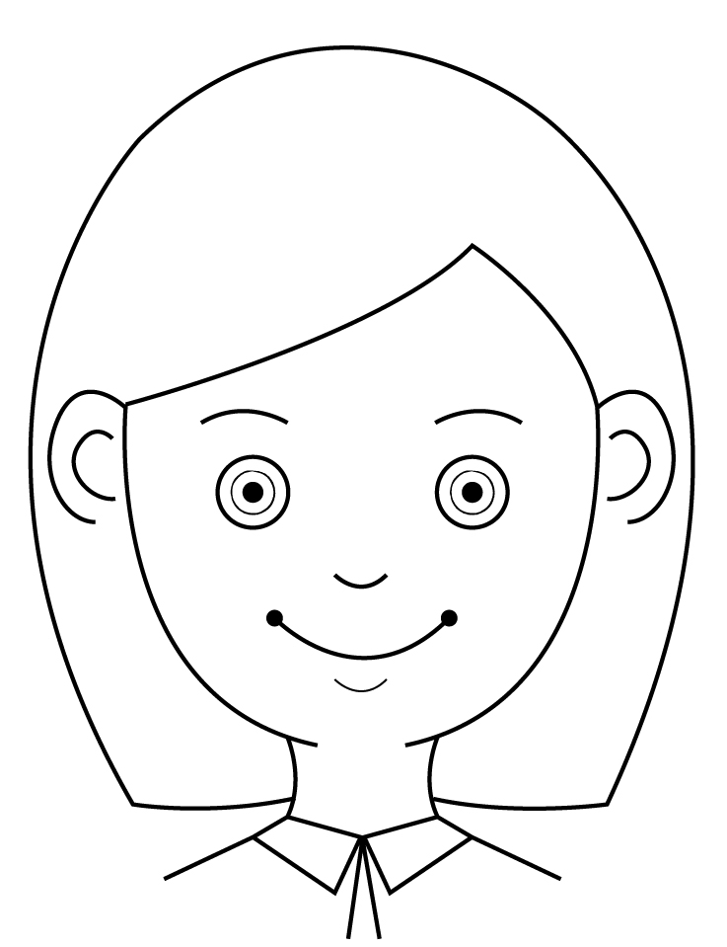

Activity：Decode the DNA code
Appendix 3a

DNA code for the facial characteristics of the first child

Facial characteristic 1:

DNA code  (Base sequence): | I have | A A A C T C C A T G T T A C C C G C  A C C C C C A C C A T T A T A
After decoding: | I have

Facial characteristic 2:

DNA code  (Base sequence): | I do not have | A A A C A G T T C T A C T T A  C A T A C C A T T A T A
After decoding: | I do not have

Facial characteristic 3:

DNA code  (Base sequence): | I have | A A A G A A C T G C T G G A A  C G T G0 G A A C C C A G C G C  A C C G A A A G T C A T G T G  C T C A C C A T T A T A
After decoding: | I have

Facial characteristic 4:

DNA code  (Base sequence): | I have | A A A G A A C G C C G T C A T  A C C A C A C T G C G C C G T  G G A T T C T G T A T A
After decoding: | I have

Activity：Decode the DNA code
Appendix 3b

DNA code for the facial characteristics of the second child

Facial characteristic 1:

DNA code  (Base sequence): | I have | A A A C T C C A T G T T A C C C G C  A C C C C C A C C A T T A T A
After decoding: | I have

Facial characteristic 2:

DNA code  (Base sequence): | I have | A A A C A G T T C T A C T T A  C A T A C C A T T A T A
After decoding: | I have

Facial characteristic 3:

DNA code  (Base sequence): | I have | A A A G A A C T G C T G G A A  C G T G0 G A A C C C A G C G C  A C C G A A A G T C A T G T G  C T C A C C A T T A T A
After decoding: | I have

Facial characteristic 4:

DNA code  (Base sequence): | I have | A A A G A A T G T C G C G T T T G T  C G T C A T A C C A C A C T G C G C  C G T G G A T T C T G T A T A
After decoding: | I have

Activity：Decode the DNA code
Appendix 3c

DNA code for the facial characteristics of the third child

Facial characteristic 1:

DNA code  (Base sequence): | I have | A A A C T C A G T G T G A T G T G T  C G C A C C C C C A C C A T T A T A
After decoding: | I have

Facial characteristic 2:

DNA code  (Base sequence): | I have | A A A C A G T T C T A C T T A  C A T A C C A T T A T A
After decoding: | I have

Facial characteristic 3:

DNA code  (Base sequence): | I have | A A A A C A A G T A C C A C C C G C  A C C G A A A G T C A T G T G C T C  A C C A T T A T A
After decoding: | I have

Facial characteristic 4:

DNA code  (Base sequence): | I have | A A A G A A T G T C G C G T T T G T  C G T C A T A C C A C A C T G C G C  C G T G G A T T C T G T A T A
After decoding: | I have

Activity：Decode the DNA code
Appendix 3d

DNA code for the facial characteristics of the fourth child

Facial characteristic 1:

DNA code  (Base sequence): | I have | A A A C T C C A T G T T A C C C G C  A C C C C C A C C A T T A T A
After decoding: | I have

Facial characteristic 2:

DNA code  (Base sequence): | I do not have | A A A C A G T T C T A C T T A  C A T A C C A T T A T A
After decoding: | I do not have

Facial characteristic 3:

DNA code  (Base sequence): | I have | A A A A C A A G T A C C A C C C G C  A C C G A A A G T C A T G T G C T C  A C C A T T A T A
After decoding: | I have

Facial characteristic 4:

DNA code  (Base sequence): | I have | A A A G A A T G T C G C G T T T G T  C G T C A T A C C A C A C T G C G C  C G T G G A T T C T G T A T A
After decoding: | I have

Activity：Decode the DNA code
Appendix 3e

DNA code for the facial characteristics of the fifth child

Facial characteristic 1:

DNA code  (Base sequence): | I have | A A A C T C A G T G T G A T G T G T  C G C A C C C C C A C C A T T A T A
After decoding: | I have

Facial characteristic 2:

DNA code  (Base sequence): | I do not have | A A A C A G T T C T A C T T A  C A T A C C A T T A T A
After decoding: | I do not have

Facial characteristic 3:

DNA code  (Base sequence): | I have | A A A A C A A G T A C C A C C C G C  A C C G A A A G T C A T G T G C T C  A C C A T T A T A
After decoding: | I have

Facial characteristic 4:

DNA code  (Base sequence): | I have | A A A G A A T G T C G C G T T T G T  C G T C A T A C C A C A C T G C G C  C G T G G A T T C T G T A T A
After decoding: | I have

Activity：Decode the DNA code
Appendix 3f

DNA code for the facial characteristics of the sixth child

Facial characteristic 1:

DNA code  (Base sequence): | I have | A A A C T C A G T G T G A T G T G T  C G C A C C C C C A C C A T T A T A
After decoding: | I have

Facial characteristic 2:

DNA code  (Base sequence): | I have | A A A C A G T T C T A C T T A  C A T A C C A T T A T A
After decoding: | I have

Facial characteristic 3:

DNA code  (Base sequence): | I have | A A A G A A C T G C T G G A A C G T  G0 G A A C C C A G C G C A C C G A A  A G T C A T G T G C T C A C C  A T T A T A
After decoding: | I have

Facial characteristic 4:

DNA code  (Base sequence): | I have | A A A G A A C G C C G T C A T A C C  A C A C T G C G C C G T G G A T T C  T G T A T A
After decoding: | I have

Activity：Decode the DNA code
Appendix 3g

DNA code for the facial characteristics of the seventh child

Facial characteristic 1:

DNA code  (Base sequence): | I have | A A A C T C C A T G T T A C C C G C  A C C C C C A C C A T T A T A
After decoding: | I have

Facial characteristic 2:

DNA code  (Base sequence): | I have | A A A C A G T T C T A C T T A  C A T A C C A T T A T A
After decoding: | I have

Facial characteristic 3:

DNA code  (Base sequence): | I have | A A A G A A C T G C T G G A A C G T  G0 G A A C C C A G C G C A C C G A A  A G T C A T G T G C T C A C C  A T T A T A
After decoding: | I have

Facial characteristic 4:

DNA code  (Base sequence): | I have | A A A G A A C G C C G T C A T A C C  A C A C T G C G C C G T G G A T T C  T G T A T A
After decoding: | I have

Activity：Decode the DNA code
Appendix 3h

DNA code for the facial characteristics of the eighth child

Facial characteristic 1:

DNA code  (Base sequence): | I have | A A A C T C C A T G T T A C C C G C  A C C C C C A C C A T T A T A
After decoding: | I have

Facial characteristic 2:

DNA code  (Base sequence): | I have | A A A C A G T T C T A C T T A  C A T A C C A T T A T A
After decoding: | I have

Facial characteristic 3:

DNA code  (Base sequence): | I have | A A A A C A A G T A C C A C C C G C  A C C G A A A G T C A T G T G C T C  A C C A T T A T A
After decoding: | I have

Facial characteristic 4:

DNA code  (Base sequence): | I have | A A A G A A C G C C G T C A T A C C  A C A C T G C G C C G T G G A T T C  T G T A T A
After decoding: | I have

Activity：Decode the DNA code
Appendix 4

The DNA code for some facial characteristics

Facial characteristics | DNA code (Base sequence)
blue eyes | A A A C T C C A T G T T A C C C G C  A C C C C C A C C A T T A T A
brown eyes | A A A C T C A G T G T G A T G T G T  C G C A C C C C C A C C A T T A T A
dimples | A A A C A G T T C T A C T T A  C A T A C C A T T A T A
attached earlobes | A A A G A A C T G C T G G A A C G T G G A  A C C C A G C G C A C C G A A A G T C A T  G T G C T C A C C A T T A T A
free earlobes | A A A A C A A G T A C C A C C C G C  A C C G A A A G T C A T G T G  C T C A C C A T T A T A
a cleft chin | A A A G A A C G C C G T C A T A C C A C A  C T G C G C C G T G G A T T C T G T A T A
an uncleft chin | A A A G A A T G T C G C G T T T G T  C G T C A T A C C A C A C T G C G C  C G T G G A T T C T G T A T A

