Learning & Teaching Resources
for Science (S1-3) Curriculum (2017)

Unit 11 Force and Motion

Design and Make a Toy Car
Rolling Down an Inclined Plane

Student Worksheet

Copyright © 2018 Science Education Section, Curriculum Development Institute, Education Bureau, HKSAR
All rights reserved.
(Developed by Hong Kong Association for Science and Mathematics Education)
Learning Objectives
After this activity, you are able to:
- design and make a toy car;
- recognise that friction and air resistance will oppose the motion of an object;
- describe the ways to reduce friction and air resistance;
- identify uniform motion and non-uniform motion; and
- use mobile applications (App) to analyse the motion of an object.

Task
With the materials provided by teacher, each group of students design and make a toy car which can travel a long distance. The car rolls down an inclined plane AB as shown in the following diagram. Then, it moves against the wind on the track BC covered by carpets. The car travelled the longest distance will win the competition.
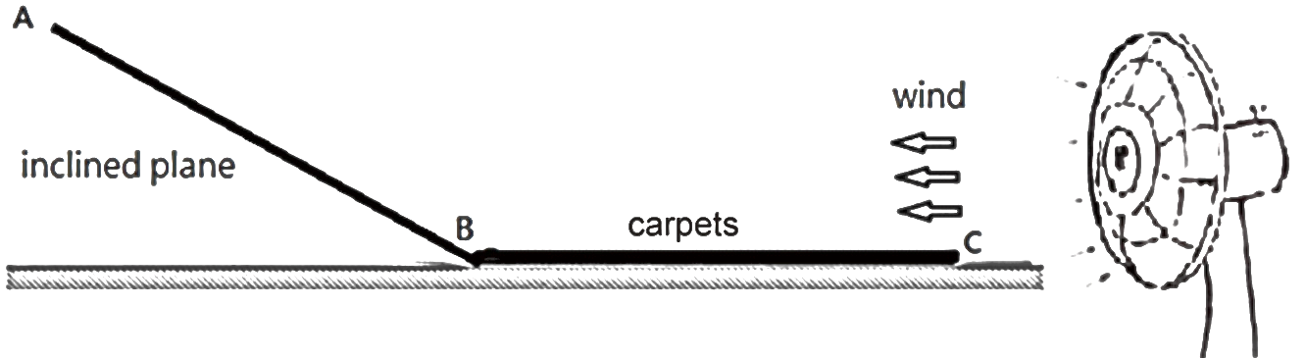
Rules of the Competition
1. All the materials, including those not in use should be placed on the car.
2. The toy car should be released at position A for rolling down the inclined plane without acting external force on it.
3. Each group has 3 trials. The trial with the longest distance travelled will be counted.

Materials and apparatus
- toy car bottom frame  - wheels  - tyres made of different materials  - axles and tubes  - beverage carton (250ml)  for making car body  - nylon straps  - adhesive tape  - scissors | 1  4  4 for each material  1 set  1  1  8  1 roll  1 | 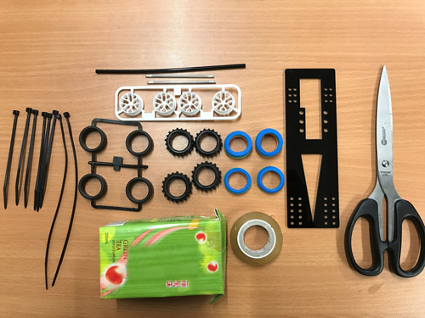
Activity 1：Design and make a toy car
1. Draw the design of your toy car in the space provided.
(Hints: the selection of tyres and the shape of car body should be considered)
2. Make the toy car according to the above design.
Activity 2：Competition of rolling toy car

Materials and Apparatus
- Tablet (with motion tracking App installed) 1
- Measuring tape 1

- Start the competition by groups in turns.
- Measure and record the distances travelled by the toy car of your group on track BC.

(Remarks: Use a mobile application (App) for tracking motion of an object to record the motion of your toy car travelled on track AC for further analysis in Activity 3.)

Results
 | Distance travelled |  |  | The longest distance travelled.
 | Trial 1 | Trial 2 | Trial 3
Group 1
Group 2
Group 3
Group 4
Group 5
Group 6
Group 7
Group 8
2. According to the results,
(a) which group wins the competition? ___________
(b) describe and explain the design of the winning car.
_________________________________________________________________
_________________________________________________________________
_________________________________________________________________
_________________________________________________________________

Activity 3：Analysing the motion of the toy car
- The ‘tracker diagram’ of the App can illustrate the change in speed of an moving object. With reference to the following three ‘tracker diagrams’ of a moving ball displayed using the mobile application, identify the motions as “uniform speed”, “increasing speed” or “decreasing speed”.

Type of Motion | Tracker diagram  (the ball is moving from left to right) | Motion of the ball
X |  | The speed of the ball is  (uniform / increasing / decreasing)
Y |  | The speed of the ball is  (uniform / increasing / decreasing)
Z |  | The speed of the ball is  (uniform / increasing / decreasing)

2. (a) In the following diagram, sketch the tracker diagram of your toy car (moving
from position A to stationary).

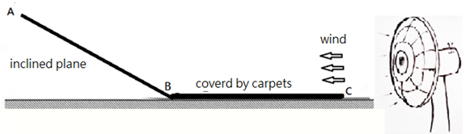

(b) (i) Which type of motions (X, Y or Z) best represents the toy car moving from
A to B? Describe the change of its speed.
_____________________________________________________________

(ii) Explain the change of the speed as described in b (i).
_____________________________________________________________ _____________________________________________________________

(c) (i) Which type of motions (X, Y or Z) best represents the toy car moving from
B to C? Describe the change of its speed.
_____________________________________________________________ _____________________________________________________________

(ii) Explain the change of the speed as described in c (i).
_____________________________________________________________
_____________________________________________________________

