Science (S1-3)
Updated Curriculum (2017)

Unit 1 Introducing Science

Making a Creative Paper Glider
(Teacher’s Version)

Ms Tsui Tsui Ping Edith
Seconded Teacher

Science Education Section, Curriculum Development Institute, Education Bureau
Unit 1 Introducing Science
Topic: Practice of Science
Estimated lesson time: 80 mins
Making a Creative Paper Glider
[Learning Objectives]
After this learning activity, students should be able to
- make a paper-hoop glider;
- practise the steps of scientific method;
- observe and state the characteristics of the glider;
- suggest ways to improve the glider, propose a hypothesis and conduct a fair test; and
- measure and record data accurately, and draw a conclusion.

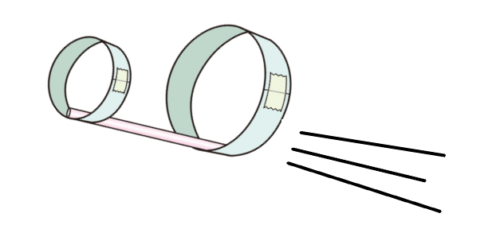

- Making a paper-hoop glider

A. Materials
● 9 cm × 15 cm stiff paper × 1 ● Plastic drinking straw × 1
● Tape × 1 ● Scissors × 1
Safety note:
Be aware of the sharp edge when handling stiff paper and using scissors.
B. Procedure
1. Please complete the sentences by using the action words (verb) below. You may use the action words more than one time. Then make your own glider following the steps given.

 |  | tape |  |  | curl | make | cut |  | join
 |  |  | - Cut the stiff paper into three strips of 3 cm × 15 cm.  - Curl one of the strips into a little hoop and tape the ends of paper tightly together using a tape. |  |  |  |  |  |  | 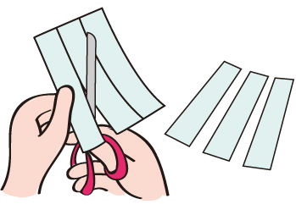
 |  |  | - Join the other two strips to make a long strip using the tape. There should be about 1 cm of length overlapped at the joining point. |  |  |  |  |  |  | 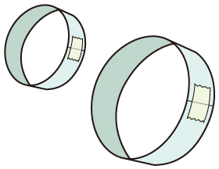  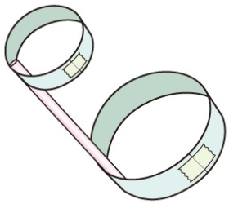
 |  |  | d. Curl this long strip into a big hoop and tape the ends of the strip tightly together.
 |  |  | e. Tape the two paper hoops to the two ends of the straw.

2. Hold the middle part of the straw and throw the glider to observe how far it can reach. | 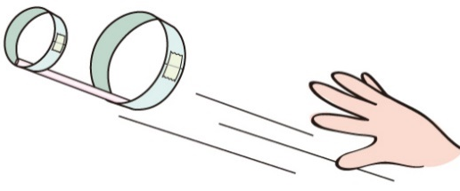
- Steps in Scientific Investigations

A. Observation
Can your paper-hood glider fly? Measure the flight distance.
It can fly. The flight distance was ( ) cm.
B. Asking a question and proposing a hypothesis
Which part of the glider should be modified in order to make the glider fly farther away?
Choose one of following factors as the investigating item.

length of the straw |  | width of the straw
number of the loops |  | thickness of the loops
size of the loops |  | other:
(Student should make his/her hypothesis based on the above variable selected)
Hypothesis:
If I replace the straw with a wider one , the glider can fly farther away from the starting point.

C. Design a fair test and carry out experiment

- Design a fair test to test your hypothesis. Complete the following variable table.

Independent variable  (the variable that you are going to change to see the effect on the glider) | Dependent variable  (the variable to be measured) | Controlled variables  (variables that should be kept the same in different sets of experiment)
- Width of straw  or any other reasonable answers :  - Length of straw  - Number of paper loop  - Size of paper loop  - Width of paper loop | - Flight distance | - Length of straw  - Number of paper loop  - Size of paper loop  - Width of paper loop  - Force for throwing the glider  or any other reasonable answers (cannot be the same with the independent variables chosen)
2. Based on the independent variable you have chosen, make another plane.

- Feature of the two gliders:
Draw glider 1 | Draw glider 2
State the special features of glider 1  (e.g. glider with thin straw) | State the special features of glider 2  (e.g. glider with wider straw)

- Measurement of the flight distance. Which measuring method will you choose?

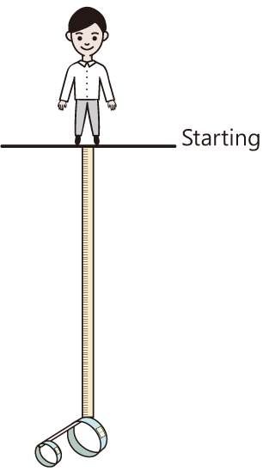 | 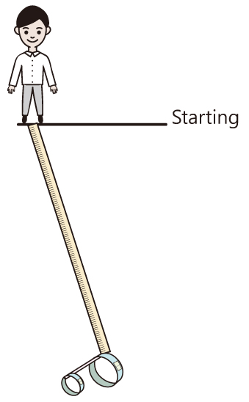 | 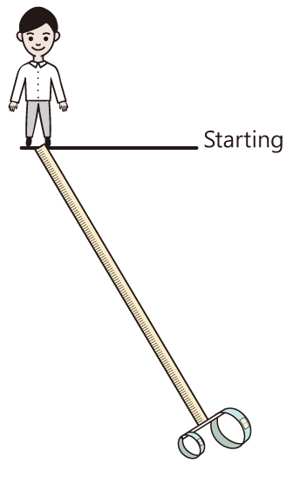
Teacher is suggested to discuss this part with students. In fact, all methods are acceptable. Once the students select the method, all measurements should be conducted in the same way.

D. Result and Analysis

Independent Variable:  Size of straw | Dependent Variable:  Flight distance (unit: m )
 | 1st round | 2nd round | 3rd round | Average
Thin straw | 0.96 | 0.87 | 0.89 | =(0.96+0.87+0.89)/3  =0.91
Wider straw | 1.24 | 1.34 | 1.37 | =(1.24+1.34+1.37)/3  =1.31

E. Discussion

- Why should the experiment be repeated three times?

The experiment should be repeated three times in order to minimise the errors and to draw

more reliable results.

- Do the experimental results support your hypothesis?

Yes / No, Student should answer with the support of experimental data.

F. Conclusion

What conclusion can you draw from the results of the experiment?

Example – The glider with a wider straw flies farther than the glider with a thin straw.

End
Teacher’s note
- Reference website:
- https://www.sophia.org/tutorials/best-hoop-glider-challenge
- https://sciencebob.com/the-incredible-hoop-glider/
- Youtube video:
https://www.youtube.com/watch?v=xI1_aSvkNMM

