Science (S1 – 3)

Updated curriculum (2017)

Unit 14: Light, Colours and Beyond

DIY Microscope

(Students Version)

Mr. Cheung Chak Man, Andrew
Seconded Teacher

Science Education Section, Curriculum Development Institute, Education Bureau

Science (S1 – 3)

Unit 14: Light, Colours and Beyond

Topics: Images formed by convex lenses
Estimated lesson time: 80 mins

DIY Microscope
【Learning objectives】
After the learning activity, I am able to:
- describe the nature of images formed by convex lenses;
- give examples of the daily applications of convex lenses; and
- make a simple microscope.

- Reading to learn

Convex lens and concave lens

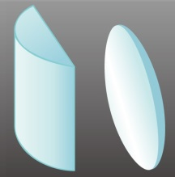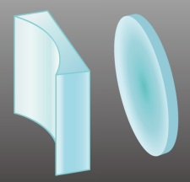  Figure 1:  Convex lens  Figure 2:  Concave lens | A lens is an optical component which is made of transparent material. Lenses are widely used in daily life, such as spectacles, magnifying glasses, telescopes and microscopes.  There are two main types of lenses. A convex lens is thicker at the center than at the edge (Figure 1), and a concave lens is thinner at the center than at the edge (Figure 2).

When parallel light rays pass through a convex lens, the refracted rays will converge (Figure 3). On the other hand, when parallel light rays pass through a concave lens, the refracted rays will diverge (Figure 4). | 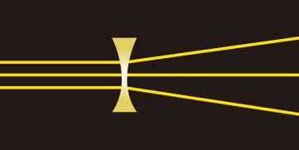  Figure 4  Figure 3

Real image and virtual image
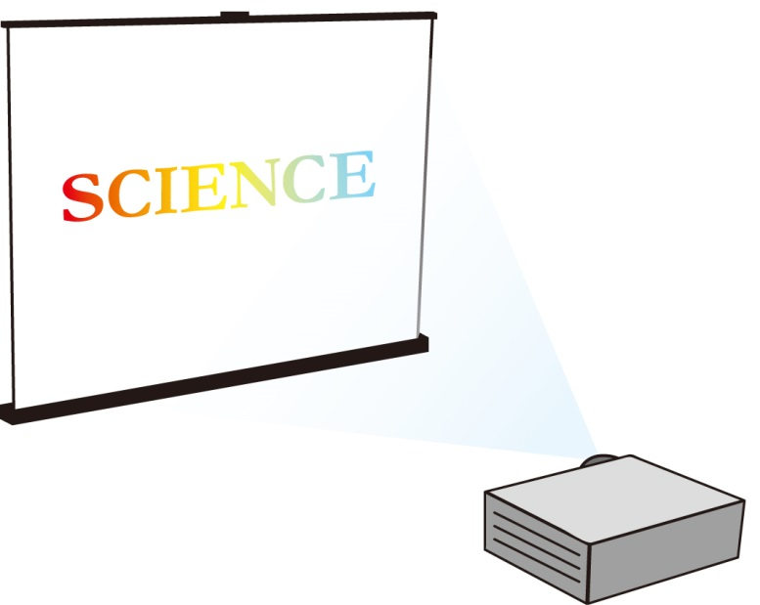
When light rays from an object passes through a lens, the image of the object is formed. If the image is formed by the convergence of light, it is a real image that can be projected onto a screen (Figure 5). We can observe the image either looking at the screen, or with naked eyes looking along the principal axis of the lens.
Figure 5

If light rays from an object passing through the lens do not converge, but appear to diverge from the image formed by the lens, the image is a virtual image (Figure 6). Although we can observe the image with naked eyes, the image cannot be projected onto the screen.
Figure 6
- Exercise (1) (Put a tick “√ ” in the appropriate box or circle the correct answers)

- Which of the following are the cross-section diagrams of convex lenses / concave lenses?
Cross-section diagrams of lenses
Types of lenses | 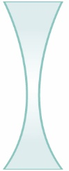 |  | 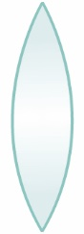 | 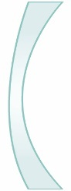 |  | 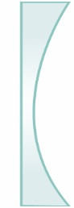
Convex lens
Concave lens

- Give THREE examples of the daily applications of convex lenses.

- When parallel rays of light pass through a convex lens, they will converge / diverge.

- When parallel rays of light pass through a concave lens, they will converge / diverge.

- Experiment: Finding the nature of the image formed by a convex lens

Part 1

- Apparatus and materials
 | Lamp housing with a letter F | 1 |  |  | Convex lenses with lens holder  (focal length of the lens: 5 cm) | 1
 | Ruler (30 cm) | 1

- Procedures

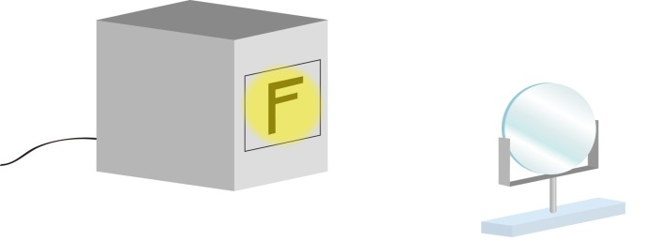
Figure 7

- Set up the apparatus as shown in Figure 7.
- Place the convex lens 2 cm away from the lamp housing. Observe the nature of the image.
- Move the convex lens from 2 cm to 4 cm away from the lamp housing. Observe the changes in the image.
- Place the convex lens 7 cm away from the lamp housing. Observe the nature of the image.
- Move the convex lens from 7 cm to 9 cm away from the lamp housing. Observe the changes in the image.
- Place the convex lens 15 cm away from the lamp housing. Observe the nature of the image.
- Move the convex lens from 15 cm to 20 cm away from the lamp housing. Observe the changes in the image.
- Complete the table below.

- Results (Put a tick “√ ” in the appropriate box)
Distance between the lens and  the lamp housing  (cm) | Nature of the image |  |  |  | As the distance increases, the size of the image becomes
 | Erect | Inverted | Enlarged | Diminished | larger | smaller
2
2 – 4
7
7 – 9
15
15 – 20

Part 2

- Apparatus and materials
 | Lamp housing with a letter F | 1 |  |  | Convex lenses with lens holders  (focal length of the lens: 5 cm) | 2
 | Ruler (30 cm) | 1 |  |  | Translucent screen | 1

- Procedures
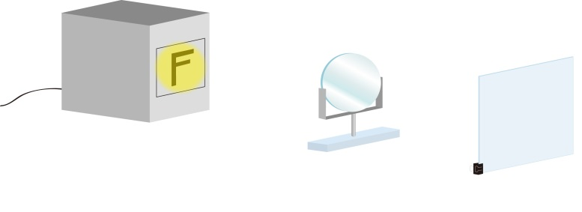
Figure 8
- Set up the apparatus as shown in Figure 8.
- Place the convex lens 2 cm away from the lamp housing.
- In order to determine whether the image is real or virtual, try moving the screen to see whether the image can be projected onto the screen.
- Place the convex lens 7 cm and 15 cm away from the lamp housing respectively and repeat Step 3.
- Complete the table below.
- Results (Circle the correct answers)
Distance between the lens and the lamp housing (cm) | Can the image be projected onto the screen?
2 | Yes / No
7 | Yes / No
15 | Yes / No

- Conclusion (Circle the correct answers)
1. | When the convex lens is placed 2 cm away from the lamp housing, the image can / cannot be projected onto the screen. Therefore the image is real / virtual.
2. | When the convex lens is placed 7 cm away from the lamp housing, the image can / cannot be projected onto the screen. Therefore the image is real / virtual.
3. | When the convex lens is placed 15 cm away from the lamp housing, the image can / cannot be projected onto the screen. Therefore the image is real / virtual.

- Summary (Circle the correct answers)
1. | When the convex lens is placed 2 cm away from the lamp housing, the image formed is erect / inverted, enlarged / diminished and real / virtual.
2. | When the convex lens is placed 7 cm away from the lamp housing, the image formed is  erect / inverted, enlarged / diminished and real / virtual.
3. | When the convex lens is placed 15 cm away from the lamp housing, the image formed is  erect / inverted, enlarged / diminished and real / virtual.

- Exercise (2) (Circle the correct answers or put a tick “√ ” in the appropriate box)

- In Figure 9, the image formed by a magnifying glass is a real image / virtual image because
□ we can see the image with naked eyes.
□ light rays converge onto the image after refraction from the lens.
□ image cannot be projected onto the screen.
Figure 9

- A film shown at a cinema house is a real image / virtual image because
□ we can see the image with naked eyes.
□ light rays converge onto the image after refraction from the lens.
□ image cannot be projected onto the screen.
- Activity: Making a simple microscope

- Background
Eyepiece
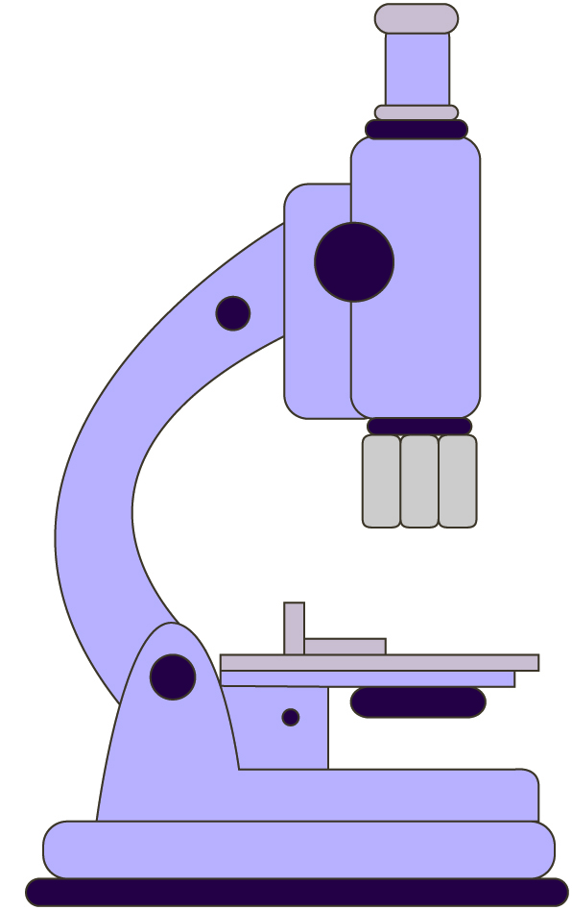

Objective

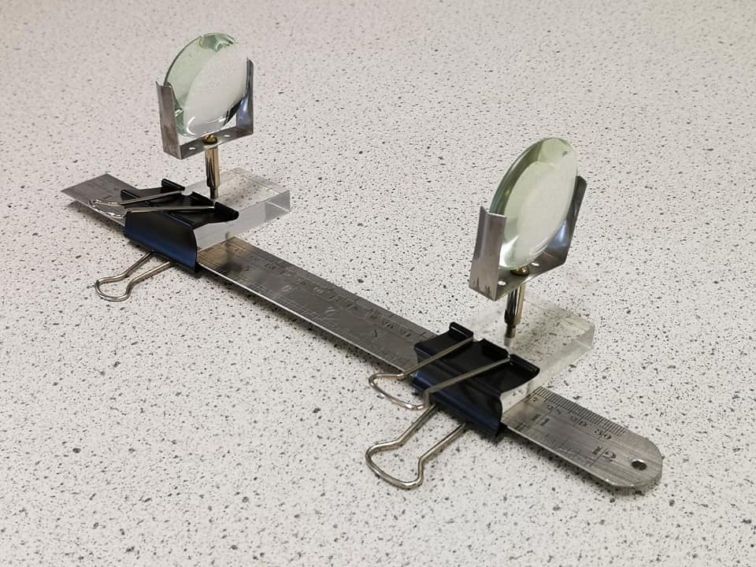

Figure 11
Figure 10

The microscope that is commonly used in school laboratories consists of two convex lenses. When light rays from an object passes through the first convex lens (objective), an enlarged and inverted real image is formed. When the light rays from this real image propagate in the microscope and pass through another convex lens (eyepiece), an enlarged and erect virtual image is formed. As a result, the image formed by a microscope is enlarged, inverted and virtual.

We are going to make a simple microscope as shown in Figure 11 by applying the scientific principles above.

- Apparatus and materials
 | Lamp housing with a letter F | 1 |  |  | Convex lenses with lens holders  (focal length of the lens: 5 cm) | 2
 | Metal ruler (30 cm) | 1 |  |  | Translucent screen | 1
 | Long tail clips (5 cm) | 2

- Procedures
 | Set up the apparatus as shown in Figure 12. | 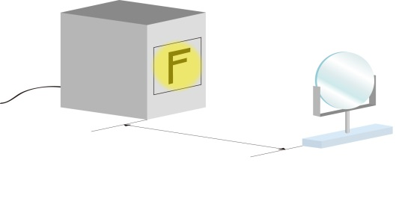
Place the convex lens at a suitable position in order to form an enlarged and inverted real image.
(Hint: refer to the Summary of the experiment in P.4)
Figure 12
 | Place a translucent screen on the other side of the lens as shown in Figure 13. Try moving the screen until the sharp image of letter “F” is projected onto the screen. | 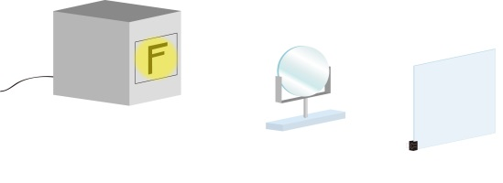  Figure 13
 | Place another convex lens at a suitable position as shown in Figure 14 so that when the light rays from the real image on the screen pass through the lens, an enlarged and erect virtual image is formed.  (Hint: refer to the Summary of the experiment in P.4) | 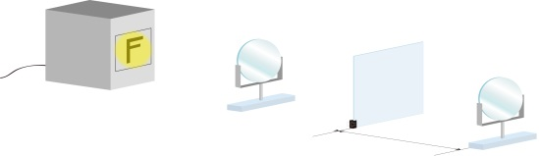  Figure 14
 | Remove the lamp housing and the screen. Secure 2 lenses with lens holders to the metal ruler by 2 long tail clips as shown in Figure 15. | 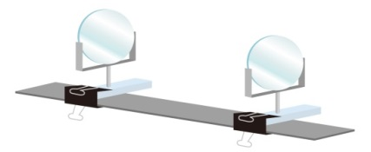  Figure 15
 | Use the simple microscope to observe the text on the worksheet as shown in Figure 16. | 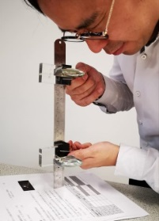  Figure 16
- Result (circle the correct answers)
The image formed by the simple microscope is enlarged / diminished and erect / inverted.

- Summary

Use the following vocabularies to write what you have learnt in this activity.

Related vocabularies: Convex lens, concave lens, converge, diverge, real image, virtual image, enlarged, diminished,
erect, inverted, microscope.

In this activity, I have learnt:

- Self-evaluation

Items |  | Evaluation  (Put a tick “√” in the appropriate box)
 |  | Highly satisfactory | Satisfactory | Unsatisfactory | Highly unsatisfactory
1. | I am able to describe the nature of images formed by convex lenses.
2. | I can give examples of the daily applications of convex lenses.
3. | I can make a simple microscope.

End

