Science (S1 – 3)

Updated curriculum (2017)

Unit 8: Making Use of Electricity

Introduction to Electric Current

Mr. Cheung Chak Man, Andrew
Seconded Teacher

Science Education Section, Curriculum Development Institute, Education Bureau
Science (S1 – 3)
Unit 8: Making Use of Electricity

Topics: Simple circuit and Current
Estimated lesson time: 120 mins

Introduction to Electric Current
【Learning objectives】
After the learning activity, I am able to:
- understand the conditions for making the bulb light up;
- use an ammeter to measure electric current;
- be aware that ampere (A) is a unit of current; and
- recognise electric current as the flow of charges.

- Experiment (1)

- Aim: Understand the conditions for making the bulb light up

- Apparatus and materials
 | Circuit board | 1 |  |  | Wires | 2
 | Cells (1.5V) | 2 |  |  | Bulb | 1

- Procedures: Connect the 5 circuits respectively as shown below. Then complete the table.

- Results (Circle the correct answers)

 | Circuit | Is there a source of energy? | Is there a complete path? | Does the bulb light up?
1. | 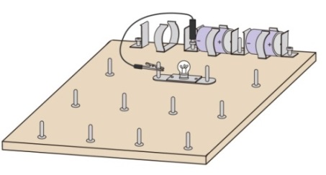  - +  - + | Yes / No | Yes / No | Yes / No
2. | 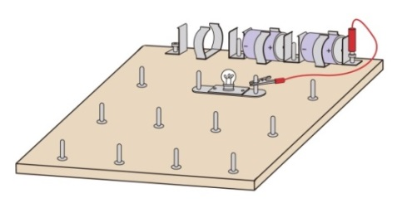  - +  - + | Yes / No | Yes / No | Yes / No
3. | 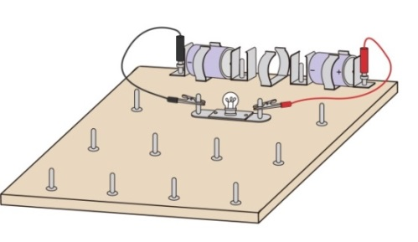  - +  - + | Yes / No | Yes / No | Yes / No
4. | 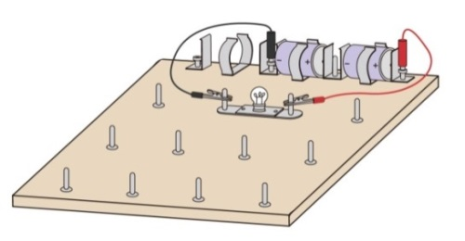  - +  - + | Yes / No | Yes / No | Yes / No
5. | 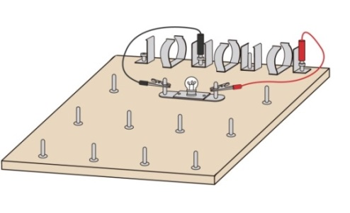 | Yes / No | Yes / No | Yes / No

- Conclusion

Based on the results above, the two conditions for making the bulb light up are
a circuit has a complete path
a circuit has a source of electrical energy

- Reading to learn (1)

Conditions for lighting up a bulb

- +
- +
Figure 1 | - +  - +  Figure 2

Consider a simple electric circuit which consists of cells, wires and a bulb. Some people believe that when one end of the cells (positive or negative terminals) and the bulb are connected with a wire, an electric current can flow to the bulb (Figures 1 and 2) and make the bulb light up. The results of the Experiment (1) show the assumption is wrong.
Direction of the flow of negatively charged particles
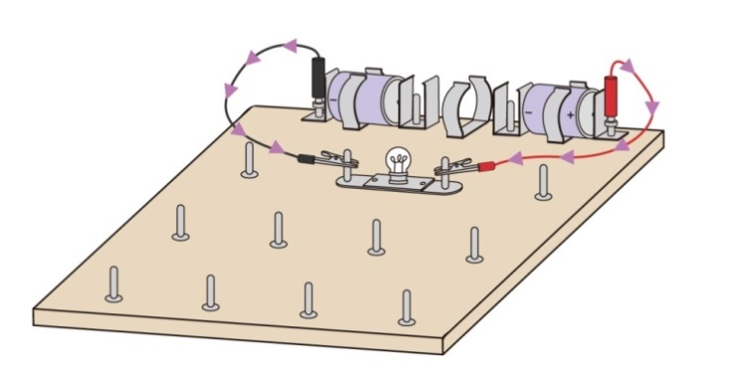  Figure 3  - +  - + | Some people believe that an electric current can flow from both ends of the cells to the bulb through the wires to make the bulb light up (Figure 3). The result of the experiment (1) shows the assumption is wrong.  Direction of the flow of negatively charged particles  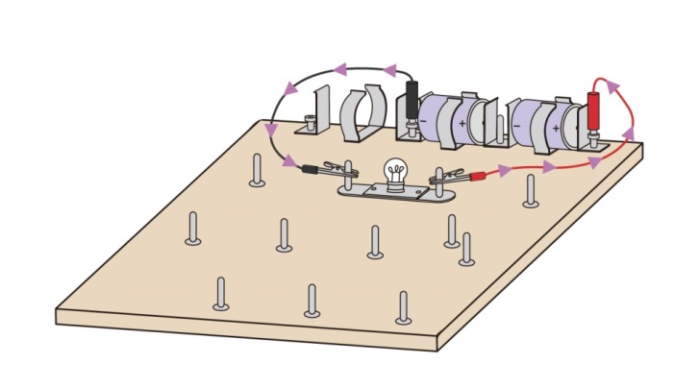
To make the bulb light up, according to the conclusion of the experiment (1), a circuit with a complete path and a source of electrical energy (i.e. cell) are needed (Figure 4). The circuit with a complete path is called a closed circuit. |  | Figure 4  - +  - +

What is an electric current?
Scientists believe that substances contain charged particles. In general situations, substances are electrically neutral because the number of positively charged particles and negatively charged particles in substances is the same.
Negatively
charged particle
Metal part of the wire
An electric current is the flow of charged particles. When the cells, the wires and the bulb are connected to form a closed circuit, the cells drive the negatively charged particles (free electrons) in the circuit, flowing from the negative terminal of the cell to the positive terminal through the bulb (Figure 5). As a result, the electric current is formed. Energy is transferred from the cells to the bulb, and converted into light energy and thermal energy by the bulb. The cell is the energy source in the circuit.
Figure 5

Direction of the flow of negatively charged particles
Wire
- +
- +
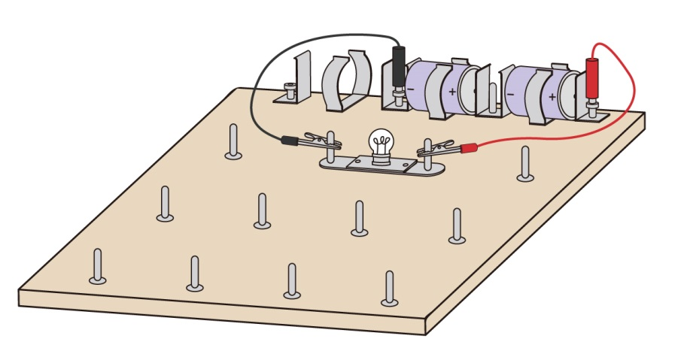
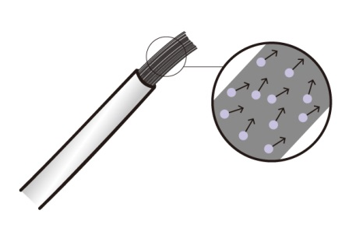
Pedal
Back wheel
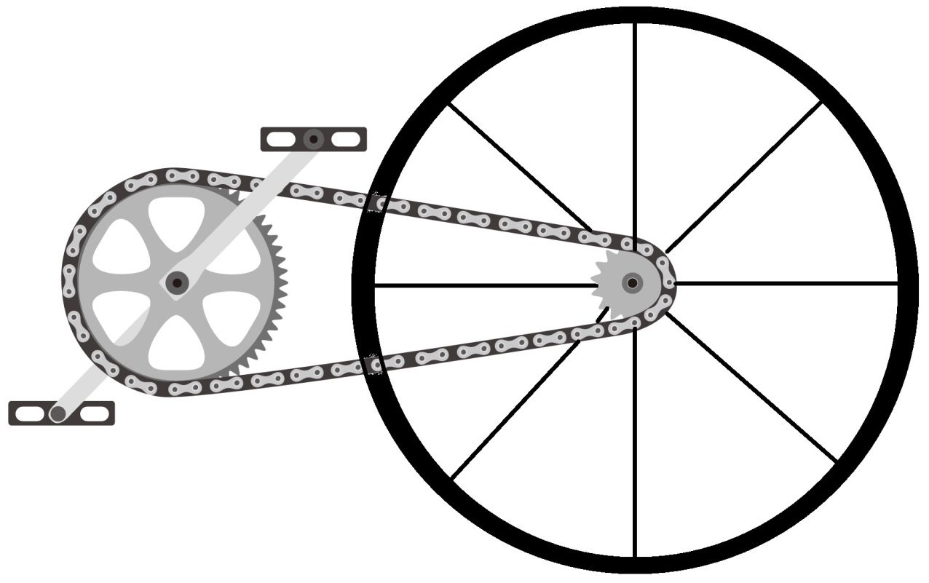

The bicycle chain analogy (Figure 6) can be used to help us understand the concept above. A Pedal (analogy to the cell) drives a bicycle chain in motion (analogy to the flow of negatively charged particles). Through the motion of the bicycle chain, energy is transferred from the pedal to the back wheel (analogy to the bulb).
Figure 6

Bicycle chain

Conventional direction of the electric current
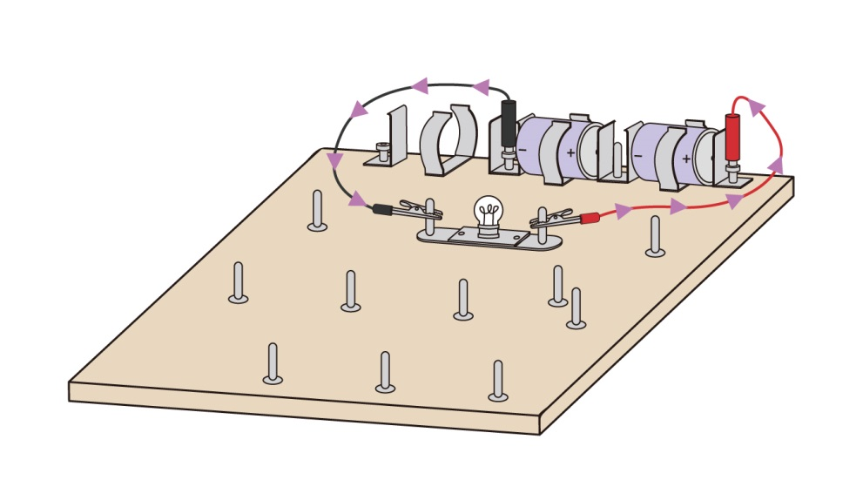
Before electrons were discovered, scientists believed that the electric current was the flow of positively charged particles from the positive terminal of the cell to the negative terminal through the bulb. It is called the conventional direction of the electric current. Actually, in the above example, the electric current is formed by the flow of negatively charged particles (free electrons) in the direction opposite to the conventional direction (Figure 7). However, we still use the conventional direction of the electric current until now.
Figure 7
Direction of the flow of negatively charged particles
Conventional direction of the electric current
- +
- +

- Exercise (1) (Put a tick “√” in the appropriate box)

- Substances contain charged particles. |  |  | True |  | √ |  | False
- Consider a simple electric circuit which consists of cells, wires and a bulb.
 | - To make the bulb light up, apart from connecting the cells to the circuit, the circuit must be closed. |  | True |  | √ |  | False
 | - When one end of the cell (positive or negative terminals) and the bulb are connected with the wire, the bulb will light up. |  | True |  |  |  | False | √
 | - The cells create and supply negatively charged particles to the circuit. |  | True |  |  |  | False | √
 | - The cells drive the negatively charged particles in the circuit to flow, and the electric current is formed. |  | True |  | √ |  | False
- In the circuit below, use arrows to indicate the direction of the flow of negatively charged particles.
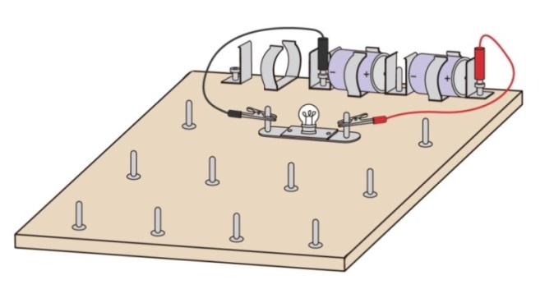
- +
- +
- In the circuit below, use arrows to indicate the conventional direction of the electric current.
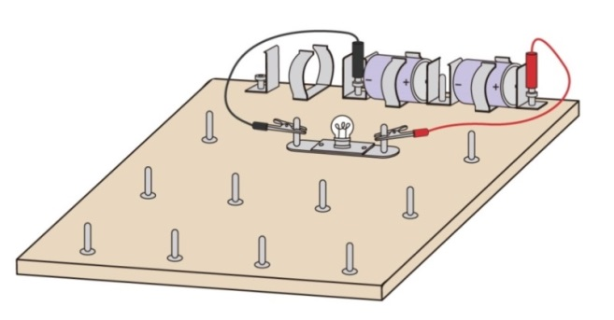
- +
- +
- Challenging question |  | Electric current is decreased after passing through the bulb. |  | True |  |  | False | √

- Reading to learn (2)

Consider the simple electric circuit which consists of cells, wires and a bulb again. After the electric current flows through the bulb, is the electric current decreased? Before answering the question, we need to learn how to use and read an ammeter.

An ammeter is a device for measuring the size of an electric current. The unit of an electric current is ampere (A). The larger the size of an electric current is, the larger the rate of flow of negatively charged particles in the circuit is.

To measure the size of the electric current in the path of the circuit (Figure 8), an ammeter is connected as shown in Figure 9 so that the electric current in that path can pass through the ammeter.
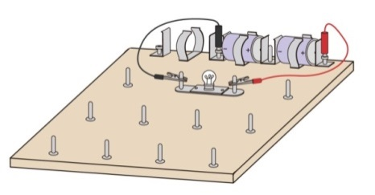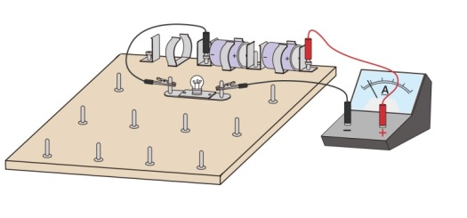
- +
- +
- +
- +
Figure 9
Figure 8
To measure the size of an electric current in this path

Moreover, the red terminal of an ammeter must be connected towards the positive terminal of the cell, and the black terminal towards the negative terminal (Figure 10). Otherwise, the ammeter may be damaged.
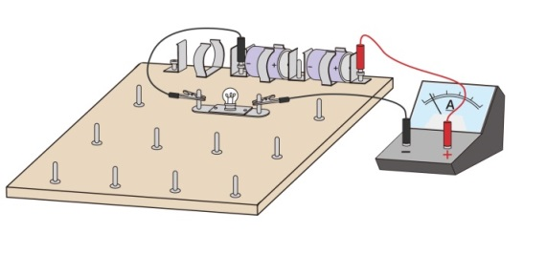  - +  - +  Figure 10: Ammeter is connected correctly | 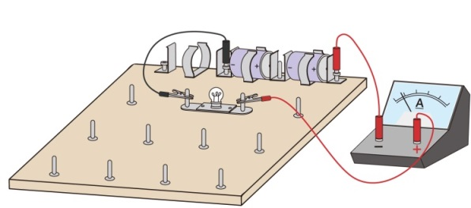  - +  - +  Figure 11: Ammeter is connected incorrectly
- Exercise (2)

- Explain why the ammeter in Figure 11 is connected incorrectly.
The red terminal of an ammeter is connected towards the negative terminal of the cell, and the black terminal towards the positive terminal.

- Write down the readings of the ammeters below.

(a) | 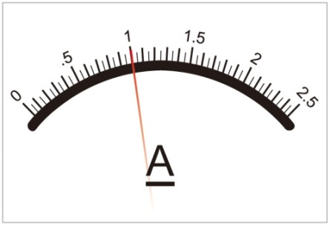 | 1A  _____________________
(b) | 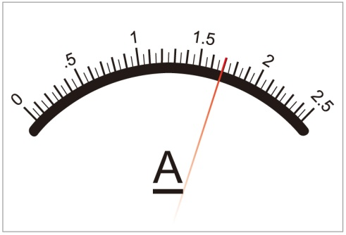 | 1.7 A  _____________________
(c) | 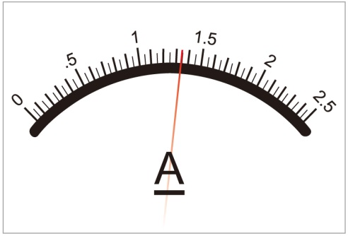 | 1.35 A  _____________________

- Experiment (2)

- Aim: Compare the size of the electric currents before and after flowing through the bulb

- Apparatus and materials
 | Circuit board | 1 |  |  | Bulb | 1
 | Cells (1.5V) | 2 |  |  | Wires | 3
 | Ammeter | 1

- Procedures
1. | Connect the circuit as shown in the figure on the right.  Path 2 | 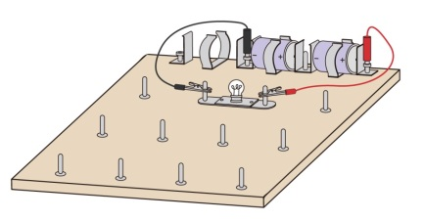  - +  - +  Path 1
2. | Measure the size of the electric current in path 1 of the circuit (the path connecting the positive terminal of the cell and the bulb). | 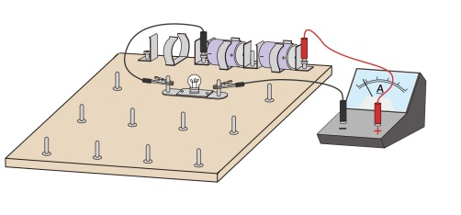  - +  - +
3. | Measure the size of the electric current in path 2 of the circuit (the path connecting the negative terminal of the cell and the bulb). | 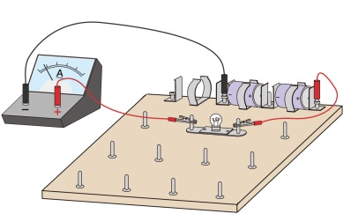  - +  - +
4. | Collect the data from other groups after the experiment.
5. | Compare the size of the electric currents in path 1 and path 2.

- Results (Fill in the correct answers or put a tick “√” in the appropriate box)

 |  | Group A | Group B | Group C | Group D | Group E | Group F | Group G | Group H
Size of the electric current in path 1 (A)
Size of the electric current in path 2 (A)
Size of the electric currents in the two paths | Same
 | Different

- Conclusion (Circle the correct answers)
As the size of the electric current in path 1 of the circuit is equal / not equal to that in path 2, the electric current is changed / unchanged after passing through the bulb. As the size of an electric current is related to the rate of flow of negatively charged particles (free electrons), the number of negatively charged particles (free electrons) is changed / unchanged after passing through the bulb.

- Summary

Use the following vocabularies to write what you have learnt in this activity.

Related vocabularies: | Cell, wire, bulb, closed circuit, electric current, negatively charged particles, conventional direction of electric current, ammeter, ampere (A).

In this activity, I have learnt:

- Self-evaluation

Item |  | Evaluation  (Put a tick “√” in the appropriate box)
 |  | Highly satisfactory | Satisfactory | Unsatisfactory | Highly unsatisfactory
1. | I understand the conditions for lighting up a bulb.
2. | I am able to use an ammeter to measure electric current.
3. | I am aware that ampere (A) is a unit of current.
4. | I recognise electric current as the flow of negatively charged particles.

End

