Science (S1 – 3)

Updated curriculum (2017)

Unit 7: Living Things and Air

Respiration and gas exchange
in animals

(Teachers Version)

Mr. Cheung Chak Man, Andrew
Seconded Teacher

Science Education Section, Curriculum Development Institute, Education Bureau
Science (S1 – 3)

Unit 7: Living Things and Air

Topics: Respiration and gas exchange in animals
Estimated lesson time: 160 mins

Respiration and gas exchange in animals

【Learning objectives】
After the learning activity, I am able to:
- recognise that food is the source of energy for all living things;
- describe respiration as a process in which food is broken down in cells to release energy in usable form for cells;
- compare the composition of gases between inhaled and exhaled air of animals;
- identify the main parts of the breathing system in humans; and
- recognise that gas exchange in humans takes place at the air sacs.

- Reading to learn (1)
Same as fuels, foods store chemical energy. During the process of burning, the chemical energy stored can be converted into thermal energy and light energy. However, due to some factors such as cost effectiveness and food shortage, people did not replace fossils fuels with food as the main source of energy.

Actually, in 1900, Garman Rudolf Diesel displayed his invention to the public at the Paris World’s Fair: the engine which was powered by peanut oil.
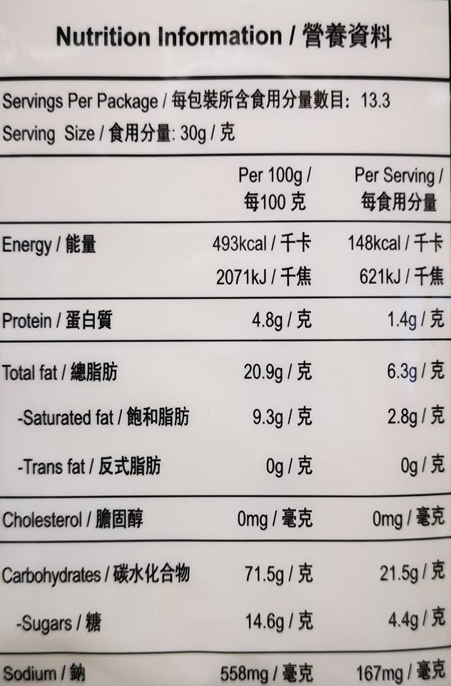
Although burning is not commonly used to convert the chemical energy stored in food into other useful forms of energy, it can be used to measure the amount of energy stored in a food. The information is shown on the food label (Figure 1).

Figure 1: Food label on the food package

- Experiment (1)

- Aim: Understand the energy conversion during the burning of peanut

- Apparatus and materials

Burning spoon | 1 |  |  | Heat-proof mat | 1
Bunsen burner | 1 |  |  | Peanut
- Procedure: Place a peanut in the burning spoon and heat it by the Bunsen burneron the heat-proof mat (Figure 2). Observe the energy released during the process of burning.
Burning spoon
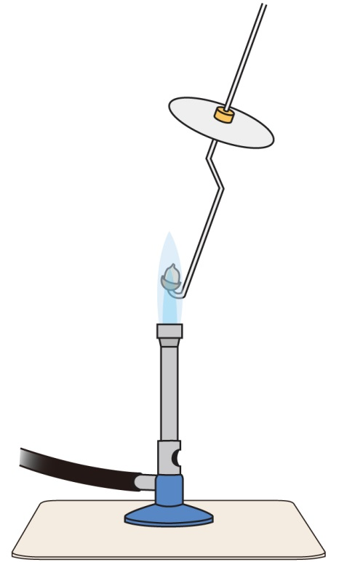
Wear safety goggle
Peanut

- Result
Bunsen burner
The energy stored in the peanut is converted into
thermal
light
Heat-proof mat
energy and energy by burning.
Figure 2

- Exercise (1)

John conducted the following experiment to compare the amount of chemical energy stored in food A and food B (Figure 3).

Food A
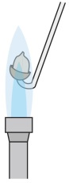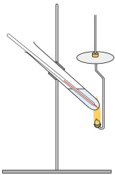
Clip
Heat-proof mat
Heat-proof mat
Burning spoon
Same volume of water
Food A
Stand
Boiling tube
Thermometer

Food B
Burning spoon
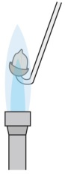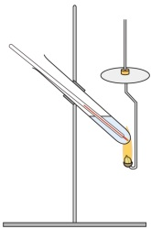
Clip
Figure 3
Food B
Stand
Boiling tube
Thermometer

The results are shown in the table below:
Food | Mass of food (g) | Increase in temperature of water  after the food is burned out（°C）
A | 5 | 3
B | 5 | 5

- What form of energy is released from the chemical energy stored in food to raise the temperature of water when burning?
Thermal energy
___________________________________________________________________________________________________________
- Which food stores a larger amount of chemical energy?
Food B
___________________________________________________________________________________________________________
- Reading to learn (2)
How does human body convert the chemical energy stored in food into the energy needed for different parts of the body? Before knowing the answer, we have to understand the knowledge about “breathing” and “respiration”.

Breathing
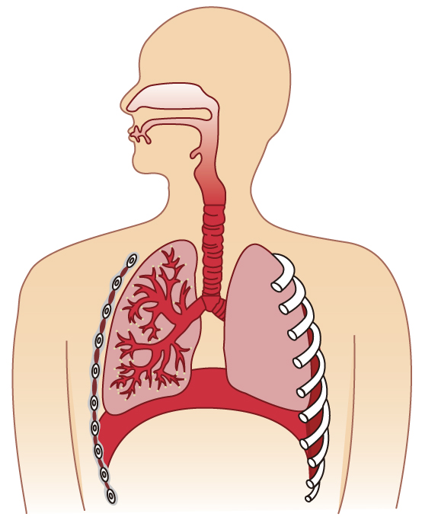
Figure 4: Basic structure of the human respiratory system
Rib
Lung
Diaphragm
Air sac
Bronchus
Nasal cavity
Trachea

Air is taken into and out of the body by the respiratory system. This process is called breathing. The main parts of the respiratory system of a human body includes: nasal cavity, trachea, bronchi, air sacs, lungs, ribs and diaphragm (Figure 4).

Respiration
The oxygen that we get through inhalation is delivered to the cells of our bodies, and react with the food in the cells (i.e., glucose). Food is broken down, and the chemcial energy stored in food is converted into usable forms of energy for cells. Besides, carbon dioxide and water are produced. This process is called respiration, which is happened inside the cells (Figure 5).
Animal cell
Figure 5: Respiration of an animal cell
Food
+
Oxygen
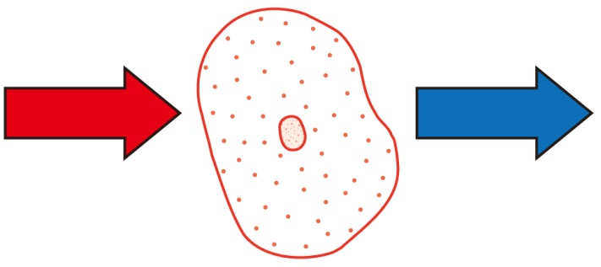
Energy
+
Carbon dioxide
+
Water

How is oxygen delivered to the cells of the body, so that respiration can take place continuously in the cell? On the other hand, how is carbon dioxide released out of the body from the cells, and not accumulate in the body?

Gas exchange
When we inhale, air enters the nasal cavity through the nostrils. Air then travels along the trachea, the bronchi and the bronchioles to the air sacs. Oxygen in the air passes through the air sacs and the capillaries around the air sacs into the blood. Through the flow of blood, oxygen is delivered to the cells of our bodies.
Carbon dioxide
Oxygen
Direction of the flow of blood
Air Sac
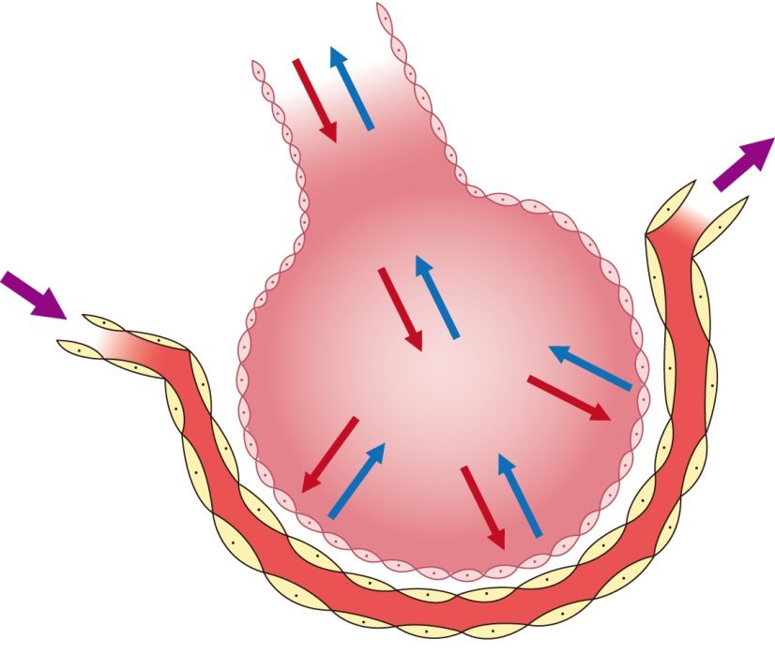

On the other hand, carbon dioxide produced by the cells in respiration enters the blood. Through the flow of blood, carbon dioxide arrives at the capillaries around the air sacs. Carbon dioxide then passes into the air sacs, and is released out of our bodies when we exhale.
Capillary
Figure 6: Gas exchange in an air sac

Therefore, gas exchange occurs continuously between our bodies and the surroundings. It is carried out in the air sacs (Figure 6).

- Exercise (2) (Fill in the blanks or put a tick “√” in the appropriate box)

 |  | Food | Energy per serving  (Kcal) | Mass per serving  (g) | Energy per 100g  (Kcal)
 | (a) | Instant noodles | 473 | 100 | 473
 | (b) | Cake | 152.5 | 50 | 305
 | (c) | Potato chips | 294.8 | 55 | 536
 | (d) | Apple | 104.2 | 200 | 52.1
instant noodles
From the table above, _____________________ stores the largest amount of energy per serving, and _____________________ stores the largest amount of energy per 100 g.
potato chips
√
- Food is the source of energy for all living things. | True | √ |  | False
- Breathing is the process of taking air into and out of the body. | True | √ |  | False
- Respiration takes place in cells. | True | √ |  | False
- Gas exchange between our bodies and the surroundings takes place in the air sacs.  chemical energy | True |  |  | False
- Respiration is the process by which the ___________________ stored in food is converted into into usable forms of energy for cells. In this process, ___________________ is needed, and ___________________ and ___________________ are produced.
water
carbon dioxide
oxygen
- Experiment (2)

- Aim: Test for carbon dioxide released from mealworms

- Apparatus and materials

 | Large-volume beakers (500 mL) | 2 |  | Plastic wrap
 | Small-volume beakers (150 mL) | 2 |  | Mealworms
 | Rubber bands | 2 |  | Hydrogencarbonate indicator

- Procedures

- Put the same amount of the hydrogencarbonate indicator into two large-volume beakers respectively (Figure 7). Observe the color of the indicator.  - Put a small amount of mealworms into a small-volume beaker. The beaker with mealworms is then put into one of the large volume beakers (Figure 8).  - Seal the two large-volume beakers respectively with plastic wrap and rubber bands (Figure 9).  - Observe the change in color of the hydrogencarbonate indicator after 30 minutes. | 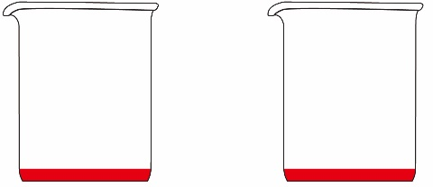  Large-volume  beaker  Indicator  Figure 7  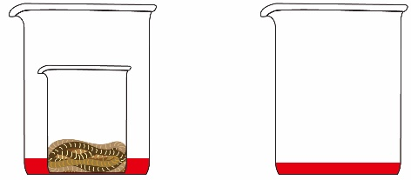  Figure 8  Small-volume  beaker  Mealworms  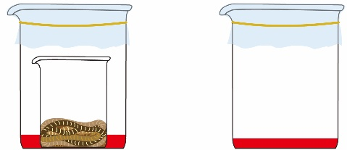  Rubber band  Figure 9  Plastic wrap

- Results
- At the beginning of the experiment, the color of the hydrogencarbonate indicator is ___________________.
red
- After 30 minutes, the color of the hydrogencarbonate indicator
yellow
- in the setup with mealworms is ___________________.
red
- in the setup without mealworm is ___________________.

- Conclusion (circle the correct answer)
Mealworms would / would not release carbon dioxide.

- Discussion
Explain why the setup without mealworm is needed in the above experiment.
This is the controlled experiment to ensure the change in colour of the indicator is due to the carbon dioxide released by the mealworms.
___________________________________________________________________________________________________________
___________________________________________________________________________________________________________
- Experiment (3)

- Aim: Compare the oxygen and carbon dioxide contents between exhaled and inhaled air of
human

- Apparatus and materials

Gas jar | 1 |  | Curved plastic drinking straw | 5
Cover plate | 1 |  | Burning spoon with candle | 1
Water trough | 1 |  | Hydrogencarbonate indicator
Stop watch | 1

- Procedures
Method of collecting exhaled air
1. | 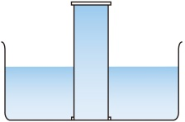  Water trough  Figure 11  Figure 10  Gas jar | Fill a gas jar with water in a water trough (Figure 10). Then turn the gas jar upside down in the water trough (Figure 11).
2. | 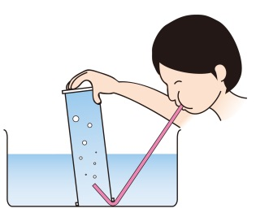  Figure 12  Curved plastic drinking straw | Hold the gas jar to make it inclined slightly. Put one end of a curved plastic drinking straw into the gas jar. Take a deep breath, then blow into the straw slowly until the gas jar is filled with exhaled air (Figure 12).
3. | 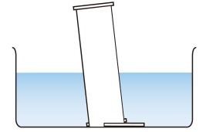  Figure 14  Figure 13  Cover plate | Cover the gas jar with a cover plate under water (Figure 13). Then take the gas jar out and put it upright (Figure 14).
Method of comparing the oxygen content between exhaled and inhaled air
4. | Cover a new gas jar with a cover plate to get a jar of inhaled air.  Buring spoon with candle
5. | 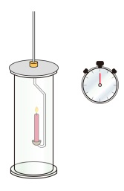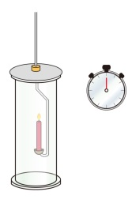  Timer  Figure 15  Gas jar with inhaled air  Gas jar with exhaled air | Light the candle on the burning spoon and put it into the jar of inhaled air and exhaled air respectively. Measure the time for a candle to extinguish by a stop watch in each gas jar (Figure 15).
Method of comparing the carbon dioxide content between exhaled and inhaled air
6. | Repeat Steps 1 – 4 to get a jar of exhaled air and a jar of inhaled air.
7. | 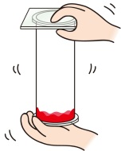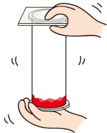  Figure 16  Indicator | Put a small amount of hydrogencarbonate indicator into the jar of inhaled air and exhaled air respectively. Then cover each jar immediately with a cover plate. Shake each jar gently and observe the color of the indicator (Figure 16).
- Results
- Compare the oxygen content between exhaled and inhaled air:

 | Exhaled air | Inhaled air
Time for the candle to extinguish
(s)

- Compare the carbon dioxide content between exhaled and inhaled air:

 |  |  | Exhaled air | Inhaled air
 | Color of the hydrogencarbonate indicator |  | yellow  red
- Conclusion (Circle the correct answers)
Exhaled air contains more / less oxygen and more / less carbon dioxide than inhaled air.

- Summary

Use the following vocabularies to write what you have learnt in this activity.

Related vocabularies: | Chemical energy, burning, respiration, energy conversion, breathing, respiratory system, nasal cavity, trachea, bronchus, air bags, lungs, inhaled air, exhaled air, oxygen content, carbon dioxide content, hydrogencarbonate indicator.

In this activity, I have learnt:

- Self-evaluation

Items |  | Evaluation  (Put a tick “√” in the appropriate box)
 |  | Highly satisfactory | Satisfactory | Unsatisfactory | Highly unsatisfactory
1. | I recognise that food is the source of energy for all living things.
2. | I can describe respiration as a process in which food is broken down in cells to release energy in usable form for cells.
3. | I can compare the composition of gases between inhaled and exhaled air of animals.
4. | I can identify the major parts of the human respiratory system.
5. | I recognise that gas exchange in humans takes place at the air sacs.

End

