Science (S1 – 3)

Updated curriculum (2017)

Giant Water Slide Investigation

Unit 1: Introducing Science

Seconded Teacher
Mr. Cheung Chak Man, Andrew

Science Education Section, Curriculum Development Institute, Education Bureau

Science (S1 – 3)

Unit 1: Introducing Science

Topics: Practice of science, laboratory equipment and basic practical skills
Estimated lesson time: 80 mins

Giant Water Slide Investigation

【Learning objectives】
After the learning activity, I am able to:
- recognise the steps in scientific investigation;
- use appropriate instruments for measuring mass, length and time;
- use appropriate units in recording measurement data;
- read the scales on the measuring instruments accurately; and
- be aware that there are errors in measurement.

Scientific investigation

Step 1: Making observation
Giant water slide is a popular amusement ride in summer. People slide down from the top of the giant water slide. Is the mass of a person affects the time taken to slide down a water slide significantly?

We are going to design and conduct an experiment to find out the answer.

Step 2: Proposing a hypothesis
(Put a tick “√” in the appropriate box)

The time taken for an object to move down an inclined plane is independent of the mass.
A more massive object takes a longer time to move down an inclined plane.

A more massive object takes a shorter time to move down an inclined plane.

Step 3: Designing and conducting an experiment
According to the aim of the experiment, we need to
(Put a tick “√”in the appropriate box and fill in the blank)
- change |  | the slope of an inclined plane
 |  | the mass of an object
 |  | the distance travelled by the object along an inclined plane, and
- measure | the time taken by the metal can to arrive at the ending point.

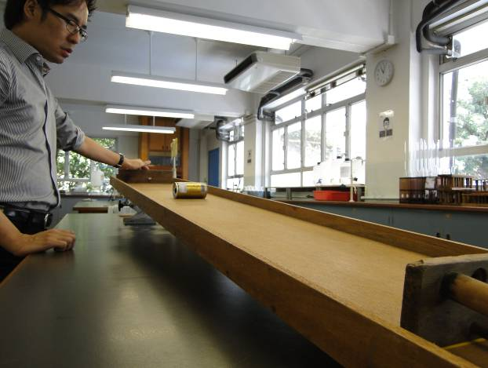
Apparatus and materials

Board | 1 |  |  | Lifting platform | 1
Digital balance | 1 |  |  | Stopwatch | 1
Metal can | 1 |  |  | Metre rule | 1
Marbles | 10 |  |  | Beaker | 1

Procedures

 | 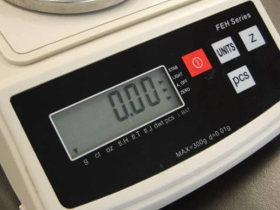 | - Switch on the digital balance.  - Adjust the unit of the digital balance to 0.00g .
 | 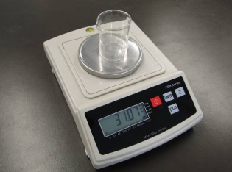 | Put the beaker onto the digital balance.
 | 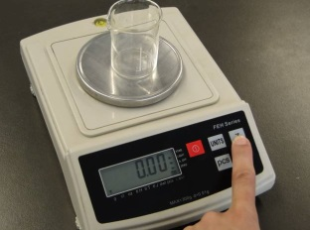 | Set the reading of the digital balance to zero.
 | 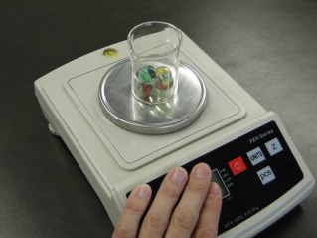 | - Put 10 marbles into the beaker.  - Measure the total mass of the marbles.  - Calculate the average mass of the marble.
 | 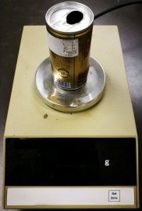 | Measure the mass of the metal can.

 | 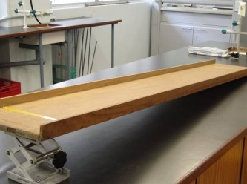 | Use the lifting platform to lift one end of the board to form an inclined plane.
 | 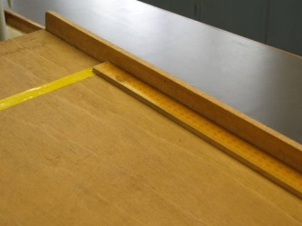 | Measure the distance between the starting point and the ending point of the inclined plane with a metre rule .
 | 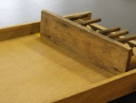 | Place an obstacle at the ending point of the inclined plane.
 | 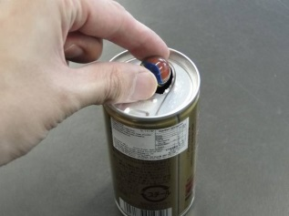 | Put 1 marble into the metal can.
 | 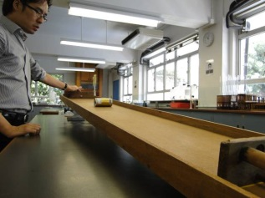 | - Let the metal can (with 1 marble inside) move down freely the inclined plane from the starting point.  - Measure the time taken by the metal can to arrive at the ending point with a stopwatch .  - Repeat (a) and (b) by other group members.  - Calculate the average value of the results and complete Table 1.
 | 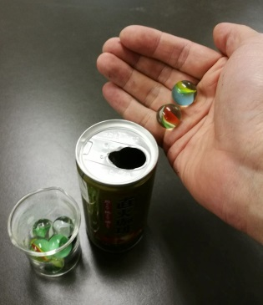 | - Use 2, 3, 4 and 5 marbles respectively to repeat Step 10.  - Collect the data from other groups.  - Calculate the average values of the results collected and complete Table 2.

Step 4: Recording results

- Total mass of 10 marbles:
- Average mass of the marble:
- Mass of the metal can:
- Length of the inclined plane:
- The time taken for the object to move down the inclined plane (procedures 10 and 11a):
Table 1 (Take one decimal place)
 | Group member 1 | Group member 2 | Group member 3 | Group member 4 | Average value
The time taken for the metal can with
1 marble (unit: _______ )
The time taken for the metal can with
2 marbles (unit: _______ )
The time taken for the metal can with
3 marbles (unit: _______ )
The time taken for the metal can with
4 marbles (unit: _______ )
The time taken for the metal can with
5 marbles (unit: _______ )

- The time taken for the object to move down the inclined plane (procedures 11b and 11c):
Table 2 (Take one decimal place)
 | Average value of time from different groups |  |  |  |  |  |  |  | Average value
 | Group A | Group B | Group C | Group D | Group E | Group F | Group G | Group H
The time taken for the metal can with
1 marble
(unit: _______ )
The time taken for the metal can with
2 marbles
(unit: _______ )
The time taken for the metal can with
3 marbles
(unit: _______ )
The time taken for the metal can with
4 marbles
(unit: _______ )
The time taken for the metal can with
5 marbles
(unit: _______ )

Step 5: Analysing result and drawing conclusion

(Circle and correct answer and fill in the blank)

When a person responds to a stimulus, the time interval between the stimulus and the response is called reaction time. Different people have different reaction times (for example, some people respond faster than the others). Generally, our reaction times lie between 0.15 seconds and 0.4 seconds, and the average value is about 0.2 seconds.

Therefore, even if we use stopwatches to measure the same event, the results may not be exactly the same. The error is due to the reaction time.

As a result, if the change in time is within 0.2 seconds in our experiment, the change is due to reaction time. On the contrary, if the change in time is larger than 0.2 seconds, the change is mainly affected by the change in mass.

According to Table 2, the maximum and minimum average value of time is and
respectively. The difference of the two values is , which is larger / smaller than 0.2 seconds. Therefore,

(Put a tick “√”in the appropriate box)
the time taken for an object to move down an inclined plane is independent of the mass.
a more massive object takes a longer time to move down an inclined plane.

a more massive object takes a shorter time to move down an inclined plane.

End

