Q2: Deconstructing Casual Explanation (CE) Genre
A factory producing bottles of detergent uses a method as shown to check the quantity of detergent inside the bottles. At both sides of conveyor belt, there is a set of radioactivity source(β), detector and counter. Both the source and detector are set at the level as the standard height for the detergent inside the bottle to reach (see the following figure).
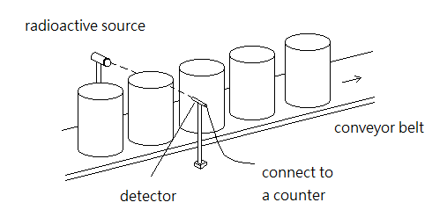
Explain how this system can identify the irregular products (that the detergent inside the bottle does not reach the standard height). (4 marks)

Suggested answer
When the detergent inside the bottle does not reach the standard height, the reading of counter is greater than the normal. The reasons are as follows. In normal condition, the detergent inside the bottle reaches the standard height. Majority of β radiations will be absorbed by the detergent and is not able reach the detector. Thus, the counter records only few β radiations and background radiation. When the detergent inside the bottle does not reach the standard height, β radiations will not be absorbed and thus they will reach the detector. The reader of counter goes up and the irregular product can be identified.
Complete the following table by decoding the above answer.
Structure | Answer | Language features
Identification of cause & effect
Absence of the factor
Presence of factor

