Q3: Reconstructing Sentences

The set-up as shown in the following figure is used to study β radiation emitted by a radioactivity source. A radioactive source and Geiger-Muller counter are placed at position P and Q respectively. Thus, the β radiation emitted from the source passes through the gap between a pair of coils A and B.
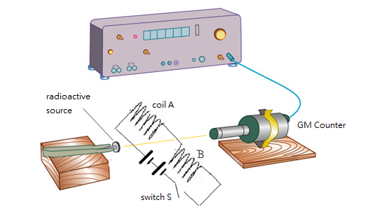
When switch S is open, the average rate recorded by GM counter is 1,000 counts per minute. When we close switch S, the rate recorded by GM counter decreases to 400 counts per minute. Explain the change of count rate.
-----------------------------------------------------------------------------------------------------------------------------
Rearrange the following sentences to form a reasonable answer to the above question.
1 | On the other hand, β radiation with negative charges emitted by the radioactive source passes through the magnetic field. It experiences an electromagnetic force and has a deflection.
2 | When switch S is open, the GM counter detects β radiation emitted from the source. Thus, the average rate recorded by GM counter is 1,000 counts per minute.
3 | When we close switch S, the count rate recorded by GM counter decreases from 1,000 to 400 counts per minute. The reasons are as below.
4 | When the circuit is closed, current flows through coil A and B. Thus, magnetic field is formed between the pair of coils.
5 | Hence, GM counter cannot detect β radiation and record only the background radiation, i.e. 400 counts per minute.

Structure |  | Content | Language  Features
Identification of phenomenon
Absence of factor
Presence of factor | Explanation Sequence 1
 | Explanation Sequence 2
 | Explanation Sequence 3

Suggested answer for teachers as reference
Structure |  | Content | Language  Features
Identification of phenomenon |  | When we close switch S, the count rate recorded by GM counter decreases from 1,000 to 400 counts per minute. The reasons are as below. | When  The reasons are as below.
Absence of factor |  | When switch S is open, the GM counter detects β radiation emitted from the source. Thus, the average rate recorded by GM counter is 1,000 counts per minute. | When  Thus
Presence of factor | Explanation Sequence 1 | When the circuit is closed, current flows through coil A and B. Thus, magnetic field is formed between the pair of coils. | When  Thus
 | Explanation Sequence 2 | On the other hand, β radiation with negative charges emitted by the radioactive source passes through the magnetic field. It experiences an electromagnetic force and has a deflection. | One the other hand
 | Explanation Sequence 3 | Hence, GM counter cannot detect β radiation and record only the background radiation, i.e. 400 counts per minute. | Hence

