Q4 Post-test

As shown in the following figure, smoke detector circuit consists of a battery and a pair of metal poles. An α radioactivity source is placed between the poles. An alarm is connected to the circuit and will sound for the decrease of current. Explain why the smoke detector can detect smoke from fire and sound an alarm.

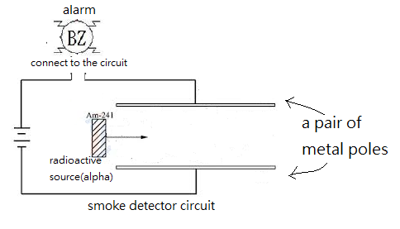

Suggested answer for teachers as reference

The smoke detector can detect smoke from fire and sounds an alarm due to the decrease of current in the circuit. The reasons are as below. There is an αradioactivity source in the detector. The air molecules are ionized byαradiations and thus the space between the pair of metal poles is filled with charged particles. Hence, the charged particles complete the smoke detector circuit with a steady current. When fire happens, the smoke particles enter the detector and block the movement of α particles and leads to the decrease of number of ionized particles. Hence, the current drops and the fire alarm sounds.

