Writing Exposition in Physics
Learning Task 2
The following questions call for answers of Exposition writing. In each question, underline or write down the subject matter on which the answer has to make a judgment or state a position.

Question 1 (Source: 2012 DSE 1B Q1c)
Cappuccino is an Italian style coffee topped with a layer of frothy milk (Figure 1.1).
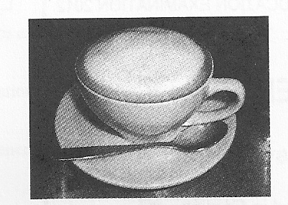
Figure 1.1

Frothy milk is made by bubbling steam through milk, which is held in a metallic jug (Figure 1.2). Steam is ejected from the steam wand of a cappuccino machine (Figure 1.3).
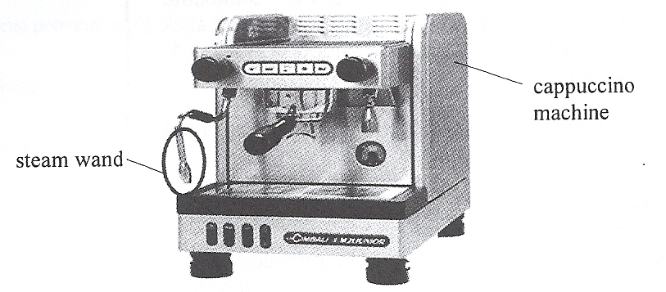
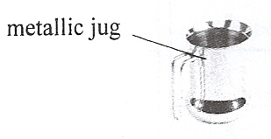
Figure 1.3

Figure 1.2

(a) Calculate the total amount of heat released when 20 g of steam at 110°C cools to 100°C and condenses to water at 100°C.
(b) 20 g of steam at 110°C is bubbled through 200 g of milk at 15°C to make frothy milk. Using the result in (a), estimate the temperature of the frothy milk.
(c) Would the actual temperature of frothy milk be higher than, equal to or lower than the value found in (b)? Explain.

Question 2 (Source: 2012-DSE-PHY Sample Paper 5b)

Anita’s house is surrounded by hills and at her house, the reception of one of the two radio channels is better. For which radio channel is the reception better ? Explain your answer.

Question 3 (Source: 2012-DSE-PHY-1B-Q3a(ii))
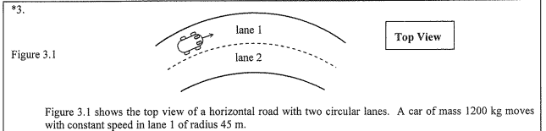

Suppose the car takes lane 2 instead of lane 1 and the maximum value of the force providing the centripetal force is still 8000 N. Would the car’s highest speed in lane 2 be smaller than, larger than, or the same as that found in (a)(i)? Explain.

Question 4 (Source: PracticePaper DSE PHY Q.7a)
A lens can be used to produce an image with the same nature as that produced by the liquid drop. State the type of lens and explain your answer.

Question 5 (Source: Practice Paper DSE PHY Q.7c)
If the refractive index of the liquid becomes smaller, explain the change, if any, in the focal length of the liquid drop.

