(Only need to respond to part b(ii))
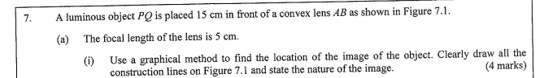
(Below is the answer to part a(i) provided for you.)
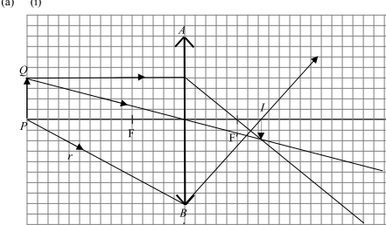

BR Steps | Referring to the Question
1. State the subject matter to make judgment on
2. State the relevant Physics knowledge
3. Apply the knowledge to the question
Write the answer in Exposition format

